This text was adapted by The Saylor Foundation under a Creative Commons Attribution-NonCommercial-Share-Alike 3.0 License without attribution as requested by the work’s original creator or licensee.

Chapter 1

Meet SS+K: A Real Agency Pitches a Real Client
Figure 1.1 Fourteen Months to Launch!
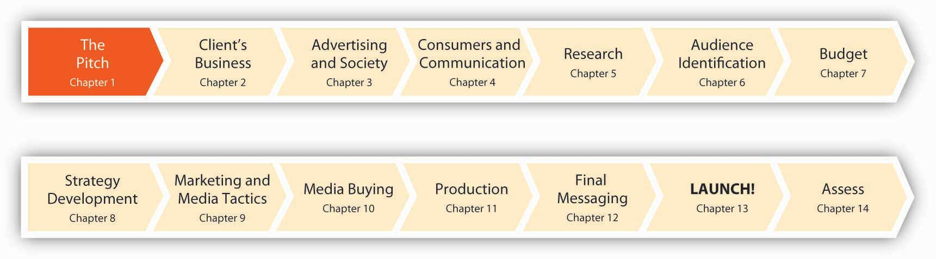

1.1 Why Launch!?

LEARNING OBJECTIVE
After studying this section, students should be able to do the following:
- Recognize the bold new approach for delivering information to today’s college students (aka digital natives).

Knowledge Is a Flat World
The textbook publishing industry is undergoing staggering change as many traditional business models and practices quickly lose relevance. Peer-to-peer textbook trading networks, online used-book sellers, and a gray market that allows low-priced international editions to displace expensive U.S. texts push publishers to reconsider outmoded ways of delivering content. Likewise, the digital natives who make up our university student bodies (that’s you!) inspire educators to think about the transfer of knowledge in exciting new ways.
How do we best communicate the most current thinking in our disciplines to students who expect up-to-the-minute information at a keystroke and who view educational materials as community—indeed, world—resources that can and should be freely shared and interactively constructed?
We’ve created a new kind of text—one premised on the idea that college course material can wield wider influence and be of greatest public benefit as it becomes easily and inexpensively available to anyone with a desire to learn.
Figure 1.2
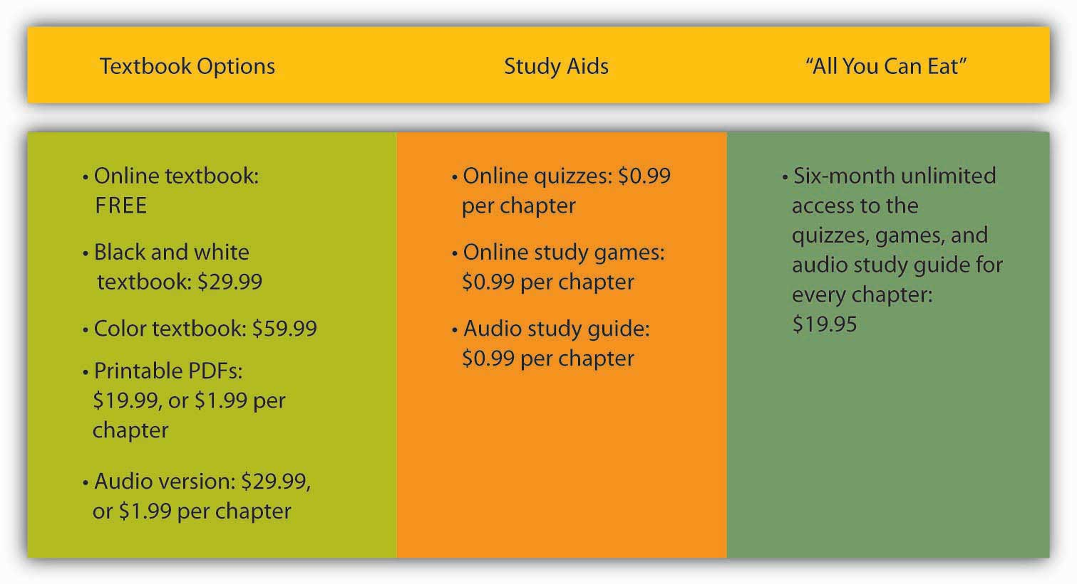
Knowledge in a Flat World…Choose only what you want. Pay only for what you use.
Launch! Advertising and Promotion in Real Time is the first free, open source text for advertising and marketing classes. A new alternative to introductory texts that can cost into three figures and provide information that is extraneous or outdated, Launch! offers a basic text at no cost to students. Instead, we generate revenue through individually priced materials such as discretionary hard copies of the text (for those of you who still like to mark up your book the old-fashioned way), study guides, podcasts and streaming interviews (à la iTunes), user-generated content, advertising sales, and corporate sponsorships.

Learn about Advertising by Learning about Advertisers (Real Ones)
There’s something else that’s really unique and cool about Launch! Welcome to the first advertising textbook written in partnership with a real-life advertising agency. It’s fine to talk about ad campaigns from the past, but we’d rather hear about one from the horse’s mouth—while it’s still happening. We’re going to teach you about the ad biz the way you’ll learn it if you choose to make it your career (and we hope you do). None of that shiny, happy, “talking heads” stuff; we’re going to take the gloves off and show you how a campaign works (and sometimes doesn’t) from the vantage point of the people who have to do it every day. Prepare to Launch!

1.2 Meet Our Agency Partner: SS+K

LEARNING OBJECTIVE
After studying this section, students should be able to do the following:
- Characterize the Shepardson, Stern and Kaminsky (SS+K) organization, a creatively-driven strategic communications firm, and how it works to secure clients.
Get to know Shepardson, Stern and Kaminsky (SS+K) as it works on a campaign for msnbc.com, a media brand in search of an identity. SS+K opened its doors in 1993 and now has offices in New York, Boston, and Los Angeles. With over $70 million in billings, SS+K is an independent agency owned by its partners, with a minority ownership by Creative Artists Agency (CAA)—perhaps the most powerful talent and literary agency in the world. CAA also owns the Intelligence Group, a market research and trend forecasting company.
Figure 1.3
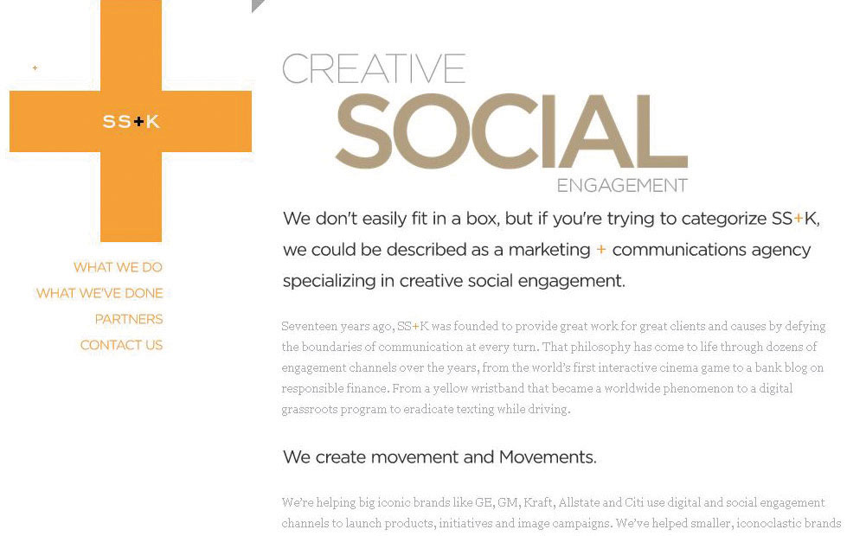
SS+K’s Web site is an immersive introduction to the history and offerings of the agency. You can find it at ssk.com.
For this text, we interview the agency partners, the creative director, the account people, the creative team (copywriter and art director), the public relations experts, the account planners and research specialists, and the digital professionals who took the msnbc.com campaign from pitch to completion.
Through their words and documents you will follow, step by step, the thirteen-month process of bringing SS+K’s campaign vision of “A Fuller Spectrum of News” to light. To allow us to bring you the inside story on how the agency created the msnbc.com campaign, msnbc.com and SS+K granted FWK full access to its creative work, internal processes, and employees. The result is a resource that offers new ways to teach and talk about the real world of advertising with course content that is affordable, accessible, timely, and relevant. Welcome to advertising education on steroids.

OK, So Who Is SS+K?
SS+K was founded in 1993 by three former political consultants—Rob Shepardson, Lenny Stern, and Mark Kaminsky—and a famous copywriter, David McCall. To this day, the agency is a mash-up of those roots in politics and creativity, bolstered by a dose of entertainment marketing via its partnership with CAA and the staff’s passion to learn and apply the latest technology. SS+K has become a haven for talented refugees from every corner of the communications world.
SS+K offers a full array of services to its clients, including advertising, marketing, design, public relations, public affairs, and research. Although many ad agencies, PR firms, and marketing consultancies endorsed integrated strategies over the last decade, SS+K believes that most agencies have built-in biases toward one type of solution. They tend to treat “integration” as an item on a check-off list. Ad agencies think in terms of ads. PR shops generate PR ideas. And so on…but not SS+K. For them, it is about delivering the right message at the right time to the right audience with the right medium. They call their approach to these types of media-neutral ideasAsymmetric Communications. Their perspective encourages the agency to “think outside the box” by employing a mix of traditional and new media (like urban games) to engage the audience in surprising ways and uncover opportunities to connect with them.

Figure 1.4 View of the Brooklyn Bridge from SS+K’s New York Office
This perspective is a consumer-centric approach the agency uses to find unique and surprising ways for clients to connect with and engage their target audiences. For example, instead of using traditional methods and messaging to increase awareness of Qwest Wireless among high school students, Qwest worked with SS+K to design an urban game called ConQwest that involved teams of students, newly created semacodes for use on cell phones, and giant inflatable game pieces. Semacode is a trade name for machine-readable two-dimensional black and white symbols that act as “barcode URLs.”
True to their political roots, the agency consulted with the Obama presidential campaign on driving more interest and participation among young voters. Since its inception, SS+K has maintained a high-profile nonprofit business, including work with UNICEF, Share Our Strength, the Bill & Melinda Gates Foundation, and the Lance Armstrong Foundation’s “LIVESTRONG” campaign.
The agency understands how to work with short lead times and mine for deep consumer insights that animate its work. It’s a combination that has made SS+K increasingly popular with a growing roster of clients, including Delta Airlines, Credo Mobile, Polo Ralph Lauren, AutoMart—and our client for this book, msnbc.com.
After fifteen years in business, all three founding partners—Rob Shephardson, Lenny Stern, and Mark Kaminsky—are still active in the firm, and they’ve added other key partners such as Executive Creative Director Marty Cooke to continue to provide fresh ideas and leadership.

Figure 1.5 The Partners of SS+K
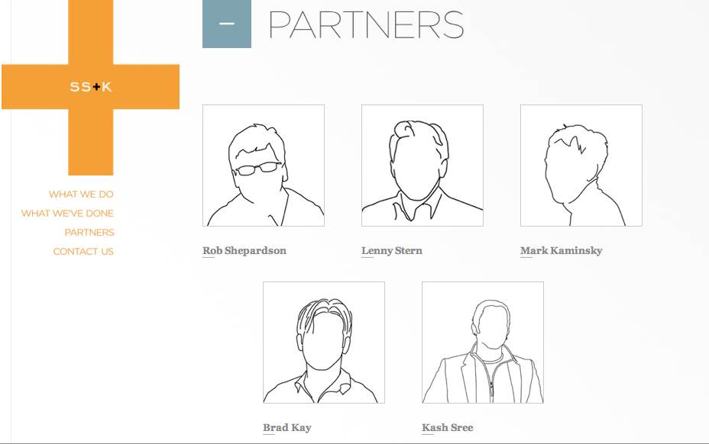

Our SS+K Odyssey
Here’s how we got started: once SS+K agreed to participate in this unique partnership, it was time for us to become familiar with the campaign. First, the author reaches out to Russell Stevens, a partner at SS+K.

Figure 1.6
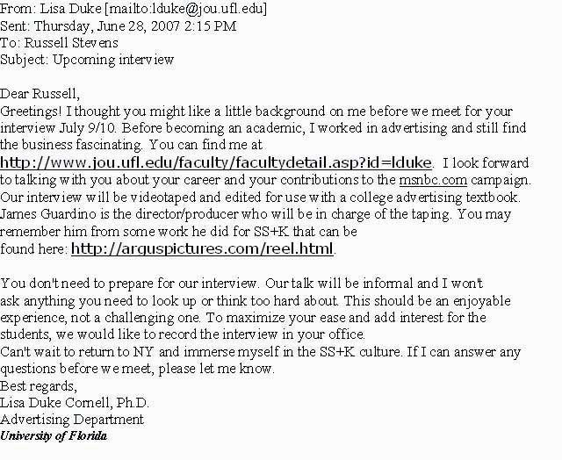
Follow the e-mail trail.
Dr. Duke Cornell flew up from Gainesville (where she teaches advertising at the University of Florida) and came in to meet the whole SS+K crew, and learn a lot about SS+K. Throughout the text, you will find links to the interviews Dr. Duke Cornell conducted with the team based in New York. In addition, she interviewed key team members from the Los Angeles and Boston offices.

Launch! unfolds chapter by chapter across a timeline for msnbc.com’s first branding campaign. Before we get into that, let’s meet the full cast of characters who worked on the msnbc.com account.

Figure 1.7
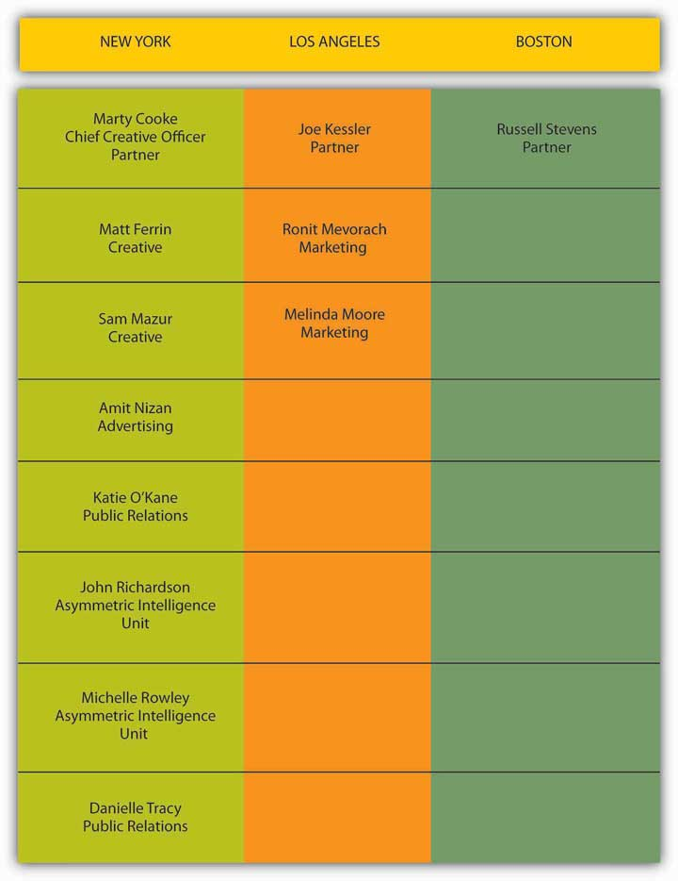
Meet the core SS+K Team assigned to the msnbc.com account.
Additional SS+K employees worked on aspects of the msnbc.com account, including Jeannie O’Toole (Head of Print Production), John Kirkwood (Web and Video Production), Tim Player (Studio Manager), Kelly Kraft (Project Manager), Amy Gaiser (PR), Janetti Chon (PR), Aaron Taylor-Waldman (Studio Designer), Alice Ann Wilson (Head of Design), Natalie Cho (Designer), Sonya Fridman (Designer), Joe Sayaman (Copywriter), and Rochelle Ardesher (Project Manager).
As you can see, it takes a village to work on an account. Each of the people beyond the core team contributed their respective expertise to the production and execution of the first-ever msnbc.com branding campaign.

How SS+K Works
How is an ad agency not an ad agency? SS+K does not consider itself an advertising agency, but instead a creatively-driven strategic communications firm that solves problems through a variety of innovative techniques—including but not limited to traditional advertising approaches. You’re going to see throughout this book that SS+K is not alone in this regard—the advertising industry seems to change its stripes almost daily as new technologies and trends evolve!
As a remnant from SS+K’s founders’ days as political consultants the agency uses an integrated model. SS+K is media-agnostic; this means it doesn’t care what medium or discipline it uses to solve a client’s problem as long as the solution delivers the right message at the right time to the right audience with the right medium.

KEY TAKEAWAY
Welcome to a new model of textbook learning. This book is different from others in two really important ways:
- It’s the first open source, professionally authored advertising/marketing textbook ever.
- It’s the first advertising textbook written in partnership with a real-life advertising agency.
The SS+K agency is going to help us learn how to do advertising by actually doing advertising. Follow along with us as we chronicle its efforts to win the important msnbc.com account and then deliver on its strategy to make this media brand the source of news for the customers the site hopes to reach.

EXERCISES
- List four facts that characterize the Shepardson, Stern and Kaminsky (SS+K) communications organization. Be specific.
- SS+K uses a distinctive trademarked approach for engaging clients and audiences in the advertising and communication process. Briefly describe SS+K’s asymmetric approach to formulating communications and ideas.
- Discuss the integrated model of communication presented in this chapter section. Why does SS+K describe itself as being “media-agnostic” in its approach to communication?

1.3 The Pitch: Win the Account

LEARNING OBJECTIVE
After studying this section, students should be able to do the following:
- Understand the process by which an agency makes a pitch for a client’s business by responding to a Request for Proposal.
How does the client decide which agencies to work with? It all starts with thepitch, where the client invites an agency to present itself with the hope of winning the account. Once a client decides on a list of agencies to pitch their business, it may send these agencies a request for proposal (RFP). In an RFP, the client lays out basic information about its business and requirements for the job, along with a list of questions that will help the client determine how the agencies work and if they are suited to the task at hand.
In some cases, agencies may approach clients they feel would be a good match for their talents or would add depth or luster to their roster. Alternatively, when agencies are well known for a particular campaign or approach, clients will seek them out. However, just as when an individual is searching for work, word of mouth and personal relationships play an important role in the process. It’s not just what you know, it’s who you know.

Why the Pitch Is Such a Big Deal
The client’s stake in agency pitches is high: management’s jobs, the brand’s future, and millions of dollars may ride on the campaigns the winning agency creates. For example, in 2007, despite having spent over $900 million on marketing that year, Microsoft was not performing well against competitors such as Google and Apple. Identifying a key need to boost market share, the software giant embarked on a search for a new agency to enhance its brand image. By February of 2008, Microsoft had narrowed its search to two agencies; it then chose Crispin Porter + Bogusky for a new $200–300 million “consumer blitz.” ^{[1]}
Just as the client invests large sums in the advertising campaign, the costs for agencies also are enormous, whether or not they win the business. In order to pitch effectively, the agency must allocate material resources and a tremendous number of team hours to meetings, research, and creation of the pitch. Sometimes, when the assignment, chemistry, or timing isn’t right, it’s just good business for the agency to walk away and leave millions of dollars in potential billings on the table.
That’s what happened in 2006, when GSD&M (now known as GSD&M Idea City)’s nineteen-year relationship with its client Wal-Mart was challenged in a client-initiated review for their business. In one of the first review meetings the incumbent agency had with its longstanding client, GSD&M agency president Roy Spence played a clip from the movie Dumb and Dumber, in which the romantically challenged character played by Jim Carrey is told by the girl of his dreams the chances they will be together are one in a million. Carrey replies, “So…you’re telling me there’s a chance?” ^{[2]}
Spence’s attempt at lightheartedness hid a hard truth: there was no salvaging the relationship. GSD&M was unsuccessful in its pitch for the business, which included a poorly received report suggesting that Wal-Mart’s declining reputation was at the root of its struggle for higher share prices. In an interesting turn of events, the agency that “won” the business, Draft FCB/Chicago, was dropped in a matter of months, and Wal-Mart once again invited GSD&M to pitch its business. This time, GSD&M swallowed hard and passed on a chance at the $580 million assignment. Like the song goes, you gotta know when to hold ’em and know when to fold ’em.

Who Conducts the Pitch?
Marketers who work on the brand for the client are the ones who initiate the pitch process when they make the decision that they would like to search for an agency. The person within the organization who generally leads the search is the chief marketing officer or the vice president of marketing.
Some marketers choose to partner with a search consultancy whose job is to conduct the search. They use different methods to determine which agencies are the most appropriate fit for their client’s pitch. They also work as liaisons between the client and the competing agencies to handle questions and logistics and to structure the pitch.

The Pitch Process
The pitch process can be short or long, depending on the information the client requests in order to make the decision. There is usually a series of steps, including but not limited to these:
- Filing the RFP. A client will send out the RFP, which will include some basic background information and preliminary statements of what the agency will be tasked to solve. The agency in turn will fill out the RFP with an introduction about themselves, as well as answers to any other questions the RFP asks.
- Chemistry meeting. Based on the responses to the RFP, the client will invite select agencies to meet in person. This meeting is generally called a chemistry meeting, as it is designed to allow the companies to determine how well they like each other and if there is “chemistry” between them.
- Initial strategic thinking. Before agencies are given a specific creative assignment, there is a step to discuss the approach to the problem. This discussion can sometimes be part of the chemistry meeting but can also be a next step. The initial strategic thinking allows the agency to demonstrate the tools it keeps in its shed without putting them all to use until the client agrees to the strategic approach.
- Creative presentation. If an agency is given a creative assignment, this meeting is where it presents its recommendations to the client.

Figure 1.8 The msnbc.com RFP
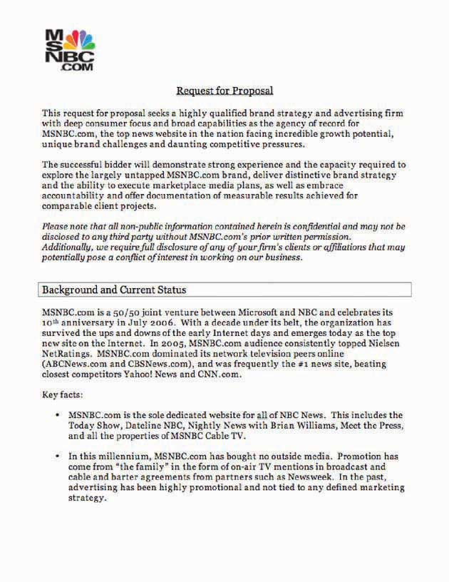
This is the first page of the RFP that msnbc.com sent to SS+K and other agencies.
Figure 1.9 The Pitch Process
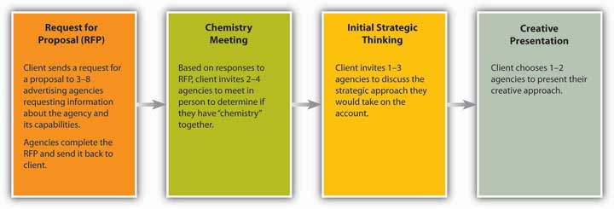
How do agencies demonstrate to clients they are the right choice for the job? In a recent interview well-known account planner Jon Steel noted, “I have always believed that the best new business weapon in an agency’s armory is the quality and effectiveness of the work it produces for its existing clients.” However, another way that agencies have demonstrated their creative ability is to present “spec” (speculative) creative work in pitches. Spec work is developed based on the agency’s best guess as to what might appeal to and work best for a client and presented in a form that is very close to “finished.”

Dig Deeper
The problem with spec work is that many in the industry feel it devalues skills such as design, art direction, and copywriting—as it forces agencies to give away for free (or at a substantially reduced cost) their most valuable product: their creativity. In the end, ownership of the ideas presented during pitches can be contested; clients who have had a number of agencies pitch creative work have been known to pick and choose among the best of all the pitching agencies’ ideas while awarding the business to just one. As a result, the American Association of Advertising Agencies (AAAA) created a Positioning Paper outlining best practice guidelines for the use of “spec” creative in the new business process: http://www.aaaa.org/eweb/upload/6712_att.pdf.
What’s your opinion? Should agencies be compensated for “spec” work even if they don’t win the account?

KEY TAKEAWAY
You can’t work on an account until you’re awarded the business. To win a client you have to present a pitch, usually along with several other agencies. Although the client doesn’t (or shouldn’t) expect to see a finished campaign, it will look for evidence that your team has put a lot of creative thought and effort into fleshing out its vision of what the advertising will look like. Preparing a pitch can be an expensive, grueling, and nail-biting experience, so an agency shouldn’t throw its hat into the ring unless it’s willing to make a commitment to go all out in order to win the business.

EXERCISES
- Define the terms “pitch” and “request for proposal (RFP).” According to material found in this chapter section, why is the pitch such a big deal?
- List and describe the four-step pitch process that SS+K must go through to win the msnbc.com account.
- How does an agency such as SS+K demonstrate to clients that it is the right choice for a communications job? Be specific in your discussion.

[1] Rupal Parekh and Alice Z. Cuneo, “Microsoft Narrows to Crispin, Fallon,” Advertising Age, December 21, 2007, http://adage.com/agencynews/article?article_id=122776(accessed July 16, 2008).
[2] “Wal-Mart, Please Don’t Leave Me,” Business Week, October 9, 2006,http://www.businessweek.com/magazine/content/06_41/b4004076.htm (accessed July 16, 2008).

1.4 Let’s Meet the Potential Client

LEARNING OBJECTIVE
After studying this section, students should be able to do the following:
- Discuss the background and primary employees (characters) of msnbc.com, a well-known media brand in search of its identity.
Established in 1996 as a joint venture between Microsoft and the National Broadcasting Corporation (NBC), ten years later msnbc.com finds itself in an increasingly crowded field of news providers and hopes to add new users to its twenty-five million unique visitors a month. As msnbc.com’s VP of marketing, Catherine Captain, says, “I am particularly concerned about distinguishing ourselves in a market where every new site is starting to look a lot alike.”
It is important to understand that the client is msnbc.com the Web site and not MSNBC the cable channel. Although the Web site msnbc.com and the cable channel MSNBC were launched together in 1996, they have always maintained separate corporate structures and news operations. NBC and Microsoft remain fifty-fifty partners in msnbc.com, but Microsoft has reduced its stake in the television network to 18 percent. And msnbc.com is editorially and financially separate from MSN, the portal site and online service operated by Microsoft, although it acts as that site’s primary news provider.
In addition to original content from its staff, which is based out of the newsroom in Redmond, Washington, msnbc.com is the news Web site for the NBC News family. It also features content from the cable television news channel MSNBC, NBC shows such as Today, NBC Nightly News, and Dateline NBC, and partners such as the New York Times and the Washington Post. In addition, msnbc.com made its first acquisition in late 2007 when it bought Newsvine, a Web site with community-driven news stories and opinions.
In its history as a company, msnbc.com never pursued or launched a branding campaign until Ms. Captain arrived just shy of the site’s tenth anniversary. In her quest for the right agency, Ms. Captain sent RFPs “to a whole slew of potential agencies.”

SS+K’s Pitch to Win the msnbc.com Account
Objective: Win the msnbc.com account!

I knew that SS+K was the perfect agency for her, because we come from the same philosophy.
Danielle Tracy, SS+K vice president

Victory! SS+K Lands the msnbc.com Account
You can guess the outcome: Catherine Captain chose SS+K to reintroduce msnbc.com to the world. Her goal was to maximize the impact of her modest $7 million marketing budget. Instead of choosing an interactive agency, which she said would “predetermine her plan,” Captain preferred the “media-agnostic” approach of SS+K. And so, in March of 2006, a decade-old msnbc.com announced it would soon launch its first branding campaign.
The idea of integrated marketing communications has been around for a long time. But the independently held SS+K embraced the concept in a way that only people from a disparate number of camps could: there are no well-populated traditional territories in the agency. Instead, it is home for a multidisciplinary cast of communication experts as well as a collection of “formers”—former actors, scientists, journalists—galvanized by a combined passion for strategic innovation and, as Captain observes, challenging the status quo. There is no allegiance to method or medium; advertising doesn’t get preferential treatment over public relations or other buzz boosters.

KEY TAKEAWAY
SS+K’s team developed its pitch by doing its homework about the types of people who visit Web sites to get their information. The agency also wasn’t afraid to think creatively about using a variety of media to capture their interest. As a result of this effort the agency won the msnbc.com account. Now the work really starts.

EXERCISE
What were the key contributing factors that allowed SS+K to win the msnbc.com account? Be sure to comment on the roles played by Joe Kessler, Danielle Tracy, and Catherine Captain.

1.5 Exercises

TIE IT ALL TOGETHER
Now that you have read this chapter, you should be able to understand how a real advertising agency pitches a real client:
- You have been introduced to Shephardson, Stern and Kaminsky (SS+K), a creatively-driven strategic communication firm, and their future client msnbc.com, a well-known media brand in search of an identity.
- You are able to identify SS+K’s distinctive communications approach called Asymmetric Communications.
- You are able to recognize the pitch process and the resulting request for proposal (RFP) SS+K used.
- You can recall that the objective of the SS+K pitch was to win the msnbc.com account.

USE WHAT YOU’VE LEARNED
- As you have read in the chapter, SS+K is a multifaceted organization that specializes in helping clients with their unique communication problems. Review the listing of SS+K personnel. Once you have completed this review, link to the SS+K Web site http://www.ssk.comfor more information on the company.
Agency Statement: “With offices in New York, Boston, and Los Angeles, SS+K has become a magnet for refugees and misfits from the most potent pillars of American society: politics, creative, entertainment, and technology. We believe that when smart, talented people from different backgrounds sit down to solve a problem, the solutions are bigger, more unpredictable and more effective. We believe it is more important to understand your business issues, delve into consumer insights and work with you to find the best solution for the brand regardless of channel. At SS+K, we don’t care what media or discipline we use to solve a client’s problem; it’s about delivering the right message at the right time in the right medium.” ^{[1]}
Using the SS+K Web site (or other search engines), review the agency’s past work. Carefully examine one of the following campaigns that SS+K has created: the Lance Armstrong Foundation, Delta Airlines, Qwest Communications, UNICEF, or the Bill & Melinda Gates Foundation. Based on your review, comment on how SS+K seems to have applied its Asymmetric Communications model to the selected client’s communication problems. Try, if possible, to pinpoint the Asymmetric Idea SS+K developed that seems to be the focal point of communications. What do you think of SS+K’s approach for the selected client?
- SS+K has made a pitch to secure the communications business of msnbc.com. Beyond material supplied in the chapter, what do you really know about proposed client msnbc.com? Visithttp://www.msnbc.com to gain additional insight.
As you review the msnbc.com Web site, list three msnbc.com offerings that impress you. Additionally, cite any features that either don’t impress you or are missing from the Web site. Once you have completed this task, visit rival news service CNN athttp://www.cnn.com. Again, list three services that impress you and cite any features that either don’t impress you or are missing from the CNN Web site. As you make your evaluations, remember to review only the Web sites of the two organizations and not their televised news broadcasts. How does msnbc.com stack up against its rival? How could SS+K use your evaluation to improve the msnbc.com Web site? Be specific in your comments. As we go forward in our discussion of SS+K’s communication and advertising strategy for msnbc.com, see how many of your suggestions are recognized and addressed.

DIGITAL NATIVES
Almost all teens have difficulties with acne. Acne is not only a health issue but a social one as well. If you ever had difficulties with acne, what would you have given to rid yourself of those unsightly blemishes? To examine a new solution to this age-old problem, visit the Zeno Web site at http://www.myzeno.com.
Zeno is, according to its Web site, “the new secret weapon in the war against pimples.” Consider the following facts as you explore how Zeno works. The Zeno device looks like a cell-phone. It is a hand-held battery-operated device that is designed with a tip that heats to a preset temperature. Once the tip is heated properly and applied to the skin, the blemish disappears in a relatively short time. Much of the procedure is customized to the user and his or her skin type. The level of heat does not cause skin damage.
After exploring the Zeno Web site and learning about the application procedure and facts about the product, develop a brief “pitch” to present to the Zeno organization. The objective of your agency’s pitch will be to demonstrate the best method for introducing the Zeno product to college-age students. Consider the basic message to be delivered to this target market and the best way to transmit that message to them. What do you perceive to be the keys in reaching the college-age students in your target market? Discuss your pitch idea and conclusions with your peers.

AD-VICE
- Go to the Lance Armstrong Foundation’s LIVESTRONG Web site (http://www.livestrong.com). Comment on any evidence you see that Asymmetric Communications have been used to reach potential donors and supporters. Be specific in your comments.
- Using a search engine of your own choosing, examine sample requests for proposal (RFPs). During your search you will observe several RFP samples and possible downloads. Select a free download. Identify and describe the parts of the sample RFP you downloaded. Compare your sample download to Figure 1.8 "The msnbc.com RFP". Comment on similarities and differences.
- After reading the information provided in the chapter, take one of the following positions: (a) integrated marketing communications should be the objective of all advertising agencies or (b) time-tested, traditional media-specific campaigns have proven to be the best way to approach communication problems and opportunities. Write a short paper that summarizes your chosen position. Participate in a class discussion that evaluates the two positions.

[1] “Shepardson Stern + Kaminsky (SS+K),” O’Dwyer’s Database of PR Firms,http://www.odwyerpr.com/pr_firms_database/prfirm_detail.htm?prid=d7df07ef171a403c34e195e0ef90e0c2 (accessed February 10, 2009).

Chapter 2

A User’s Manual: Advertising, Promotion, and Marketing Essentials
Figure 2.1 Build a Foundation
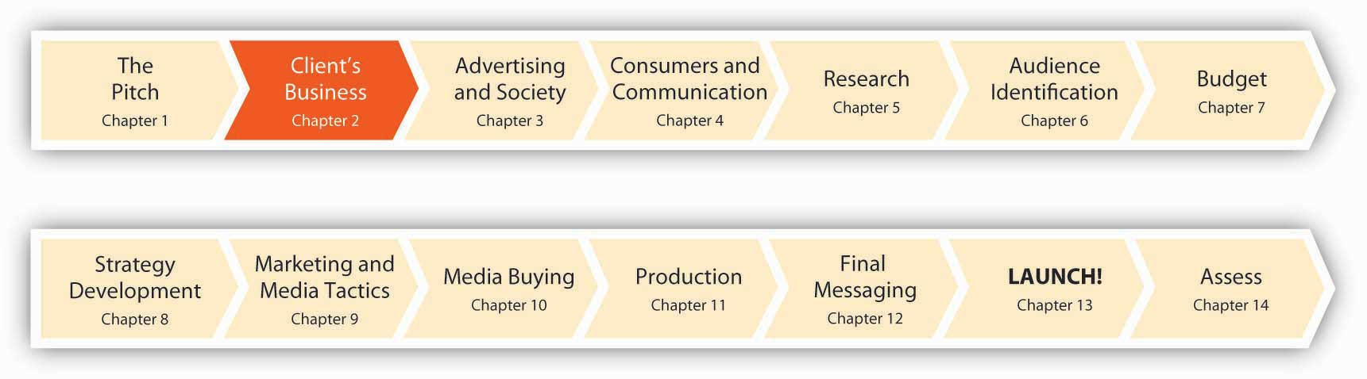
Advertising is in trouble only if you think of the narrow box advertising has traditionally been in, which is getting on TV or in print.
Linda Kaplan Thaler, Founder, Kaplan Thaler Group
This is not a book about advertising.
This is a book about touching consumers where they live—and work and play. Now that we’ve met some of the folks from SS+K and msnbc.com, let’s take a look at the fundamentals the members of these teams have under their belts. We’ll pick back up with them in Chapter 4 "Consumers and the Communications Process: SS+K Gets to Know Its Consumers" to follow how they’ve applied these fundamentals from Chapter 2 "A User’s Manual: Advertising, Promotion, and Marketing Essentials" and Chapter 3 "Advertising and Society".

2.1 Advertising Is Old—and Brand New

LEARNING OBJECTIVES
After studying this section, students should be able to do the following:
- Understand how the background and history of U.S. advertising impacts modern advertising and its clients.
- Define the various types of advertising and promotion agencies employ in today’s marketplace.
Hammers and screwdrivers did the trick for years, but today marketing communications professionals have a whole new box of power tools. The marketing to-do list is long and so is the list of instructions.
Agencies and their clients sorted madly through the box for the past decade as they tried to find the most effective tools for the job. Now, an avalanche of new technology adds to an increasingly daunting pile. It’s hard for some experienced advertising professionals to let go of what they “know.” “There’s still a little fear out there about shifting away from the traditional marketing tactics,” said Doug Scott, executive director for branded content and entertainment for the North American operations of Ogilvy & Mather Worldwide, part of the WPP Group, in 2006. ^{[1]}
But some marketers get it. They understand that advertising is a key driver of popular culture in addition to just reflecting what is going on in our world. Think about Burger King, for example: How does a company that sells dead meat sandwiches and strips of deep-fried potatoes dig its way deep into popular consciousness and (dare we say it?) actually become cool? As CEO John Chidsey (who refers to himself as Chief Whopper Flipper) explains, “We want to stay on the cutting edge of pop culture.” How cool is it to sell more than three million Burger King–branded Xbox video games in two months? Or to get its creepy icon The King included in seventeen skits on Jay Leno in the same amount of time? How about having a highly visited profile on MySpace, or posting your menu as a video on YouTube (http://www.youtube.com/v/7-QFQOfkZ1k)? ^{[2]} There’s something more than basic burger ads going on here.
Fifteen years ago, we defined advertising agencies by the essential tools they used: television commercials, radio spots, billboards, print ads. But today traditional advertising approaches, even in the hands of our most skilled and lauded practitioners, are no longer good enough.
Before we see how things are changing, let’s back up and start with a traditional definition: Advertising is nonpersonal communication from an identified sponsor that intends to inform, persuade, and/or remind. Now let’s break that down a bit so we understand what advertising is—and how it differs from other forms of marketing communication:
- Advertising is nonpersonal communication: The message gets delivered through one or more forms of paid mass media such as television or billboards.
- Advertising comes from an identified sponsor: Whether or not we pay attention to the message, we know who sent it.
- Advertising informs: Some messages try to make consumers aware of a product, service, or specific brand. You won’t choose a specific MP3 player until you know what it is and believe it’s better than listening to music on a CD player.
- Advertising persuades: Some messages try to change our opinion or motivate us to take action. You might decide to buy a Toyota Scion after you see a cool ad for it while you’re watching American Idol.
- Advertising reminds: Some messages try to encourage us to keep buying what we already like and use. “Got milk?”
Later we’ll talk about other kinds of marketing communication (such as sales promotions) and see how they differ from advertising. For now, suffice it to say that the lines are blurring and the tried and true is no longer so true. For example, while it’s mostly accurate to say that advertising comes from nonpersonal communications sources, today some companies recruit “brand ambassadors” who literally become walking billboards for their brands. They may get a tattoo of the company’s logo, or in some cases (we’re not making this up) name their children after a brand in exchange for some kind of payment. Or, consider the growing use of human directionals, which is what the advertising industry calls people who twirl signs outside restaurants, barbershops, and new real estate subdivisions. Southern California in particular has become a mecca for this new “sport” as locals cook up new moves to out-style their competitors. These include the Helicopter, in which a spinner does a backbend on one hand while he twirls a sign above his head. Then there’s the popular Spanking the Horse, where the human directional puts the advertising sign between his legs, slaps his own behind, and giddy-ups. ^{[3]}
In addition, it’s no longer necessarily crystal clear just who (if anyone) is the sponsor of a message. For example, we’ll learn later about some guerrilla marketing tactics that involve paid performers who impersonate everyday people and endorse products in public places. No, you’re not paranoid—they really are trying to fake you out. Finally, as we’ll see, the Web is in some ways taking the “mass” out of “mass media.” New technologies allow advertisers to customize messages so that (literally) each person who sees an ad actually gets a personalized communication that reflects his or her own unique interests and past purchases.
Figure 2.2
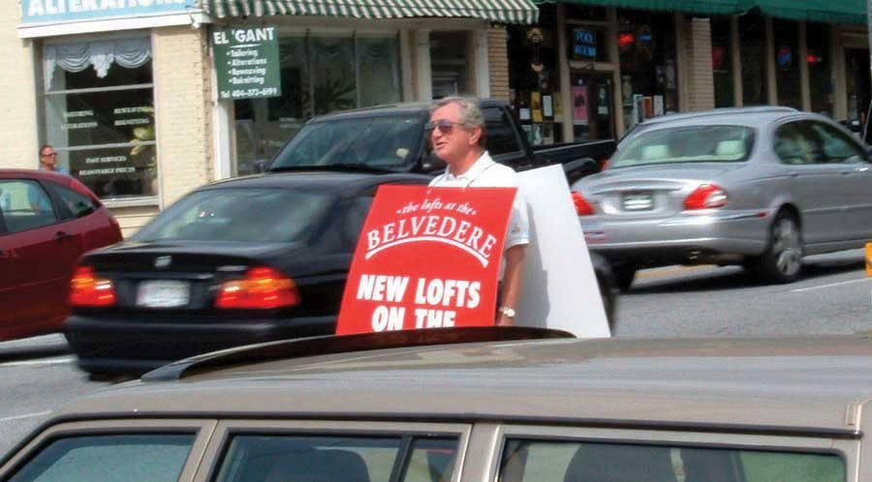
A human billboard tries to drum up business for a Realtor in Atlanta.
However, these innovative (and sort of scary) techniques remain in the minority of advertising efforts—at least for now. The reality is that most advertising agencies (and their clients) have been sleeping with their eyes open. According to an online survey of 184 marketers recently cited in the Wall Street Journal, “Less than 24 percent of those polled considered their companies ‘digitally savvy,’ citing several issues, including ‘lack of experience in new media’ and ‘dearth of digital talent.’” ^{[4]} Still, the world of advertising is changing rapidly—and you’ll be in the forefront of that change.
What is happening to advertising?
Transformation. A melding of forms and disciplines. Evolution of species.
Despite conventional definitions and expectations, we need to understand that advertising isn’t just about ads. Messages that sell may not originate with marketers or agencies, but rather with you. Marketing messages may not be paid for by advertisers. They are multinational and multidimensional, providing any combination of information, identity, and entertainment.
They don’t stay in place. Today, most any place is ad space (maybe even your own forehead!). By emphasizing the visual and experiential, today’s advertising messages are difficult to analyze critically. By incorporating authentic experience and online collaboration, new marketing is very difficult to predict and control. An old Chinese curse says, “May you live in interesting times.” We do.
There is a fundamental change in the advertising vehicles themselves as media and technology converge. Traditional radio is losing share to digital options, online “television” viewing is increasingly popular, and marketers continue to divert print dollars to online budgets. ^{[5]} Once thought to be a specialized type of advertising, now interactive/online approaches often are a fundamental way to engage consumers—especially younger digital natives who have grown up on MySpace, IM, and YouTube. Yet in an article on how advertisers seek less intrusive, more measurable ways to deliver online messages, the Wall Street Journal reports, “Many sites and advertisers remain in the throes of experimentation, with mixed or disappointing results to date. Some say the industry hasn’t yet figured out how to make video ads as interactive and effective as they can be.” ^{[6]}
Clients are similarly challenged. They no longer have the luxury of telling you only what they want you to know about their brand. Today, you can ask your neighbor or a Norwegian sitting in an Internet café while he’s vacationing in Majorca about that new bottled water you’ve been thinking about trying—all you need to do is type in a few well-chosen key words on your Google search bar and you’re off to the races.
It didn’t take long for some forward-thinking marketers to ask how they could use blogs for their own purposes. However, as recently as 2006 a poll showed just how far most Fortune 1000 executives have to go to catch up with the consumers with whom they hope to engage in dialogue. Only 30 percent said they understood the meaning of the term Internet blog, while 12 percent reported their companies had resorted to legal action to stop a blog that someone else had posted about their company! ^{[7]} The executives know there is a new tool out there. Most don’t understand or use it themselves. But their first instinct is that it must be reined in and controlled.
Like many marketers now, they battle twin fears: being late to the game and lacking the proper skills required to play. The danger is in choosing nontraditional routes uncritically because they have the cachet of being on the “bleeding edge.” According to Marc Schiller, chief executive of the digital-marketing shop Electric Artists, “There is always this pressure of saying we weren’t early enough on MySpace. We weren’t early enough on Facebook.…Suddenly there is this herd mentality and people are doing it because they feel like if they are not there, they are missing out.” ^{[8]}
A word of caution: in a business like advertising that prides itself on cultural currency, there is always a temptation to choose interactive solutions solely because you can. Sometimes, however, the best answer to a marketing problem is as low-tech and simple as the vivid yellow LIVESTRONG bands on your friends’ wrists. But before we talk about where we’re going, let’s talk about where we’ve been.
It’s time to take a step back and first learn a bit about where advertising came from and how many organizations still do it today.

Some Quick Background and History
Advertising has been with us since the days of ancient Greece, when announcements were etched on stone tablets or shouted by town criers. While Pizza Hut painted its logo on a Russian rocket and delivered a pizza to the Mir Space Station, in reality many of the ad formats we see today haven’t fundamentally changed in hundreds of years. ^{[9]}
Advertising in the United States began before we were even a nation. Colonial Americans saw ads on posters and in newspapers—the first newspaper ad was for real estate and appeared in 1704. For a comprehensive timeline covering the history of advertising, check outhttp://adage.com/century/timeline/index.html. The true rise of modern advertising, however, coincided with the Industrial Revolution for three reasons:
- Technologies enabled mass production of consumer goods, which meant that companies could grow to a larger size and make many more products efficiently. Next, they needed to find ways to sell these goods.
- Railroads linked the nation and provided a way to get newspapers and mass-produced products into towns across America. Quaker Oats—the first mass-marketed breakfast food—was introduced in 1878. Ivory Soap followed in 1879, and in 1888 Eastman began advertising the first hand-held Kodak cameras.
- The same technologies that enabled mass production accelerated the growth of mass media. The invention of the rotary press in 1859 and the process of making paper from wood pulp developed in 1866 enabled mass production of newspapers, which in turn provided the medium to distribute ads to more people.
Early examples of mass media include the New York Times, which published its first issue in 1851 (it was then called the New-York Daily Times). The New York Tribune doubled its advertising between October 1849 and October 1850. The magazines Harper’s Bazaar and Vanity Fair debuted in 1867 and 1868, respectively. By 1870, 5,091 newspapers were in circulation in the United States.
Capitalism also fueled advertising as it created a growing middle class that could afford to buy an array of consumer products. Soon the proliferation of mass-distributed consumer goods sparked the rise of the advertising profession. As competing manufacturers grew and more products were available on the market, the need to distinguish one’s products from the rest of the pack created a need for professional advertising agents, and advertising grew from an emerging to a legitimate profession. In 1890, the J. Walter Thompson Company (the oldest continuously operating advertising agency in the United States) had billings totaling over $1 million (in those days, a million was still a lot of money!).

Types of Advertising/Promotion
Today, the realm of advertising has expanded vastly beyond newspapers—way beyond. Consider Target’s recent ads that entertained passersby at New York’s Grand Central Station. The retailer showcased its designer apparel in a spooky fashion show that repeated every ten minutes; it used holograms (two-dimensional moving images that give the illusion of having three dimensions) to project images of garments (sans models) prancing down a surreal runway. ^{[10]} Yes, we’ve come a long way from stone etchings.
In addition to holograms, take a look at all the media channels available to advertisers today.

Print Advertising
Print advertising includes national, regional, and local newspapers, as well as magazines, which, like newspapers, can be geographical or subject based. For example, Dog Fancy reaches dog lovers across the nation.

Direct Mail
Direct mail is advertising sent directly to people’s homes through postcards, brochures, letters, and catalogs. Sponsored e-mails are a new form of “direct mail.”

Specialty Print Media
Specialty print media include booklets, folders, and CD/DVD inserts developed to provide targeted groups with specialized information on products and services.

Broadcast Media
The broadcast media consist of television and radio.
We subdivide television (TV) according to major networks, independent stations, cable, broadband, and satellite.
Radio, which was the first broadcast medium (bringing free advertising to American homes from the 1920s onward), can be local or network.

Outdoor Advertising
Also known as out-of-home advertising, outdoor advertising includes billboards on roadsides, and posters on transit (buses, subways, rail, airports, trucks, and taxis), at gas pumps, and on park benches.

Point of Purchase
Point-of-purchase (POP) displays refer to displays next to cash registers or elsewhere in retail environments—we often find them at the point at which people are ready to buy.

Online Advertising
Pop-ups, pop-unders, banners, and text ads associated with Web pages provide targeted online advertising on the Web.

Dig Deeper
U.S. consumers go to the Web 15 percent of the time they spend with all media. This online migration makes the Web where the action is for many advertisers. Most big, traditional companies were very cautious about marketing online, but now they’re cranking up their efforts as this media channel continues to gain legitimacy. According to John Galloway, vice president of sports, media, and interactive marketing at PepsiCo Inc.’s Pepsi-Cola North America unit, “Our job is to invest in where consumers are engaging with media.”
And online is where they’re going. For example, General Mills spends about double on online advertising what it laid out just one or two years ago, while Kraft reports similar numbers. Some media analysts believe the pattern of Web spending will mimic what they saw in earlier times with spending on broadcast and cable TV—both media benefited from huge growth once they reached a tipping point in terms of consumer adoption. This trend bodes well for companies like Yahoo! and Google that make their money from online search and advertising. But these consumer packaged goods (CPG) companies still have some catching up to do: in 2005, consumer packaged goods accounted for more than 11 percent of the $145 billion in U.S. ad spending, but CPG companies spent just 1.6 percent of their ad dollars online on average, compared with an overall average of 5.8 percent of total ad spending for U.S. advertisers. ^{[11]}
Check out some online ads for packaged goods companies like General Mills and Kraft to see how they’re making this transition from traditional media. For example, you can find some nice recipes at Kraft’s http://www.kraft.com/switch-site.htm. What could the company do to increase the appeal of this site? If you wanted to appeal to consumers who spend a lot of time browsing online, what changes might you make?

Sales Promotions
Sales promotions build interest in or encourage purchase of a good or service during a specified period. These activities range from coupons that we receive in our newspapers to contests and sweepstakes to sales competitions a company might host for its own employees.

Specialty Advertising
Specialty advertising involves the distribution of merchandise (called promotional products, premiums, or swag) to promote awareness of a company. These include coffee mugs, pens, jackets, and many items that are usually imprinted with a company’s name, logo, or slogan and given away at trade shows or conferences or in mail campaigns.

User-Generated Content and Word of Mouth (WOM)
These days, many advertisers strive to get consumers to help get the word out about a product or service. The reason is simple: people trust the recommendations of others more than they trust paid advertising. Almost 90 percent of people say they trust recommendations from consumers compared to less than 50 percent who trust radio ads and less than 10 percent who say they trust online banner ads. ^{[12]} It’s fair to say that user-generated content is one of the biggest advertising and promotion stories of this decade.

Dig Deeper
How believable are advertisements that big companies sponsor? Is buzz truly more effective than a glitzy ad with a highly paid celebrity who tells you to use a company’s product or service? Find some cool print ads and show them to your friends. Ask them to talk about how effective they think the ads are and why they do or don’t make it more likely that they’ll actually buy the advertised brand.

Ad-Supported Content
Ad agencies are well aware that many consumers watch TV with their TiVo firmly in hand, ready to skip through their wonderful ads. People read fewer newspapers as well (especially college students!). Advertisers lose a lot of sleep worrying about how to get their clients’ brands noticed in this ad-hostile environment. This means moving away from traditional advertising and the model of adding prepackaged ads to precreated content.
Ad-supported content (content that advertisers explicitly create or modify to feature products or services) has grown exponentially in the early twenty-first century. The trend toward integrating advertising messages with program content continues to accelerate, and new variations appear all the time. For example, product placement refers to the insertion of real products in fictional movies, TV shows, books, and plays. Many types of products play starring (or at least supporting) roles in our culture; in 2007, for example, the most visible brands ranged from Coca-Cola and Nike apparel to the Chicago Bears football team and the Pussycat Dolls band. ^{[13]} This practice has become so commonplace and profitable now that it’s evolving into a new form of promotion we call branded entertainment, where advertisers showcase their products in longer-form narrative films instead of brief commercials. For example, SportsCenter on ESPN showed installments of “The Scout, presented by Craftsman at Sears,” a six-minute story about a washed-up baseball scout who discovers a stunningly talented stadium groundskeeper. ^{[14]}

Is Traditional Advertising Dead?
We’ve seen that advertisers have many, many more weapons in their arsenal than they used to. With all of these exciting options available, it’s tempting to conclude that traditional methods like a TV commercial or a magazine space ad are history. Is traditional advertising dead?
Don’t write an obituary for traditional advertising—at least not yet. It’s true that fewer people may be watching TV, especially the major networks, but TV is still the medium that reaches the greatest number of people at the same time. That’s why advertisers continue to pay top dollar to make and air TV commercials. But the industry is shifting from the sell-and-tell mindset that traditionally prevailed in broadcast and print media. The new mindset engages people in a conversation. This perspective understands that advertising needs to show customers how a product will satisfy their needs—and do it better than the competition. Broadcast media builds awareness of a brand, but, as SS+K’s Rob Shepardson says, awareness is only “the first step of the process.” Advertising and promotion must now build the relationship, too. Understanding the components of this relationship is part of the marketing discipline. Let’s turn to that next.

KEY TAKEAWAY
Advertising has been with us for thousands of years. As technologies develop and competition for consumers’ attention increases, advertisers need to keep alert to new media formats in addition to relying on the traditional platforms they’ve used for many years.

EXERCISES
- Describe the differences between advertising and other forms of marketing communication.
- Explain how guerrilla marketing can be used to bring advertising to the “street.”
- It is said that the true rise of advertising coincided with the Industrial Revolution for three reasons. Briefly list and comment on those reasons.
- Characterize print advertising, broadcast television (TV), radio, and online advertising. Be sure to cite characteristics that distinguish the four terms.

[1] Stuart Elliott, “Nike Reaches Deeper into New Media to Find Young Buyers,” New York Times Online, October 31, 2006,http://www.nytimes.com/2006/10/31/business/media/31adco.html?_r=1&oref=slogin&fta=y&pagewanted=print (accessed January 30, 2009).
[2] Quoted in Bruce Horovitz, “Burger King of Cool?” USA Today, February 6, 2007,http://www.usatoday.com/money/industries/food/2007-02-06- burger-king-usat_x.htm(accessed July 3, 2008).
[3] Alana Semuels, “The Fine Art of Making a Point: ‘Human Directionals’—Those Guys Spinning Advertising Arrows—Can Cost $60 an Hour. Some of Their Best Moves Are Filed in the Patent Office,” Los Angeles Times, May 1, 2007, http://www.Latimes.Com/Business/La-Fi-Spinners1may01,0,7358645 (accessed July 8, 2008).
[4] Suzanne Vranica, “Password to Marketers’ Meeting: Digital Survey Finds Spending Is Weak Despite Change in Consumer Behavior,” Wall Street Journal, October 11, 2007, B6.
[5] “Traditional Radio’s Digital Competition Increases in Q4,”http://www.marketingcharts.com/radio/traditional-radios-digital- competition-increases-in-q4-2125 (accessed January 30, 2009).
[6] Kevin J. Delaney and Emily Steel, “Are Skins, Bugs or Tickers the Holy Grail of Web Advertising?” Wall Street Journal, August 13, 2007, B1.
[7] “Fortune 1000 Senior Executives’ Opinions Regarding Blogs and Their Company,”http://goliath.ecnext.com/coms2/gi_0199-6832426/Fortune- 1000-senior-executives-opinions.html (accessed July 3, 2008).
[8] Emily Steel, “Marketers Explore New Virtual Worlds. Some Create Own as Second Life Site Loses Some Luster,” Wall Street Journal, October 23, 2007, B9.
[9] “Cosmonaut to Tee Up for Monster Orbital Golf Shot (Reuters),” NowPublic, November 18, 2006, http://www.nowpublic.com/cosmonaut_to_tee_up_ for_monster_orbital_golf_shot_reuters (accessed February 13, 2009).
[10] Ann Zimmerman, “Target Campaign Goes ‘Model-Less,’” Wall Street Journal, October 29, 2007, B4.
[11] Kevin J. Delaney, “Once-Wary Industry Giants Embrace Internet Advertising,” Wall Street Journal, April 17, 2006, A1.
[12] Forrester Research Inc. and Intelliseek, http://www.nielsenbuzzmetrics.com/cgm.
[13] “Top 10 Product Placements in First Half of ’07,” Marketing Daily, September 26, 2007,http://www.mediapost.com (accessed September 26, 2007).
[14] Nat Ives, “Commercials Have Expanded into Short Films with the Story as the Focus rather than the Product,” New York Times on the Web, April 21, 2004,http://query.nytimes.com/gst/fullpage.html?res=9402E2DF163 AF932A15757C0A9629C8B63 (accessed February 13, 2009).

2.2 The Four Cornerstones of Marketing: The Four Ps

LEARNING OBJECTIVE
After studying this section, students should be able to do the following:
- Describe the four cornerstones of marketing (e.g., the Four Ps—product, price, place, and promotion).
Marketing: Typically when people hear the word marketing they think it means either advertising or selling. Others even think of it in a very negative way, as in, “That’s not really true. It’s just marketing.” In reality, marketing relates to both advertising and selling, but it’s not the same thing as either term. And let’s hope the second perspective isn’t true!
According to the American Marketing Association, “Marketing is the activity, set of institutions, and processes for creating, communicating, delivering and exchanging offerings that have value for customers, clients, partners, and society at large.” ^{[1]} That’s a pretty long-winded definition—but when you boil it down, it basically means that marketing is about all parties to a transaction walking away with something of value. Thus, marketers ideally try to satisfy everyone involved in the process, including those who make a product or promote an idea, those who advertise it, and those who purchase it or endorse it.
And the process is in many ways the same regardless of what the transaction is about—whether it’s a can of peas, a reggae concert, a blood drive, or a political campaign. In each case marketing is about satisfying needs. A need is the difference between a consumer’s actual state and some ideal or desired state. For example, if you drive a junky old car but you crave a hot ride, you have a need. If you know that a poor child in a third world country goes without proper food and you believe she should have access to healthy meals, you also have a need.
Most successful organizations today practice the marketing concept; marketers first identify customers’ needs and then provide products or services that satisfy those needs. A product delivers a benefit when it satisfies a need. It probably won’t surprise you to learn that a lot of advertising tries to show consumers just how a product, service, or idea will do a good job of satisfying a need as it informs, persuades, or reminds.
Advertising is one important element in the marketer’s strategic toolbox. We call this toolbox the marketing mix, which consists of the tools the organization uses to create a desired response among a set of predefined consumers. These tools include the product itself, the price of the product, the promotional activities that introduce it to consumers, and the places where it is available. We commonly refer to the elements of the marketing mix as theFour Ps: product, place, price, and promotion. The word mix reminds us that no single marketing activity is sufficient to accomplish the organization’s objectives; the key is to blend these together to create the desired impact. Let’s take a closer look at each of these four basic tools.

Product
Product, broadly defined, is a good, service, or idea. Sometimes the “product” can even be a person, such as a political candidate. SS+K’s work for (now President) Barack Obama certainly illustrates that idea. A product may consist of a single item, such as a printer, or a portfolio of interrelated items such as a package that includes a printer, specialized software, and online photo-sharing services.
It’s important to remember that the product you sell is a lot more than the physical item the company manufactures. We also have to think about augmented products; aspects of the product or service that help the consumer to use the core product. These augmented products include components like a warranty for a vacuum cleaner, the soft drinks an airline serves, and the instructions (maybe even written in English) that come with your new camera.
Figure 2.6
CREDO Mobile, an SS+K client, includes a distinctive logo and design on its phones as part of its product strategy. This design communicates the unique offering of CREDO Mobile from other standard phones.
Packaging is a very important augmented product; in addition to the value it provides in terms of storing a product and allowing it to be transported safely, packaging fulfills the important role of making a product visually distinctive to customers. “Consumers are looking for what’s new,” said Kimberly Drosos, director for package development at Unilever North America. “They say, ‘What else do you have for me? That was nice last year, but I want the packaging to be refreshing.’” Unilever’s innovative packaging includes Axe shower gel bottles shaped like video-game joysticks.

Place
Place refers to where you offer your product for sale, whether it’s at your local grocery store, at a big discounter like Wal-Mart, or at a vending machine in your dorm. A key to successful marketing is to make your offering available at a time and location that are desirable to the customer.
Every product requires a channel of distribution—a series of firms or individuals that facilitate the movement of the product from the producer to the final consumer. At minimum, a channel of distribution consists of a producer and the customer. This short producer-to-consumer channel is called a direct channel because the consumer buys directly from the producer. For example, if you buy a peach from a local farmer, you’re using a direct channel. Similarly, when you buy a shirt from the Eddie Bauer catalog or Web site, you’re buying direct.
An indirect channel, by contrast, includes one or more intermediaries—such as wholesalers, agents, brokers, or retailers—who help move the product from the manufacturer to the consumer. For example, a farmer in New Zealand may sell apples to a wholesaler, who in turn sells the apples to several supermarkets in North America. In this case, each supermarket acts as a retailer—the last point in the distribution chain, which sells to the final customer.

SS+K Spotlight
Today, news is ubiquitous, and most people’s preferred mode of delivery no longer includes a bicycle and a strong throwing arm. On services like msnbc.com, the latest headlines greet us when we flip up our cell phones or pop open our laptops. It’s easy and fast to find coverage of the same story from a variety of sources and to tailor news supply from providers for the types of information we want to see. There are thousands of choices among online news sources, with hard copy newspapers competing against the online versions of themselves and losing. Additionally, aggregators further commodify online news information, lumping together “name brand” news and less pedigreed sources by topic. There is an increasingly thin layer of audience spread across the rapidly proliferating URLs of major and start-up news providers.
Follow Up: “Creative Destruction: An Exploratory Look at News on the Internet,”http://www.ksg.harvard.edu/presspol/carnegie_knight/creative_destruction_web.pdf.

Price
Price is the amount that the consumer pays to acquire a product (but you knew that). Setting a price for a product involves a number of considerations. For example, the seller must decide upon a basis for pricing. Products may be priced by the unit (a single TV or computer), by volume (gasoline), by time of use (monthly cable TV or Internet service), by amount of use (utilities or cell phone minutes), or by performance (overnight versus two-day package delivery).
In addition to the list price, producers may offer discounts and allowances to its channel partners—the firms or individuals in its channel of distribution. The producer may offer each channel partner a different price if they buy in different quantities or if the deal includes cooperative advertising, where two or more channel partners agree to pitch in to promote a product. For example, a candy company and a grocery store might agree to share the cost of a Halloween newspaper circular that includes an advertisement featuring party ideas and coupons for trick-or-treaters.
Figure 2.7
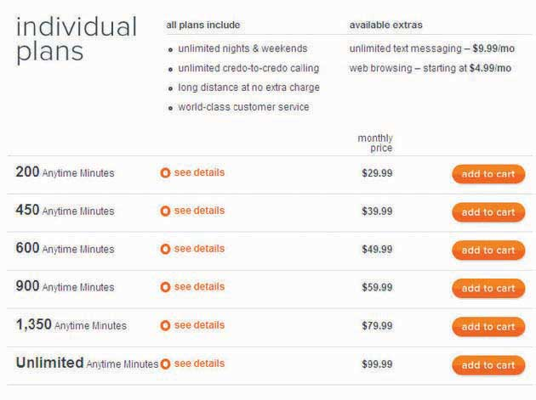
CREDO Mobile pricing chart allows consumers to easily compare their offerings to competitors. The key distinction is that CREDO Mobile and their customers donate part of their bills and profits to progressive causes of their choice. Go tocredomobile.com for more information.
For very expensive items, price may also include a payment period and credit terms. This allows consumers to purchase products, such as new cars, that they otherwise would be unable to afford. In some cases, a seller may offer credit incentives to encourage consumers to buy big-ticket items. For example, furniture stores frequently offer customers up to ninety days of free credit (zero percent financing) when they make large purchases such as a sofa or bedroom suite.

Promotion
Last but definitely not least, the final P is for promotion, which refers to all the activities that inform and encourage consumers to buy a given product. This includes print and broadcast ads, coupons, billboards, personal sales, and online sales. This P is so important that, believe it or not, entire textbooks have been written about it. By the way, you’re reading one now (but you knew that too).
We call a promotional effort aimed at the final customer a promotional pull strategy. The goal is to convince the customers that they want a product, in order to create a “pull” demand in which the customer goes to a store and asks for the product by name. Stores that do not already carry the product may be motivated to carry it in order to satisfy customer demand. So, in this case the customer “pulls” the product through the channel.
Promotion can be targeted at distributors as well as customers. Manufacturers often develop programs designed to motivate channel members to stock certain products. Such a program is called a promotional push strategy. For example, a software manufacturer like TurboTax may propose a cooperative ad campaign with a software retailer such as Office Max, sharing the cost of an ad that says “Buy your TurboTax at Office Max.” Alternately, TurboTax may offer retailers introductory discounts on TurboTax products to encourage them to promote or prominently display TurboTax products in their stores. If TurboTax advertises these discounts in trade publications that office products store managers read, we call that trade advertising. In this case the manufacturer tries to “push” its products through the channel down to the end consumer. Promotional push strategies are often less expensive than pull strategies, so a firm with a smaller promotional budget will likely pursue a push strategy.

Figure 2.8
A sales promotion is a time-based strategy to stimulate consumer demand for a product or service. SS+K’s client CREDO Mobile sponsored a promotion to entice customers to give up their current phone service and switch to CREDO. This is a pull strategy.

“To P or Not to P”: How One P Affects Another
Marketers look not only at each of the four Ps individually, but also at the interaction of product, price, promotion, and place. They fine-tune and adjust each to meet the needs of the market and create the best outcome for the company. For example, a seller may lower the price of a product during a promotional event. Likewise, holding a special promotional event may affect place because the seller must supply stores with enough products to meet the demand that the promotion will stimulate. Finally, the promotion might affect the product’s packaging, such as bundling a shampoo with a free sample of conditioner.

Dig Deeper
A new experiment Microsoft Corporation is running illustrates how different elements of the marketing mix can work together. The company is testing a grocery cart–mounted console that helps shoppers find products in the store, then scan and pay for their items without waiting in the checkout line. As they shop, consumers will see video ads playing on these cart screens. But it gets better: Before they leave home, customers with a ShopRite loyalty card log into a Web site and type in their grocery lists. They go to the store and swipe their card on the cart, and the list appears. As they scan their purchases and put them in their cart, they get a running price tally, and their shopping list automatically checks off these items. The system also can sense where the cart is in the store so it can send ads to shoppers just when they wheel by certain key areas—for example, the cart might offer a discount on Lay’s potato chips at the exact moment they walk by the potato chip section. ^{[2]} Price, product, promotion, and place—all in play.

KEY TAKEAWAY
The marketing process attempts to create value for all parties involved to satisfy everyone’s needs. Marketers use the marketing mix of product, price, place, and promotion to do this.

EXERCISES
- Demonstrate the differences between a “need” and a “benefit.” How are these concepts used to build the marketing concept?
- Discuss and characterize the four elements of the marketing mix.

[1] MarketingPower.com, “Marketing Definitions,”http://www.marketingpower.com/content4620.php (accessed April 17, 2008).
[2] Jessica Mintz, “Cart Console Finds Grocery Items for You,” USA Today,http://www.usatoday.com/tech/news/techinnovations/2008-01-14-microsoft-shopping-carts_N.htm (accessed February 13, 2009).

2.3 Advertising Industry Structure

LEARNING OBJECTIVES
After studying this chapter, students should be able to do the following:
- Identify three types of advertising agencies and discuss when each type of advertising agency might be appropriate for an advertising client.
- Explain the structure of advertising agency compensation methods.
- Classify the various types of clients with which advertising agencies might interact.
- Review the advertising careers mentioned and personally rate the careers.

Types of Agencies
There are several different types of advertising agencies. Each type has its advantages and disadvantages, depending on the client’s needs and budget and the marketing problem the client is aiming to solve.

Full-Service Agencies
Full-service agencies provide clients with all the services they need for the entire advertising function. This includes planning, creating, producing, and placing the ads, as well as research before the campaign and evaluation after it to assess the campaign’s effectiveness. Full-service agencies have expanded in recent years through consolidation—larger agencies buy them when they want to provide a one-stop shop for their global clients. In the process, the types of services that agencies provide has expanded to include PR, design, and event planning.

Figure 2.9 Typical Full-Service Agency Organization
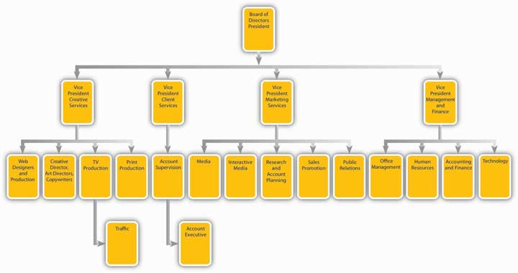

Figure 2.10 Matrix Organization in Advertising Agency
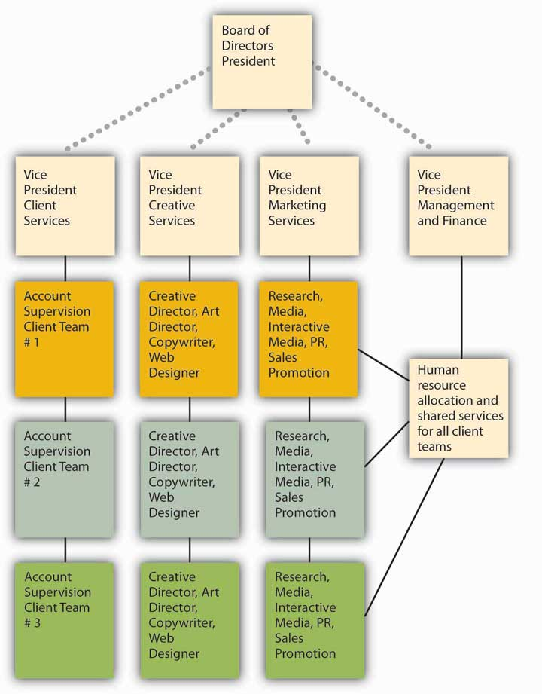

Specialized and In-House Service Agencies
Some agencies focus on one aspect of the creative process, such as creative production work or media buying. They refer to themselves as specialized agencies. Some examples will include a company that specializes in media planning and buying, such as The Media Kitchen or Greater Than One. Interactive agencies like BEAM, gaming agencies such as Fuel Games, and search agencies such as 360i will partner up with other agencies to provide services for the full campaign as determined by the client or the lead agency. These agency partners all contributed to the msnbc.com campaign led by SS+K.
Some companies prefer to retain control over advertising and set up in-house agencies within the corporation. An advertising director typically runs the in-house agency; she chooses which services to buy and which to perform internally. For example, the in-house agency could retain creative services in house, create advertisements itself, and then purchase media-buying services from the outside. The inside agency may buy services from a specialized service agency or buy services à la carte from a full service agency.
Why bother to form an in-house agency? The two main reasons are to save the company money and to give the company greater control over the entire process. In addition, internal employees may have a deeper understanding of the company and its customers than would an outside agency. Insiders can also coordinate the promotion better with the firm’s overall marketing program and other functions, such as ensuring that enough products are made and delivered in advance of a promotion. Target works with their in-house agency as well as with outside agencies. They do not have an outside agency of record.
Agencies also clarify their specializations in terms of location; SS+K, for example, is a U.S. agency. Some agencies are considered global agencies, such as JWT, TBWA, BBDO, and others. These agencies have offices worldwide and specialize in clients whose audiences are worldwide, such as MasterCard (McCann Worldwide is the agency).
There are a few holding companies that own a number of agencies to create a network of agencies that can work together in the network. Omnicom Group, WPP, Interpublic Group, MDC Partners are the biggest media holding companies.

Agency of Record
In addition to the types of agencies, there is also the role that the agency plays in the client’s business. The most common and secure relationship is the agency of record, or lead agency. As clients may work with many different agencies for their various needs, the agency of record is the lead agency partner and usually has the majority of the client’s business. SS+K is the agency of record for msnbc.com.

Dig Deeper
The traditional approach to farm out different functions may change if some big clients get their way. Johnson & Johnson and Dell are but two of several major advertisers that are dissatisfied with this strategy. More specifically, they join Procter & Gamble and others to call for more collaboration between the people who do the consumer research and the people who actually create the ads. In most cases, separate companies carry out communications planning and creative functions, so coordination can be difficult, and self-serving biases may color some decisions. For example, an advertising agency might be tempted to suggest a network television campaign because it would be involved in creating the ads (and billing more in the process). Instead, advertisers prefer a media-agnostic approach, where the agency picks whatever medium works best for a specific campaign. We saw earlier that SS+K strongly endorses this philosophy.
P&G reacted to this problem when it shifted all its ad and marketing duties for its Oral B brand to a newly created team at Publicis Groupe that will not work on any other brands. As P&G’s global marketing officer explained, “We find many of our brands are working with lots of agencies who all have their own creative people, their own planners, their own account people, and it gets to be unmanageable.” Only time will tell if other advertisers follow P&G’s lead. ^{[1]}

How Do We Get Paid?
Historically, an agency receives a commission or percentage of the cost of the media it buys for the client. Traditionally, mass media has paid advertising agencies a 15 percent commission on all business brought to them. The commission covers the agency’s copywriting, art direction, and account service charges. Today, this compensation model makes less sense because many advertising services no longer include a traditional media buy.
Figure 2.11
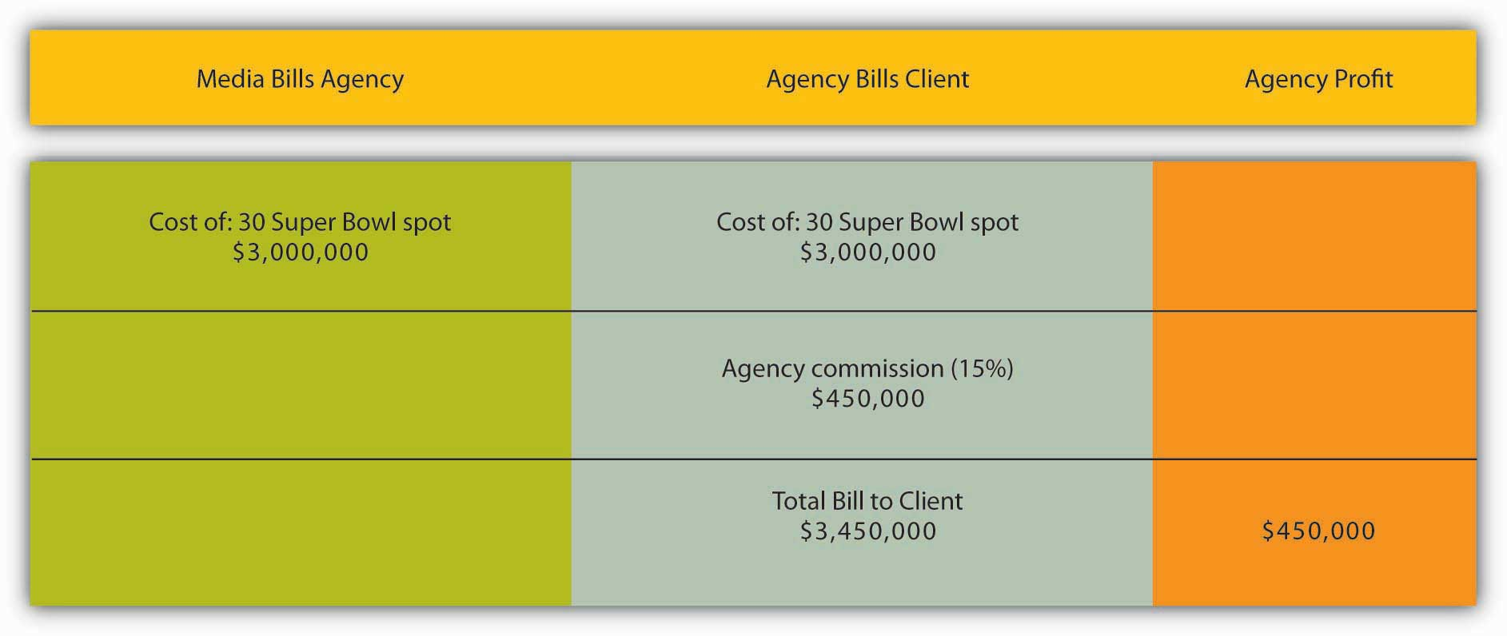
Here is an example of how agency compensation works for a single commercial during the Super Bowl.
The straight 15 percent commission is still used in some cases, but some agencies charge less than 15 percent, or have sliding scales based on how much the client spends (the more money spent, the lower the percentage fee). Some agencies offer flat-fee arrangements that clients and the agency agree upon, while others charge on an hourly basis. Others will do a combination of a flat base fee plus smaller percentages per media. Interactive media currently charges the highest commission because it requires the most management time from agency personnel.
Other innovative models include licensing fees or royalties for ideas. Some even use performance fees, in which the agency’s fee depends on the success of the campaign. The client and the agency define what they mean by “success” at the start; they might measure this by looking at how well consumers recall the ads or might measure actual product sales. Agencies using performance-based models can earn much more—or much less—than the standard 15 percent commission. The rationale, however, is that the compensation would be tied to the value of the ideas. As we’ll see later, the question of just how—and whether—we should quantify the effect of advertising is one of the burning issues the industry faces.

Types of Clients
We group clients into three main categories:
- Manufacturers and service providers (like Boeing and Bank of America)
- Trade resellers (namely, retailers like Best Buy or Starbucks, as well as wholesalers and distributors)
- Government and social organizations (such as local, state, or federal governments and their specialized offices like tourism boards; and social organizations from national groups like the United Way or local hiking clubs)

Job Functions inside the Agency

Account Managers
Account managers (with titles like account executive, account supervisor, or account manager) work with clients to identify the benefits a brand offers, to whom it should focus its messages (the target audience), and the best competitive position. They then develop the complete promotion plan.

Account Planners
On the market research side, account planners from the agency work with clients to obtain or conduct research that will help clients understand their markets and audiences.

Creative Services Staff
Creative services staff (such as an art director or copywriter) work with clients to develop the concepts and messages that will catch consumers’ interest and attention.

Media Buyers
Media buyers and media planners evaluate the multitude of options available for ad placement—now greatly expanded by the Internet. They decide how best to allocate the client’s budget to use the best media to most effectively reach the target audience.

Job Functions Sometimes outside the Agency
A variety of ancillary companies support ad agencies by providing specialized services.

Art Studios and Design Firms
Art studios and design firms create a company’s logo, stationery, business cards, and packaging design for products.

Film/Video Companies
Film/video companies produce film and video for TV and the Web, including infomercials.

Web Designers
Web designers create Internet media for advertising.

Printers
Printers produce printed material for a variety of media channels.

Sales Promotion Agencies
Sales promotion agencies handle price discounts, sampling, rebates, premiums, trade shows, in-store merchandising, and point-of-purchase displays.

Research Companies
Research companies assess channel viewership, ad response, consumer attitudes, and trends.

Careers in Advertising
If you’re interested in advertising, you can work at an ad agency, at an advertising client (manufacturer, trade reseller or service firm), or in the media. Jobs in ad agencies (including in-house agencies) typically fall into four main categories:

Account Services
Account managers act as the client’s representative at the agency, getting the best work from the agency for the client while still generating a profit for the agency. Account managers must be good at working with people and acting as leaders or strategists to communicate the client’s needs to the agency team. The best account managers learn as much as they can about the client’s business. The career ladder of position titles in account services is assistant account executive, account executive, senior account executive, and accounts superior or accounts manager.

Creative Services
The creative department generates the ideas, images, and words of the advertising message. Art directors (assistant art director, junior art directors, art directors, senior art directors) develop the artistic strategy of the creative campaign, often presenting several concepts for the client to choose among. Copywriters (junior copywriter, copywriter, senior copywriter, copy chief) are responsible for developing the words of the campaign. Production staff (layout workers, graphic artists, production managers) select photos, choose the print size and type, and oversee the actual printing, filming, or audio recording of the campaign.

Media Services
Media planners gather information about people’s viewing or reading habits and combine it with information about specific media vehicles (such as a specific magazine’s target audience, circulation size, and advertising space costs) in order to find the best placement for the advertising. They use their judgment to balance reaching the greatest number of people in the target group versus keeping the client’s costs to a minimum. Media buyers purchase the advertising space and negotiate prices. They must be good with numbers but also skilled negotiators—they’ll be working with budgets and responsible for spending their client’s money wisely.

Market Research
Market researchers learn all they can about the target customer—their wants, desires, fears, and goals. They use focus groups and one-on-one interviews, test reactions to campaigns, and purchase secondary information (such as the total market size in a given location). Job titles include public opinion researcher, research supervisor, project director, associate research director, research director, and executive research director.

Media Jobs
Advertising jobs in the media include the advertising director, who heads the advertising sales department and oversees advertising rate policies, promotion, and the sales staff, including sales planners and sales reps.

Corporate Advertising
Within a company, the jobs of the advertising department typically parallel those in ad agencies, but there is an additional category: brand manager. Brand managers are responsible for all the advertising and marketing for their product or brand. This includes the marketing strategy, business planning, and market research associated with the brand. The brand manager works closely with account services and creative staff to develop and implement campaigns best suited for that brand. Brand managers oversee the selection and work of any outside ad agencies used by the corporation.

SS+K Spotlight
SS+K needs to have a formal management structure, and this is what it looks like. However, the agency doesn’t tend to pay much attention to formalities, so these little boxes aren’t as solid as they look.…
Figure 2.12SS+K’s Structure
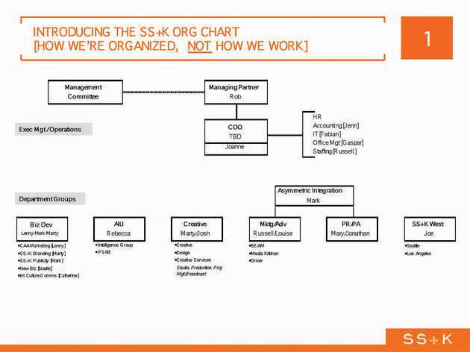

Figure 2.13This Is How SS+K Works
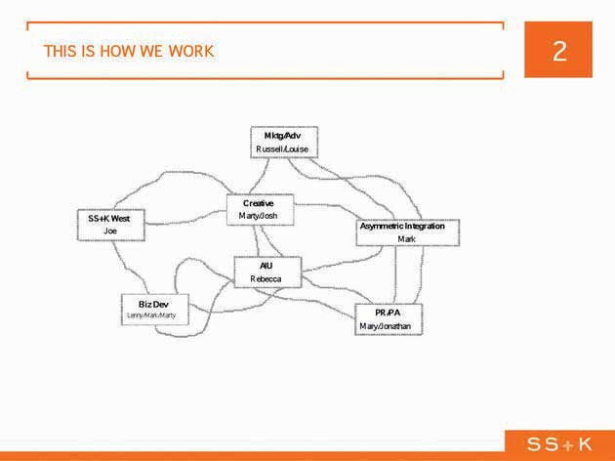

KEY TAKEAWAY
The advertising industry is complex, and many different types of skills are required to create a successful ad campaign. Career possibilities abound for people who are artistic, good at writing, analytical, and creative.

EXERCISES
- What type of advertising agency would a marketer be most likely to choose if that marketer wanted to introduce a new product on a nationwide scale? Explain your rationale.
- Briefly explain how advertising agencies link to clients. In your explanation, focus on the management and planning staff found in agencies. Be specific with your terms.
- Pick one of the careers mentioned in the chapter and describe how you could get more information on the career, find potential employers, and secure an interview. Be creative in your response.

[1] Suzanne Vranica, “Ad Houses Will Need to Be More Nimble: Clients are Demanding More and Better Use of Consumer Data, Web,” Wall Street Journal, January 2, 2008, B3; Suzanne Vranica, “J&J Joins Critics of Agency Structure: Consumer Researchers and Creative Teams Shouldn’t Be Separate,” Wall Street Journal, May 11, 2007, B4.

2.4 Exercises

TIE IT ALL TOGETHER
Now that you have read this chapter, you should be able to understand the advertising, promotion, and marketing essentials necessary to win the msnbc.com account:
- You can define the term advertising.
- You can differentiate advertising from other marketing communication forms.
- You have reviewed the colorful history and background of advertising.
- You can classify the various types of advertising and promotion in use today.
- You can identify the four cornerstones of marketing (e.g., the Four Ps).
- You can recall how the advertising industry is structured and recognize the different types of advertising agencies found in today’s marketplace.
- You can describe how agencies have been compensated historically and in present times.
- You can indicate the type of clients that are available to advertisers and their agencies.
- You can list the different careers in advertising available to students and professionals.

USE WHAT YOU’VE LEARNED
- If you were to build the perfect laptop computer, how would you design it? This is the very question faced by any company that wishes to compete in today’s highly competitive laptop computer market. Two heavyweight competitors, Lenovo and Apple, are betting that their products will win the market share race in the laptop market. Lenovo has the superthin ThinkPad X300 positioned against Apple’s MacBook Air. Comparison tables show that each of these highly desirable products has very similar features and characteristics with a slight positive edge going to the ThinkPad X300. Prices are also similar. Considering the facts you have been given and the types of advertising and promotion discussed in this chapter, recommend the forms of advertising and promotion that Lenovo should use to exploit its slight advantage over Apple’s product. Be sure to consider whom you would address with your message and the best way to reach them as you write your recommendation.
- Let’s assume that you and a few close friends have just invented a new video game that has all the people you know raving about it. It’s a spin-off from the wildly popular Guitar Hero concept where the music player can become a keyboardist (keyboard sold with game unit), bass player, or drummer (complete with drumsticks and simulated drumhead pad). Given what you know about the video game market and buying video games, take a position and defend it with respect to whether it would be better for your company and partners to pursue a promotional push or promotional pull communication strategy to present your “Rock Man” to the video game market. Explain and support your position.

DIGITAL NATIVES
Most consumers are familiar with the term advertising agency; however, most would be hard pressed to explain exactly what an advertising agency does or even name some of the most prominent agencies. Surprisingly, most advertising agencies do not toot their own horns to the general public. The exact opposite is true with respect to courting potential clients. Advertising agencies are extremely competitive with one another and have different ways of communicating their messages to prospective clients. Today, a solid Web presence is a necessity for any advertising agency. Some take the familiar “listing of services” approach and others take a more creative approach.
Go to the JWT (formerly the J. Walter Thompson advertising agency) Web site (http://www.jwt.com) and compare its client contact and promotion approach with that of the Texas-based Stevens FKM public relations and advertising agency (http://www.stevensfkm.com). Can you tell which (if either) agency would be characterized as a full-service agency? Explain. If you were a prospective client, which agency’s Web approach would you prefer? Explain your thoughts and rationale for your preference.

AD-VICE
- Based on your review of the two SS+K organizational charts presented in the final SS+K Spotlight in the chapter, compare the organizational structure to the work structure. List and explain any perceived advantages or disadvantages of the two structures.
- Based on information supplied by your review of the chapter and any outside research you may have conducted, take one of the two following positions and write a three-paragraph defense of your position. Position #1—Traditional media (such as radio, newspapers, and television) are adapting sufficiently to the “wired world” and will most likely retain their strength as the primary choice for advertising dollars. Position #2—Internet advertising and other maverick forms of promotion (such as viral and guerrilla marketing) are now the media of choice and will most likely continue to push traditional media into the background in market share competition.
- Pick any two products or services to illustrate a direct and indirect channel of distribution. In each instance explain the advantages and disadvantages of the channel configuration.
- Our marketing world is filled with product placements. Explain what a product placement is, how it can be used by marketers and advertisers, and what you believe to be the likelihood of success for this form of marketing. Use a real product placement example to illustrate your discoveries and research.

ETHICAL DILEMMA
Traditionally, the mass media has paid advertising agencies a 15 percent commission on all business brought to them. The advertising agency also represents a client and may receive fees from that client. Since the advertising agency receives a commission on the amount billed from a client from the mass media, some believe that a conflict of interest exists—two masters are being served. While the advertising agency is supposedly cutting the best deal they can with the mass media for their client in terms of media prices, they may also be receiving commissions based on billing where more money is made by the advertising agency as billing revenues for the agency and mass media increase.
After considering the ethics of this situation, take a position on the practice and make comments. Remember to try to see the issue from the viewpoint of all parties—the mass media, the client, and the advertising agency. Be prepared to discuss your thoughts and position.

Chapter 3

Advertising and Society
Figure 3.1 Build a Foundation
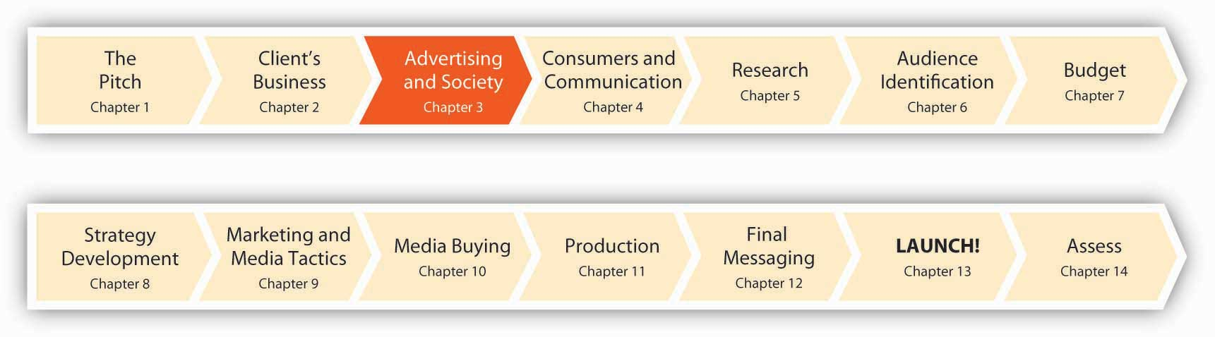
Advertising is part of the glue that holds our culture together. It allows us to share a common experience in a landscape populated (for better or worse) by brands, images, logos, and even silly jingles. We define who we are by what we buy and wear because we know that others judge us by what we buy and wear. And advertising influences those judgments. “We understand each other not by sharing religion, politics, or ideas. We share branded things. We speak the Esperanto of advertising, luxe populi,” says advertising professor and commercial culture observer James Twitchell. ^{[1]}
Advertising is a sort of “commercialized gossip,” a collection of stories that companies tell customers about their products in order to make them distinguishable from one another. Some brands do such a good job of holding our attention that they become cultural icons in their own right—Apple, Nike, even the lowly Charmin (where would we be without Mr. Whipple?), and the Keebler Elves. And in collectively listening to the commercialized gossip and buying the associated products, consumers align themselves with the images and stories, knowing that other consumers will know those same stories.
The cultural dimension of advertising came of age in the 1920s. Agencies and publicists no longer sought merely to convey objective facts about the products—they sought to link products with a particular lifestyle, imbue them with glamour and prestige, and persuade potential consumers that purchasing an item could be, as historian Alan Brinkley describes it, “a personally fulfilling and enriching experience.” ^{[2]} The images of ads sought to both resonate with and help define the lifestyles of those who bought the products.
People seek to differentiate themselves, so much so that a particular kind of advertising—called dog whistle advertising—targets a group with messages only that group can hear and appreciate. Like an inside joke, these ads reinforce a sense of belonging to the group and show that the advertised company “gets it” too. For example, Apple’s “Rip, Mix, Burn” campaign, which targeted young computer users with a message of ease-of-use of its iTunes music software, alluded to the prevailing (and illegal) practice of music sharing among that group.
In many ways—for better or for worse—modern advertising may be the most significant U.S. contribution to global culture. Sociologist Andrew Hacker calls advertising “this country’s most characteristic institution.” ^{[3]} But, to say the least, this contribution is not without controversy. Critics claim that ads manipulate the public into wasting money on unneeded products. Some say advertising has corrupted holidays like Christmas and Thanksgiving, making the season a time of materialism rather than a deeper celebration of thankfulness. There’s even a common rumor that Coca-Cola invented the modern-day Santa Claus (http://www.snopes.com/cokelore/santa.asp). Others just want to hide from the commercial messages that bombard them at every turn and enjoy some peace and quiet. Let’s take an objective look at advertising, warts and all.

1] James Twitchell, Living It Up: Our Love Affair with Materialism (New York: Simon & Schuster, 2002), xv.
[2] Alan Brinkley, American History: A Survey (New York: McGraw-Hill, 1991), 648.
[3] Quoted in Stephen Fox, The Mirror Makers: A History of American Advertising and Its Creators (Champaign: University of Illinois Press, 1997), cover quote.

3.1 Economic Effects of Advertising

LEARNING OBJECTIVES
After studying this section, students should be able to do the following:
- Recognize the key role advertising plays in our economy.
- Discuss the economic rationale for creating, accepting, and using advertising.

Advertising Is a Major Industry
Advertising supports the core principles that shaped our nation: free speech, competition, and democracy. Since colonial times, advertising has provided a source of vital information about our open, market-based economy. Two Nobel Laureates in economics, Dr. Kenneth Arrow and the late Dr. George Stigler, praise the value of advertising: “Advertising is a powerful tool of competition. It provides valuable information about products and services in an efficient and cost-effective manner. In this way, advertising helps the economy to function smoothly—it keeps prices low and facilitates the entry of new products and new firms into the market.” ^{[1]}
U.S. advertising accounts for about 2.5 percent of the country’s $14 trillion gross national product. American consumers rely heavily on advertising to influence how they spend some $9 trillion annually on various goods and services. A 1999 study by one of the country’s premier econometric modeling firms, the WEFA Group, and Nobel Laureate in economics Dr. Lawrence R. Klein further underscored this economic impact. The study found that advertising played a key role in generating 18.2 million of the 126.7 million jobs in the United States in that year. The report further concluded that advertising expenditures contributed between 12 and 16 percent of private sector revenues throughout the country, in rural as well as urban areas.
A later study, conducted in 2005 by the financial analysis firm Global Insight, demonstrated that advertising helps to generate more than $5.2 trillion in sales and economic activity throughout the U.S. economy annually. That represents 20 percent of the nation’s $25.5 trillion in total economic activity. This economic stimulus provided support throughout the economy for more than twenty-one million jobs, or 15.2 percent of the U.S. workforce. The purpose of the study was to quantify the economic and employment impacts of advertising. The study removed intervening effects (like consumers simply buying a product to replace an old one or a depleted one) to measure the role of advertising itself.
Advertising plays a strong role in the economy:
- It provides useful information to consumers that tells them about product and service choices, as well as comparing features, benefits, and prices. With more complete information, consumers and businesses often choose to purchase additional products and services.
- It “causes an economic chain reaction that (a) generates a net gain in direct sales and jobs due to the promotion of the industries’ products and services, (b) generates indirect sales and jobs among the first level suppliers to the industries that incur the advertising expenditures, and (c) generates indirect sales and jobs among all other levels of economic activity as the sales ripple throughout the economy.” ^{[2]}
Advertising also plays a significant role in the business cycle. As the broader economy shifts between periods of growth and recession, advertising shifts its focus. During downturns, like the one we’re in now, ads may focus on the price of a product or service. If one company curtails advertising in order to cut costs during a downturn, another company might boost ad spending to grab customers and grow its market share. Advertising helps stimulate economic growth. In a country in which consumer spending determines the future of the economy, advertising motivates people to spend more. By encouraging more buying, advertising promotes both job growth and productivity growth both to help meet increased demand and to enable each consumer to have more to spend.

Economic Rationale to Create Advertising
Companies spend money on advertising because it increases sales of existing products, helps grow adoption of new products, builds brand loyalty, and takes sales away from competitors. Although the exact return on investment (ROI) varies tremendously across industries, companies, campaigns, and media channels, studies have found that a dollar spent on advertising returns $3–20 in additional sales. To compete and grow in today’s diverse, ever-changing marketplace, businesses must reach their target customers efficiently, quickly alerting them to new product introductions, improved product designs, and competitive price points. Advertising is by far the most efficient way to communicate such information.

Economic Rationale to Accept Advertising
The economics of advertising extends to the media channels that depend on advertising revenues. Many forms of advertising support the creation of content and make that content available at a much lower price (or free). For example, roughly 75 percent of the cost of a newspaper is supported by advertising. If newspapers contained no advertising, they would cost four times as much to buy on the newsstand. Broadcast radio and TV rely exclusively on ads—people get news, music, and entertainment for free while advertisers get an audience. Forms of media that the public takes for granted would be extremely expensive to the reader or viewer or would simply be out of business without the revenues advertising produces. The demand created by advertising helps the economy to expand. ^{[3]}
Advertising supports the arts. Advertisers need music that calls attention to the brand. Musical artists visit ad agencies to meet with directors of music and pitch songs to them that they can use in ads. They come to agencies because they know that companies spend tens of millions of dollars on media buys. “The major record labels don’t have that kind of money,” says Josh Rabinowitz, senior vice president and director of music at Grey Worldwide. What’s more, “TV ads give you the kind of heavy rotation you can’t get on MTV anymore. In the very near future, some of the best bands will produce jingles.” ^{[4]}
For example, Jonny Dubowsky, lead singer and guitarist for Jonny Lives! uses corporate sponsorships to get exposure for his indie band. The band debuted a single on an EA video game and launched a video at nine hundred American Eagle stores. ^{[5]} For those with (slightly) different musical tastes, it’s worth noting that “rock star” Barry Manilow wrote advertising jingles before he crossed over to recording songs. His credits include the Band-Aid song (“I am stuck on Band-Aid, cuz Band-Aid’s stuck on me”) and the theme for State Farm insurance (“And like a good neighbor, State Farm is there”). ^{[6]}

Economic Rationale to Use Advertising
The perspective called the economics of information shows how consumers benefit from viewing advertising. By providing information, advertising reduces consumers’ search costs (time spent looking for products) and reduces disutility (unhappiness or lost value) from picking the wrong products. Advertising performs the following functions:
- Describing new products and what they do
- Alerting consumers to product availability and purchase locations
- Showing consumers what to look for on store shelves
- Helping them differentiate among competitive choices
- Advising them of pricing information and promotional opportunities
- Saving consumers money by encouraging competition that exerts downward pricing pressures

KEY TAKEAWAY
Advertising is a major industry. It contributes to the economy directly (via the jobs it creates to produce ad messages) but also indirectly as it stimulates demand and provides information about other products and services.

EXERCISES
- Advertising is “the glue that holds our culture together.” Evaluate this statement and decide whether you are in agreement with it or not. State and defend your position.
- Describe the economic rationale for creating, accepting, and using advertising.
- List and describe the six information subjects relevant to consumers that advertising addresses.

[1] Kenneth Arrow and George Stigler, paper for the Advertising Tax Coalition, quoted in House Subcommittee on Select Revenue Measures of the Committee on Ways and Means, Miscellaneous revenue issues: hearings before the Subcommittee on Select Revenue Measures of the Committee on Ways and Means, 103rd Cong., 1st sess., 1994,http://www.archive.org/stream/miscellaneousrev02unit/miscellaneous rev02unit_djvu.txt (accessed February 4, 2009).
[2] Global Insight, “The Comprehensive Economic Impact of Advertising Expenditures in the United States,” http://www.naa.org/Resources/Articles/Public-Policy-The- Comprehensive-Economic-Impact-of-Advertising-Expenditures-in-the-United-States/Public-Policy-The-Comprehensive-Economic-Impact-of-Advertising-Expenditures- in-the-United-States.aspx (accessed November 1, 2007).
[3] S. William Pattis, Careers in Advertising (Blacklick, OH: McGraw-Hill Professional, 2004), 9.
[4] Cora Daniels, “Adman Jangles for a Hit Jingle,” Fast Company, July 2007,http://www.fastcompany.com/magazine/117/fast-talk-rabinowitz.html (accessed February 4, 2009).
[5] Cora Daniels, “Band Plays a Brand-New Game,” Fast Company, July 2007,http://www.fastcompany.com/magazine/117/fast-talk-dubowsky.html (accessed February 4, 2009).
[6] AllExperts, “Manilow, Barry,” http://en.allexperts.com/q/Manilow-Barry-511/Manilow-TV-jingles.htm (accessed July 17, 2008).

3.2 The Good: Advertising Enhances Our World

LEARNING OBJECTIVES
After studying this section, students should be able to do the following:
- Describe the prosocial aspect of advertising and advertising institutions.
- Explain the concept of green marketing and its impact on contemporary advertising.
Advertising is part and parcel of the daily world in which we all live—it’s the lifeblood of popular culture. It’s also an incredibly powerful mirror that reflects our values, aspirations, and fears (whether of social rejection, financial hardship, or just plain body odor). True, we may not always like what we see in this mirror. And it may not deliver a totally accurate reflection—like the looking glass in a funhouse, it may be distorted to magnify our noblest dreams as well as our basest desires. It’s a formidable weapon that people, businesses, and countries can harness for good or exploit for evil.

Advertising Is Culture Is Advertising
Advertising’s cultural impact is hard to overlook, although many people do not seem to realize how much these pervasive messages influence their preferences for movie and musical heroes, the latest fashions in clothing, food, and decorating choices, and even the physical features that they find attractive or ugly in men and women.
For example, consider the product icons that companies use to create an identity for their products. Many imaginary creatures and personalities, from the Keebler Elves to the Burger “King,” have at one time or another been central figures in popular culture. Although these figures never really existed, many of us feel as if we “know” them. Check out the Icon Advertising Museum that will soon open in Kansas City to learn more. Even better, visit the museum’s Web site to see how many icons you recognize: http://advertisingiconmuseum.org.
To give you a head start, here are the most popular spokescharacters of 2008, according to research done by the research company Marketing Evaluations, which measures the public familiarity and appeal of more than six hundred characters featured in advertising campaigns:
- Mars’ M&Ms characters
- The GEICO Gecko
- The AFLAC duck
- Poppin’ Fresh (aka the Pillsbury Doughboy)
- Tony the Tiger ^{[1]}
Advertising pervades all of our lives, and its presence only continues to grow as advertisers expand the formats they use to reach us and as we try to slake our growing appetites for information and entertainment. The average adult is exposed to about 3,500 pieces of advertising information every single day—up from about 560 per day thirty years ago.
Here’s a statistic to chew on: American Internet users ages twelve and older spend an average of 6.1 hours per day interacting with video-based entertainment. About four of these hours are devoted to television viewing (live and recorded), while the rest goes to video games, Web and PC video, DVDs, and video on mobile devices. This sizeable chunk of time is projected to grow to eight hours per day by 2013. Where will the growth come from? One answer is online video; Nielsen tells us that in 2007 Americans watched 7.5 billion streams and 16.4 billion minutes in total of online video, and children ages two to eleven spend almost one-third of their online time watching videos. Expect advertisers to follow suit. ^{[2]}
So, is advertising a vapid cloud of superfluous fluff, or is it an efficient and entertaining process that enriches our lives? Obviously that depends on whom you ask. Let’s focus (first) on the reasons we should regard advertising as a glass half full. Then we’ll deal with the negative stuff.

Prosocial Advertising
Can advertising save lives? Let’s investigate a recent project that answers a resounding “yes!” A public health professor named Val Curtis spent years in the developing world fighting what seems like a simple problem but turns out to be a frustrating battle: get people to wash their hands regularly with soap (sound like your mother?). It turns out that dirty hands spread diseases like diarrhea that kill a child somewhere in the world about every fifteen seconds, and about half those deaths could be prevented with the regular use of soap.
Dr. Curtis, an anthropologist then living in Burkina Faso, was almost ready to throw in the towel (pardon the pun). Then she decided to ask some consumer goods companies how they would convince people to wash their hands using the same techniques they rely upon to sell vitamins or deodorant that people tend to consume out of habit. As she observed, “There are fundamental public health problems, like hand washing with soap, that remain killers only because we can’t figure out how to change people’s habits. We wanted to learn from private industry how to create new behaviors that happen automatically.” ^{[3]}These companies know very well how to create and reinforce such habits. For example, a century ago it was rare for anyone to brush her teeth twice a day, but efforts by Colgate and others changed all that.
Public health campaigns have had limited success in changing unhealthy habits. For example, evidence suggests that antidrug campaigns actually increase drug use, presumably because they remind people about the drugs to which they’ve become attached. It’s sort of like telling someone, “Whatever you do, don’t think of an elephant.” Did that work?
Procter & Gamble, Colgate-Palmolive, and Unilever accepted Dr. Curtis’s challenge and joined an initiative called the Global Public-Private Partnership for Handwashing with Soap. The group’s goal was to double the handwashing rate in Ghana, a West African nation where almost every home contains a soap bar but only 4 percent of adults regularly lather up after they use the toilet.
When participants started to look into the issue, they had the insight that the problem resembled one Procter & Gamble first encountered when it introduced Febreze, a product it developed to remove odors from smelly clothes and furniture. Its ads initially focused on smelly situations, like pets, sweaty teenagers, and stinky minivan interiors. The launch flopped, and P&G was ready to kill the product. Then its researchers found that consumers liked Febreze when they used it, but that many customers simply forgot that it was in the house. P&G’s ads needed to give them the right cues to use the product. The company identified one: the act of cleaning a room. So, it created commercials showing women spraying Febreze on a perfectly made bed and on freshly laundered clothing instead of in smelly areas. The ads worked well—and the more people sprayed Febreze, the more automatic the behavior became. Now consumers buy $650 million of the stuff each year.
Back to handwashing in Ghana: studies showed that while about half of the people washed their hands before they ate or after they used the bathroom, only about 4 percent of Ghanaians included soap in this process. They also found that mothers often didn’t see symptoms like diarrhea as abnormal but instead viewed them as a normal aspect of childhood. But they also unearthed an interesting tidbit: Ghanaians did use soap when they felt that their hands were dirty, for example, after they cooked with grease. This habit was prompted by feelings of disgust, and they applied soap to eliminate this bad feeling.
So the team came up with a big idea: create a habit to instill a feeling of disgust when people use the toilet, so that the emotional reaction would cue the use of soap. While many of us don’t hesitate to grimace at the thought of a less-than-sparkling bathroom, in many places in the developing world any toilet is a symbol of cleanliness, because flush toilets have replaced pit latrines. So the task was to create commercials to teach the audience to feel disgust after they went to the bathroom. The solution: the team shot ads of mothers and children walking out of bathrooms with a glowing purple pigment on their hands that contaminated everything they touched. These spots didn’t sell soap use, but rather disgust. Soap was almost an afterthought—one fifty-five-second television commercial only showed soapy hand washing for four seconds. Still, the link between disgust and its removal via soap was clear: the team’s follow-up research showed a 13 percent increase in the use of soap after the toilet, while the number of Ghanaians who reported washing their hands with soap before they eat rose by an impressive 41 percent. ^{[4]} This is no soap opera: advertising can save lives when it’s used creatively and when it thoughtfully applies what social scientists understand about human behavior.

PSAs
The Advertising Council, a private, nonprofit organization, is one of the most important and influential organizations in the advertising industry. The Ad Council coordinates advertisers, advertising agencies, and media in its efforts to create effective public service messages and other forms of advertising and deliver those messages to the public. ^{[5]}
Advertising agencies enhance society’s well-being when they create (usually pro bono, or for free) public service announcements (PSAs) like the “Friends don’t let friends drive drunk” campaign. PSAs intend to change the society’s culture as they focus awareness on specific issues that address the public as a whole. For example, after the anti–drunk driving campaign, its creators reported that 70 percent of people said that the ad helped them to stop someone from driving drunk.

SS+K Spotlight
On May 29, 2008, SS+K launched a PSA they’d produced pro bono (for free) in support of United Nations Peacekeepers.

Advocacy Advertising
Like PSAs, advocacy advertising intends to influence public opinion about an issue relevant to some or all members of a society. However, advocacy ads espouse a particular point of view that not everyone may share, so they tend to be more strident in tone. For example, while virtually everyone advocates designating a driver to abstain from drinking (even the alcohol industry), not all of us agree with messages that exhort us to practice safe sex or avoid eating meat.
The organization People for the Ethical Treatment of Animals (PETA) is a good example of a group that employs graphic messages to drive home its agenda, whether it’s advocating an end to using lab animals for product testing or urging a boycott of the fur industry. PETA has used former Baywatch actress Pamela Anderson and ex-Beatle Paul McCartney in spots to protest the handling and killing of poultry, and most recently the group even involved the Pope in its efforts. The group’s KentuckyFriedCruelty.com Web site featured the Pope’s photo next to a quote it attributed to him: “Animals, too, are God’s creatures.…Degrading [them] to a commodity seems to me in fact to contradict the relationship of mutuality that comes across in the Bible.” (Note: PETA didn’t ask for or receive the Catholic Church’s permission to use the photo or the quote.)^{[6]}

Nonprofit Advertising
Many not-for-profit organizations, including museums, zoos, and even churches, rely on advertising to recruit members, attract donations, and promote their activities. Churches aggressively brand themselves to fill empty pews. For example, the “megachurch” Willow Creek Community Church near Chicago uses sophisticated marketing techniques (including selling copies of sermons on CDs) to attract over twenty-five thousand worshippers.
Local governments use advertising to attract new businesses and industries to their counties and cities. Even states are getting into the act: We’ve known for a long time that I ♥ NY, but recently Kentucky and Oregon hired advertising agencies to develop statewide branding campaigns. The official state motto of Oregon is now “Oregon. We love dreamers.” ^{[7]} A publicity campaign to select a state slogan for New Jersey generated a lot of questionable entries, including “It’s Jersey: Got a problem with that?” “New Jersey: We’ll look the other way,” and “New Jersey: Be sure to pick up a complimentary chemical drum on your way out.” The state went with something a bit less colorful: “New Jersey, Come See For Yourself.” ^{[8]}

Dig Deeper
How far should nonprofit organizations go to promote their agendas? The Nationwide Children’s Hospital in Columbus, Ohio (a $50 million donation from the Nationwide Insurance Company prompted this name) recently came under fire for its embrace of corporate sponsors. In 2008 the hospital announced plans to rename its emergency department the Abercrombie & Fitch Emergency Department and Trauma Center in exchange for a $10 million donation from A&F. Citing A&F’s racy ads that feature (apparently) underage models, an advocacy group called The Campaign for a Commercial-Free Childhood vigorously protested the name and submitted a letter signed by more than a hundred doctors and child welfare advocates. A spokesman explained, “A company with such cynical disregard for children’s well-being shouldn’t be able to claim the mantle of healing.” ^{[9]} What do you think: is this use of corporate sponsorship over the top, or would forbidding it be throwing out the baby with the bathwater?

SS+K Spotlight
SS+K regularly engages in philanthropic work through an informal organization it calls David’s Work. This is named after David McCall, the creative founder who was on the board of SS+K before his untimely death while on a mission with his wife. After leaving the ad biz, David donated his time and effort to doing good, so SS+K does something in his honor every few months; typically this involves fundraisers for local schools.

Green Marketing
In the early twenty-first century, we are witnessing a profound shift in priorities as people clamor for products and services that are good for their bodies, good for their community, and good for the earth. Some analysts call this new value conscientious consumerism. They estimate the U.S. market for body-friendly and earth-friendly products at more than $200 billion.
In particular, some marketers single out a type of consumer they call LOHAS—an acronym for “lifestyles of health and sustainability.” This label refers to people who worry about the environment and spend money to advance what they see as their personal development and potential. These so-called “Lohasians” (others refer to this segment as cultural creatives) represent a great market for products such as organic foods, energy-efficient appliances, and hybrid cars, as well as alternative medicine, yoga tapes, and ecotourism. One organization that tracks this group estimates they make up about 16 percent of the adults in the United States, or 35 million people; it values the market for socially conscious products at more than $200 billion. ^{[10]}
Just how widespread is conscientious consumerism? In a 2007 survey, eight in ten consumers said they believe it’s important to buy green products and that they’ll pay more to do so. Corporate responsibility is now one of the primary attributes shoppers look for when they decide among competing brands. Consumer research strongly suggests that this awareness often starts with personal health concerns and then radiates outward to embrace the community and the environment. Predictably, advertisers have been quick to jump on the green bandwagon. Green marketing, which emphasizes how products and services are environmentally responsible, is red hot. Established agencies are setting up divisions to specialize in green campaigns and a host of new agencies (with names like The Green Agency and Green Team) are opening to meet the demand.
The advertising industry has the potential to radically change people’s attitudes and (more importantly) their behaviors as we face the real consequences of environmental contamination. Unfortunately, there’s also the very real potential that it will “poison the well” as it jumps onto the bandwagon a bit tooenergetically. It’s almost impossible to find an ad for virtually any kind of product, service, or company that doesn’t tout its environmental credentials, whether the focus of the ad is a detergent, a garment, a commercial airplane, or even an oil company. As a result, complaints about greenwashing, or misleading consumers about a product’s environmental benefits, are skyrocketing. One egregious example is an ad for a gas-guzzling Japanese sport utility vehicle that bills the car as having been “conceived and developed in the homeland of the Kyoto accords,” the international emissions-reduction agreement.
To prevent a greenwash backlash, it’s imperative for advertisers to act responsibly. There’s nothing wrong with trumpeting the environmental value of your product—if the claims are accurate and specific. Or you can suggest alternative methods to use your product that will minimize its negative impact—for example, Procter & Gamble runs an ad campaign in the United Kingdom that urges consumers of its laundry detergents to wash their clothing at lower temperatures. ^{[11]} The FTC (Federal Trade Commission) provides guidelines to evaluate green advertising claims; for example, it suggests that “if a label says ‘recycled,’ check how much of the product or package is recycled. The fact is that unless the product or package contains 100 percent recycled materials, the label must tell you how much is recycled.” ^{[12]}
The advertising industry can help us heal our toxic environment: please don’t poison the well.

KEY TAKEAWAY
Advertising creates awareness and persuades people to change their opinions or behaviors. The same principles that advertisers use to sell cameras and cars apply to conservation or even contraception. Prosocial messages can significantly influence consumers’ daily lives in positive ways. Of late we see a huge emphasis on green messages; these can help to galvanize the world to take action in order to save the environment—if they don’t turn us off first by bombarding us with insincere claims.

EXERCISES
Advertising has been described as being the good and the bad (and sometimes ugly).
- Explain the “good” perspective by naming some benefits that advertising conveys to society.
- Explain the role played by the Advertising Council and how it uses public service announcements (PSAs) to influence public opinion. Give an example.
- Characterize the green movement in advertising. Evaluate its success in changing advertising’s view of environmental issues and causes.

[1] Lacey Rose, “America’s Most-Loved Spokescreatures,” Forbes, July 9, 2008,http://www.forbes.com/home/2008/07/08/advertising-mars-geico-biz- media-cx_lr_0708spokescreatures.html (accessed July 17, 2008).
[2] eMarketer, “Video to Consume One-Third of Each Day” June 25, 2008,http://www.Emarketer.Com/Article.Aspx?Id=1006381&Src=Article1_Newsltr (accessed June 25, 2008); Brian Stelter, “Whichever Screen, People Are Watching,” New York Times Online, July 8, 2008 (accessed July 8, 2008).
[3] Charles Duhigg, “Warning: Habits May Be Good for You,” New York Times Magazine, July 13, 2008, http://www.nytimes.com/2008/07/13/business/13habit.html? pagewanted=1&sq=Warning%20-%20Habits%20May%20Be%20Good%20 for%20You&st=cse&scp=1 (accessed July 17, 2008).
[4] Charles Duhigg, “Warning: Habits May Be Good for You,” New York Times Magazine, July 13, 2008, http://www.nytimes.com/2008/07/13/business/13habit.html?pagewanted=1&sq=Warning%20-%20Habits%20May%20Be%20Good%20for%20You&st=cse&scp=1 (accessed July 17, 2008).
[5] S. William Pattis, Careers in Advertising (Blacklick, OH: McGraw-Hill Professional, 2004), 13.
[6] Richard Gibson, “PETA Uses Religion in Boycott,” Wall Street Journal Online Edition, April 11, 2007, http://online.wsj.com/article/SB117625218878365729.html (accessed April 11, 2007).
[7] Stuart Elliott, “Introducing Kentucky, the Brand,” New York Times Online, June 9, 2004 (accessed July 19, 2008).
[8] Mister Snitch!, “Top Ten Rejected Jersey State Slogans,” October 28, 2005,http://mistersnitch.blogspot.com/2005/10/top-ten-rejected- jersey-state-slogans.html(accessed July 19, 2008); “Governor’s Call to Action,” January 12, 2006,http://www.state.nj.us/slogan (accessed July 19, 2008).
[9] Quoted in Natalie Zmuda, “Children’s Hospital in Hot Water over Corporate Sponsorships: Critics Dismayed by Association with Racy Retailer Abercrombie & Fitch,”Advertising Age, March 12, 2008, http://adage.com/abstract.php?article_id=125672(accessed March 12, 2008).
[10] http://www.lohas.com (accessed February 1, 2009).
[11] Suzanne Vranica, “Ad Houses Will Need to Be More Nimble: Clients Are Demanding More and Better Use of Consumer Data, Web,” Wall Street Journal, January 2, 2008, B3; Eric Pfanner, “Cooling Off on Dubious Eco-Friendly Claims,” New York Times Online, July 18, 2008, http://www.nytimes.com/2008/07/18/business/media/18adco.html? scp=1&sq=Cooling%20Off%20on%20Dubious%20Eco-Friendly%20Claims&st=cse(accessed July 19, 2008).
[12] “Sorting Out ‘Green’ Advertising Claims,” Federal Trade Commission, April 1999,http://www.ftc.gov/bcp/edu/pubs/consumer/general/gen02.shtm (accessed July 19, 2008).

3.3 The Bad: Ethical Hot Buttons

LEARNING OBJECTIVES
After studying this section, students should be able to do the following:
- Identify the dark side of advertising and advertising practice.
- Review the practice of behavioral targeting and appraise its validity.
- Compare arguments for and against materialism.
We’ve considered some of the good that advertising can do. Now let’s check out some of the bad—and the ugly. It’s certainly not hard to identify the hot buttons—a lot of people slam advertising for a lot of different reasons. Some objections may be a bit paranoid, as when the social critic Vance Packard wrote more than fifty years ago, “Large-scale efforts are being made, often with impressive success, to channel our unthinking habits, our purchasing decisions, and our thought processes by the use of insights gleaned from psychiatry and the social sciences.” ^{[1]} Still, there are plenty of valid reasons to question the methods and goals of the advertising industry. Forewarned is forearmed. Here are some common objections we hear:
- Ads make us feel bad about ourselves as they constantly throw images of perfect, beautiful people in our faces.
- Ads reinforce insulting ethnic and racial stereotypes.
- Ads invade our privacy.
- Ads create false needs that make us crave brand names and material possessions.
Let’s examine these charges one by one.

The Ugly
Ads make us feel bad about ourselves as they constantly throw images of perfect, beautiful people in our faces.
You are how (you think) you look. Our physical appearance is a large part of our self-concept. Body image refers to a person’s subjective evaluation of his or her physical self. The key word here is subjective—your image of your body may not be what your body looks like to other people. You might have an exaggerated notion of the bulge of your muscles or the bulge of your thighs. Knowing that people’s body images are often distorted, some marketers exploit our insecurities and suggest that purchasing their product will help alleviate the “problem.”
Indeed, advertising can affect a person’s self-esteem when it takes advantage of our powerful instinct to gauge our physical and mental states relative to others. Numerous studies have noted that female college students compare their physical appearance to that of models in ads. Participants who viewed ads with beautiful women expressed lower satisfaction with their own appearance afterwards than did women who didn’t see these ads. Another study showed that as little as thirty minutes of TV programming can alter young women’s perceptions of their own body shape. ^{[2]}
One of the prevailing arguments in the history of advertising is whether advertising merely reflects existing cultural values and views of gender or whether it constructs and creates those views. Some analysts believe that advertising is merely a “mirror” of culture. Others argue that advertising is a “distorted mirror” that both reflects and shapes our culture. ^{[3]} The advertising industry likes to say that ads simply reflect existing values because this view absolves advertisers of blame for perpetuating unreal standards. Denise Fedewa, senior vice president and planning director for the LeoShe subsidiary of the Leo Burnett agency, presented an updated, unified view when she said, “Advertising is so fascinating, because it’s both a mirror of the culture and it moves culture forward. I think the best advertising…taps into a direction that we are moving in, but we are not there yet, and it helps take us there…I think we’ve gotten a lot better at doing that…in tapping into where they [women] are moving next.” ^{[4]}

Dig Deeper
A provocative advertising campaign by Dove features underwear-clad women with imperfect bodies to call attention to the unrealistic messages about our bodies that some marketing messages communicate. Unilever (which makes Dove soap) initiated the Campaign for Real Beauty after its research showed that many women didn’t believe its products worked because the women shown using them were so unrealistic. ^{[5]} The marketers decided to focus the campaign’s message on reassuring women about their insecurities by showing them as they are—wrinkles, freckles, pregnant bellies, and all. Taglines ask “Oversized or Outstanding?” and “Wrinkled or Wonderful?” Dove even has a Web site (campaignforrealbeauty.com) where visitors can view the ads and cast their votes. For a real treat (and to appreciate how much “postproduction editing” goes into the fashion business), see how experts morph an average woman into a billboard beauty on this Dove Web site:http://www.boardsmag.com/screeningroom/commercials/3421.
Perhaps because of the success of the Dove campaign, other companies also are turning to ordinary people instead of professional models when they advertise. As an extension of its “I’m lovin’ it” campaign, McDonald’s held a casting call for consumers (as opposed to professional models) who will appear on its world cup and bag packaging. Nike and Wal-Mart also have run advertisements with average-looking employees. ^{[6]}
Will this emphasis on “keeping it real” continue, or will it give way to consumers’ desires to aspire to perfection (and buy the products they think will help them get there)?
So, which way is it? Is advertising a mirror or an idealized picture? It’s likely that advertising both reflects and affects gender roles in our daily lives. Since the 1970s, researchers have investigated the extent to which American advertising portrays women in stereotypical roles. Most report that ads do tend to portray women as subservient to men, as preoccupied with physical attractiveness, and as sex objects who are preoccupied with their appearance, and they tend to minimize depictions of women in positions of authority. To rub salt into the wound, this media exposure can indeed influence real women’s self-concepts and aspirations. ^{[7]}
James Twitchell, in his book Twenty Ads that Shook the World, takes a more positive view. Using the example of the ads for Charlie perfume in the 1970s and 1980s, he shows how this advertising provided the imagery of the new woman in the workplace: striving, not strident, proud of her accomplishments and not afraid to say so, but not the dour “make room for me or else” feminist that the press portrayed at the time. Twitchell’s view is that Madison Avenue is not immoral in imposing stereotypes but amoral in reflecting prevailing roles; that is, advertising follows whichever way the wind is blowing. The point is that if stereotyped roles didn’t sell products, advertisers would gladly use different imagery. ^{[8]}
One celebrated ad campaign—Nike’s “If You Let Me Play”—challenged stereotypes about women while at the same time achieving Nike’s advertising objective of enticing more women to buy its shoes. This effort successfully blended statistics with a powerful story that showed how exclusion and outdated norms concerning girls’ participation in school sports hurt their self-esteem and even their health. The campaign included lines like these:
“If you let me play sports, I will like myself more. I will have more self-confidence, if you let me play sports. If you let me play, I will suffer less depression.…If you let me play, I will be more likely to leave a man who beats me. If you let me play, I will be less likely to get pregnant before I want to. I will learn what it means to be strong. If you let me play sports.” ^{[9]}
And what about guys—is what’s good for the goose good for the gander? Let’s not forget that advertising also can influence how boys and men feel about themselves. In addition to “cheesecake” ads that show plenty of female skin, there are plenty of “beefcake” ads. That helps to explain why men spend $7.7 billion on grooming products globally each year. In Europe, 24 percent of men younger than age thirty use skincare products—and 80 percent of young Korean men do. ^{[10]}
Ripped abs aside, even a casual analysis of TV commercials for products from laundry detergent to computers turns up no shortage of spots that depict men as incompetent, bumbling idiots. Organizations like Stand Your Ground and the U.K.-based Advertising Standards Authority object to misandry (the male counterpart of misogyny, which means a hatred of women). ^{[11]} They protest ad campaigns that show men acting as buffoons who do nothing but ogle cars and women and who can’t perform the simplest household tasks. ^{[12]}

Uncle Ben or CEO Ben?
Ads reinforce negative ethnic and racial stereotypes.
Advertisements have a long history of relying on stereotypical characters to promote products. For many years Aunt Jemima sold pancake mix and Rastus was a grinning black chef who pitched Cream of Wheat hot cereal. The Gold Dust Twins were black urchins who peddled a soap powder for Lever Brothers and Pillsbury hawked powdered drink mixes using characters such as Injun Orange and Chinese Cherry—who had buck teeth.
These negative depictions began to decline in the 1960s as the civil rights movement gave more power to minority groups and their rising economic status began to command marketers’ respect. Frito-Lay responded to protests by the Hispanic community and stopped using the Frito Bandito character in 1971, and Quaker Foods gave Aunt Jemima a makeover in 1989. As part of its fiftieth-anniversary celebration for Crest toothpaste, Procter & Gamble reintroduced its “Crest Kid,” who first appeared in 1956 as a “white bread,” apple-cheeked girl painted by artist Norman Rockwell. It’s telling that the new Crest Kid is Cuban American. Similarly, a recent campaign gives a radical makeover to the black Uncle Ben character who appeared on rice packages for more than sixty years dressed as a servant. (White Southerners once used “uncle” and “aunt” as honorary names for older African Americans because they refused to address them as “Mr.” and “Mrs.”) The character is remade as Ben (just Ben), an accomplished businessman with an opulent office who shares his “grains of wisdom” about rice and life on the brand’s Web site. ^{[13]}
These positive steps are motivated by both good intentions and pragmatism. Ethnic minorities spend more than $600 billion a year on products and services. Immigrants make up 10 percent of the U.S. population, and California is less than half Caucasian. Advertisers and their agencies couldn’t ignore this new reality even if they wanted to.
Multicultural advertising is a major force in today’s industry. Like the green-marketing phenomenon, the changing environment motivates both well-established agencies as well as those that specialize in talking to racial and ethnic segments to redouble their efforts. The Advertising Research Foundation, for example, sponsors a Multicultural Research Council to promote a better understanding of relevant issues. ^{[14]} We still have a way to go to overcome stereotypes—not all African Americans are into hip-hop and not all Asian Americans are studious—but many agencies are working hard to address these issues, especially as they aggressively try to add diversity to their organizations.

We Know Where You Live
Ads invade our privacy.
Behavioral targeting is a fancy way to describe the growing number of techniques that allow advertisers to track where you surf on the Web so that they can deliver relevant ads to you. As we’ve discussed elsewhere in this book, that’s very convenient, and it’s clear that ads tailored to your interests are going to be both less intrusive and more valuable to you—but at what cost?
For example, cable and phone companies say their growth increasingly depends on being able to deliver targeted advertising to their Internet and TV customers. But privacy advocates are not happy about this, and due to their vocal protests some companies are backpedaling on plans to integrate advanced ad-targeting technology. NebuAd, one particularly controversial form of tracking software, tracks users wherever they go on the Web. Company executives claim the data can’t be traced back to individuals; instead, the software categorizes consumers as they surf the Web. Marketers then buy ads to appear online before certain subgroups of consumers when the technology recognizes their encrypted identity. Categories can be made quite specific; for example, you could come to the attention of an appliance manufacturer if you searched for “microwave ovens” within the past month. ^{[15]}
At the end of the day, just how important is this privacy issue? Scott McNealy, CEO of Sun Microsystems, famously observed at a 1999 press conference, “You already have zero privacy—get over it.” ^{[16]} Apparently many consumers don’t agree; one survey reported that consumers are more worried about personal privacy than health care, education, crime, and taxes. People are particularly concerned that businesses or individuals will target their children. Nearly 70 percent of consumers worry about keeping their information private, but according to a Jupiter Media Metrix survey, only 40 percent read privacy policies posted on business Web sites. And many consumers seem more than happy to trade some of their personal information in exchange for information they consider more useful to them. A 2006 survey on this issue reported that 57 percent of the consumers it polled say they are willing to provide demographic information in exchange for a personalized online experience. ^{[17]}

Dig Deeper
Let’s bring the argument a bit closer to home: how private is your Facebook page? The popular social networking site ignited a huge controversy after it rolled out a marketing tool it calls Beacon in 2007. Facebook users discovered that their off-Facebook Web activities—such as purchases at online retailers, reviews at other sites, and auction bids, among other things—were being broadcast to their friends. The idea behind Beacon is to offer “trusted referrals”; if my Facebook friends see that I’ve been buying stuff at Alloy, they’ll be more likely to check out the site as well. Unfortunately, the folks at Facebook neglected to ask users if they would consent to share this information. In response to heated criticism, founder Mark Zuckerberg was forced to post a shamefaced apology, and Facebook now allows users to opt out of Beacon completely. But some privacy advocates still see this event as only the tip of the iceberg. ^{[18]} Do you?

Living in a Material World
Ads create false needs that make us crave brand names and material possessions.
The validity of this criticism depends on how you define a “need.” If we believe that all consumers need is the basic functional benefits of products—the transportation a car provides, the nutrition we get from food, and the clean hair from a shampoo—then advertising may be guilty as charged. If, on the other hand, you think you need a car that projects a cool image, food that tastes fantastic, and a shampoo that makes your hair shine and smell ever so nice, then advertising is just a vehicle that communicates those more intangible benefits.
Critics say that advertising makes us buy products that we don’t need—or even want—but that we think we must have. In his seminal book The Affluent Society, economist John Kenneth Galbraith portrayed advertising as “manipulating the public by creating artificial needs and wants.” ^{[19]} He charged that radio and TV manipulate the masses. His view was that ads created new desires, encouraging consumers to spend their scarce resources buying highly advertised products rather than on basic items that fulfilled actual needs.
Galbraith voiced a common fear—that marketers link their products to desirable social attributes so that people feel measured by what they buy and guilty or anxious if they don’t measure up. As an example, when the eminent psychologist John Watson joined the J. Walter Thompson (now JWT) advertising agency, he worked on a campaign for Johnson’s baby powder. In a 1925 lecture, he explained how he increased sales of the baby powder by making the mother who did not use it “feel bad, that she was less of a mother, not really a good mother.” ^{[20]}
But is advertising really all-powerful? The reality is that 40 percent to 80 percent of all new products fail. Advertising can’t magically make a product succeed (at least for very long) if it doesn’t have some merit. Johnson’s baby powder would not still be on store shelves after more than 110 years if it didn’t provide some benefit. As one former advertising agency president noted, “The fact of the matter is we are successful in selling good products and unsuccessful in selling poor ones. In the end, consumer satisfaction, or lack of it, is more powerful than all our tools and ingenuity put together. You know the story: we had the perfect dog food except for one thing—the dog wouldn’t eat it.” ^{[21]} The heart of the matter is: does advertising give people what they want, or does it tell them what they should want?
In fact, we can even make the argument (one that advertisers such as high-end stores like Neiman-Marcus, Prada, or Tiffany surely will welcome) that we should want things we can’t afford. According to author James Twitchell, not everyone can buy a $200 cashmere sweater from Saks for their baby—but we can always dream of owning one. He claims that such a collective dream life is important to the continuing vigor of a culture. In the bigger scheme of things, advertising is a simple reflection of an age-old drive: “Human beings did not suddenly become materialistic. We have always been desirous of things.” ^{[22]}
Luxury products are not a bad or wasteful thing (goes this argument) because history shows that one generation’s decadent indulgence becomes the next generation’s bare necessity. Former luxury products that are now in daily use include buttons, window glass, rugs, door handles, pillows, mirrors, combs, and umbrellas, not to mention cars, electric lights, and indoor plumbing. The phenomenon of striving to afford “luxury” is the driving force for a rising standard of living. When we buy a luxury good, we increase the demand for it, which leads companies to produce more of it, ultimately leading to lower prices that make it affordable to the masses. At the same time that each new luxury creates new demand, it also creates the potential for a new industry with new jobs that enable people to afford the new luxuries. People become individually and collectively richer as they strive to buy new products and create new businesses to make these products. Advertising accelerates this cycle by both stimulating demand and helping suppliers communicate with customers. ^{[23]}
Numerous organizations such as Adbusters and The Campaign for a Commercial-Free Childhood work to counteract what they view as the debilitating effects of commercial messages in our culture. ^{[24]} Adbusters sponsors numerous initiatives, including Buy Nothing Day and TV Turnoff Week, intended to discourage rampant commercialism. These efforts, along with biting ads and commercials that lampoon advertising messages, are part of a strategy called culture jamming that aims to disrupt efforts by the corporate world to dominate our cultural landscape.” ^{[25]}
Is Adbusters right? Does advertising encourage us to be shallow, or to value material rewards over spiritual ones? The jury is still out on that question, but there is little doubt that ads reinforce the things our society values. Images of happy (and popular) people who drive gas guzzlers and eat junk food surround us.

KEY TAKEAWAY
Because it’s so powerful, advertising can hurt as well as help us. A consumer would have to live in a deep hole not to be affected by the images of “shiny happy people” (to quote from the REM song of the same name) that constantly bombard us. To decide whether advertising causes us to feel insecure about our bodies, engage in self-destructive behaviors, or covet others’ possessions is to raise a chicken-and-egg question that elicits strong feelings on both sides (just ask your professor). Nonetheless, whether they create the problems or merely perpetuate them, advertising practitioners certainly need to remind themselves (preferably every day) of the power they wield. Hopefully, if you go into the biz, you’ll remember that too.

EXERCISES
- List and briefly discuss four common objections to advertising and its practice in our society.
- Briefly trace the history of how advertising has reflected and affected gender roles and racial and ethnic stereotypes in our culture since 1970.
- Evaluate the practice of behavioral targeting. Take a position on whether or not this practice invades privacy in a positive or negative way. Support your position.
- We can see materialism as a “drain on society” or a “promoter of prosperity.” Pick one of these views and support your choice with an effective argument.

[1] Quoted in William Leiss, Stephen Kline, and Sut Jhally, Social Communication in Advertising: Persons, Products and Images of Well-Being (Scarborough, Ontario: Nelson Canada, 1990), 11.
[3] Richard W. Pollay, “The Distorted Mirror: Reflections on the Unintended Consequences of Advertising,” Journal of Marketing 59 (1986): 18–36, and Morris B. Holbrook, “Mirror, Mirror, on the Wall, What’s Unfair in the Reflections on Advertising?” Journal of Marketing 51 (1987): 95–103.
[4] Eileen Fischer, “Interview with Denise Fedewa,” Advertising and Society Review 4, no. 4 (2003), http://muse.jhu.edu/journals/advertising_and_society_review/toc/asr4.4.html.
[5] Erin White, “Dove ‘Firms’ with Zaftig Models: Unilever Brand Launches European Ads Employing Non-Supermodel Bodies,” Wall Street Journal, April 21, 2004, B3.
[6] Laura Petrecca, “More Ads Star Regular People,” USA Today Online, April 3, 2006,http://www.usatoday.com/money/advertising/2006-04-02-mcdonalds-usat_x.htm(accessed February 13, 2009).
[7] Earl D. Honeycutt, Jr., “Gender Role Portrayals in Japanese Advertising: A Magazine Content Analysis,” Journal of Advertising, March 22, 1998,http://www.accessmylibrary.com/coms2/summary_0286-391205_ITM (accessed February 10, 2009).
[8] James Twitchell, Twenty Ads that Shook the World: The Century’s Most Groundbreaking Advertising and How It Changed Us All (New York: Three Rivers Press, 2001).
[9] Jean Grow and Joyce M. Wolburg, “Selling Truth: How Nike’s Advertising to Women Claimed a Contested Reality,” Advertising & Society Review 7, no. 2 (2006): 1.
[10] Vivian Manning-Schaffel, “Metrosexuals: A Well-Groomed Market?”http://brandchannel.com (accessed May 22, 2006).
[11] Advertising Standards Authority, “Taste and Decency—The Depiction of Men,”http://www.asa.org.uk/asa/focus/background_briefings/Taste+and+ Decency+-+the+depiction+of+men.htm (accessed July 19, 2008); http://www.standyourground.com(accessed July 19, 2008).
[12] Courtney Kane, “Men are Becoming the Ad Target of the Gender Sneer,” New York Times Online, January 28, 2005,http://www.nytimes.com/2005/01/28/business/media/28adco.html (accessed February 13, 2009).
[13] Marty Westerman, “Death of the Frito Bandito,” American Demographics, March 1989, 28; Stuart Elliott, “Uncle Ben, Board Chairman,” New York Times Online, March 30, 2007 (accessed March 30, 2007); http://www.unclebens.com (accessed February 1, 2009).
[14] Advertising Research Foundation, http://www.thearf.org/assets/multicultural-council (accessed July 19, 2008).
[15] Emily Steel and Vishesh Kumar, “Targeted Ads Raise Privacy Concerns: Pressure Could Imperil Online Strategy Shared by Phone and Cable-TV Firms,” Wall Street Journal, July 8, 2008, B1.
[16] Quoted in Edward C. Baig, Marcia Stepanek, and Neil Gros, “The Internet wants your personal info. What's in it for you?” BusinessWeek, April 5, 1999,http://www.businessweek.com/1999/99_14/b3623028.htm (accessed February 1, 2009).
[17] “Consumers Willing to Trade Off Privacy for Electronic Personalization,”http://www.mediapost.com (accessed January 23, 2007).
[18] Jacqui Cheng, “Facebook Reevaluating Beacon after Privacy Outcry, Possible FTC Complaint (Updated),” Ars Tecnica, November 29, 2007, http://arstechnica.com/tech-policy/news/2007/11/facebook-reevaluating-beacon-after-privacy- outcry-possible-ftc-complaint.ars (accessed July 19, 2008); Mark Zuckerberg, “Thoughts on Beacon,” The Facebook Blog, December 5, 2007, http://blog.facebook.com/blog.php?post=7584397130(accessed July 19, 2008).
[19] John Kenneth Galbraith, The Affluent Society (Boston: Houghton Mifflin, 1958), as cited in William M. O’Barr, “What Is Advertising?” Advertising & Society Review 6, no. 3 (2005): 11.
[20] John Watson quoted in Humphrey McQueen, The Essence of Capitalism (Montreal: Black Rose Books, 2003), 157.
[21] Association of National Advertisers, “The Role of Advertising in America,”http://www.ana.net/advocacy2/content/advamerica (accessed February 4, 2009).
[22] James Twitchell, Living It Up: Our Love Affair with Luxury (New York: Columbia University Press, 2002).
[23] James Twitchell, Living It Up: Our Love Affair with Luxury (New York: Columbia University Press, 2002).
[24] http://www.commercialfreechildhood.org (accessed July 19, 2008);http://www.adbusters.org (accessed July 19, 2008).
[25] Adbusters Media Foundation, “Adbusters,” June 27, 2002, http://www.adbusters.org(accessed July 19, 2008).

3.4 Advertising Regulation: Who Looks Out for Us?

LEARNING OBJECTIVE
After studying this section, students should be able to do the following:
- List the primary government and industry regulatory agencies that control advertising and the advertising industry.

Government Regulation
The United States government has numerous agencies whose mandates include regulating advertising and other marketing activities. These include the Federal Trade Commission, the Federal Communications Commission, the Food and Drug Administration, the Securities and Exchange Commission, the Environmental Protection Agency, and the Department of Agriculture.

The Federal Trade Commission
The Federal Trade Commission (FTC) was established in 1914 to promote “consumer protection” and to monitor “anticompetitive” business practices. Within the FTC, the Bureau of Consumer Protection works to protect against abuses in advertising as well as other areas such as telemarketing fraud and identity theft. The bureau is also responsible for the United States National Do Not Call Registry, which allows consumers to opt out of receiving telemarketers’ calls on their home or mobile phones (https://www.donotcall.gov).
Figure 3.6
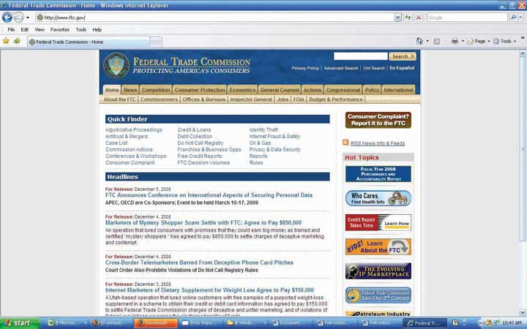
The Federal Trade Commission protects consumers.
The FTC’s Division of Advertising Practices enforces federal truth-in-advertising laws. Its law enforcement activities focus on the accuracy of claims for foods, drugs, dietary supplements, and other products promising health benefits; advertising to children; performance claims for computers and other high-tech products; tobacco and alcohol advertising; and related issues. FTC investigations may pertain to a single company or an entire industry. If the results of the investigation reveal unlawful conduct, the FTC may seek voluntary compliance by the offending business, or its lawyers may choose to take the case to court. ^{[1]}

The Federal Communications Commission
The Federal Communications Commission (FCC) was established by the Communications Act of 1934. It regulates interstate and international communications by radio, television, wire, satellite, and cable.
The FCC monitors the proper use of broadcast media. As an example of a current issue that could have major repercussions for the advertising industry, the FCC recently initiated a formal inquiry into the degree to which networks have to disclose whether advertisers have paid to have products embedded in TV shows and movies (a widespread practice the industry calls product placement).
According to the FCC, as product placement becomes more widespread, its rules must “protect the public’s right to know who is paying to air commercials or other program matter on broadcast television, radio and cable.” But it added that the rules must be considered in light of “the First Amendment and artistic rights of programmers.” One possible outcome is that the agency will mandate that when a sponsored product appears on the screen this placement will have to be disclosed simultaneously—perhaps with lettering that covers at least 4 percent of the screen and lasts for at least four seconds. Also up for debate is whether disclosures should be required before or perhaps even before and after a show that includes product integrations. ^{[2]}

Industry Regulation

The National Advertising Review Council (NARC)
To discourage the need for the government to pass additional legislation that would restrict its activities, advertising agencies vigorously police themselves to minimize abuses. To do this, the advertising industry created the National Advertising Review Council (NARC—no, not that kind of narc) in 1971. This group is a strategic alliance among four major trade organizations: the AAAA (American Association of Advertising Agencies), the ANA (Association of National Advertisers), the AAF (American Advertising Federation), and the Council of Better Business Bureaus Inc.
This system maintains two bodies that investigate claims of abuse or deception: the National Advertising Division (NAD) and the Children’s Advertising Review Unit (CARU). If an advertiser disagrees with NAD or CARU decisions, it can appeal to the National Advertising Review Board. The system covers advertising in traditional media as well as on the Internet. The large majority of cases get settled through this route—95 percent, in fact. ^{[3]}
A 2007 case involving a very public dispute between two online dating services illustrates how the NAD works to insure that advertising is as fair and accurate as possible. One site, Chemistry.com, claims in its advertising that answers to questions like “Do you watch people kissing in public?” and “Is your ring finger longer than your index finger?” can predict whether the people it matches up are likely to have “dating chemistry.” The site’s rival eHarmony.com objected to this claim and brought its charge to the NAD. After investigating the scientific basis for the claim, the division ruled that indeed Chemistry could not support its argument. As a result, the matchmaker has to find other ways to compete for the $700 million Americans spend each year to find their dream mate online.^{[4]}

The Interactive Advertising Bureau (IAB)
The Interactive Advertising Bureau was founded in 1996 to represent over 375 companies that conduct business in cyberspace. Its members sell about 86 percent of the online advertising that gets placed in the United States. The IAB evaluates and recommends standards and very specific practices to govern what interactive ads can and cannot do. For example, it mandates that an advertiser wishing to use a pop-up ad can show the message only one time during a person’s visit to an online site. Furthermore, the pop-up must be clearly labeled with the name of the network, the advertiser, and the publisher; there are limits on how big the image can be, and it must offer a “close box” so the user can choose to shut it down. ^{[5]}

Word of Mouth Marketing Association (WOMMA)
The Word of Mouth Marketing Association (WOMMA) is the official trade association for the word-of-mouth marketing industry. The organization promotes “best practices” and sets standards to regulate how “buzz marketers” interact with consumers. This has been an important issue due to some early buzz campaigns in which professional actors pretended to be everyday consumers in public places like tourist areas and bars, where they told other people about the advantages of using a particular product or service. Today WOMMA’s members must adhere to a code of ethics that the group summarizes as the Honesty ROI:
- Honesty of Relationship: You say who you’re speaking for.
- Honesty of Opinion: You say what you believe.
- Honesty of Identity: You never obscure your identity. ^{[6]}

The Direct Marketing Association (DMA)
The Direct Marketing Association represents more than thirty-six hundred companies, based in forty-seven countries, that employ direct marketing tools and techniques. It provides information to help consumers recognize fraudulent practices as well as to remove themselves from mailing or call lists.^{[7]}

KEY TAKEAWAY
Numerous organizations monitor the advertising industry to detect instances of false or deceptive advertising. The government enforces rules regarding content through federal agencies such as the FTC and the FCC. In addition, the industry vigorously polices itself to try to head off problems before the legal authorities must deal with them. As new media platforms continue to evolve (such as product placement and word-of-mouth marketing), the industry needs to be vigilant about tracking these applications to prevent additional abuses.

EXERCISES
- List and briefly characterize the major governmental and industry “watchdogs” that regulate and influence advertising and the advertising industry.
- Describe how the National Advertising Review Council processes complaints. Illustrate your description with a summary of the 2007 case (described above) concerning “dating chemistry” and “kissing in public.”

[1] Federal Trade Commission, “A Guide to the Federal Trade Commission,”http://www.ftc.gov/bcp/edu/pubs/consumer/general/gen03.shtm (accessed July 19, 2008).
[2] David Goetzl, “Game-Changer: FCC Considers Product Placement Disclosures,” Media Daily News, June 30, 2008, https://www.mediapost.com/publications/index.cfm?fa=Articles.showArticle&art_aid=85685 (accessed July 19, 2008).
[3] American Association of Advertising Agencies, “Working with the Industry,”http://www2.aaaa.org/advocacy/industry/Pages/default.aspx (accessed July 19, 2008); National Advertising Review Board, http://www.narbreview.org (accessed July 19, 2008); Federal Communications Commission, “About the FCC,” http://www.fcc.gov/aboutus.html(accessed July 19, 2008).
[4] Jessica E. Vascellaro, “Regulators Say Love Ain’t ‘Chemistry’ After All: Scientific Claim by Dating Service Comes Under Fire,” Wall Street Journal, September 17, 2007, B5.
[5] Interactive Advertising Bureau, “Pop-Up Guidelines,”http://www.iab.net/iab_products_and_industry_services/1421/1443/1461 (accessed July 19, 2008).
[6] Word of Mouth Marketing Association, “WOMMA’s Practical Ethics Toolkit,”http://www.womma.org/ethics/code (accessed July 19, 2008).
[7] Direct Marketing Association, http://www.dmachoice.org/consumerassistance.php(accessed July 19, 2008).

3.5 Exercises

TIE IT ALL TOGETHER
Now that you have read this chapter, you should be able to understand how the economic effects of advertising are constantly being spread throughout the economy:
- You can recognize that advertising is the glue that holds our culture together.
- You can identify the various economic effects of advertising with respect to overall size and impact.
- You can interpret the economic rationale for creating, accepting, and using advertising.
- You can describe the positive effects of advertising and how it enhances our world.
- You can discuss the ethical hot buttons that engage our social institutions in critical discussions of advertising.
- You can recall the various federal and industry regulators that monitor advertising and advertising practice in the United States.

USE WHAT YOU’VE LEARNED
- Picture yourself driving your electric car down the highway of tomorrow looking for a place to refuel. Though this vision might be optimistic at this point in time, electric and alternative-fuel cars are realities just over the horizon. Refueling stations for electric cars will most likely not resemble the corner or freeway gas station. Instead, refueling sites are more likely to look like roadside parks. Refueling stations that recharge batteries may have solar roofs that provide the current for the refueling. Since refueling is expected to take several minutes, refueling stations will provide for rest and activities. If advertising is the “glue of a nation” with respect to its culture, explain what role advertising would play in making electric and alternative fuel cars and their refueling stations become a reality in the future. Consider aspects of social responsibility as you form your explanation.
- Do you have any idea how often your life is impacted by Bluetooth technology? In case you didn’t know this, it is Bluetooth technology, developed by communication giant Ericsson, that enables all of our electronic and informational devices to talk to one another. For example, Bluetooth technology enables wireless headsets to communicate with other devices. You might have noticed that Aliph has just introduced a new Bluetooth-enabled headset called Jawbone that is smaller, lighter, and cuts wind noise more than any previous headset designs. The headset is about the size of a large rectangular earring or about one-half the size of existing headset models. There is, however, a significant problem that must be addressed before headset communication is advised for everyone. There are reports linking forms of brain cancer to cell phone and headset use. Experts are studying the possibilities and connections. No conclusions have been reached yet. Your task is to assume that you are a member of the Advertising Council and have been asked to design a PSA (public service announcement) that will both quiet fears and encourage information-seeking about the subject as research progresses. Write your message. How do you think those who support headset and cell phone development would respond to what you have to say? Comment.

DIGITAL NATIVES
Being environmentally friendly is one of the objectives valued by many of us today. The “green movement” is being embraced in a variety of ways. One of the ways is through the development of alternative energy sources such as wind power. Wind power has proven to be an efficient method for generating electricity. One of the companies attempting to harness wind energy and make it profitable is Dutch-based Vestas. Since it has 20+ percent market share of the industry and puts up one of its wind towers somewhere in the world about every five minutes, Vestas would have to be considered a growth-oriented company with a bright future. The company recently has expanded its international operations to North America by establishing a U.S. office in Houston, Texas.
Go to the Vestas Web site at http://www.vestas.com and learn more about the company, wind power solutions, and what Vestas plans to do in the future. Once you have gathered background information on the company and wind industry, use the six-item list found in the “Economic Rationale to Use Advertising” section of the chapter to determine what informational strategy (or strategies) would be best for introducing Vestas to U.S. consumers. Write your ideas down. Remember to focus your suggestions on the main themes of the list.

AD-VICE
- Assume that you are a representative of the advertising industry who has been asked to debate a leading economist on whether advertising is wasteful and manipulative or not. Develop four reasons to support your contention that advertising serves a useful function in our society. Your reasons should anticipate the comments that would be made by your adversary—the economist.
- Based on your understanding of how advertising assists in defining “who you are” with respect to your body image and self-esteem, take three market segments—teens, thirty- to forty-year-olds, and seniors (sixty- to seventy-year-olds)—and demonstrate how advertising provides “definition” to these segments. In your opinion, are these “definitions” correct? Be specific in your demonstration, illustration, and assessment.
- Some critics have claimed that advertising is responsible for perpetuating sexism and poor environmental practices. How would you respond to such criticism? Summarize and support your position. Present your position during an open class discussion of such criticism.
- Advertisers aim to present advertising messages to those who want the messages or would be open to new information. One of the ways to accomplish this objective is to use product placements in strategic positions in movies, video games, communications, and our daily lives. Evaluate product placement by listing the pros and cons of the practice. Cite illustrations to match your assessment of the practice. Does the practice need more or less regulation? Explain and comment.

ETHICAL DILEMMA
According to media and advertising critics, one of the chief causes of negative body image among teens and younger adults is the models used to display everything from cars to fashions to makeup. As indicated in the chapter, body image “refers to a person’s subjective evaluation of his or her physical self.” The key word is “subjective.” Messages are open to different interpretation. Critics claim advertising messages by their very nature cause consumers to reject their current situation or status quo and embrace change toward some ideal state as specified by the advertiser. If true, this could have a negative impact on those who read or view commercials, especially those who are younger and more impressionable.
To illustrate the ethical difficulty in dealing with body image, prepare two collages using pictures from contemporary magazines. One of your collages should illustrate unrealistic body images displayed in commercials that are, in your opinion, ethically questionable. The other collage should illustrate what you perceive to be a more realistic and ethical way to deal with the presentation of body image. Once they are completed, compare your collages; comment on where you think this debate over body image might be headed in the next few years. Be prepared to discuss your collages, thoughts, and position.

Chapter 4

Consumers and the Communications Process: SS+K Gets to Know Its Consumers
Figure 4.1 Twelve Months to Launch!
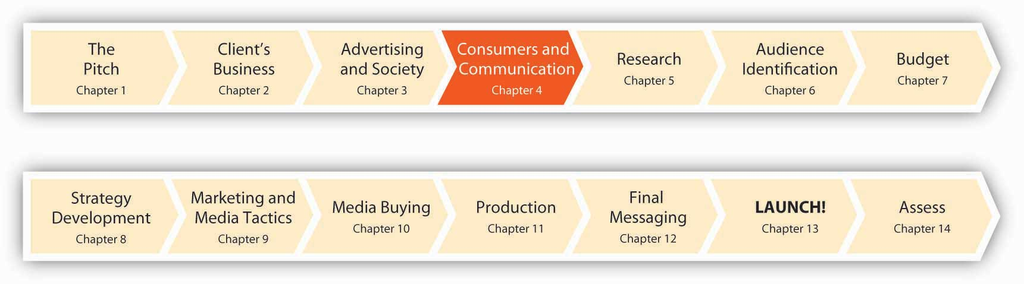
We are now twelve months from the launch of the msnbc.com campaign. The SS+K team needs to start thinking seriously about how it’s going to make consumers crave the msnbc.com brand of news. Before they can do that, however, they need to take a step back to understand how advertisers “talk” to customers—what works and what doesn’t, and what determines what works. This means we need to take a look at communications and break down a complicated process into simpler elements. Does it matter exactly what we say? Who says it? Where people get the message? How about others’ opinions—to what extent are our own preferences shaped (consciously or not) by what we believe others like or dislike? And, with the magical world of technology, how might the advertiser/consumer relationship evolve?

4.1 From Talking to Consumers to Talking with Consumers

LEARNING OBJECTIVES
After studying this section, students should be able to do the following:
- Describe the traditional linear communications model.
- Describe the new interactive, nonlinear, multivocal communications model.

The Traditional Linear Communications Model
Figure 4.2 The Traditional Communications Model
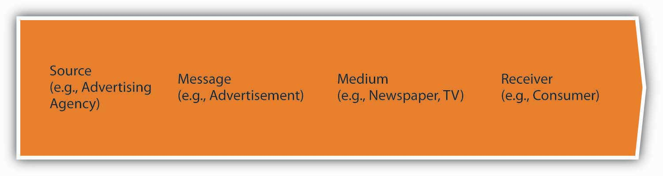
For most of history, advertisers talked to consumers—the traditional communications model was a one-way street. It was pretty simple, really: The source (such as an advertising agency) created a message (the advertisement) and selected the medium (newspaper, TV, outdoor, etc.) that carried it to the receiver (the consumer). The consumer may have given feedback to the source about the message (typically only indirectly, namely by buying the advertised product or service or not)—and of course she may have ignored it, just as people often do today—but the line of communication was clearly drawn. The producer called the shots and the message was univocal (one voice).

A New Interactive, Nonlinear, Multivocal Communications Model
Flash forward to a more dynamic—and chaotic—picture. Today, advertising messages come from many sources simultaneously through different media that target different receivers (consumers, business partners, stockholders, even government officials). At the same time, receivers talk with one another and they may initiate their own communication with the sender, whether that organization wants to hear it or not.
The updated communications model is interactive, nonlinear, and multivocal (many voices). In addition, consumers now may choose to opt out of listening to a particular message—they often get to decide which messages they see or hear, and when. In the old days, opting out meant getting up to make a sandwich when a TV commercial came on, but today many of us have a lot more control to determine what messages will appear for us to consider in the first place. For marketers, this permission marketing strategy makes sense (even though some may be indignant that they’re losing control over the situation). The rationale is very simple: A message is more likely to persuade consumers who have agreed to listen to it in the first place.
Figure 4.3 A New Interactive, Nonlinear, Multivocal Communications Model
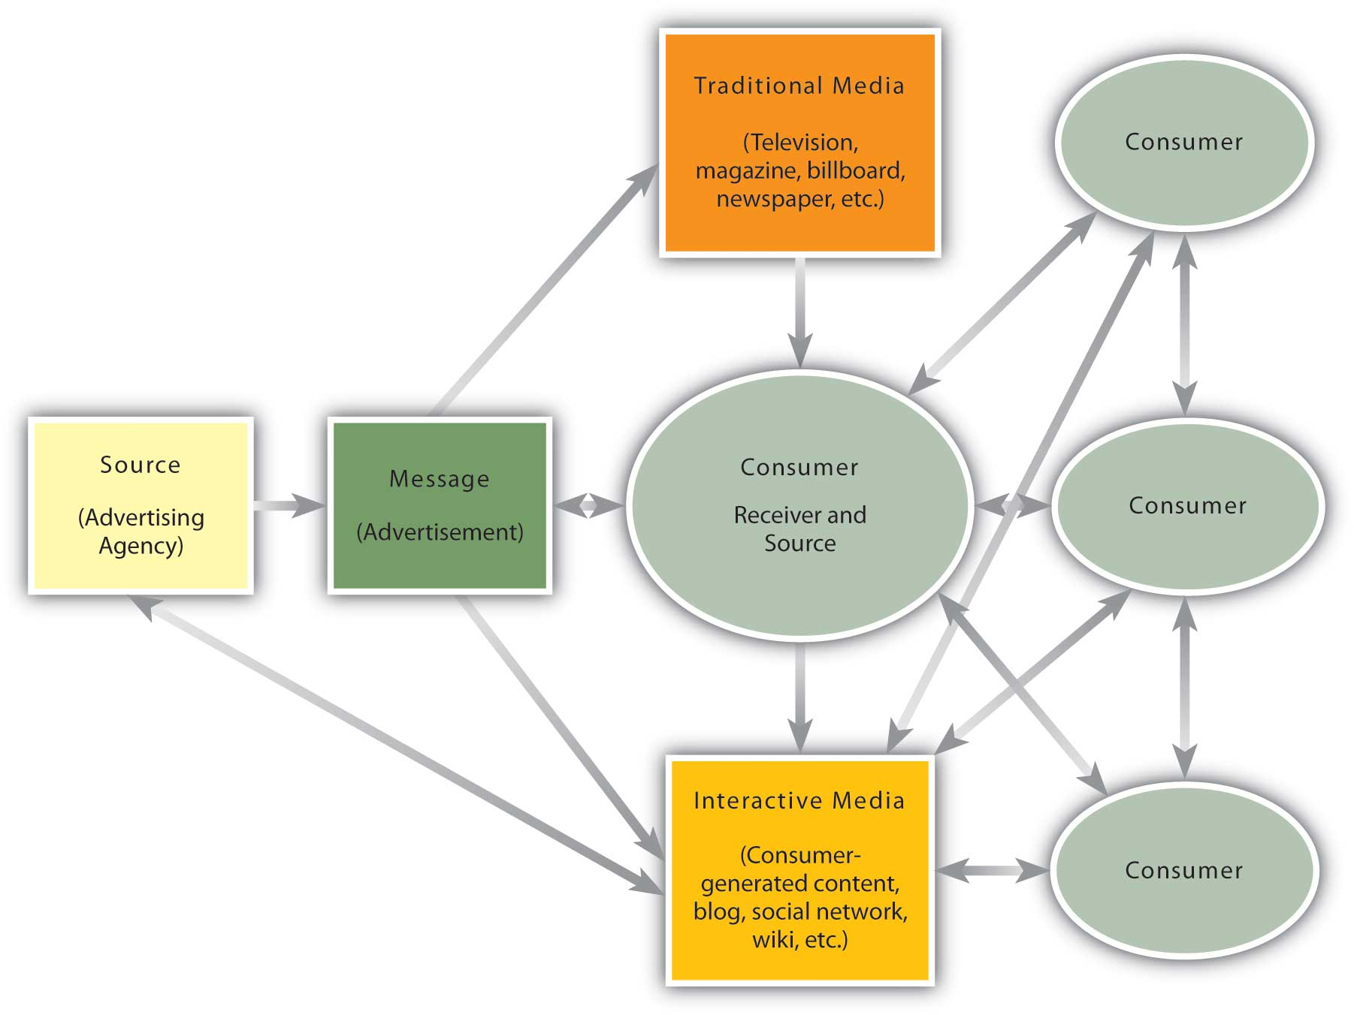
Seth Godin, founder of direct interactive marketing agency Yoyodyne (which Yahoo! later acquired) explains the importance of permission marketing: “We’re getting good at avoiding spam: e-mail spam, newspaper spam, TV spam, calling-me-at-home-over-dinner spam. The point of advertising shouldn’t be to interrupt more people who don’t want to talk to us.” To be heard above the noise, advertisers should seek permission from people to tell their story and begin a private, personal conversation that revolves around mutual interest and respect. ^{[1]}

Understand Communication to Create Effective Advertising
If we understand the communications model, we appreciate how messages affect people, how people make purchase decisions, and what influences these choices. These issues can help advertisers understand why people accept some messages while they ignore others. After all, it’s frustrating to be ignored—but in the world of advertising it’s also expensive.

KEY TAKEAWAY
We are used to thinking about communication as a one-way process that moves from a source who chooses what to say, how to say it, and where to say it to a receiver who either absorbs the message or not. That basic assumption is no longer valid in many cases, as consumers today become more proactive in the communications process. This creates many more interesting advertising possibilities, but it’s also harder to control the process once the inmates run the asylum.

EXERCISES
- Describe the traditional communications model. How does it differ from the updated communications model?
- Explain why permission marketing is so important to today’s marketer and advertiser.

[1] Quoted in “Expert Tells Marketers: To Be Memorable, Get Permission” InformationWeek, May 18, 2007,http://www.informationweek.com/news/internet/showArticle.jhtml?articleID=199602077(accessed May 18, 2007).

4.2 Is the Medium the Message? Components of Communications

LEARNING OBJECTIVES
After studying this section, students should be able to do the following:
- Identify the components of communication that one must master to successfully communicate with consumers.
- Compare and contrast one-sided versus two-sided messages.
Elements of who, how, and where an advertiser sends a message significantly affect how—or if—the audience receives it.

Source Effects
Who communicates the message (the source) has a big impact on whether a receiver will accept the message. You’re a lot more likely to download the latest Rihanna cut if your buddy recommends it than if you get the same advice from your kindly old uncle (unless he happens to be Jay-Z). The power of source effects, in fact, underlies the millions that celebrities make when they agree to endorse products. Obviously, advertisers feel it’s worth the substantial expense to pay a movie star or athlete to associate themselves with a certain brand’s message. Indeed, the pairing of a well-known person with a product is hardly new: Mark Twain’s image appeared on packages of flour and cigars in the late 1800s, while Buffalo Bill Cody hawked Kickapoo Indian Oil and Elvis was the face of Southern Maid Doughnuts. What makes an effective source? The important characteristics are credibility and attractiveness.

Source Credibility
Source credibility means that consumers perceive the source (the spokesperson) as an expert who is objective and trustworthy (“I’m not a doctor, but I play one on TV”). A credible source will provide information on competing products, not just one product, to help the consumer make a more informed choice. We also see the impact of credibility in Web sites like eBay or Wikipedia and numerous blogs, where readers rate the quality of others’ submissions to enable the entire audience to judge whose posts are worth reading.

Source Attractiveness
Source attractiveness refers to the source’s perceived social value, not just his or her physical appearance. High social value comes partly from physical attractiveness but also from personality, social status, or similarity to the receiver. We like to listen to people who are like us, which is why “typical” consumers are effective when they endorse everyday products.
So, when we think about source attractiveness, it’s important to keep in mind that “attractiveness” is not just physical beauty. The advertising that is most effective isn’t necessarily the one that pairs a Hollywood hottie with a product. Indeed, one study found that many students were more convinced by an endorsement from a fictional fellow student than from a celebrity. As a researcher explained, “They [students] like to make sure their product is fashionable and trendy among people who resemble them, rather than approved by celebrities like David Beckham, Brad Pitt or Scarlett Johansson. So they are more influenced by an endorsement from an ordinary person like them.” ^{[1]}
Still, all things equal, there’s a lot of evidence that physically attractive people are more persuasive. Our culture (like many others) has a bias toward good-looking people that teaches they are more likely to possess other desirable traits as well. Researchers call this the “what is beautiful is good” hypothesis. ^{[2]}Unfortunately, in many cases, while beauty is only skin deep, “ugly is to da bone.” ^{[3]}

Is It Better to Be an Expert or Hot?
Is source attractiveness more important than source credibility? The answer depends on the product or service you sell.
When to use credibility. If the product is utilitarian and complex (that is, consumers may not know much about how to use it), then a credible expert will be the most effective at persuading people to buy the product or service.
When to use attractiveness. If, on the other hand, the item is simple to understand (like clothing) but has a high social risk (that is, we’re concerned about the impression we’ll make on others if we’re seen with this item) then an attractive source will be more persuasive.
Sometimes you’re lucky enough to have a spokesperson who is both credible and attractive. This was the case for SS+K’s pro bono campaign for the United Nations peacekeepers when ads featured hunky UN messenger for peace George Clooney.

Figure 4.4
SS+K used actor George Clooney in its work for the United Nations peacekeepers.

Message Effects
How the message is said or presented is just as important as who communicates the message. Emotional messages appeal to, resonate with, or attempt to create an emotional response in the receiver. One common emotional message style is the fear appeal, which depicts the consequences of not using the product (e.g., social ostracism due to body odor). Another advertising strategy is to use humor. A study by Mediamark Research Inc. found that humor is the element in advertising that most appeals to kids. ^{[4]}
Rhetorical questions engage the receiver, don’t they? The question makes the receiver an active participant even if the medium of the message is passive or one-directional.
Examples versus statistics. Although examples and statistics can convey the same information, they do so in very different ways. Examples help put a human face on the product or its use, which creates an emotional connection and helps the receiver see how the product might influence his or her life. Statistics provide cold, hard numbers that may provide a rationale for purchase but not an emotional bond with the brand or product.
Interestingly, even among products whose purchase you might expect to be more rationally driven, such as pharmaceuticals, consumers are persuaded more by words and pictures from people who have had good results using the drug. Having Mrs. Jones’s picture with the words “Acme Sleep gave me my first restful night in fifteen years!” turns out to be more persuasive. Indeed, a study that included television ads for seven of the top ten best-selling prescription drugs for 2004 found that 95 percent of them used a positive emotional appeal (such as a character who’s happy after taking the product). ^{[5]}
One-sided messages present only the positive attributes of the product—they provide one or more objective reasons to buy the product. These often include objective variables such as price, performance, size, and power.
Two-sided messages present both positive and negative information about the product. Although most advertising messages are one-sided, research indicates that a two-sided message is very effective. Although it seems counterintuitive that an advertiser would want to publicize negative attributes of a product, doing so actually builds credibility by making the message more balanced. People who hear only one-sided arguments may be more skeptical of the message, wondering what hasn’t been said. Refutational arguments, therefore, which raise a negative issue and then refute it can be quite effective if the audience is well educated and if the receivers are not already loyal to the product. (If they are already loyal to the product, then discussing possible drawbacks has little merit and may actually raise doubts.)
Comparative messages explicitly trumpet a brand’s virtues vis-à-vis one or more named competitors. To promote its latest line of chicken sandwiches, the Arby’s fast-food chain aired TV commercials that took direct aim at rivals McDonald’s and Wendy’s. In one spot, a young man stands in a (fictitious) McDonald’s boardroom as he tries to convince McDonald’s executives to serve a healthier type of chicken. Framed against a familiar golden arches logo, he proclaims, “I propose that McDonald’s stops putting phosphates, salt and water into its chicken. Consider replacing your chicken, that is only about 70 percent chicken, with 100 percent all-natural chicken.” Board members break out in laughter. At the end of the spot, a voice-over chimes in: “Unlike McDonald’s, all of Arby’s chicken sandwiches are made with 100 percent all-natural chicken.”^{[6]} This messaging strategy is more common in the United States than in other cultures like Japan, where it is extremely rare because some people consider it a rather abrupt and even rude way to communicate.

SS+K Spotlight
SS+K developed a comparative message in recent work for its client My Rich Uncle to draw attention to the different options that parents and students have to pay for college. See the ad below and listen to the radio spot, titled “Ahem.” At the beginning of the spot you’ll hear a man’s voice stating an ISCI code, agency, and title of spot. This is called a slate, and it is used by radio stations to ensure they are playing the correct spot.

Figure 4.5One of the Print Ads SS+K Created for Its Client My Rich Uncle
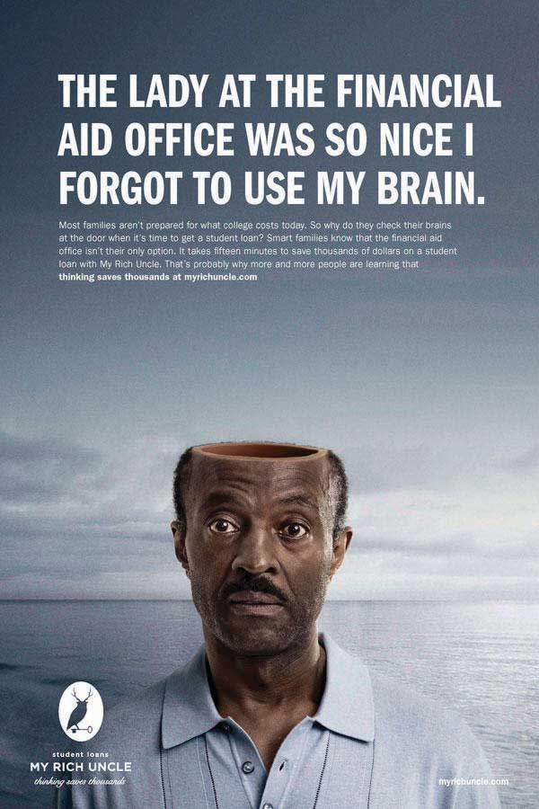

Audio Clip
“Ahem”
http://app.wistia.com/embed/medias/0dd16a8843
The radio spot “Ahem” features a humorous voice of a brain to continue the comparative approach of the campaign.

Situational Effects
Where a message is said—that is, our physical and social environment—affects how receptive we are to the advertising message. What’s part of the physical environment? Surroundings and decor, for example. Our arousal levels rise when we’re in the presence of others. This arousal can be positive or negative. Watching a funny movie is often more enjoyable in a full movie theater where everyone else is laughing, too. But if we feel uncomfortably crowded, we may put up our guard.
Intangibles like odors and even temperature affect our ability and desire to listen to messages. Indeed, a growing number of marketers are counting on scents to turn into dollars as they invest in costly new technologies to create scented ads (a magazine ad with a scent strip costs four to eight times as much as an odorless version). Sure, we’re used to a bombardment of perfume smells when we open a fashion magazine, but today the boundaries have widened considerably. Kraft Foods promoted its new DiGiorno Garlic Bread Pizza with a scratch-and-sniff card (good to carry with you if you plan to encounter vampires). On behalf of its client the pay-cable Showtime network, TV Show Initiative (a unit of Interpublic Group) promoted the popular show “Weeds” by adding the scent of marijuana to strips in magazine ads. (So far, no reports of anyone trying to roll up the page and smoke it.) ^{[7]}
Finally, the message has to stand out from the clutter of competing messages and stimuli, which can be a challenge given the multiple stimuli vying for our attention at any one time. Consumers often are in a state of sensory overload, where they are exposed to far more information than they can process. The average adult is exposed to about 3,500 pieces of advertising information every single day—up from about 560 per day thirty years ago.
Getting the attention of younger people in particular is a challenge—as your professor probably knows! By one estimate, 80 percent of teens today engage in multitasking, where they process information from more than one medium at a time as they attend to their cell phones, TV, instant messages, and so on. ^{[8]}One study observed four hundred people for a day and found that 96 percent of them were multitasking about a third of the time they used media. ^{[9]}Advertisers struggle to understand this new condition as they try to figure out how to talk to people who do many things at once.

KEY TAKEAWAY
How a message is said can often be as important as what is said. Key elements to consider include the nature of the message’s source, how it’s structured, and the environment in which people see or hear it.

EXERCISES
- Explain how advertisers use source credibility and source attractiveness to communicate more effectively.
- List and describe the various types of messages that advertisers can use to communicate with their markets. Use specific terms in your description.

[1] Quoted in “Celebrity Ads’ Impact Questioned,” BBC News, 27 February 2007,http://news.bbc.co.uk/1/hi/england/somerset/6400419.stm (accessed October 31, 2007).
[2] Karen Dion, Ellen Berscheid, and Elaine Walster, “What Is Beautiful Is Good,” Journal of Personality and Social Psychology 24 (1972): 285–90.
[4] Mark Dolliver, “Critical Beer Drinkers, Confident Eaters, Etc.” Adweek, January 8, 2007, 24.
[5] Alicia Ault, “Drug Ads Play on Emotions,” Family Practice News, February 15, 2007, 45; Steve Smith, “Mastering the Direct Appeal,” Sleep Review 8, no. 4 (2007): 54.
[6] Suzanne Vranica, “Arby’s TV Spots Play Game of Fast-Food Chicken,” Wall Street Journal, July 5, 2006, A16.
[7] Stephanie Kang and Ellen Byron, “Scent Noses Its Way into More Ad Efforts,” Wall Street Journal, October 8, 2007, B7.
[8] Jennifer Pendleton, “Multi Taskers,” Advertising Age, March 29, 2004, S8.
[9] Sharon Waxman, “At an Industry Media Lab, Close Views of Multitasking,” New York Times, May 15, 2006, http://www.nytimes.com/2006/05/15/technology/15research.htm(accessed May 15, 2006).

4.3 Diffusion of Innovations

LEARNING OBJECTIVE
After studying this section, students should be able to do the following:
- Discuss the diffusion of innovations process and its various stages.
Communications often involves new ideas, new products, and new information. Whether people adopt a new idea or product depends on many factors. The communications model for advertising (discussed above) is affected by the forces that govern the diffusion of innovation.

The Diffusion Model
The Burger “King.” The GEICO gecko. “Bounty, the quicker picker upper.” “Where’s the beef?” The “swoosh.” Most of us are very familiar with these advertising characters and phrases—in fact, some days it seems everyone we know sends us the same hilarious YouTube clip to check out the latest spot. Did you ever wonder why a phrase you hear for the first time one day suddenly comes out of everyone’s lips a week later? How does this process work, and why should we care? The latter question is easy: Advertising depends on the transmission of information among members of a society to spread the word about new ideas, products, and services.
A lot of cutting-edge advertising strategies depend on our willingness—and enthusiasm—to share information and ideas that appeal to us with others. Indeed, this is the backbone of viral marketing, which we’ll talk about in detail later—basically this term refers to a process where people pass on a phrase, a joke, a slogan, or perhaps a URL to their network of friends, who in turn pass it on to others until thousands or even millions of us see it (think about how often more than one friend or acquaintance sends you the same e-mail joke). Each of these little pieces of information is a meme, a unit of cultural information (the biologist Richard Dawkins coined this phrase in his book The Selfish Gene). ^{[1]}
Today memes travel at ferocious speeds as they bounce around in cyberspace. For example, the Web site http://www.4chan.org is one of the most prolific launchers of new memes. Its progeny include LOL (laugh out loud) cats (humorous images of cats with loud text beneath them in a fake language called “LOLspeak”; this meme also spawned the popular Web siteicanhascheezburger.com), the phrase “So I herd u like mudkips” (a reference to a sea creature from the animated show “Pokémon” that generated thousands of tribute videos on YouTube), and the practice of “Rickrolling” (where a friend e-mails you to check out an online video; when you open the link expecting to see something amazing, instead you’re sent to a video of Rick Astley’s 1988 hit “Never Gonna Give You Up”—dude, you’ve been Rickrolled). ^{[2]}
An innovation is any idea (whether a LOL cat or a new religion), product, or service that consumers perceive to be new (whether it actually is or not!).Diffusion of innovations refers to the process by which an idea spreads through a population. To grasp how this works, think about the way a cold spreads through a dorm or office. One person “imports” the germ, and sure enough, some of those in his immediate vicinity start to hack away. They in turn transmit the cold to others so that before you know it almost everyone in the building is yearning to breathe free. Hence the viral in viral marketing. To check out (and probably share with your friends) a great new viral site, visithttp://www.elfyourself.com.

Who Spreads the “Cold”?
An idea spreads in much the same way as a cold or other virus (hopefully with more pleasant results). The process begins with a small group of people, and then if it’s appealing enough it spreads (diffuses) into a larger market. We define the “spreaders” in terms of the relative speed with which they pick up the new idea:
Innovators (about 2.5 percent of the population) adopt the idea first. These are usually people who are the hard-core members of a taste culture (e.g., “tuners,” enthusiasts of hopped-up cars, or “gamers,” who closely follow the blogs about a new videogame still under wraps at a studio).
Early adopters (about 13 percent of the population) often are influential people (including those in the media, such as advertising columnists) who build buzz around a new idea, ad campaign, or product.
The early majority (about 34 percent of the population) adopt a product once it has become known. They like to be “up” on things, but only after they’ve already started to make their way into the mainstream.
The late majority (another 34 percent) are skeptical of new products and take even longer to adopt them. Together with the early majority, this is your true “mass market” consumer.
Laggards (about 16 percent of us) are the last to adopt. In fact, they may never try a new variation—“if it ain’t broke, don’t fix it.” Ironically, sometimes they stick with the tried-and-true for so long that it becomes fashionable again (e.g., Hush Puppy shoes, overalls, or farm caps).

Figure 4.6 Diffusion of Innovations
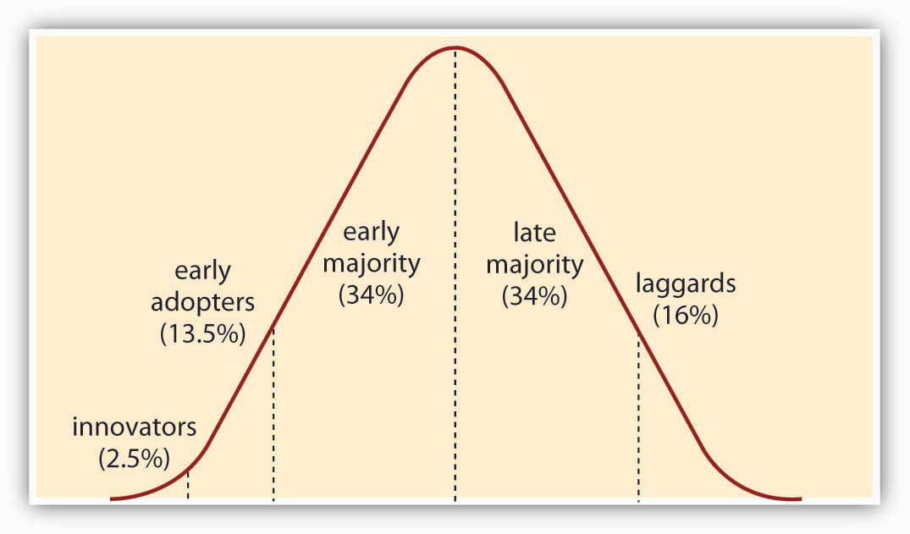

SS+K Spotlight
The memes and trends are constantly morphing, and new influencer groups are constantly emerging, so as your career goes on as an advertising or marketing professional, you will need to stay ahead of these types of changes and understand how to apply them to your or your client’s business.
Figure 4.7
Many companies specialize in monitoring memes and selling their “cultural intelligence” to agencies like SS+K.
Communication professionals stay on top of things individually, but SS+K also does a few extra things to ensure that its staff is ahead of the curve. The agency conducts a Monday meeting for all three offices, where different account teams present the latest work they’ve launched for a client. Noelle Weaver, vice president, also coordinates Friday Fodder, an event where outside professionals come to speak about their business offerings. The msnbc.com team was inspired by a Friday Fodder presentation from the Brand Experience Lab that ultimately resulted in a piece of the msnbc.com campaign (which you’ll learn about later).
SS+K also uses resources like PSFK, Iconoculture, and The Intelligence Group’s Cassandra Report; their latest report is available to the public:http://www.trendcentral.com/WebApps/App/SnapShots/Article.aspx?ArticleId=7276.

KEY TAKEAWAY
Information including new ideas, phrases, and brand names diffuses through a culture as memes. These memes tend to get adopted by certain types of people initially, who spread them to others much like a cold gets transmitted among members of a group. Advertisers need to understand who is more or less likely to “catch” a meme.

EXERCISE
Pick an example of a new style, product, or idea and demonstrate how the diffusion of innovations can spread an idea through society and the marketplace.

[1] Richard Dawkins, The Selfish Gene (London: Oxford University Press, 1978).
[2] Jamin Brophy-Warren, “Modest Web Site is Behind a Bevy of Memes,” Wall Street Journal Online, July 9, 2008, http://online.wsj.com/article/SB121564928060441097.html(accessed July 10, 2008); http://icanhascheezburger.com (accessed July 10, 2008).

4.4 Decision Making

LEARNING OBJECTIVES
After studying this section, students should be able to do the following:
- Demonstrate an ability to match the decision process model with a purchase decision.
- Describe the various consumer behavior models based on motivation.
Understanding how we make decisions helps advertisers choose the right message to send at the right time.

The Decision-Making Process
The decision to purchase a product has five stages, each of which implies the need for a different type of communication. The five stages are:
- Need recognition: first, we realize we have a need for a product. Advertising for this stage may highlight an unmet need, a common life problem, or a desirable new capability.
- Information search: we seek out information about the product by searching the Web or asking friends. Informative advertising can demonstrate product performance or superiority.
- Evaluation of alternatives: we compare the choices available based on various attributes. Comparative ads and two-sided messages spell out the pros (and to a lesser extent the cons) of an advertiser’s brand versus competing brands.
- Purchase: we choose the option we like best and buy it. Ads facilitate purchase by telling us where or how to buy, or perhaps they announce a price reduction for the product.
- Postpurchase satisfaction or dissatisfaction: we use the product and we’re either satisfied with the purchase or not. Postsale communications, such as feedback and social networks, help consumers confirm their choices or resolve issues.
Figure 4.8 The Decision-Making Process
Advertisers can help consumers through the decision-making process. Some ads intend to create awareness that a need exists (it was an adman, not a doctor, who invented the term “halitosis” to describe bad breath!). Other ads provide information to facilitate information search and comparisons. Progressive Insurance, for example, lets customers shop online and compare prices among major competitors. The company does not promise to have the lowest price, but it makes clear what its price is in relation to the competition. This is particularly helpful in the “evaluation of alternatives” stage as customers compare different competitive offerings. ^{[1]}

Who Decides?
The people who make the purchase decision can be individuals, couples, families, or businesses. In businesses, the “buying center” (a group of people tasked with making purchase decisions on behalf of the organization) typically is involved in the decision-making process because organizational decisions are more complex. Each member of the buying center plays a different role in the process, which may require different types of messages. For example, new corporate computer software might advertise how it enhances business performance for managers while it emphasizes technical sophistication for IT professionals.
SS+K’s client, the Blue Cross and Blue Shield Association, has many audiences ranging from individuals to small businesses to national accounts (companies with over five hundred people, sometimes in multiple states). The agency recently designed a campaign to address the needs of national accounts business decision makers (the HR or corporate group in charge of making insurance decisions for a corporation.)

Dig Deeper
Ariba, a provider of procurement and spending management software and services, sells to organizations such as banks. Ariba has learned that marketing to banks means understanding their priorities and challenges. Banks tend to be more conservative in their software purchase decisions because buying software often requires being able to roll it out across different branch locations. Purchasing agents at banks want to know if the manufacturer will support the product across locations and if it can be scaled quickly to other regions or departments. They want to know that the software will improve their bottom line and that others have deployed it successfully. ^{[2]}
Interview people whose jobs include the responsibility of purchasing items for their businesses to use. Ask them how they go about making these decisions, and what information sources they consult in this process. How important are criteria such as brand name, reputation, cutting-edge features, and color?

Models of Decision Making
Motivation refers to the processes that lead people to behave as they do. For example, why do consumers decide to buy a timeshare vacation property? An industry survey found that the most important reasons to purchase a timeshare include flexibility, low cost, a desirable resort, and the certainty of quality accommodation. ^{[3]} It’s important that advertisers understand what drives customers so they can design messages to address central concerns rather than minor ones.

Involvement and Perceived Risk
One important driver is a consumer’s extent of involvement with a brand or product category. It’s tempting to assume that we put more thought into purchases that are expensive, but this isn’t necessarily true. We might be motivated to put a great deal of thought and effort into choosing even a relatively cheap product if we feel our choice will reflect something about ourselves to others.
And involvement often is a function of the product’s degree of perceived risk:
- Physical risk. Will the wrong choice endanger my health or that of my family?
- Financial risk. Will the wrong choice cost me too much money?
- Social risk. Will the wrong choice embarrass me or lead to the wrong impression?

Heuristics: Rules of Thumb
Hershey or Nestlé? Coke or Pepsi? Charmin or Bounty? Lil Wayne or Usher? People don’t have the time or desire to ponder endlessly about every purchase. Heuristics are shortcuts or mental “rules of thumb” that we use when we make a decision—especially when we choose among products in a category where we don’t see huge differences or if the outcome isn’t do or die. These rules simplify the decision-making process by making it quick and easy. Common heuristics include these:
- Save the most money. Many people follow a rule like, “I’ll buy the lowest-priced choice so that I spend the least money right now.” Using this heuristic means you don’t need to look beyond the price tag to make a decision. Wal-Mart built a retailing empire by pleasing shoppers who follow this rule.
- You get what you pay for. Others might use the opposite heuristic, namely, “I’ll buy the more expensive product, because higher price often means better quality.” These consumers are influenced by ads alluding to exclusivity, quality, and uncompromising performance.
- Stick to the tried and true. Brand loyalty also simplifies the decision-making process—we buy the brand that we’ve always bought before, and thus we don’t need to spend more time and effort on the decision. It’s hard to downplay the importance of brand loyalty—and of the role that advertising plays in creating and maintaining it. In a study of the market leaders in thirty product categories, twenty-seven of the brands that were number one in 1930 (such as Ivory Soap and Campbell’s Soup) still were at the top over fifty years later. ^{[4]} Clearly “choose a well-known brand name” is a powerful heuristic.

KEY TAKEAWAY
Some purchases matter to us a lot more than others, so it makes sense that we don’t devote the same amount of attention to advertising for every idea, product, or service. An advertiser needs to appreciate how involved her customers are likely to be; we are more likely to search out detailed information for products that are highly involving to us. In other cases we tend to fall back on heuristics, “rules of thumb” that reflect well-learned rules (such as “it must be better if it costs more”).

EXERCISES
- Take a common product or service and demonstrate the decision-making process that an average consumer would go through when purchasing it.
- Consumer motivation is very important to marketers and advertisers. Describe how involvement and perceived risk are used to heighten consumer motivation.
- What is a heuristic? How do marketers and advertisers use heuristics to achieve brand loyalty?

[1] Nancy Michael, “Customer Loyalty: Elusive, but Critical,” ABA Banking Journal 99, no. 2 (2007): 42.
[2] Roger Slavens, “Understand Client Priorities, Then Deliver Solutions” B to B, March 12, 2007, 24.
[3] Beverley Sparks, Ken Butcher, and Grace Pan, “Understanding Customer-Derived Value in the Timeshare Industry,” Cornell Hotel & Restaurant Administration Quarterly 48 (February 2007): 28.
[4] Richard W. Stevenson, “The Brands with Billion-Dollar Names,” New York Times, October 28, 1988, A1.

4.5 Internal Influences on Consumers

LEARNING OBJECTIVES
After studying this section, students should be able to do the following:
- Explain how attitudes influence the information processing element in communication.
- Define the multiattribute attitude model and the elaboration likelihood model of behavior.
- Compare and contrast behavioral learning theories versus cognitive learning theories.
- Illustrate the memory process by relating how things are remembered and forgotten.

Attitudes and Information Processing
An attitude is a predisposition to evaluate an object or product positively or negatively. The attitudes we form about a product or service will affect whether we’re likely to buy that product or not. Attitudes have three components:
- Cognition: our beliefs about a product
- Affect: how we feel about a product
- Behavior: what we intend to do regarding the product

Response Hierarchies: Which Comes First?
Thinking, feeling, and doing can happen in any order. Psychologists originally assumed that we form attitudes through a fixed sequence of these three components: We first think about the object, then evaluate our feelings about it, and finally take action: Cognition → Affect → Behavior.
Research evidence, however, shows that we form attitudes in different sequences based on different circumstances. If we’re not very involved in or don’t care much about a purchase, we may just buy a product on impulse or because we remember a catchphrase about it instead of carefully evaluating it in relation to other products. In that case, action precedes feeling and thought: Behavior → Affect → Cognition.
Conversely, feelings—rather than thoughts—may drive the entire decision process; our emotional reactions may drive us to buy a product simply because we like its name, its packaging design, or the brand image that ads create. In this case, we see the product, have a feeling about it, and buy it: Affect → Behavior → Cognition.

Dig Deeper
Subaru of America’s researchers discovered that Subaru owners were extremely outspoken about their passionate feelings for their cars—that’s the good news. But there was bad news too: while most consumers who didn’t own a Subaru had heard of the company, very few had any strong emotional connections with the cars. In response, Subaru launched a new marketing campaign that targets car buyers who pass through three stages: the heart, the head, and the wallet. The heart stage emphasizes the love owners feel for their cars in ads that tell about taking meaningful trips together or bidding a sad farewell to an old Subaru before driving off in a new model. In the head stage, spots feature rational reasons why someone should buy a Subaru, such as the couple that decides they’d rather sell their boat than get rid of their Subaru. The final wallet stage focuses on (you guessed it) financial reasons to buy a Subaru, and this includes messages from local dealers. ^{[1]}

SS+K Spotlight
SS+K worked with the Massachusetts Teachers Association to create television and radio spots that would help the public to understand the issues around education prior to the state’s gubernatorial election. The ads featured actual public school students in Massachusetts schools learning in classroom settings. The voice-over recalled statistics that allowed viewers to understand the impact of their choices on the public school system. The spot wraps with a strong call to action—vote for Deval Patrick (who was eventually elected). What is the order of cognition, affect, and behavior in this example?

Multiattribute Attitude Models
As you can see, attitudes are complex. Because of this complexity, researchers use multiattribute attitude models to explain them. Simply put, multiattribute models say that we form attitudes about a product based on several attributes of that product, our beliefs about those attributes, and the relative importance we assign to those attributes.
The decision to purchase a car like an SUV offers a good illustration of how a multiattribute model affects purchase behavior. On the one hand, the styling and stance of a particular model might evoke feelings of power, confidence, and ruggedness. The vehicle’s high ground clearance and roomy back might be great for the consumer’s intended camping trips. On the other hand, the brand could make the consumer ill at ease—perhaps a friend had a bad experience with that car maker. And the more rational side of a consumer might balk at the high cost and poor gas mileage. Yet the vehicle looks great, so the consumer isn’t sure. And, regardless of his personal feelings about the vehicle, the consumer may also factor in social pressure: will his friends criticize him as a wasteful gas-guzzler if he buys an SUV instead of a compact hybrid? Will he buy or won’t he? The decision depends on how the buyer combines and weights these positive and negative attitude components. The suspense is killing us…

The Gift or the Wrapping? The Elaboration Likelihood Model
So what’s the bottom line for advertising—is it the gift or the wrapping that counts? The research helps us understand how to design the advertising message so that it has the most influence. If we advertise to consumers who are highly involved in the purchase decision-making process, then those consumers will primarily use their thinking to drive the decision. Therefore, strong, rational arguments (the “gift”) will be most persuasive for them.
On the other hand, consumers who are less involved will be more influenced by the “wrapping”—the images, sounds, and feelings they see or remember about the product. For them, it may be more important that Tiger Woods endorsed the car than that it gets better gas mileage than another model.
The elaboration likelihood model summarizes this theory. Under conditions of high involvement, the consumer will be more likely to process the content of the message, form an attitude about it, and make a purchase decision. Under low involvement, the consumer will respond to the style of the message (an attractive package, a popular spokesperson) rather than its substance.

Perceiving Advertising Messages
The perception process refers to the sensory stimuli (sights, sounds, smells, tastes, textures) that enter through our sensory receptors (eyes, ears, nose, mouth, and skin). We select, organize, and interpret these sensations. Promotional messages rely on as many stimuli as possible to get our attention. When creating an advertising message, creatives choose sensory stimuli carefully so that they communicate a particular meaning and feeling. For example, certain colors (especially red) create feelings of arousal and stimulate the appetite, whereas other colors (like blue) are more relaxing.

Sensory Marketing and Advertising Stimuli
Before a stimulus such as an image or sound can elicit a particular reaction in us, we first have to notice it. In today’s cluttered advertising environment, that’s no small feat. How can advertisers break through the clutter and get into the game?
Stimuli that differ from other stimuli around them are more likely to get noticed. Four ways to command a receiver’s attention are size (bigger stimuli tend to command more attention), color that differs from its surroundings, position (right-hand page magazine ads get more attention than left-hand ones), and novelty (ads in places where you don’t expect them, like walls of tunnels or restrooms).
Procter & Gamble decided to use the sense of smell to catch consumers’ attention. P&G put up posters at bus stops in London for its antidandruff shampoo Head & Shoulders Citrus Fresh. The twist: passersby could get a whiff of the scent by pushing a button on the poster. ^{[2]}
In a very different application, Miller Genuine Draft uses a label on its beers that has special optical brighteners that light up in black light. When a nightclub turns on its black lights, for example, the bottles visually pop off the shelf because the labels glow in the dark. ^{[3]}

Subliminal Advertising
What is the hidden message in that magazine ad you’re looking at? Are you getting brainwashed by innocent-looking TV commercials that “order” you to buy a product? If you believe advertisers are doing their best to place “secret messages” all around you, you’re not alone. Subliminal perception is a topic that has captivated the public for more than fifty years, despite the fact that there is virtually no proof that this process has any effect on consumer behavior. Another word for perceptual threshold is limen (just remember “the secret of Sprite”), and we term stimuli that fall below the limen subliminal. So subliminal perception (supposedly) occurs when the stimulus is below the level of the consumer’s awareness.
A survey of American consumers found that almost two-thirds believe in the existence of subliminal advertising, and more than one-half are convinced that this technique can get them to buy things they do not really want. ^{[4]} They believe marketers design many advertising messages so the consumers perceive them unconsciously, or below the threshold of recognition. For example, several authors single out beverage ads as they point to ambiguous shapes in ice cubes they claim are actually women’s bodies or erotic words. Most recently, ABC rejected a Kentucky Fried Chicken (KFC) commercial that invited viewers to slowly replay the ad to find a secret message, citing the network’s long-standing policy against subliminal advertising. KFC argued that the ad wasn’t subliminal at all because the company was telling viewers about the message and how to find it. The network wasn’t convinced—but you should be. ^{[5]}
Like this KFC ad, most examples of subliminal advertising that people “discover” are not subliminal at all—on the contrary, the images are quite apparent. Remember, if you can see it or hear it, it’s not subliminal; the stimulus is above the level of conscious awareness. Nonetheless, the continuing controversy about subliminal persuasion has been important in shaping the public’s beliefs about advertisers’ and marketers’ abilities to manipulate consumers against their will.
Although some research suggests that subliminal messages can work under very specific conditions, this technique has very little applicability to advertising even if we wanted to resort to it. For one, an advertiser would have to send a message that’s very carefully tailored to each individual rather than to a large audience. In addition, there are wide individual differences in threshold levels (what we’re capable of consciously perceiving); for a message to avoid conscious detection by consumers who have low thresholds, it would have to be so weak that it would not reach those who have high thresholds.
However, a new study surely will add fuel to the long-raging debate. The researchers reported evidence that a mere thirty-millisecond exposure to a well-known brand logo can in fact influence behavior; specifically the study found that people who were exposed to a quick shot of Apple’s logo thought more creatively in a laboratory task (mission: come up with innovative uses for a brick) than did those who saw the IBM logo. ^{[6]} Apple will no doubt love the implication, but most other advertisers are too focused on efforts to persuade you when you’re aware of what they’re up to.

Learning and Memory for Advertising
Subliminal messages aside, the reality is that consumers have to remember the name of a product or recognize it on the shelf if they are to buy it. Snappy lyrics, unusual colors, or a distinctive logo can help consumers remember. Using a spokesperson like a talking gecko for the similar-sounding GEICO insurance company may be unique and visually appealing enough to make it memorable.

Learning
Learning is a relatively permanent change in behavior caused by experience. The learner need not have the experience directly; we can also learn by observing events that affect others. ^{[7]} We learn even when we don’t try: Consumers recognize many brand names and they can hum many product jingles, for example, even for products they themselves do not use. We call this casual, unintentional acquisition of knowledge incidental learning.
Theories of learning range from those that focus on simple stimulus-response connections (behavioral theories) to perspectives that regard consumers as solvers of complex problems who learn abstract rules and concepts as they observe others (cognitive theories). Basic learning principles are at the heart of many advertising efforts.

Behavioral Learning Theories
Behavioral learning theories assume that learning takes place as the result of responses to external events. For example, if a song we remember fondly from high school gets repeatedly paired with a brand name, over time our warm memories about the tune will rub off onto the advertised product. This process works even when the product’s name initially has no meaning at all—think about the likes of Marlboro, Adidas, and Exxon, which we have learned to respond to with strong emotions.
According to this perspective, the feedback we receive as we go through life shapes our experiences. Similarly, we respond to brand names, scents, jingles, and other marketing stimuli because of the learned connections we form over time. People also learn that actions they take result in rewards and punishments; this feedback influences the way they will respond in similar situations in the future. Consumers who receive compliments on a product choice will be more likely to buy that brand again, but those who get food poisoning at a new restaurant are not likely to patronize it in the future.

Learning about Brands
What’s more, the reactions we learn to one object tend to transfer to other, similar objects in a process psychologists term stimulus generalization. That explains why a drugstore’s bottle of private brand mouthwash deliberately packaged to resemble Listerine mouthwash may evoke a similar response among consumers, who assume that this me-too product shares other characteristics of the original. Indeed, consumers in one study on shampoo brands tended to rate those with similar packages as similar in quality and performance as well. ^{[8]}
Stimulus generalization is the basic idea underlying numerous branding strategies that share this approach: (1) Create a brand name that consumers learn to associate with positive qualities; (2) paste that brand name on other, reasonably similar products; (3) stand back and let the positive associations transfer to the new item.
This approach explains the success of these branding strategies:
- Family branding. Many products capitalize on the reputation of a company name. Companies such as Campbell’s, Heinz, and General Electric rely on their positive corporate images to sell different product lines.
- Product line extensions. Marketers add related products to an established brand. Dole, which we associate with fruit, introduced refrigerated juices and juice bars, whereas Sun Maid went from raisins to raisin bread.
- Licensing. Companies often “rent” well-known names. Christian Dior licenses the designer’s name to products from underwear to umbrellas.

Cognitive Learning Theories
According to the behavioral learning perspective, to a large extent the same principles that animal trainers use to teach dogs to dance (i.e., rewarding some movements with a treat while discouraging others with a loud no) operate to condition our preferences for brands. OK, it’s a little insulting—but the sad truth is it’s often true!
Of course (you respond indignantly), many things we learn are far more complex than a simple association between a stimulus and a response—and many powerful ads succeed because they tell complicated stories or convey abstract meanings. In contrast to behavioral theories of learning, cognitive learning theory approaches stress the importance of internal mental processes. This perspective views people as problem solvers who actively use information from the world around them to master their environments. Supporters of this view also stress the role of creativity and insight during the learning process.
Figure 4.9 Observational Learning
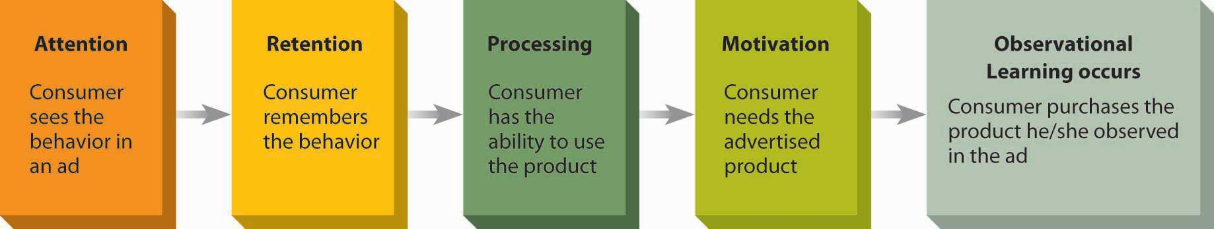
One important aspect of a cognitive learning perspective is observational learning; this occurs when people change their own attitudes or behaviors simply by watching the actions of others—learning occurs as a result of vicarious rather than direct experience. This type of learning is a complex process; people store these observations in memory as they accumulate knowledge, perhaps using this information at a later point to guide their own behavior. Modeling (not the kind Tyra Banks does) is the process of imitating the behavior of others. For example, a woman who shops for a new kind of perfume may remember the reactions her friend received when she wore a certain brand several months earlier, and she will mimic her friend’s behavior with the hope of getting the same feedback. You should have no trouble thinking of advertisements you’ve seen that encourage you to model an actor’s behaviors at a later point in time. Try teaching that to a lab rat.

How Do We Remember What We’ve Learned?
The most exciting advertisement is worthless if it doesn’t make a reasonably lasting impact on the receiver. So, advertisers need to understand how our brains encode, or mentally program, the information we encounter that helps to determine how we will remember it (if we do at all). In general, we have a better chance of retaining incoming data we associate with other information already in memory. For example, we tend to remember brand names we link to physical characteristics of a product category (e.g., Coffee-Mate creamer or Sani-Flush toilet bowl cleaner) or that we can easily visualize (e.g., Tide detergent or Mercury Cougar cars) compared to more abstract brand names. ^{[9]}
The encoding process is influenced by the type of meaning we experience from a stimulus. Sometimes we process a stimulus simply in terms of its sensory meaning, such as the literal color or shape of a package. We may experience a feeling of familiarity when, for example, we see an ad for a new snack food we have recently tasted. In many cases, though, we encode meanings at a more abstract level. Semantic meaning refers to symbolic associations, such as the idea that NASCAR fans drink beer or that cool women have Asian-inspired koi designs tattooed on their ankles.
Advertisers often communicate these kinds of meanings through a narrative, or story. For example, in 2006 SS+K created television spots for the New York Knicks basketball team that featured some of the biggest Knicks fans, including film director Spike Lee, talking about the current state of the team, as well as lifelong Knicks fans who share fond memories of past glories.
Much of the social information we acquire gets represented in memory in story form, so constructing ads in the form of a narrative can be a very effective technique to connect with consumers. Narratives persuade people to construct mental representations of the information they view. Pictures aid in this construction and allow for a more developed and detailed mental representation. ^{[10]}

Types of Memory
Psychologists distinguish among three distinct types of memory systems, each of which plays a role in processing brand-related information:
- Sensory memory permits storage of the information we receive from our senses. This storage is very temporary; it lasts a couple of seconds at most. For example, a woman walks past the perfume counter in a department store and gets a quick, aromatic whiff of Brit for Women by Burberry. Although this sensation lasts only a few seconds, it is sufficient to allow her to consider whether she should investigate further. If she retains this information for further processing, it passes into short-term memory.
- Short-term memory (STM) also stores information for a limited period of time, and it has limited capacity. This is similar to working memory in a computer; it holds the information we are currently processing. Our memories can store verbal input acoustically (in terms of how it sounds) or semantically (in terms of what it means). We store it when we combine small pieces of data into larger chunks. A chunk is a configuration that is familiar to the person and that she can think about as a unit. For example, a brand name like Glow by JLo can be a chunk that summarizes a great deal of detailed information about the product.
- Long-term memory (LTM) is the system that allows us to retain information for a long period of time. Information passes from STM into LTM via the process of elaborative rehearsal. This means we actively think about the chunk’s meaning and relate it to other information already in memory. Advertisers sometimes assist in the process when they devise catchy slogans or jingles that consumers repeat on their own. So, “don’t leave home without it,” “just do it,” or “let your fingers do the walking.”

How Do We Store Information in Memory?
It’s important to understand how we store all of the massive amounts of information we retain in our minds. Just like a really disorganized “filing cabinet from hell,” our memories about brands (not to mention everything else we know) are useless if we don’t know where to find them. Advertisers can structure their communication to make it more likely that subsequent messages will call up the knowledge of a brand we’ve already absorbed.
A popular perspective on this process is an activation model of memory, which proposes that each incoming piece of information in LTM is stored in an associative network that contains many bits of information we see as related. Each of us has organized systems of concepts relating to brands, manufacturers, and merchants stored in our memories; the contents, of course, depend on our own unique experiences.
Think of these storage units, or knowledge structures, as complex spider webs filled with pieces of data. Incoming information gets put into nodes that link to one another. When we view separate pieces of information as similar for some reason, we chunk them together under some more abstract category. Then we interpret new incoming information to be consistent with the structure we have created. This helps explain why we are better able to remember brands or merchants that we believe “go together”—for example, when Juicy Couture rather than Home Depot sponsors a fashion show.
A marketing message may activate our memory of a brand directly (for example, by showing us a picture of it), or it may do so indirectly if it links to something else that’s related to the brand in our knowledge structure. If it activates a node, it will also activate other linked nodes, much as tapping a spider’s web in one spot sends movement reverberating across the web. Meaning thus spreads across the network, and we recall concepts, such as competing brands and relevant attributes, that we use to form attitudes toward the brand. Researchers label this process spreading activation.

How Do We Access Our Memories?
Retrieval is the process whereby we recover information from long-term memory. Each of us has a vast quantity of information stored in our heads (quick: What team won last year’s Super Bowl? Who is the current “American idol”?), but these pieces of data may be difficult or impossible to retrieve unless the appropriate cues are present.
Individual cognitive or physiological factors are responsible for some of the differences we see in retrieval ability among people. ^{[11]} Some older adults consistently display inferior recall ability for current items, such as prescription drug instructions, although they may recall events that happened to them when they were younger with great clarity. ^{[12]} Other factors that influence retrieval are situational; they relate to the environment in which the message is delivered.
Not surprisingly, recall is enhanced when we pay more attention to the message in the first place. Some evidence indicates that we can retrieve information about a pioneering brand (the first brand to enter a market) more easily from memory than we can for follower brands, because the first product’s introduction is likely to be distinctive and, for the time being, has no competitors to divert our attention. ^{[13]} In addition, we are more likely to recall descriptive brand names than those that do not provide adequate cues as to what the product is. ^{[14]}
Of course, the nature of the ad itself also plays a big role in determining whether we’ll remember it. We’re far more likely to remember spectacular magazine ads, including multipage spreads, three-dimensional pop-ups, scented ads, and ads with audio components. ^{[15]} Here are some other factors advertisers need to remember:
- State-dependent retrieval. We are better able to access information if our internal state is the same at the time of recall as when we learned the information. If, for example, we recreate the cues that were present when the information was first presented, we can enhance recall. That’s why Life cereal uses a picture of “Mikey” from its commercial on the cereal box, which facilitates recall of brand claims and favorable brand evaluations. ^{[16]}
- Familiarity. Familiarity enhances recall. Indeed, this is one of the basic goals of marketers who try to create and maintain awareness of their products. However, this sword can cut both ways: Extreme familiarity can result in inferior learning and recall. When consumers are highly familiar with a brand or an advertisement, they may pay less attention to the message because they do not believe that any additional effort will yield a gain in knowledge. ^{[17]}
- Salience. The salience of a brand refers to its prominence or level of activation in memory. As we have already noted, stimuli that stand out in contrast to their environments are more likely to command attention which, in turn, increases the likelihood that we will recall them. This explains why unusual advertising or distinctive packaging tends to facilitate brand recall. ^{[18]}
- Novelty. Introducing a surprise element in an ad can be particularly effective in aiding recall, even if it is not relevant to the factual information the ad presents. ^{[19]} In addition, mystery ads, in which the ad doesn’t identify the brand until the end, are more effective at building associations in memory between the product category and that brand—especially in the case of relatively unknown brands. ^{[20]}
- Pictorial versus verbal cues. Is a picture worth a thousand words? Indeed, we are more likely to recognize information presented in picture form at a later time. ^{[21]} Certainly, visual aspects of an ad are more likely to grab a consumer’s attention. In fact, eye-movement studies indicate that about 90 percent of viewers look at the dominant picture in an ad before they bother to view the copy. ^{[22]} But, while ads with vivid images may enhance recall, they do not necessarily improve comprehension. One study found that television news items presented with illustrations (still pictures) as a backdrop result in improved recall for details of the news story, even though understanding of the story’s content did not improve. ^{[23]}

What Makes Us Forget?
Marketers obviously hope that consumers will not forget about their products. However, in a poll of more than thirteen thousand adults, more than half were unable to remember any specific ad they had seen, heard, or read in the past thirty days. ^{[24]} How many can you remember right now? Clearly, forgetting by consumers is a big headache for marketers (not to mention a problem for students when they study for exams!).
Why do we forget? Some memories simply fade with the passage of time; they decay as the structural changes learning produces in the brain simply go away. But most forgetting is due to interference; as we learn additional information, it displaces the earlier information. Because we store pieces of information in associative networks, we are more likely to retrieve a meaning concept when it’s connected by a larger number of links. As we integrate new concepts, a stimulus is no longer as effective to retrieve the old response. These interference effects help to explain why we have trouble remembering brand information. Since we tend to organize attribute information by brand, when we learn additional attribute information about the brand or about similar brands, this limits our ability to activate the older information. ^{[25]}

KEY TAKEAWAY
A major objective of advertising is to create or modify customers’ attitudes toward an idea, product, or service. Advertisers need to be aware of the complex mental processes that relate to this process. These include the factors that determine how we perceive and make sense of external stimuli, how we learn about them, and whether or not we will remember them.

EXERCISES
- List and briefly describe the three components of attitude. Think of an ad that might illustrate each of the three categories.
- Take any common product that you have recently purchased and relate that purchase to the response hierarchy described in this chapter section. Which response hierarchy most closely matches your purchase?
- Create an example involving a low involvement product versus a high involvement product to illustrate the Elaboration Likelihood Model. Explain how your example matches this model.
- Compare and contrast the behavioral learning theory model with the cognitive learning theory model. Which model seems to be most applicable to the learning process in consumer behavior? Why?

[1] Aaron Baar, “New Subaru Campaign Takes Aim with Cupid’s Arrow,” Marketing Daily, April 28, 2008, http://www.mediapost.com (accessed April 28, 2008).
[2] facstaff.bloomu.edu/sbatory/Adoption%20diffusion%208Aug06%20n36%20.ppt (accessed October 31, 2007).
[3] Leah Genuario, “Sensory Packaging: Branding that Makes Sense(s)” Flexible Packaging9, no. 7 (2007): 12.
[4] Michael Lev, “No Hidden Meaning Here: Survey Sees Subliminal Ads,” New York Times, May 3, 1991, D7.
[5] Ron Ruggless, “2006 the Year in Review: Even as High Costs, New Regulations and Health Concerns Test Operators, Industry Moves forward with Innovative Products, Proactive Strategies and Big Business Deals,” Nation’s Restaurant News, December 18, 2006, http://www.accessmylibrary.com/coms2/summary_0286-29087275_ITM (accessed February 13, 2009).
[6] Thomas Claburn, “Apple’s Logo Makes You More Creative than IBM’s,”Informationweek, March 19, 2008,http://www.Informationweek.Com/News/Internet/Showarticle.Jhtml?Articleid=206904786(accessed March 19, 2008).
[7] Robert A. Baron, Psychology: The Essential Science (Boston: Allyn & Bacon, 1989).
[8] James Ward, Barbara Loken, Ivan Ross, and Tedi Hasapopoulous, “The Influence of Physical Similarity of Affect and Attribute Perceptions from National Brands to Private Label Brands,” in American Marketing Educators’ Conference, ed. Terence A. Shimp and others (Chicago: American Marketing Association, 1986), 51–56.
[9] Kim Robertson, “Recall and Recognition Effects of Brand Name Imagery,” Psychology & Marketing 4 (Spring 1987): 3–15.
[10] Jennifer Edson Escalas, “Narrative Processing: Building Consumer Connections to Brands,” Journal of Consumer Psychology 14, nos. 1 & 2 (2004): 168–80; Rashmi Adaval and Robert S. Wyer, Jr., “The Role of Narratives in Consumer Information Processing,”Journal of Consumer Psychology 7, no. 3 (1998): 207–46.
[11] S. Danziger, S. Moran, and V. Rafaely, “The Influence of Ease of Retrieval on Judgment as a Function of Attention to Subjective Experience,” Journal of Consumer Psychology 16, no. 2 (2006): 191–95.
[12] Roger W. Morrell, Denise C. Park, and Leonard W. Poon, “Quality of Instructions on Prescription Drug Labels: Effects on Memory and Comprehension in Young and Old Adults,” The Gerontologist 29 (1989): 345–54.
[13] Frank R. Kardes, Gurumurthy Kalyanaram, Murali Chandrashekaran, and Ronald J. Dornoff, “Brand Retrieval, Consideration Set Composition, Consumer Choice, and the Pioneering Advantage” (unpublished manuscript, the University of Cincinnati, Ohio, 1992).
[14] Judith Lynne Zaichkowsky and Padma Vipat, “Inferences from Brand Names,” paper presented at the European meeting of the Association for Consumer Research, Amsterdam, June 1992.
[15] Erik Sass, “Study Finds Spectacular Print Ads Get Spectacular Recall,” Marketing Daily, February 23, 2007, http://www.mediapost.com (accessed February 23, 2007).
[16] Kevin Keller, “Memory Factors in Advertising: The Effect of Advertising Retrieval Cues on Brand Evaluations,” Journal of Consumer Research 14 (1987): 316–33.
[17] Eric J. Johnson and J. Edward Russo, “Product Familiarity and Learning New Information,” in Kent Monroe, ed., Advances in Consumer Research 8 (Ann Arbor, MI: Association for Consumer Research, 1981): 151–55; John G. Lynch and Thomas K. Srull, “Memory and Attentional Factors in Consumer Choice: Concepts and Research Methods,”Journal of Consumer Research 9 (June 1982): 18–37.
[19] Susan E. Heckler and Terry L. Childers, “The Role of Expectancy and Relevancy in Memory for Verbal and Visual Information: What Is Incongruency?” Journal of Consumer Research 18 (March 1992): 475–92.
[20] Russell H. Fazio, Paul M. Herr, and Martha C. Powell, “On the Development and Strength of Category-Brand Associations in Memory: The Case of Mystery Ads,” Journal of Consumer Psychology 1, no. 1 (1992): 1–13.
[21] Terry Childers and Michael Houston, “Conditions for a Picture-Superiority Effect on Consumer Memory,” Journal of Consumer Research 11 (September 1984): 643–54; Terry Childers, Susan Heckler, and Michael Houston, “Memory for the Visual and Verbal Components of Print Advertisements,” Psychology & Marketing 3 (Fall 1986): 147–50.
[22] Werner Krober-Riel, “Effects of Emotional Pictorial Elements in Ads Analyzed by Means of Eye Movement Monitoring,” in Advances in Consumer Research 11, ed. Thomas C. Kinnear (Provo, UT: Association for Consumer Research, 1984): 591–96.
[23] Hans-Bernd Brosius, “Influence of Presentation Features and News Context on Learning from Television News,” Journal of Broadcasting & Electronic Media 33 (Winter 1989): 1–14.
[24] Raymond R. Burke and Thomas K. Srull, “Competitive Interference and Consumer Memory for Advertising,” Journal of Consumer Research 15 (June 1988): 55–68.
[25] Joan Meyers-Levy, “The Influence of Brand Name’s Association Set Size and Word Frequency on Brand Memory,” Journal of Consumer Research 16 (September 1989): 197–208.

4.6 External Influences on Consumers

LEARNING OBJECTIVES
After studying this section, students should be able to do the following:
- Discuss opinion leaders and their impact on the marketing and advertising process.
- Categorize the various group identifications (e.g., reference groups, subcultures, taste cultures, and brand communities).
As social creatures, human beings like to “fit in” and belong to groups. These group memberships help us define our identity. Both individuals and groups influence our attitudes toward products in profound ways.

Opinion Leaders
Most of us eagerly solicit others’ opinions about brands, but we don’t pay attention to just anyone. An opinion leader is a person who is frequently able to influence others’ attitudes or behaviors. ^{[1]} Advertisers like to reach opinion leaders when they can, so they can enlist these individuals to help them spread the word on their behalf. For example, the BzzAgent word-of-mouth network identifies people who like to talk to others about products. The company recruits BzzAgents at its Web site (http://www.bzzagent.com), where it invites prospective agents to be “part of a growing international network of over 425,000 consumers” who share their honest opinions about its clients’ products with people they know. ^{[2]}
Figure 4.10 BzzAgents
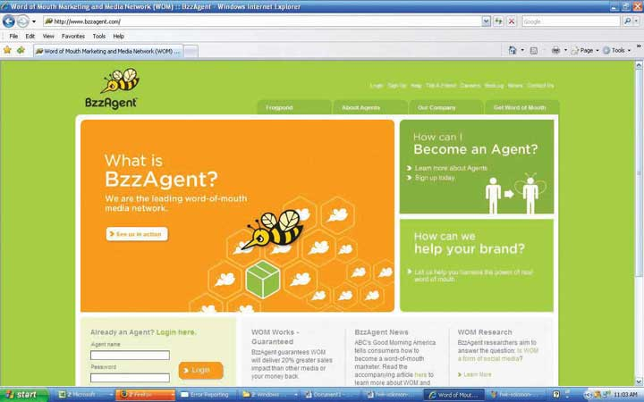
In addition, opinion leaders also are likely to be opinion seekers. They are generally more involved in a product category and actively search for information. As a result, they are more likely to talk about products with others and to solicit others’ opinions as well. ^{[3]} Contrary to an outmoded, static view of opinion leadership, most product-related conversation does not take place in a “lecture” format in which one person does all of the talking. A lot of product-related conversation occurs in the context of a casual interaction rather than as formal instruction. ^{[4]}

The Market Maven
Opinion leaders tend to “specialize” in a category (e.g., fashion or electronics), while a market maven likes to transmit marketplace information of all types. These shopaholics simply like to stay on top of what’s happening in the marketplace. ^{[5]} They are likely to strongly agree with statements like “I like helping people by providing them with information about many kinds of products” and “My friends think of me as a good source of information when it comes to new products or sales.” Anyone you know?

The Surrogate Consumer
Unlike an informal opinion leader, a surrogate consumer is a person whom we hire to provide input into our purchase decisions. These include interior decorators, stockbrokers, professional shoppers, and even college consultants who help prospective students identify schools that will be the best match for them. Surrogates can exert a huge influence on consumers’ decisions. Advertisers tend to overlook surrogates when they try to convince consumers to buy their goods or services. This can be a big mistake: they may mistarget their communications to end consumers instead of to the surrogates who actually sift through product information and decide among product alternatives. For example, in many cases (particularly for more affluent people) it’s an interior designer who makes a lot of decisions about the furnishings a client will put into a room; the client just writes the check. ^{[6]}

Group Identification

Reference Groups
A reference group is “an actual or imaginary individual or group conceived of as having significant relevance upon an individual’s evaluations, aspirations or behavior.” ^{[7]} Reference groups are important because they determine to whom we’ll listen (for example, we’re more likely to heed the advice of friends than strangers). Advertising messages that come from members of our reference group will have more influence over us, because we want to fit in and conform to that group.
Why are reference groups so persuasive? The answer lies in the potential power they wield over us. Social power is “the capacity to alter the actions of others.” ^{[8]} To the degree to which you are able to make someone else do something, regardless of whether they do it willingly, you have power over that person. The experts and beautiful people we discussed earlier tend to possess social power over the rest of us, but for different reasons.

Subcultures
A subculture is a group of people whose members share common beliefs and common experiences. A subculture may be based on religion, age, ethnic background, race, and even on the place where we live. Silicon Valley subculture contrasts with that of the Deep South or Boston’s Back Bay, for example. We’ll get into some of these groups in more detail when we discuss market segmentation.

Taste Cultures
In contrast to larger, demographically based subcultures (which nature usually determines), people who are part of a taste culture freely choose to identify with a lifestyle or aesthetic preference. For example, vegans avoid using or consuming animal products; they choose to avoid eating meat or eggs; wearing fur, leather, wool, or down; and using cosmetics or chemical products tested on animals. These are overt expressions of a lifestyle philosophy (cruelty-free), but adherents also respond to messages that are consistent with their needs. For example, at http://www.mooshoes.com, you can buy vegan shoes that feature faux leather lining and a faux suede exterior.

Brand Communities
A brand community is a group of consumers who share a set of social relationships based upon usage or interest in a product. At the Web sitehttp://www.jonessoda.com, community members submit their own label photos, and they view and rate the forty-three thousand photos other members have submitted. ^{[9]} Unlike other kinds of communities, these members typically don’t live near each other—except when they may meet for brief periods at organized events or brandfests that community-oriented companies such as Jeep, Saturn, or Harley-Davidson sponsor. These events help owners to “bond” with fellow enthusiasts and strengthen their identification with the product as well as with others they meet who share their passion.
A consumer tribe is a similar concept; this term refers to a group of people who identify with one another because of a shared allegiance to an activity or a product. Although these tribes are often unstable and short-lived, at least for a time members identify with others through shared emotions, moral beliefs, styles of life, and of course the products they jointly consume as part of their tribal affiliation. Pontiac opened a community hub on Yahoo! it calls Pontiac Underground (http://pontiacunderground.com, “Where Passion for Pontiac Is Driven by You”). The carmaker does no overt marketing on the site; the idea is to let drivers find it and spread the word themselves. Users share photos and videos of cars using Flickr and Yahoo! Video. A Yahoo! Answers Zone enables knowledge sharing. Meanwhile, a list of Pontiac clubs in the physical world and on Yahoo! Groups allows users to connect offline and online. ^{[10]}

Dig Deeper
For many years BMW’s advertising has emphasized its sophisticated engineering as it appealed to affluent car enthusiasts. Lately, however, the company is broadening its message to be one of innovation and independence, as it hopes to entice drivers who are more captivated by the style of a car’s interior than the engine that sits under the hood. In one ad, the company highlights the design for a glass-walled new factory in Leipzig rather than a car model. Its strategy is to appeal to what it calls “the idea class”: self-motivated architects, professionals, and entrepreneurs who value authenticity and independent thinking. They buy luxury cars, but they’re not car nuts.
Why the change? An internal study found that of the 1.9 million consumers who bought luxury cars in a recent year, 1.4 million didn’t even consider BMW. About six hundred thousand of those non–BMW purchasers said they were looking for a car that’s fun to drive. A BMW marketing executive noted that for the company, “that is low-hanging fruit.” Still, many of those buyers instead drove home a Saab, Infiniti, Acura, or Lexus. The new ads were created by GSD&M/Idea City, BMW’s ad agency, to convince these people that the values of innovation and independent thinking run deep in the company’s corporate culture (presumably in contrast to larger automakers that aren’t as free to innovate). As this executive observed, “It should appeal to the idea class that we are independent, that we are free to do something.” ^{[11]}

KEY TAKEAWAY
Each of us belongs to many groups—some by birth and some by choice. To a greater or lesser extent these group memberships influence our consumption choices and the types of advertising messages that appeal to us. A product’s (perceived) connection to a group we find desirable often is a key theme in advertising.

EXERCISES
- Explain the role opinion leaders and market mavens play in shaping communications about new products.
- List and describe each of the various group identification forms discussed in this section of the chapter. Provide a brief example of each of the forms you have listed.

[1] Everett M. Rogers, Diffusion of Innovations, 3rd ed. (New York: Free Press, 1983).
[2] http://www.bzzagent.com/signup/NewAgentSignup.do (accessed July 8, 2008).
[3] Laura J. Yale and Mary C. Gilly, “Dyadic Perceptions in Personal Source Information Search,” Journal of Business Research 32 (1995): 225–37.
[4] Russell W. Belk, “Occurrence of Word-of-Mouth Buyer Behavior as a Function of Situation and Advertising Stimuli,” in Combined Proceedings of the American Marketing Association, series no. 33, ed. Fred C. Allvine (Chicago: American Marketing Association, 1971): 419–22.
[5] For discussion of the market maven construct, see Lawrence F. Feick and Linda L. Price, “The Market Maven,” Managing (July 1985): 10; scale items adapted from Lawrence F. Feick and Linda L. Price, “The Market Maven: A Diffuser of Marketplace Information,”Journal of Marketing 51 (January 1987): 83–87.
[7] C. Whan Park and V. Parker Lessig, “Students and Housewives: Differences in Susceptibility to Reference Group Influence,” Journal of Consumer Research 4 (September 1977): 102–10.
[8] Kenneth J. Gergen and Mary Gergen, Social Psychology (New York: Harcourt Brace Jovanovich, 1981), 312.
[9] http://smackinc.com/media/pdf/brand_communities_jones_soda.pdf (accessed July 8, 2008).
[10] Laurie Petersen, “Pontiac Goes Underground to Tap Fans,” Marketing Daily, February 8, 2007, http://www.mediapost.com/publications/?fa=Articles.show Article&art_aid=55227 (accessed February 8, 2007);http://pontiacunderground.autos.yahoo.com (accessed July 8, 2008).
[11] Quoted in Neal E. Boudette and Gina Chon, “Brawny BMW Seeks ‘The Idea Class,’”Wall Street Journal, August 2, 2006, B1.

4.7 Culture, Globalization, and Advertising

LEARNING OBJECTIVES
After studying this section, students should be able to do the following:
- Describe the advantages and disadvantages associated with standardization versus localization in global markets.
- Explain the concept of semiotics and its impact on communication and marketing.
Culture is the accumulation of shared meanings, rituals, norms, and traditions among the members of an organization or society. We can’t understand advertising unless we consider its cultural context: culture is the lens through which consumers make sense of marketing communications.

Myths and Rituals
In China eight is the luckiest number. The Chinese word for eight is ba, which rhymes with fa, the Chinese character for wealth. It was no coincidence that the Summer Olympics in Beijing opened on 8/8/08 at 8 p.m. ^{[1]} Virtually every culture believes in “lucky” or “unlucky” numbers (just try to find a thirteenth floor in an American hotel).
Myths and rituals are the stories and practices that define a culture. A myth is a story with symbolic elements that represents a culture’s ideals. Each culture creates its own stories to help its members understand the world. Many companies (and perhaps most advertising agencies) are in a sense in the myth business; they tell us stories that we collectively absorb. Some marketers tell these stories more overtly than others: Disney stages about two thousand Cinderella weddings every year; the princess bride wears a tiara and rides to the park’s lakeside wedding pavilion in a horse-drawn coach, complete with two footmen in gray wigs and gold lamé pants. ^{[2]} And the Shrek movies remind us that even the ugliest suitor can land the princess if his heart is in the right place. To appreciate some more of the “popular culture gods” we worship, just tune in to next year’s Macy’s Thanksgiving Day Parade and observe the huge balloon figures floating by.
A ritual is a set of multiple symbolic behaviors that occurs in a fixed sequence and is repeated periodically. ^{[3]} We all engage in private consumer rituals, whether this involves grooming activities that we perform the same way every morning or that obligatory trip to Starbucks on the way to school. And as members of a culture we share public rituals such as Thanksgiving, the Super Bowl, or even tuning in each week to vote on American Idol. Advertisers often create messages that tie in to these myths and rituals, such as selling HDTVs for the Super Bowl and Doritos to share with your friends as you watch the game. Sometimes they deliberately create rituals among their customers, be it an evening cleansing ritual for a beauty product or a nine-step pouring ritual to pour a perfect beer, as Stella Artois showcases on its Web site,http://www.stellaartois.com. ^{[4]}

Is the World Flat?
Since a country’s culture is so complex and integral to how we make sense of the world, advertisers constantly grapple with a Big Question: does advertising “travel” from country to country? There are two viewpoints on this important issue.

Yes: Standardize for Greater Efficiency
Some advertisers say that advertising does travel from country to country. Proponents of this viewpoint argue that many cultures, especially those of industrialized countries, have become so homogenized that the same advertising will work throughout the world. By developing one approach for multiple markets, an advertiser benefits from economies of scale because it does not have to incur the substantial time and expense to develop a separate campaign for each culture. ^{[5]} The 2006 World Cup, which was broadcast in 189 countries to one of the biggest global television audiences ever, illustrates how a standardized approach looks. MasterCard ran ads that appeared in thirty-nine countries, so its ad agency came up with a spot called “Fever,” in which a hundred-odd cheering fans from thirty countries appear. There’s no dialogue, so it works in any language. At the end, the words, “Football fever. Priceless” appeared under the MasterCard logo. ^{[6]}

No: Customize to Appeal to Local Tastes
Other advertisers point to huge variations across cultures. They feel that each culture is unique, with its own value system, conventions, and regulations. This perspective argues that each country has a national character, a distinctive set of behavior and personality characteristics. ^{[7]} An advertiser must therefore tailor its strategy to the sensibilities of each specific culture.
At a basic level, the need to customize is a no-brainer: Consumers speak many different languages, and intended meanings in one tongue don’t always translate seamlessly to another. It’s unlikely that Bimbo, a popular Mexican bread brand, or Super Piss, a Scandinavian product to unfreeze car locks, would go over well in the United States.
Advertisers have (for the most part) learned the hard way over the years to avoid obvious language gaffes. They often conduct back-translation, where a different interpreter retranslates a translated ad back into its original language to catch errors. ^{[8]} Still, mistakes do creep in:
- The Scandinavian company that makes Electrolux vacuum cleaners introduced the products in United States with this slogan: “Nothing sucks like an Electrolux.”
- When Parker marketed a ballpoint pen in Mexico, its claim “It won’t leak in your pocket and embarrass you” came out as “It won’t leak in your pocket and make you pregnant.”
- Fresca (a soft drink) is Mexican slang for “lesbian.”
- Ford also ran into problems in Latin markets. The company had to change the names for its Fiera truck and its Caliente and Pinto cars. In Spanish, afiera is an ugly old woman and a caliente is slang for a streetwalker; pinto is Brazilian slang for “small male appendage.”
- Buick had to rename its LaCrosse sedan the Allure in Canada after the company discovered that the name comes awfully close to a Québécois word for masturbation.
- IKEA had to explain that the Gutvik children’s bunk bed is named “for a tiny town in Sweden” after German shoppers noted that the name sounded a lot like a phrase that means “good f**.” IKEA has yet to issue an explanation for a workbench it calls the Fartfull. ^{[9]}
Language aside, there are many instances where cultural sensitivities vary widely, and advertisers that try to export their own symbolism to another country do so at their own peril. In China, an ad for Nippon Paint (a Japanese brand) caused an uproar; it showed a sculptured dragon unable to keep its grip on a pillar coated in smooth wood-coating paint. Dragons are potent symbols in China, and seeing one easily defeated by a Japanese product proved too much.^{[10]}

How Local Do Ads Need to Be?
So what’s the correct answer? Although it feels warm and fuzzy to state that people are people wherever you go, in practice the standardization perspective hasn’t worked out too well. One reason for the failure of global marketing is that consumers in different countries have varying conventions and customs, so they simply do not use products the same way. Kellogg’s, for example, discovered that in Brazil people don’t typically eat a big breakfast—they’re more likely to eat cereal as a dry snack.
True, some large corporations such as Coca-Cola have been pretty successful at crafting a single, international image. Still, even the soft drink giant must make minor modifications to the way it presents itself in each culture. Although Coke commercials are largely standardized, the company permits local agencies to edit them so they highlight close-ups of local faces. ^{[11]} In their product as well as their advertising, Coke modifies the flavors of its product based on the tastes of the locals. These flavors can be taste-tested at Coke Headquarters in Atlanta or World of Coke at Disney’s Epcot Center in Orlando.
For a standardized approach to work, it needs to appeal to consumers in each market that share a lot in common (other than perhaps language and allegiance to one soccer team or another). Two types of consumers are good candidates: (1) affluent people who are “global citizens” and who come into contact with ideas from around the world through their travels, business contacts, and media experiences; and (2) young people whose tastes in music and fashion are strongly influenced by MTV and other media that broadcast many of the same images to multiple countries.

Semiotics: What Does It All Mean?
Advertising is about communicating meaning—but how do we know what something means? This question is not as obvious (or perhaps as crazy) as it seems. Very often we make sense of a word, phrase, or image because we’ve learned to associate extremely subtle cultural distinctions with it. For example (speaking of standardizing advertising across cultures), some Chinese companies use ancient pictograms to create new corporate logos that make sense both to native consumers and to potential customers elsewhere. The Chinese alphabet uses symbols that stand for the words they signify. For example, China Telecom’s logo features two interlocking letter Cs that together form the Chinese character for China but also represent the concept of “customer” and “competition,” the firm’s new focus. In addition, though, the symbol also resembles the horns of an ox, a hard-working animal. The software company Oracle redesigned its logo for the Chinese market by adding three Chinese characters that signify the literal translation of the word oracle, “writing on a tortoise shell.” The expression dates back to ancient China when prophecies were scrawled on bones. The California firm was enthusiastic about the translation because it conveyed Oracle’s core competency—data storage.^{[12]}
Semiotics is the field of study that looks at the relationship between signs and symbols and their role in assignment of meaning. Advertisers turn to semiotics to help understand what meanings people assign to specific symbols. These may vary across taste cultures and geographies—a spokesperson in a dark business suit signifies one thing in New York City and another in Silicon Valley.
Why do they bother? Their goal is to create product names, brand names, logos, and visual images that people will naturally interpret as meaning something they hope to convey. For example, advertisers might use the image of a cowboy to signify rugged individualism. The challenge is to come up with continually fresh, new, distinctive images that still both carry the intended meaning and stand out in the clutter of ad images.
This task gets interesting because on the surface many marketing images have virtually no literal connection to actual products. What does a green lizard have to do with an insurance company (GEICO)? How can a celebrity like Morgan Fairchild enhance the meaning of a store like Old Navy? Does supermodel Heidi Klum really eat at McDonald’s? A computer created the name Exxon—just what does that mean anyway?

Components of Meaning
From a semiotic perspective, every marketing message has three basic components: an object, a sign (or symbol), and an interpretant. The object is the product that is the focus of the message (e.g., Burger King’s menu items). The sign is the sensory image that represents the intended meanings of the object (e.g., a funky “King”). The interpretant is the meaning derived (e.g., quirky, cool).
Signs relate to objects in one of three ways: They can resemble objects, be connected to them, or be conventionally tied to them. ^{[13]} An icon is a sign that resembles the product in some way (e.g., the Apple logo is literally an apple). An index is a sign that is connected to a product because they share some property (e.g., the Rock of Gibraltar that stands for Prudential Insurance conveys the property of endurable dependability, which is what the company hopes clients will associate with its policies). A symbol is a sign that relates to a product by either conventional or agreed-on associations (e.g., the green Starbucks logo depicting an “earth mother” with long hair conveys environmental responsibility and alignment with nature). A lot of time, thought, and money go into creating brand names and logos that will clearly communicate a product’s image. The Nissan Xterra combines the word terrain with the letter X, which many young people associate with extreme sports, to give the brand name a cutting-edge, off-road feel.

Hyperreality
One of the hallmarks of modern advertising is that it creates a condition of hyperreality. This refers to the process of making real what is initially simulation or “hype.” In other words, advertisers create new relationships between objects and interpretants as they invent new connections between products and benefits, such as when they equate Marlboro cigarettes with the American frontier spirit.
Over time, the true relationship between the symbol and reality is no longer possible to discern in a hyperreal environment. The “artificial” associations between product symbols and the real world may take on lives of their own. Fictional characters routinely cross over from make-believe to the real world—sometimes they even “endorse” other products, as when a talking Mrs. Butterworth’s syrup bottle shows up in a TV commercial for GEICO insurance.

KEY TAKEAWAY
Advertising is an integral part of culture, and culture is an integral part of advertising. We need to understand the norms, beliefs, and practices of a culture in order to communicate with people who inhabit it. Many advertising messages relate to a culture’s myths and rituals; in some cases they create new ones. Because a culture is so complex, a major strategic question is how much a campaign needs to be customized to each individual country if it is involved in several markets. While some standardized approaches can be effective, overall it is best to take into account local differences to ensure that the meanings the campaign intends to communicate are what the audience receives. Successful execution in these situations requires attention to the semiotics, or meanings, of images and words that represent underlying values and properties.

EXERCISES
- Identify the arguments for and against standardization versus localization of global products and communications.
- Define semiotics. Describe how advertisers can use the principles of semiotics to enhance their communications.

[1] Jim Yardley, “First Comes the Car, Then the $10,000 License Plate,” New York TimesOnline, April 16, 2006, http://www.nytimes.com/2006/07/05/world/asia/05china.html(accessed April 16, 2006).
[2] Merissa Marr, “Fairy-Tale Wedding? Disney Can Supply the Gown,” Wall Street Journal, February 22, 2007, B1; Lauram M. Holson, “For $38,000, Get the Cake, and Mickey, Too,” New York Times on the Web, May 24, 2003,http://www.nytimes.com/2003/05/24/business/24WEDD.html?pagewanted=2&ei=5007&en=8bd92e1431ff9b1a &ex=1369108800&partner=USERLAND&adxnnlx=1207627760- 9tjoRyeGvDg0tX6caBRguA(accessed February 1, 2009).
[3] See Dennis W. Rook, “The Ritual Dimension of Consumer Behavior,” Journal of Consumer Research 12 (December 1985): 251–64; Mary A. Stansfield Tetreault and Robert E. Kleine, III, “Ritual, Ritualized Behavior, and Habit: Refinements and Extensions of the Consumption Ritual Construct,” in Advances in Consumer Research 17, ed. Marvin Goldberg, Gerald Gorn, and Richard W. Pollay (Provo, UT: Association for Consumer Research, 1990): 31–38.
[4] “Stella Artois Launches New, Film-Inspired, Global Brand Website,” Telecomworldwire, September 19, 2007,http://findarticles.com/p/articles/mi_m0ECZ/is_2007_Sept_19/ai_n20513193 (accessed February 1, 2009).
[5] Theodore Levitt, The Marketing Imagination (New York: The Free Press, 1983).
[6] Aaron O. Patrick, “World Cup’s Advertisers Hope One Size Fits All: Month-Long Tournament Sets Off Scramble to Reach Huge Global TV Audience,” Wall Street Journal, March 28, 2006, B7.
[7] Terry Clark, “International Marketing and National Character: A Review and Proposal for an Integrative Theory,” Journal of Marketing 54 (October 1990): 66–79.
[8] Shelly Reese, “Culture Shock,” Marketing Tools (May 1998): 44–49; Steve Rivkin, “The Name Game Heats Up,” Marketing News, April 22, 1996, 8; David A. Ricks, “Products That Crashed into the Language Barrier,” Business and Society Review (Spring 1983): 46–50.
[9] Mark Lasswell, “Lost in Translation,” Business (August 2004): 68–70.
[10] “China Bans Offending Nike Advert,” BBC News, December 6, 2004,http://news.bbc.co.uk/2/hi/asia-pacific/4072203.stm (accessed February 13, 2009).
[11] J. S. Hill and J. M. Winski, “Goodbye Global Ads: Global Village Is Fantasy Land for Big Marketers,” Advertising Age 58, no. 49 (1987): 22, 36.
[12] Gabriel Kahn, “Chinese Characters Are Gaining New Meaning as Corporate Logos,”Wall Street Journal Interactive Edition, July 18, 2002, n.a.
[13] Arthur Asa Berger, Signs in Contemporary Culture: An Introduction to Semiotics (New York: Longman, 1984); Charles Sanders Peirce, in Collected Papers, ed. Charles Hartshorne, Paul Weiss, and Arthur W. Burks (Cambridge, MA: Harvard University Press, 1931–1958).

4.8 Exercises

TIE IT ALL TOGETHER
Now that you have read this chapter, you should be able to understand how advertisers study and analyze consumers and construct communication processes to reach them:
- You can compare and contrast the traditional linear communications model with the new interactive, nonlinear, multivocal communications model.
- You can identify the various components of communications that are necessary to establish effective communications.
- You can describe the diffusion of innovations process.
- You can list and explain five stages of the consumer decision-making process.
- You can recognize and recall several models for studying attitudes and information processing.
- You can characterize the external influences on consumers.
- You can explain culture’s role in globalization and advertising.

USE WHAT YOU’VE LEARNED
- Do you ever get much sleep when you’re on an airplane? Most people don’t, and that’s a problem for airline commuters who travel the globe. With an eye toward serving the public better, Continental Airlines has decided to retrofit many of its planes with new lie-flat seats. The new seats will be in premium sections of aircraft and will allow passengers to lie completely flat. Another feature of the new seats is their size—they will give customers six and a half feet of sleeping space without appreciably impacting cabin space. Continental hasn’t forgotten gadgetry for the new seats and their occupants. Each seat will be equipped with laptop power, headsets, and USB ports.
Considering that Continental wants to introduce its new seats this year, what message format would you suggest? What target customer is likely to receive the first messages about the new seat? Explain how your chosen message format will effectively reach the designated target customer.
- “Fashions come and go,” as they say; however, with Baby Boomers approaching their sixties, the 1960s seem to be coming back in fashion. AMC’s Mad Men, a stylized adult drama about advertising and ad men (and women) from the 1960s, has grown rapidly in popularity with U.S. television audiences. Period costuming and retro taste cultures have brought back memories and stories to those who grew up in the time period. Smoking, heavy drinking, no seat belts in cars, fascination with early TV, sexism, racism, and sexual harassment in the office are themes that are as common in the program as the ad campaigns that are masterminded by the Mad Men. The uncanny attention to detail in this “period drama” has won the creators critical acclaim.
The viewer of Mad Men will notice rather quickly that 1960s-eraMad Men smoked and encouraged America to smoke. Review information about Mad Men and the 1960s approach to smoking. Review the chapter section on motivation. Assuming the role of a social critic, describe how 1960s-era ad campaigns encouraged smoking. Focus on motivations, involvement, and perceived risk used in these campaigns. Provide illustrations of the motivations if possible.

DIGITAL NATIVES
One of the keys to understanding a consumer’s behavior is to understand how consumers perceive advertising messages. Advertisers often use size, color, position, and novelty to impact consumers’ perception. Inverted Advertising, a Houston-based advertising company, has come up with a new twist on how to reach a mobile population. Consumers often walk, skate, or ride through the organization’s advertising messages. The company uses projected 3-D holograms on sidewalks, ice sheets, walls, ceilings, kiosks, and other smooth surfaces to stimulate consumer perception and gain attention.
Go to the Inverted Advertising Web site at http://www.invertedadvertising.com and review the features and the ad gallery provided. Your assignment is to construct a brief plan for introducing “Inverted Advertising” to a client of your own choosing. Comment on how you might be able to use inverted advertising to reach a designated target audience. Discuss your concept and plan with peers.

AD-VICE
- Source credibility and source attractiveness are both extremely important in advertising and communication. Using advertisements as your focal point, list what you perceive to be five credible sources for purchasing products. Comment on the degree of source attractiveness among those sources. Provide examples if possible.
- Marketers believe that early adopters can make or break a new product launch. Describe the early adopter and his or her function. Pick a new product that has recently been introduced and demonstrate how early adopters could have created, or did create, a “buzz” for the product. How should advertisers reach early adopters with messages? Explain your rationale.
- How do you learn about brands? The question is not easy to answer. Think for a few minutes about all the information you process about brands during a single day; create a diary that lists that information as you receive it. Keep the diary for a few days. Compare your results with others. What common threads with your peers do you find? What unique ways did brands attempt to communicate with you? Comment on what you observed and your conclusions about your diary.
- Describe a brand community and a consumer tribe. Discuss similarities and differences. Are you in one of these groups? Describe and comment. How could marketers and advertisers use brand communities and consumer tribes to stimulate acceptance and purchase of their products?

ETHICAL DILEMMA
As the chapter indicates, subliminal persuasion is “a topic that has captivated the public for more than fifty years.” Basically, subliminal persuasion attempts to reach consumers below the conscious thought or awareness threshold. Validity of the technique is, however, open to serious question by scholars and critics. Review material on subliminal persuasion in the chapter section and use a search engine of your own choosing to find additional information. Be sure to review historical work by Wilson Brian Key during your investigation. Once you understand the concept of subliminal persuasion and its colorful history, take an ethical stance either for or against the technique. Support your position. Describe any examples that would help you defend your position. Participate in a class discussion and present your position and findings.

Chapter 5

Know Your Audience: SS+K Learns All About msnbc.com, Inside and Out
Figure 5.1 Ten Months to Launch!
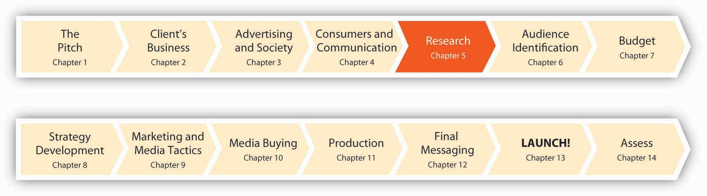
The more information you have the more effective you can be.
Joe Kessler, partner, SS+K/LA
Joe Kessler understands that knowledge is power. In the ad biz, that power comes from knowing as much as you can about your audience. Who is buying what you’re selling? What are their hot buttons? What are their needs, and which of those needs is your client’s product or service equipped to satisfy? For msnbc.com, SS+K needs to figure out what makes consumers of online news tick. After all, you can create the prettiest ad in the world, but if it doesn’t address the right customer you might as well throw your money out the window (or perhaps buy a lottery ticket). Now that we’ve covered a lot of the fundamentals, it’s time to jump in and get our hands dirty as we learn about msnbc.com and who its customers are.
Enter the research department, or as they are called at SS+K, the Asymmetric Intelligence Unit (AIU). It’s their job to gather consumer intelligence that enables everyone else to make intelligent decisions. So, what’s the best way to do that? “Simple,” you might say. “If you want to know something about somebody, just ask them.” If only the world were that simple! Sometimes we can just ask—but we’re never sure we’re getting the correct answer. Imagine being asked to explain your own habits and preferences: Why do you drink what you do? What makes you splash on a certain fragrance? Tune in a certain TV show? Hang out in MySpace versus Facebook? Your answers might or might not be helpful to a prospective advertiser.
To go beyond simple questions, researchers have many tools in their arsenal. In the 1950s a psychoanalyst interviewed a few men, each for several hours at a time, to find out why they “really” liked to drive cars. He concluded that to a man driving is all about sexual conquest—and Esso’s tagline “Put a tiger in your tank” was born.
Today, we find both extremes in consumer research—from “up close and personal” encounters with consumers in their own homes to massive surveys that yield gigabytes of data. SS+K, as we’ll see, relies on both extremes. For example, The Creative Artists Agency is a part owner of SS+K. CAA’s research division, the Intelligence Group, sponsors a one-day event each month it calls Trend School in both New York and Los Angeles. Each session features presentations either by in-house execs or by outsiders who are into cutting-edge popular culture. At one recent seminar, a panel of über-cool sixteen- to twenty-five-year-olds talked to attendees about how they spend their leisure time (including giving them some quick Nintendo Wii lessons), viral-marketing hits, and the best emerging bands and music trends. ^{[1]}
Which technique is the one to use? Here’s a clue: don’t be a hammer in search of a nail, where you doggedly choose one favorite research method no matter what the situation. Let’s see what our options are, and how SS+K made use of them for its client.

[1] Beth Snyder Bulik, “Want to Build a Hipper Brand? Take a Trip to Trend School,”Advertising Age, February 19, 2007, http://www.adage.com (accessed February 19, 2007).

5.1 Types of Data

LEARNING OBJECTIVES
After studying this section, students should be able to do the following:
- Recognize that data is the key to understanding the consumer.
- Describe the various types of data.

Source of the Data: Primary versus Secondary
Data is the key to knowing the customer. An advertiser and its agency can obtain this knowledge from two basic kinds of sources, each with respective advantages and disadvantages. Primary data is new information the company gathers directly from respondents the company talks to, surveys, or researches. Primary research focuses specifically upon the issues that need to be answered to develop the campaign. For example, if a company does a telephone survey of consumers’ opinions of the latest ad campaign, that’s primary research. Although primary data can be expensive to collect, it’s often extremely useful because it’s “just what the doctor ordered” to guide the organization’s thinking.
Figure 5.2 Primary versus Secondary Data
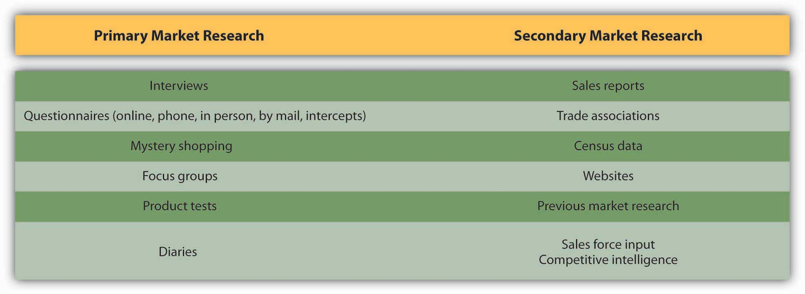
In contrast, secondary data refers to information that has already been collected for a previous purpose, often by a third party that routinely performs such research. For example, government census data is secondary data—the government collects information about citizens’ household size, ages, and incomes for its own purposes. This information is available free in its raw form, and in addition numerous companies “package” it and sell it in various ways to third parties.

Type of Data: Quantitative versus Qualitative
Primary data and secondary data can be either quantitative (numerical) orqualitative (verbal). Quantitative research is usually based on a large-scale sample of respondents and is typically expressed in numeric terms such as averages, percentages, or statistics. The advantage of quantitative research is its precision in providing a specific answer, such as the number of pizzas sold in March or the percentage of people who say they plan to buy a product in the next three months.
Figure 5.3 Qualitative versus quantitative data
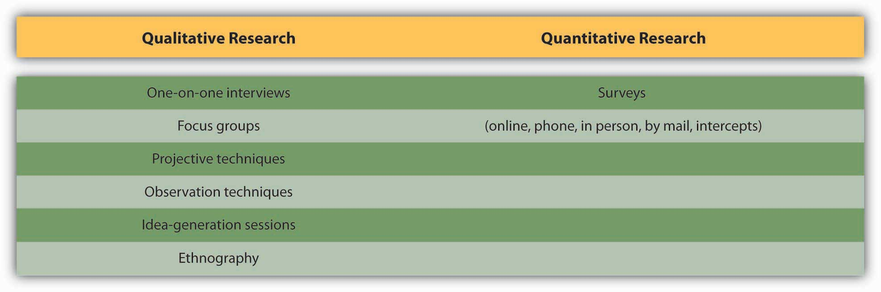
Qualitative research is more open ended in eliciting the stories, anecdotes, and descriptive words people have for products or lifestyle attributes. For example, a survey might ask people to describe a product they see in an ad; the advertiser can then analyze the words and emotions those responses contain. Qualitative data tend to be useful for exploratory work and to help “flesh out” the emotions, attitudes, and values behind the numbers.

SS+K Spotlight
SS+K’s first step in getting to know msnbc.com was to review the existing research the client had already done around their branding, audience, and features. John Richardson and Michelle Rowley immersed themselves in the data provided in order to understand what msnbc.com’s current research was telling them. By reviewing this research first, they were able to identify what information they still needed so they could gain a better understanding of the brand and the audience.

KEY TAKEAWAY
We broadly describe data along two dimensions: source and type. Source refers to where we obtain the information. Here the important distinction is between primary data that we collect specifically to guide the current campaign and secondary data that already exists in some form. Primary data is often preferable but harder and more expensive to collect; in some cases the information we need is out there if we know where to look. Type refers to the form of the data; is it numerical or verbal or observational? Numerical (quantitative) data can be generalized; we can combine one respondent’s scores with those of many others to obtain a broad (but often shallow) picture. In contrast, verbal or observation (qualitative) data is difficult to generalize because it’s coded in words or based upon a researcher’s subjective impressions. This type of data is useful for generating ideas and drilling down into the underlying reasons for consumers’ reactions to ads or products; it gives us a narrow but deep picture. The ideal is to combine both types of data to yield a broad and deep snapshot of our customers.

EXERCISE
Compare primary data to secondary data. Compare quantitative data to qualitative data.

5.2 Primary Data

LEARNING OBJECTIVES
After studying this section, students should be able to do the following:
- Explain why surveys are the most common form of quantitative research.
- Discuss how focus groups are used to collect data.
- Explain the value of conducting ethnographic study in advertising.
- List and discuss the advantages and disadvantages of primary data.
Sources of primary data include focus groups, customer interviews, and surveys the company conducts to understand the needs, behaviors, and reactions of consumers or other stakeholders such as business customers, vendors, or policymakers. Regardless of the data collection method, researchers conducting primary research need to decide whether to target a random sample of the entire population or to screen their participants according to a demographic, psychographic, or behavioral profile.

SS+K Spotlight
After John and Michelle reviewed the existing data, the next step was to speak to the people who know msnbc.com best—their employees. SS+K interviewed the key stakeholders within the organization including the president and representatives from editorial, design, ad sales, and technology. It was important for SS+K to understand how each of them perceived the brand, its challenges, and its opportunities.
After the interviews were conducted, in person by Joe Kessler or Melinda Moore, with Michelle, John, and Amit on the phone in New York taking notes, the AIU team (Michelle and John) started drawing some conclusions from those interviews.
They found that stakeholders agreed on interesting points and what they believed were the differentiators for msnbc.com versus their competitors. The research also showed that they each brought interesting and different ways to communicate this perceived difference. Some suggested approaching the communication through the technological advantages; others suggested touting original and high-quality journalism as the key message. Still other ideas involved better use of NBC personalities and the company’s multimedia experience.
One really encouraging finding from the interviews was the optimism that emerged about the future of the company and the future of the brand. The stakeholders noted that positive elements included the collaborative approaches within their vast organization, the increase in Web traffic, and the new online technologies that enable people to consume more and more information. Blogs, social networks, and other message-board technologies were going to continue to be important as the organization grew.

Surveys
Surveys are the most common form of quantitative research. They can be conducted by mail or telephone, online, or through “intercepts” such as when a market researcher stops shoppers in a shopping mall to answer a few survey questions. Surveys ask consumers about their activities, interests, and opinions. This often sheds light onto which publications or media the target audience reads or watches, which enables the advertising agency to fine-tune its message.
Mail surveys increasingly are giving way to online questionnaires, because this format allows for instantaneous data collection and analysis (rather than waiting for printed surveys to be mailed and returned). Online questionnaires are also more flexible and cost much less. In both cases, however, while respondents are likely to be more honest because they can participate anonymously, we can’t be 100 percent sure who actually responds to the survey or whether the same person is responding multiple times. To design and administer your own surveys (for free!), check outhttp://www.surveymonkey.com.

Dig Deeper
Many online surveys basically reproduce their boring offline counterparts—scroll down the screen and answer a long series of questions by clicking on a number from 1 to 7. But some researchers take advantage of the Web’s unique capabilities as they create research instruments that are more vibrant and engaging for respondents. For example, an online survey could ask you to watch streaming video of different versions of an advertising execution and then prompt you to select the one you like best. Another might show you color pictures of facial expressions, landscapes, or celebrities and ask you to match them up with different brands. In one creative application, an online research company posted a gift finder on its Web site (http://www.youniverse.com). To come up with gift ideas for a friend, the user chooses from sets of photos to answer questions about the person such as “Their favorite color is…” or “Their house looks like.…” The program then matches the answers with everything from gadgets to books. This kind of technology allows clients like MSN, Vodafone, and others to gauge consumers’ reaction to ad campaigns and identify clusters of consumers that respond most positively to different products. ^{[1]}
Brand Tags, another ingenious application of Web research, shows visitors the logos of big companies and asks them to type in the first word or phrase that pops into their head when they see the logo. Within a few days after it went live, the site attracted more than thirty thousand visitors. Results of these snap reactions are reported as a tag cloud—a format in which the size of the word corresponds to its frequency among responses. Frequently submitted words are shown in giant type, while rarely submitted ones look tiny on the screen. This type of data is merely suggestive because we can’t be sure who responds, but it can be an eye opener to advertisers. For example, two popular responses for Wal-Mart are cheap and evil, one of Burger King’s largest tags is fat, while people label Toyota with words like quality and reliable—but also boring. ^{[2]}
Telephone surveys offer even more flexibility in questioning, but they suffer from higher cost and often have lower participation because respondents screen calls or put themselves on do-not-call lists. Unfortunately, in recent years telemarketers who masquerade as survey-takers poisoned the well for legitimate research companies; in some cases when they call (usually during dinner!) they lure unsuspecting respondents into answering questions until they reveal toward the end that they’re actually selling something.
However, as mobile phones continue to evolve into the “third screen” for many of us (the first two are the TV and the computer monitor), it’s likely that enterprising researchers will discover new ways to collect people’s feedback via their phones. For example, the startup company Mimieo offers an application that enables a client to capture respondents’ emotional reactions to an ad or product on their iPhones. ^{[3]}
Face-to-face interviews provide the most flexibility in questioning—it’s clear to the researcher if the respondent is having difficulty understanding the question—but they are time consuming and expensive. They are also less likely to yield truthful results, for two reasons. First, being face to face with the interviewer, respondents may tend to give answers they think the interviewer wants to hear. Second, the interviewer’s biases (none of us is bias free, much as we may wish to think of ourselves that way) may skew the results.

Figure 5.4 Brand Tags
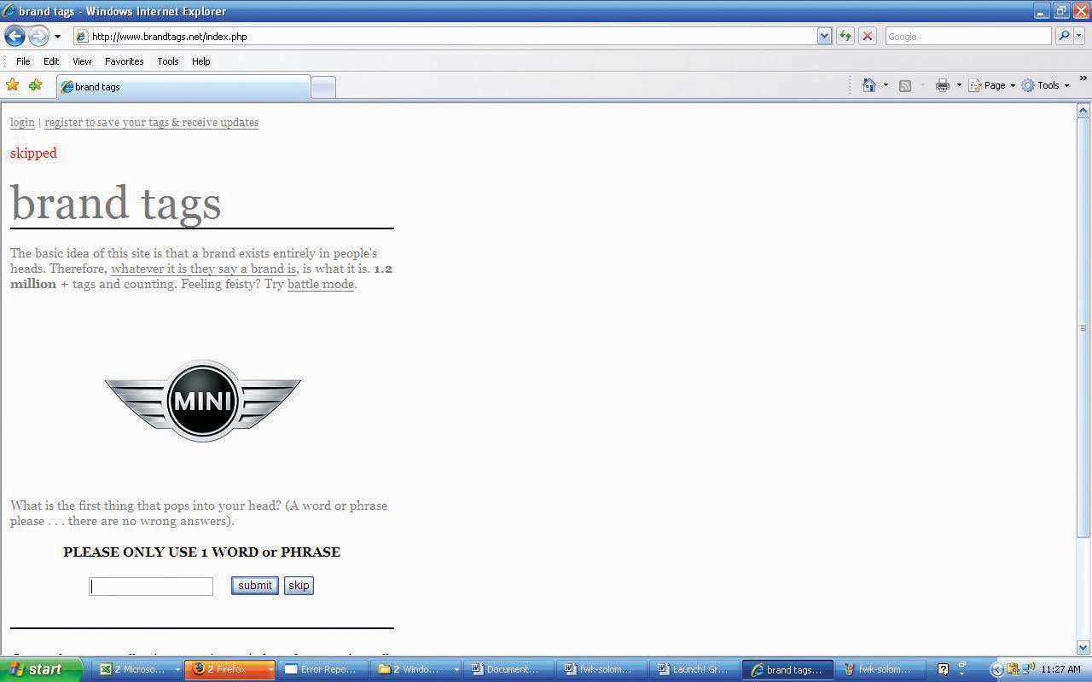

Dig Deeper
The logic behind deprivation research is to figure out how loyal consumers are to a brand by taking it away from them. Dunkin’ Donuts forced a group of its customers to drink Starbucks coffee for a week instead. Verizon Wireless did something even more impressive: the company got a group of teens to give up using cell phones for an entire weekend.
Burger King gets hard-core Whopper fans to go without their burger fixes and keep journals about how they deal with this indignity. This strategy evolved into a recent successful ad campaign the chain’s ad agency Crispin Porter + Bogusky called “Whopper Freakout.” The TV and online ads captured real customers at two Nevada outlets who were informed that the Whopper was no longer on the menu. These were not happy campers: one customer cried, “What are you going to put on the logo now—home of the ‘Whatever we got’?” ^{[4]} For a closer look at this campaign, check outhttp://www.whopperfreakout.com/embed.swf.

SS+K Spotlight
After conducting the internal stakeholder interviews and reviewing the existing data, msnbc.com and SS+K set out to understand the consumer’s point of view and also to test a few hypotheses they’d drawn based on what they currently knew.
These hypotheses revolved around three themes: (1) functional (What role does online news play in consumer’s lives?), (2) attitudinal (How do consumers feel about msnbc.com?), and (3) thematic (Are there certain categories of news to which consumers look?). It was important to understand what need they currently met in their consumers’ lives, and they designed their questions for the group to explore those areas.
They planned to explore these ideas and flesh them out in focus groups, which we’ll discuss next.

Focus Groups
Often, an advertising campaign seeks to understand more subtle (or deeply held) attitudes than a survey can capture. This requires a more exploratory, interactive approach, such as one-on-one interviews between a consumer and a researcher or through a focus group discussion (a discussion with a small group of consumers, led by a trained facilitator). The professional moderator is crucial to this process, preventing vocal members from overwhelming or dominating the group and effectively handling answers that don’t provide meaningful information or answers that a group member gives who is merely trying to impress other members (yes, this happens a lot!). Focus group discussions usually involve six to ten group members, and discussions are sometimes held in a room with a one-way mirror so that agency executives can watch or videotape the discussion—listening to real people talk about their product can be a real eye-opener for these folks!
For example, the city of Las Vegas decided to use focus groups to get a sense of how it should advertise itself in other countries as a tourist destination. The city worried that its “What happens in Vegas stays in Vegas” campaign in the United States might not play well in countries like Mexico, which has a more Catholic and conservative population. To find out, the city held focus groups with travelers. The results of the focus groups showed that Mexicans were comfortable when the Vegas story lines fit with family customs and did not allude to casual sex. In the United Kingdom, in contrast, focus groups showed that the ad campaign needed more sex, not less, to catch the attention of U.K. audiences (who tend to see more provocative and explicit advertising). About a dozen focus groups of middle- and upper-income British men and women under age fifty-five revealed that the American tagline wasn’t compelling enough for irreverent British tastes. “In the U.S. we think our slogan and ads push the envelope, [but in Britain] for our message to have the same impact we discovered that we need to make it edgier,” said Rob O’Keefe, account director at R&R Partners, the agency for the Las Vegas tourism group. “We need a bolder brand statement articulating that you can do things in Vegas you can’t do anywhere else.” ^{[5]}
Focus group disadvantages to watch out for are that people may be too tired to think after a hectic day, or that they may say what they think the researcher wants to hear, or that they may even feel pressured to make things up. Also, focus groups take people out of their normal lives and put them into a quiet room, which may lose the context of the real experience. For this reason, individual or group interviews in natural settings may be more desirable. Having a collaborative discussion with consumers in places where people actually use the products in question, such as a bar or laundromat rather than a research lab or an agency’s conference room, may provide more fruitful ideas. Some companies try to get consumers’ input across multiple stages, from focus groups to natural settings like supermarkets (if the product is a packaged food product) to journal entries that consumers record. This multifaceted approach imparts richness to the ideas, rather than just a slice that a phone interview or focus group can yield.

SS+K Spotlight
Johanna Steen, who works with Catherine Captain at msnbc.com, was the leader of the focus groups conducted in various locations around the country. Working with the team at SS+K led by Michelle and John, Johanna facilitated the discussion and outlined conclusions so the team could determine what more they knew about the msnbc.com consumers and if they needed anything more.

Ethnography
Finally, qualitative data can be gathered through an ethnographic study, in which a researcher visits a person’s home or business and directly observes how the customer uses a product. For example, when it designed its Quicken software, Intuit sent software engineers to consumers’ businesses to watch how they used accounting software. The program was called “follow me home,” and the reason for watching consumers in their homes was to seek a natural, unscripted setting. Intuit continues to listen to customers through all sorts of channels, including blog posts and feedback buttons on the software itself. The 2006 version of Quicken, for example, included more than 121 customer-recommended improvements. ^{[6]}
The ad agency Saatchi & Saatchi went even further: when it was working on a new campaign for its client JC Penney, the agency assigned staffers to hang out with more than fifty women for several days. They helped the women clean their houses, carpool, cook dinner, and shop as they observed the women’s behaviors and emotions. This may not be the most glamorous task for the researcher (do they do windows?), but as Saatchi’s global head of strategic planning observed, “If you want to understand how a lion hunts, you don’t go to the zoo—you go to the jungle.” ^{[7]}

SS+K Spotlight
After gaining some insights from the focus groups, Michelle Rowley and John Richardson considered doing ethnographies in order to further understand what really drives the news junkie, but they, along with Catherine Captain, decided to conduct triad interviews instead. Using this technique, a moderator interviews three people who have been screened to fit the desired demographic, psychographic, and behavioral profile. The interviewers gave these respondents a homework assignment before the interviews: they were asked to change their usual routine by trying different news resources before they returned to discuss their experiences together. The inclusion of three similar respondents makes it easier for the researchers to identify shared themes or feelings versus sentiments that one individual may express that are more idiosyncratic and perhaps not as useful. During the triad interviews, the moderator worked with a guide to help her probe for additional details. This guide was agreed upon by the research company, SS+K, and msnbc.com. The results of this final piece of research informed the next steps in the campaign development process, which is the communications brief.

Advantages and Disadvantages of Primary Data
Primary data often is richer and more directly useful, but it also has its downsides. The following are primary data’s advantages:
- Specific. The company gets to define the goals of the research and focus the research on their own particular product.
- Proprietary. The company can keep the results private.
- Controlled. The company has a say in which consumers it talks to, the methodology it uses, and the analytical tools it employs.
The following are primary data’s disadvantages:
- Costly. The company bears all the expenses itself.
- Time-consuming. The company must wait while its analysts design, execute, and analyze the research.

KEY TAKEAWAY
Primary data refers to information an agency or its client collects to specifically address the current campaign. There are several ways to collect primary data, ranging from one-on-one interviews to large-scale mail or online surveys.

EXERCISES
- Describe how surveys can be used to collect information.
- Discuss how Web research can be used by advertisers to target consumers.
- Explain how focus group research is conducted. Comment on the advantages and disadvantages of this form of research.
- List and discuss the advantages and disadvantages of primary data.

[1] Leila Abboud, “Picturing Web Shoppers: Start-Up Taps ‘Visual DNA’ to Gather Data,”Wall Street Journal, January 23, 2007, B9.
[2] Tom Weber, “What Do People Think About Your Brand? Here’s a New Way to Find Out,” Wall Street Journal Online, May 13, 2008,http://blogs.wsj.com/buzzwatch/2008/05/13/what-do-people-think-about-your-brand-here’s-a-new-way-to-find-out (accessed July 21, 2008).
[3] http://www.mimieo.com/corp/home.aspx (accessed July 21, 2008); Laurie Sullivan, “Marketing Feedback Cards Go Digital via Cell Phones,” Marketing Daily, February 27, 2008, http://www.mediapost.com (accessed February 27, 2008).
[4] Suzanne Vranica, “Hey, No Whopper on the Menu?! Hoax by Burger King Captures Outrage,” Wall Street Journal, February 8, 2008, B3.
[5] Quoted in Joan Voight, “How to Customize Your U.S. Branding Effort to Work around the World,” Adweek Online, September 3, 2007,http://www.nationaljewelernetwork.com/aw/esearch/article_display.jsp? vnu_content_id=1003634197 (accessed September 3, 2007).
[6] http://www.fastcompany.com/magazine/99/open_customer-intuit.html (accessed on September 9, 2007).
[7] Suzanne Vranica, “Ad Houses will Need to be More Nimble: Clients are Demanding More and Better Use of Consumer Data, Web,” Wall Street Journal, January 2, 2008, B3.

5.3 Secondary Data

LEARNING OBJECTIVES
After studying this section, students should be able to do the following:
- Identify several pertinent secondary data sources.
- List and discuss the advantages and disadvantages of secondary data.

Government Sources
A lot of secondary data is available from the government, often for free, because it has already been paid for by tax dollars. Government sources of data include the Census Bureau, the Bureau of Labor Statistics, and the National Center for Health Statistics.
For example, through the Census Bureau, the Bureau of Labor Statistics (http://www.bls.gov) regularly surveys consumers to get information on their buying habits. These surveys are conducted quarterly, through an interview survey and a diary survey, and they provide data on consumers’ expenditures, their income, and their consumer unit (families and single consumers) characteristics. For instance, of the total money spent on food per household in 2005 ($5,931), the average family spent $445 on cereals and bakery products that were eaten at home. Looking at the details of this expenditure by race, Whites spent $455 on at-home cereals and bakery products, while Asians spent $492 and African Americans spent $393. Detailed tables of the Consumer Expenditures Reports include the age of the reference person, how long they have lived in their place of residence, and which geographic region (see MSAs in Chapter 6 "Segment, Target, and Position Your Audience: SS+K Identifies the Most Valuable News Consumer") they live in. See http://www.bls.gov/cex for more information on the Consumer Expenditure Surveys.

Syndicated Sources
A syndicated survey is a large-scale instrument that collects information about a wide variety of consumers’ attitudes and actual purchases. Companies pay to access the parts of this large dataset they find relevant. For example, the Simmons Market Research Bureau conducts a National Consumer Survey by randomly selecting families throughout the country that agree to report in great detail what they eat, read, watch, drive, and so on. They also provide data about their media preferences. So, if a client that makes bowling balls, for example, wants to know more about what bowlers do and what TV shows and magazines they prefer, an agency could buy data relevant to this group rather than going out and polling bowlers on its own. ^{[1]}
Companies like Yankelovich Inc. (http://www.yankelovich.com) conduct regular large-scale surveys that track American attitudes and trends. Yankelovich goes deeper than the demographic data the government provides to enable clients to identify consumer beliefs and aspirations as well. For example, the Yankelovich Monitor, which is based on two-hour interviews with four hundred people, looks at changes in American values.
Recent Yankelovich Monitor insights include a multinational Preventative Health and Wellness Report that looks at consumer attitudes and behaviors related to physical, mental, emotional, and spiritual dimensions of health and wellness across seventeen countries. The survey was conducted via forty-minute online questionnaires and answered by twenty-two thousand adults over age eighteen. Another report, called Food for Life, followed up with five thousand consumers who had completed an earlier survey and interviewed them in depth to delve into their attitudes about food with respect to preventive healthcare. For example, most consumers agreed with the statement “If it takes a lot of extra work to prepare it, I won’t eat it, no matter how healthful and nutritious it is.” The implication of this finding to advertisers is that healthful foods need to be convenient. Another finding, “I like to show off how healthfully I eat,” suggests that advertisers should emphasize the “badge value” of their health-related products by making it obvious to others what the person is eating. ^{[2]}
Other sources of secondary data include reports by Frost & Sullivan, which publishes research across a wide range of markets, including the automotive and transportation and energy industries, or Guideline (formerly FIND/SVP), which provides customized business research and analysis (http://www.guideline.com). Gallup, which has a rich tradition as the world’s leading public opinion pollster, also provides in-depth industry reports based on its proprietary probability-based techniques (called the Gallup Panel), in which respondents are recruited through a random digit dial method so that results are more reliably generalizable. The Gallup organization operates one of the largest telephone research data-collection systems in the world, conducting more than twenty million interviews over the last five years and averaging ten thousand completed interviews per day across two hundred individual survey research questionnaires. ^{[3]}

Internal Secondary Sources
So far, we have discussed examples of secondary data from external sources—sources that are external to the advertiser. But secondary data can also come from internal sources, such as a database containing reports from the company’s salespeople or customers, or from previous company research. This is often an overlooked resource—it’s amazing how much useful information collects dust on a company’s shelves! Other product lines may have conducted research of their own or bought secondary research that could be useful to the task at hand. This prior research would still be considered secondary even if it were performed internally, because it was conducted for a different purpose.

Advantages and Disadvantages of Secondary Data
Like primary data, secondary data offers pros and cons. The following are its advantages:
- Inexpensive. The costs are shared or already paid.
- Rapidly accessible. The data has already been collected and analyzed.
- Large sample size. The pooled resources of the government agency or trade organization allow it to survey thousands or millions of people.
- Reliable. The external research organization may have years of experience in gathering and analyzing a particular type of data.
The following are secondary data’s disadvantages:
- Dated. The secondary research may have been done months or years before.
- Widely disseminated. A company’s competitors have access to the same information when they devise their strategies.
- Generic or off-target. The goals of the external research organization may be different from those of the company.

KEY TAKEAWAY
Secondary data is information that already exists in some form; we just have to know how to mine it to get answers we need. The government is a good source for secondary data about consumers and businesses. In addition, many syndicated surveys that private companies conduct provide detailed descriptive information about what people think and what they buy. The client itself is often an overlooked source of data; prior experiences in similar situations or with similar campaigns can help an agency avoid making the same mistakes twice.

EXERCISES
- Identify and discuss the significant sources of secondary data.
- List and discuss the advantages and disadvantages of secondary data.

[1] http://www.simmonssurvey.com (accessed July 21, 2008).
[2] http://www.iddba.org/0906dig.htm (accessed September 8, 2007).
[3] http://www.galluppanel.com (accessed July 22, 2008).

5.4 Physiological Data

LEARNING OBJECTIVES
After studying this section, students should be able to do the following:
- Compare and contrast each of the physiological sources of data.
- List and discuss the advantages and disadvantages of physiological data.

Conscious versus Subconscious Responses
All of the techniques we’ve reviewed so far ask consumers to tell researchers what they think or feel. But as we’ve seen, people sometimes tell researchers what they think they want to hear. Or they give “socially correct” answers rather than their real opinions. For example, a consumer might claim that “safety” is her top criterion when she chooses a baby’s car seat when in fact she is a bargain hunter who shops for the best deal. Many times, this isn’t because people are dishonest or intentionally misrepresent themselves—they may simply not know or may not be aware of their behaviors and motivations.
Have you ever met someone who puts up a good front about being self-assured and confident—but when you go to shake his hand it’s dripping with clammy sweat? Our bodies sometimes tell truths our words deny. One way to address the gap between our internal reactions and what we say is to use physiological tests—technologies that measure consumers’ physical responses, such as eye movements or galvanic skin response—to identify what consumers look at or how they react to an ad. Researchers usually collect physiological data in a lab or test setting, but the increasing portability of the equipment is making it possible to take it out into natural settings as well.

Eye-Tracking
Eye-tracking technology, as its name implies, tracks where a person’s eyes move and what their pupils do as they look at a particular feature. These tests objectively measure how engaged a person is with an ad and how they react to the images or copy. For example, an abrupt change in a person’s pupil diameter indicates how much mental effort she is exerting. If she’s looking at a Web site, for example, and suddenly her pupil diameter changes, it’s likely she is having difficulty understanding something. What’s more, the eye-tracker can tell exactly where the person was looking, to identify the point of confusion. All of this is more natural and objective than interrupting a person to ask them “How difficult was it for you to complete this task?” or “Did you like Design 1 better than Design 2?”
Advertisers also use the Web to apply eye-tracking technologies that measure how people navigate a Web site, where they look for specific information about an item, how they compare different items, and how they navigate to a shopping cart or other areas of the site. For example, EyeTracking Inc. (ETI) offers its GazeTraces tool that shows the scanning behavior of a person when she looks at a screen display. This helps the advertiser or agency know which features on the page caught the consumer’s attention, which elements she missed, and which elements may have been confusing. ETI uses a patented technique (that the military initially used for training) to estimate cognitive load based on changes in pupil dilation and another tool to estimate the emotional response to television commercials, pictures, and other types of visual displays. ETI will test anywhere from ten to hundreds of people for any given project. The testing usually takes less than thirty to ninety minutes and analysts collect thirty thousand data points each minute. ^{[1]}
Companies like STA Travel use eye-tracking to find out if computer-generated branded content is catching people’s attention in Web sites or in virtual environments like Second Life. Advertisers use gaze trails to determine if viewers look at products placed within TV shows, and if so, for precisely how many seconds. The technology is so precise that it can help an advertiser decide just how to create a set; for example, where would be the best place to put that Coke bottle on the judge’s table during a shoot of American Idol? ^{[2]}
Companies like Toyota, Dell, T-Mobile, and Carl’s Jr. use eye-tracking technology to measure the effectiveness of their video-game advertising. A study conducted by Double Fusion (a major player in the video-game advertising space) found that more than 80 percent of gamers notice ads while they play video games. One surprise the study discovered: the size of the ad mattered less than where it was placed. On average, smaller ads placed at eye level attracted a gamer’s attention 38 percent longer than larger, peripheral ads. For example, gamers who played “Rainbow Six” noticed a small Carl’s Jr. ad placed at eye level with the in-game action for 7 percent of the forty-five seconds it was onscreen, but they didn’t notice at all a larger ad for Mazda in the game “Need for Speed” because it was placed toward the top of the screen, away from where they needed to concentrate to play the game. ^{[3]} Apparently size doesn’t always matter.

Galvanic Skin Response (GSR)

Galvanic skin response (GSR) is another physiological measure that advertising researchers have used for a long time. This measure is based on the fact that a person’s skin undergoes a change in its ability to conduct electricity when she experiences an emotional stimulus like fright, anxiety, or stress. Theoretically, the greater the change in electrical resistance, the more positive the subject’s reaction to the stimulus. There is some controversy about the validity of this technique, but proponents believe that GSR, like eye-tracking, is more objective than responses researchers collect during interviews or surveys. ^{[4]}
Sometimes a study will combine several physiological measures to yield better understanding of respondents’ reactions to a commercial or a show. For example, NBC outfitted volunteers with specially designed vests designed to measure their heart rate, respiration, galvanic skin response, and physical activities as they watched a playback of the TV show Heroes. The network wanted to determine if viewers still are affected by commercials that they fast-forward through, even though they aren’t aware of these reactions as the images flicker past. Sure enough, the study found that people’s bodies continue to react to these messages even though they are not consciously aware of these responses. “People did remember brands pretty much to the same extent as they did during real time,” said NBC Universal vice president of news research Jo Holz. ^{[5]}

Neuromarketing
Neuromarketing is the study of the brain’s response to ads and brands. Unlike eye-tracking and GSR, neuromarketing techniques are more cumbersome and invasive (they require the volunteer to lie down in a big machine and look at pictures, rather than to sit comfortably in front of a computer or TV).
Because the techniques measure brain activity, not just eye or skin response, they have also sparked more protest. Gary Ruskin of Commercial Alert (a nonprofit organization that argues for strict regulations on advertising) is lobbying Congress and the American Psychological Association to stop the research, fearing that it could eventually lead to complete corporate manipulation of consumers (or of citizens, with governments using brain scans to create more effective propaganda).
Proponents argue, however, that just because advertising influences consumers doesn’t mean that consumers don’t have free choice. The governmental regulatory bodies to which Ruskin appealed decided not to investigate the neuromarketing issue, and more companies are commissioning neuromarketing studies. For example, Chrysler conducted a functional MRI (fMRI) study to test men’s reactions to cars. Results showed that sportier models activate the brain’s reward centers—the same areas that light up in response to alcohol and drugs. ^{[6]}
Researchers at Carnegie Mellon University used fMRI on study participants who were given $20 to spend on a series of products. If participants made no purchases, they would be able to keep the money. As the products and their prices appeared on the screen, researchers were able to see which parts of participants’ brains were activated. A brain region called the nucleus accumbens, associated with pleasure, would light up in anticipation of purchasing a desired product, while the insula, a region associated with pain, would activate when they saw a product whose price was excessive. Based on the interaction of these two brain regions, the researchers were able to successfully predict whether a given participant would purchase the product or not. When the region associated with excessive prices was activated, participants chose not to buy a product. ^{[7]}

Advantages and Disadvantages of Physiological Methods
As we’ve seen, physiological measures often can be a useful supplement to other techniques. The following are advantages of physiological methods:
- Remove interviewer bias
- Gather data from the consumer without interrupting them, letting the consumer interact completely naturally with the advertisement or product
- Gather subconscious or hard-to-articulate data (e.g., exactly how many seconds a subject looked at the brand-name pretzels bag on the table during a thirty-minute sitcom)
But these methods can be cumbersome and complicated. The following are disadvantages of physiological methods:
- Costly one-on-one methods that require specialized equipment
- Prone to yielding ambiguous data (e.g., if GSR registers a relaxation response, was it due to pleasure or apathy?)

KEY TAKEAWAY
Our bodies don’t lie. Physiological measures help researchers to identify emotional reactions to advertising messages. They also can assist in the process of tweaking ads or Web sites to insure that the audience homes in on the important contents (for example, by carefully tracking just where people look in an ad). These measures often are too general to be used in isolation; they might identify a negative emotional reaction to an ad but not yield specifics about just which part of the message is a turnoff. Still, they can be a valuable supplement to more traditional measures of advertising effectiveness.

EXERCISES
- Compare and contrast conscious versus subconscious responses to physiological data.
- Characterize the primary methods for obtaining physiological data for advertisers.
- List and discuss the advantages and disadvantages of physiological data.

[1] http://www.eyetracking.com/technology/learn (accessed July 22, 2008); Jessica Long, “Eye Tracking Keeps Focus on a Growing Prize,” San Diego Business Journal, July 16, 2007, 1.
[2] “Market Research: As Easy as Putting in a Plug?” Marketing Week, September 6, 2007, 29.
[3] Abbey Klaassen, “Buying In-Game Ads?” Advertising Age, July 23, 2007, 8.
[4] Jane Imber and Betsy-Ann Toffler, Dictionary of Marketing Terms, 3rd ed. (Hauppauge, NY: Barron’s Educational Series, 2000).
[5] Christian Lewis, “Marketers Brainstorm Tactics,” Multichannel News, July 30, 2007, 37.
[6] http://www.pbs.org/wgbh/pages/frontline/shows/persuaders/etc/neuro.html(accessed September 9, 2007).
[7] http://www.neurosciencemarketing.com/blog/articles/brain-scan-buying.htm(accessed September 10, 2007).

5.5 Using Research to Guide a Successful Launch

LEARNING OBJECTIVES
After studying this section, students should be able to do the following:
- Explain how advertisers use a communications brief to expand idea generation and concept design and testing.
- Assess the importance of audience profiling to advertisers.
Research plays a role in each of several phases of a successful campaign or product launch. Michelle and John, the account planners on the msnbc.com account, used the information and learnings from the research to compose the communications brief, which is the basis for the entire campaign. Michelle and John worked closely with the internal team at SS+K as well as with Catherine Captain at msnbc.com to ensure that everyone agreed with their conclusions.
You’ll learn more about the communications brief in Chapter 8 "Create a Strategy: SS+K Puts Its Research to Use as the Agency Creates the Brief", but it’s important to note how these elements build on each other. The creative brief (informed by research) is the jumping-off point for any communications or ideas related to the campaign.

Idea Generation
Early on, research can help feed the idea generation phase of the creative process. Research conducted during preconcept development can uncover relevant brand messages by observing purchase behavior, evaluating brand images and profiling customers. Research can help identify unmet needs, changing attitudes, and demographic trends.
For example, Chris Hannigan, director of new ventures at Del Monte, said, “We monitor consumer trends closely, and we’re constantly vetting ideas on what will meet consumer needs. We’ll work closely with the R&D team to develop concepts that we think meet the needs. Then we’ll test them with consumers to determine if they’re appealing.” ^{[1]}
In addition to using traditional research, some agencies will pull together one-time groups, asking people from diverse backgrounds to join in a few hours of brainstorming to generate ideas. For example, Don Carlton, CEO of Paragraph Project, was working on a campaign to make a regional fast-food company iconic in the Pacific Northwest. An icon in the marketing or advertising context refers to a well-known, enduring symbol of an underlying quality—for example, the Nike swoosh or McDonald’s golden arches. As Carlton explained, “In addition to some traditional research, I pulled together people who I thought would have some good ideas about icons: a professor of architecture from the University of Illinois, to talk about iconic buildings; the founder of Second City in Chicago, to talk about iconic comedians; people who worked on iconic movies like ‘Return of the Jedi’ and ‘Rocky IV,’ to talk about iconic movies.…The whole point was to [identify] the qualities of iconic people and things to help this client understand how to represent what the whole region was about in an iconic way.” ^{[2]}
Movie studios conduct test screenings of their films to generate ideas for marketing campaigns that run upwards of $50 million. For example, First Look president Ruth Vitale did a test screening for A Guide to Recognizing Your Saints (Dito Montiel’s Sundance Film Festival entry starring Robert Downey Jr.). The purpose of the screening was not to change the film but “to have a conversation about: Who’s the primary audience? How do we reach them?” Vitale said. Although First Look screened Saints only once, most studios hold three to five screenings for each film. At a cost of $10,000–20,000 for each screening, one source says, “It is the best money you could spend.” ^{[3]}

Concept Design and Testing
Research is important in the concept design phase because it helps determine whether a concept is in line with the intended message and what the likelihood is that the concepts will influence the behaviors and attitudes of the intended consumers.
Concept testing provides a way to get feedback on an advertisement or a specific new product concept. Concept tests involve asking consumers to evaluate a new ad or new product idea, typically asking them if they understand the message, if the ad gets their attention, and if they would consider buying the product (and if so, how much they would be willing to pay for it). The purpose of the concept test is to gather consumer feedback before the advertiser spends large sums of money finishing the product or creating the ad campaign. Research determines whether the concepts are in line with the intended messages and whether they will influence the intended audience.
For example, Kraft wanted to gauge customer response to its planned “Heavenly Angels” TV and newspaper campaign for its Philadelphia Light Cream Cheese. During pretesting of the newspaper ad concepts, the company got valuable feedback from consumers. Consumers liked the ad’s idea of suggesting Philadelphia Light cheese as an ingredient in cooking, not just as a bread spread. The recipes in the ads were seen as “new news” by consumers. But consumers also had suggestions for improvement: they wanted to see recipes for lighter foods (which would also be “more heavenly”), and they suggested brighter and lighter blue colors for the background, which were more evocative of what they envisioned “heaven” to look like. Kraft made these improvements and enjoyed strong sales results from the campaign: the newspaper ads increased the product’s sales volume by 15 percent, and the combined newspaper and TV campaign generated a 26 percent increase in sales. ^{[4]}

SS+K Spotlight
While feedback to a concept can sometimes be helpful, it is the brand and the agency experts who are ultimately responsible for deciding whether the campaign works. There is a strong school of thought that opposes concept testing, as we can imagine some of the most brilliant work we’ve seen out there would have been “killed” by a focus group.
At msnbc.com they decided not to test their creative concepts because the brand was making a new statement and everyone involved knew that they had to take a stand. However, there are other situations where a larger consensus is necessary. For example, SS+K’s design team, led by Alice Ann Wilson, collaborated with the creative team Matt Ferrin and Sam Mazur to update the msnbc.com logo. After giving feedback and narrowing it down to a few options, Catherine Captain offered msnbc.com employees a chance to opine and vote on the new identity for the brand. Ultimately, marketers should learn from feedback but rely on their expertise to make the final call.

Audience Definition and Profiling
Defining and targeting your audience is the best way to ensure a match between the company’s product or service and the consumer’s needs. Often, the more a company knows about its audience, the more effective its ads will be—and the company may uncover needs for new products that it didn’t know about. Granular audience profiling includes all aspects of demographics (age, gender, income, ethnicity, geography, industry, and job function) as well as psychographic information (interests, behaviors, and values) coupled with media habits across all media channels (print; online ads, searching, blogging, podcasting, social networking; radio; mobile and SMS; billboards; TV; trains, buses, subway). The goal is to carve out segments within your audience universe and develop target-specific messaging in the media that each target uses.
The more information you can provide to the creatives, the better. For example, consider the differences among the consumer profiles for hiking shoes compared to walking shoes compared to casual sneakers. The consumer of hiking shoes tends to be younger, more rugged, and more outdoorsy compared to the others and is likely to read a magazine like Outdoors. The consumer for walking shoes tends to be older than the other two and more affluent; he is concerned about appearance, comfort, and status. The consumer of casual sneakers is more easygoing, less affluent, and more likely to watch TV. The clearer the picture creatives have of their potential customer, the better they can target the advertising. Thus, the walking shoe customer will be more likely to respond to an ad that touts the health benefits of walking than will a casual sneaker customer.

SS+K Spotlight
After extensive research and data, SS+K and msnbc.com identified a niche for their product, and a newly defined segment of their audience was born. We’ll learn more about that new audience in Chapter 6 "Segment, Target, and Position Your Audience: SS+K Identifies the Most Valuable News Consumer".

KEY TAKEAWAY
Research provides crucial inputs at several stages of message development. It helps to generate ideas based upon the experiences of real people and how their needs evolve. It provides reactions to concepts so that the agency can choose those that work as it throws a bunch of ideas against the wall to see which stick. And research that profiles potential customers is imperative; insights will help strategists to select the most attractive market and creatives can develop a position for a brand that best meets the needs of that market.

EXERCISES
- Describe the role research plays in the creation of a successful campaign or product launch.
- Explain the process of idea generation and provide an example of a new idea you have seen or experienced lately.
- Explain the process of concept design and testing. Create an example to illustrate how this process might work.
- Criticize the process of audience definition and profiling. As you review the positives and negatives, remember to comment on what you perceive to be the future of audience profiling.

[1] Quoted in Lisa McTigue Pierce, “Del Monte Foods: Revived, Responsive and Rarin’ to Grow,” Food & Drug Packaging 70, no. 1 (2006): 48.
[2] Quoted in Jennifer Rooney, “Tapping the Brilliance of Ad Hoc Experts,” Advertising Age77, no. 36 (September 4, 2006): 18.
[3] Stephen Galloway, “Test Pattern,” Hollywood Reporter, July 25, 2006, 18.
[4] “Newspaper Advertising: Case Study—Philadelphia Light,” Campaign, January 26, 2007, 10.

5.6 Exercises

TIE IT ALL TOGETHER
Now that you have read this chapter, you should be able to determine how primary and secondary data are collected and used by advertisers:
- You recognize that data is the key to knowing the consumer.
- You can demonstrate the value of using surveys and focus groups to provide data.
- You can explain why ethnographic study should be done by advertisers.
- You can describe the advantages and disadvantages of primary data.
- You can classify the primary sources of secondary data.
- You can describe the advantages and disadvantages of secondary data.
- You can compare and contrast each of the physiological sources of data.
- You can list and discuss the advantages and disadvantages of physiological data.
- You can construct a communications brief.
- You can recall the importance of idea generation and concept design and testing in developing advertising strategy.
- You can explain how audience definition and profiling can be used in advertising.

USE WHAT YOU’VE LEARNED
- Gathering physiological data on consumers can be difficult; however, in the future we may all be providing such data every time we enter a store. Imagine entering a store and having your face “mapped” via an infrared sensor. Your face map is then used to match you against a data bank of shopper profiles suggesting whether or not you are in a mood to buy. Does this sound too futuristic?
Face mapping is currently receiving a lot of attention from a variety of quarters. Security experts tell us that face mapping can alert security services to certain profiled behaviors. Dermatologists say face mapping may provide solutions to long-term skin care. Others say that face mapping can be used to insert a person’s picture in real-time advertisements. That’s right—you’ll be in the ad that you see in the store or are viewing on a screen. You could watch yourself flying a helicopter in a U.S. Army ad, see yourself walking across the graduation stage in a college recruitment ad, or check yourself out as you model the latest fashion that the store has to offer.
Research the subject of face mapping via secondary research sources. Think of a new application (i.e., idea generation) for face mapping and describe it. Describe how you would test to see if your new application might work. What ethical and legal issues might face mapping bring if it was practiced on a large scale? Summarize your thoughts on the application and future of this technique.
- How do you illuminate a world that has increasing difficulties with power generation and transmission? As the cost of electricity rises, rural populations the world over have an even greater difficulty obtaining power for their villages and electricity for their homes. Several innovative manufacturers have found ingenious solutions to the problem. Picture a solar-powered twenty-five-watt lantern that could illuminate a small room when suspended from the ceiling or sit on the floor to serve as a personal reading light. Cosmos Ignite Innovations, d.light design, and Phillips have all produced these simple lanterns. Most of these solar “night light” lanterns can shine for about five hours without being recharged. The companies believe that the simple idea of “recharge by day and shine at night” can be learned quickly by villagers and communities. Currently, the companies are shipping lanterns to India, the Middle East, and Africa.
Assume that you have been assigned the task of informing the target markets about the lantern products. Given the limited media resources in the regions, design a communications brief that will accomplish the information distribution objective. Follow the method described in Section 5.5 "Using Research to Guide a Successful Launch" of this chapter. Discuss your ideas with peers. Critique the various briefs.

DIGITAL NATIVES
Do you wear glasses or some other vision-correction device? Supplying eyewear is a huge industry. Many of the companies that manufacture and distribute eyewear products and services have taken their products and messages to the Web. Let’s examine one of these companies—Eye Glass Guide 2.0 athttp://www.eyeglassguide.com. Review the various features of the Web site. Take particular interest in the product videos provided. Remember, it is not necessary to fill out any company solicitation information to view the videos.
Once you have reviewed the eyeglassguide.com videos, design a questionnaire for collecting primary data information in one of the product areas (e.g., kids’ eyewear). The research objective of your questionnaire will be to gain information on those who might be willing to establish contact, buy eyewear, or request an appointment via the company’s Web site. Decide what you want to know and how you will find the information. Discuss your questionnaire with peers. Ask for feedback and criticism on your questionnaire’s design.

AD-VICE
- Demonstrate your knowledge of primary data by devising a ten-item questionnaire to identify food favorites among adults. Administer your questionnaire to ten people. Tabulate and report the responses.
- Review the chapter material on the focus group testing done by SS+K for their client msnbc.com. Examine the value propositions tested. Comment on the focus group process as a means to generate data. Critique the SS+K focus group effort. Comment on your conclusions.
- After reviewing chapter materials on ethnographic studies, design an ethnographic study for examining whether or not ethnicity (or culture) impacts the selection and eventual purchase of an automobile. Remember to include what you want to know, how you will find your data, sample questions, and a plan for reaching the right targets with your study questions.
- Using any library’s facilities or the Web as your search vehicles, find ten sources that would give you secondary information on consumer taste preferences. You can limit the extent of your secondary research by designating the taste preference (e.g., soft drinks, fast food, beer or wine), or you can generalize in your research. Briefly describe what you learned about researching secondary data sources in this exercise.

ETHICAL DILEMMA
As the chapter states, “Defining and targeting your audience is the best way to ensure a match between the company’s product or service and the consumer’s needs.” It only makes good sense that a market-oriented company would want to know as much as possible about its target audiences in order to serve them better. Today, technology has the capability to provide an increasing volume of data that allows audience profiling to become more targeted. Technology-driven audience profiling includes demographics, psychographics, multimedia preference, and characteristics studies in its analysis arsenal. From an ad agency or marketing organization perspective, the idea is simple: the more information you can supply to the creatives the better.
OK, so what’s wrong with the picture we just presented to you? There are most likely many faults; however, chief among them are concerns about data collection methods and information security. In other words, there is worry about privacy rights. To investigate this ethical issue, conduct research on the privacy rights of consumers. Specifically, examine privacy rights on the Web and company statements about how consumer information is used. Summarize your findings. Once this is done, summarize your thoughts on how researchers seeking audience profiles can honor consumers’ privacy rights and still conduct meaningful research.

Chapter 6

Segment, Target, and Position Your Audience: SS+K Identifies the Most Valuable News Consumer
Figure 6.1 Nine Months to Launch!
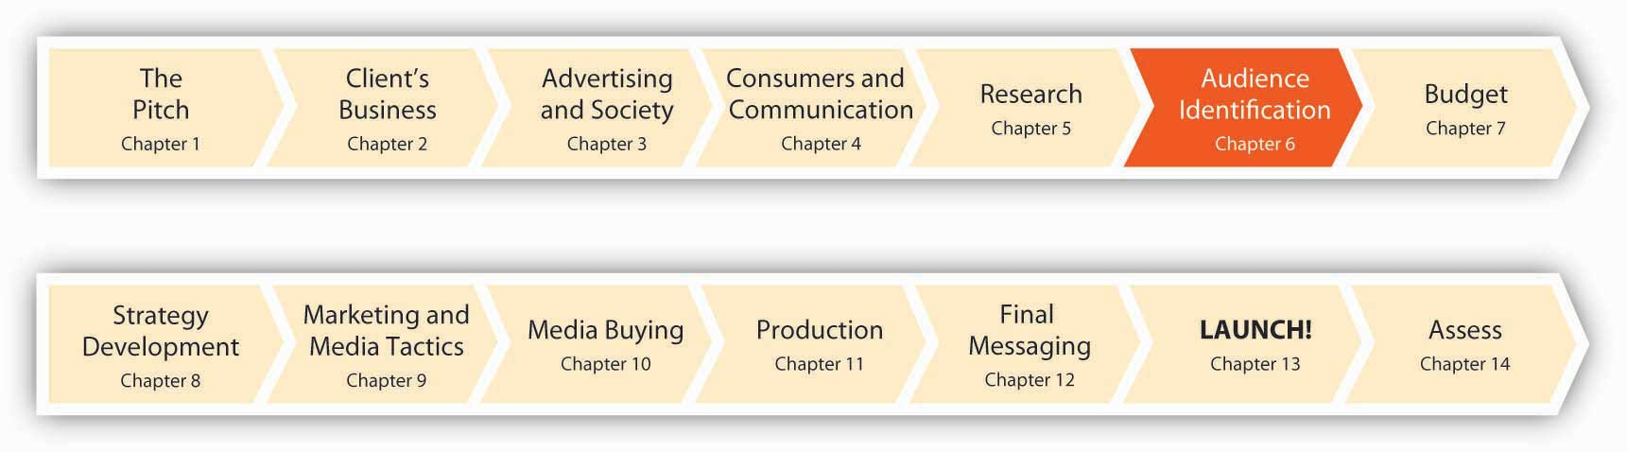
Good advertising is all about hitting customers where they live. But before you can craft a killer message to send, you have to know what address to send it to. Here’s a profound idea: people are different. A message that turns one person on may leave another cold. And, of course, not everybody’s likely to be interested in any idea, product, or service your client wants to sell (OK, maybe eternal youth…).
Before an advertiser can decide what a campaign should say, the advertiser needs to devote a lot of thought to identifying the target of the message. Target marketing is the process of identifying the types of people who are most likely to want your product and then tailoring your efforts to satisfy their unique needs. We do this when we use the STP (Segmenting, Targeting, Positioning) process, which consists of these three steps:
- Segmenting subdivides the population to help you think about who are and are not the potential customers for your product and the potential audience of the advertising.
- Targeting picks the segment(s) for the campaign that will be the focus of the advertising.
- Positioning is how to think about the relationship between your product and the customer/audience, with the purpose of distinguishing your product from the competition.
In short, STP gives you a framework for understanding: Who are your customers? How many customers are there? Where do they live? How do they spend their time? Why do they buy?

SS+K Spotlight
“The key turning point of this whole thing was when we started thinking about explorers and addicts and junkies.”
—Russell Stevens
“Really, all research and planning is telling a good story.”
—Account Planner Michelle Rowley
Figure 6.2
Michelle Rowley is one of the main planners in charge of articulating the characteristics of the consumer and of the marketplace. She works in what SS+K calls the “Asymmetric Intelligence Unit,” or the research and planning group.
One of the primary jobs of the account planner is to develop an empathic understanding of the target consumer, to get under their skin and understand their rational and sometimes irrational attractions to brands. This task comes naturally to Michelle, who describes herself as a “failed actor” who fell into her job—and then fell in love with it. Michelle and her colleagues need to identify the most relevant audience for the msnbc.com branding message, get “under their skin,” and then figure out how to align their client with what these viewers want. That’s the segmenting, targeting, and positioning process in a nutshell.

6.1 Segment Your Market: Who’s Out There?

LEARNING OBJECTIVES
After studying this section, students should be able to do the following:
- Recognize the target marketing process that includes segmenting, targeting, and positioning.
- Describe the key characteristics of market segments by examining the demographic, geographic, psychological/lifestyle (psychographic), and behavioral variables found in those segments.
Segmentation is the process of dividing a larger market into smaller pieces based on one or more meaningful and measurable shared characteristics. It’s crucial to slice up the pie so you can focus your resources on customers whose needs you have the best chance of satisfying. These are the benefits of a segmentation approach.
Segmenting the population gives you a concrete vision of your potential customer. For example, targeting upper-income unmarried men with a college education gives you a more specific vision of the intended audience than does simply advertising to “people.”
Segmenting the population provides focus and specificity on those people most likely to buy your product. It’s better to find the five million people who are 80 percent likely to buy than it is to find the eighty million people who have a 5 percent chance of buying.
Segmenting the population lets you estimate the number of people in a given category (such as “Affluent Retirees”), which gives you an idea of your potential market size. Knowing how many potential customers you’ll have influences your sales estimates, your total marketing budget, and the advertising media you use. For example, if you’ll be targeting Hispanic consumers in Phoenix, your total market size will be 1.36 million people. ^{[1]}

Demographic Segmentation
Demographics are measurable aspects of a population. Each key variable is usually defined in terms of a small number of categories or ranges. For example, age data might record the number of thirty- to forty-year-olds in aggregate, rather than separately tallying each age group of people who are thirty, thirty-one, thirty-two, thirty-three, and so on.
These are widely used demographic measures:
- Gender of the individual or head-of-household (e.g., Female)
- Age (e.g., 18–24)
- Life stage (e.g., empty-nest parents who have more time for each other now that their kids are in college)
- Household income (e.g., $30,000–$40,000 per year)
- Education (e.g., college graduate)
- Occupation (e.g., banker)
- Race/ethnicity (e.g., African American)
- Religion (e.g., Buddhist)
- Socio-economic status or SES (e.g., DINKs—“double income, no kids”)

SS+K Spotlight
While demographics can be an effective way to begin to understand your potential consumers, msnbc.com and SS+K knew that they would need to dig deeper to identify the specific audience for their branding campaign. While some product categories can move forward with demographic information only, services such as news, entertainment, and sports media need more information to fine-tune their targets. For example, the Bravo network, which has successfully created numerous high-style reality shows that revolve around upscale pursuits like gourmet cooking, fashion modeling, or home design, recently developed for advertisers a one-off (that is, one-time publication) magazine it called Bravo Affluencer. Each of the two people on the cover represented a distinct psychographic segment that is key to Bravo’s targeting strategy: an attractive man and woman, both in their late twenties, shopping bags and PDAs in hand, passports visible in pockets, dressed casually but stylishly. These two models are reminiscent of the popular stars of the sitcom Will and Grace—and that’s no accident. Bravo executives actually use the phrase “Will and Grace” to describe two of their key viewer segments: urban gay men and single female professionals. Many of the network’s most popular shows such as Project Runway and Top Chef attract these viewers in large numbers. ^{[2]} As we learned in Chapter 5 "Know Your Audience: SS+K Learns All About msnbc.com, Inside and Out", SS+K and msnbc.com had done significant segmenting and research to identify their target audience, the News Explorer.

Dig Deeper
MySpace recently launched a separate version of its site to reach twenty-eight million Americans who are Spanish speakers at latino.myspace.com. Users can still become friends with MySpace users across the network of sites. Nielsen//NetRatings reports that MySpace is one of the top five Web sites U.S. Hispanics visit. ^{[3]} How do U.S. advertisers appeal to non-English speakers on social networking sites? What else might they do to broaden their reach?

Geographic Segmentation
Geography plays three roles in the target marketing process:
- Customer and market characteristics. Geography defines key aspects of climate, culture, and customer density. Think about where people buy snowshoes, the time of year Midwesterners hold backyard barbecues, or the differences between laid-back Southern Californians and ambitious New Yorkers. News items and ads served on msnbc.com when possible need to be relevant to the geographic profile of a registered user; a web surfer in Florida probably isn’t too interested in today’s ski conditions.
- Advertising channels. Some advertising strategies, such as newspapers and direct mail, are strongly tied to geography. For example, automobile companies tailor their ads by geography. Automakers purchase TV time on local cable stations and tailor the ads based on where people live. People who live in zip codes located in the suburbs see ads for SUVs, while those in the cities see commercials for cars—during the same programs. As you’ll learn in the media planning chapter, msnbc.com made very strategic geographic media and messaging decisions in order to maximize the value of their buy. ^{[4]}
- Product distribution: Many companies, especially small and medium-size businesses, have a regional scope. Even national companies like Wal-Mart want to assess how many people live within ten miles of a store that carries a product that they will promote.
Most geographic segmentation schemes use definitions the government created for census, postal, and economic forecasting purposes.
- Zip code. Zip codes, as defined by the U.S. Postal Service, identify each of roughly forty-three thousand neighborhoods. Other countries, too, have analogous postal code systems. Zip codes are often the basis for direct mail advertising. Car dealers use zip code information as a proxy for income, making different offers, such as lease-to-own or cash incentives, to entice potential buyers in different neighborhoods.

Dig Deeper
In addition to other applications, a widely used system called PRIZM helps clients to fine-tune their advertising by directing mailings to specific types of customers based upon where they live (“birds of a feather flock together”). PRIZM (Potential Rating Index for Zip Markets) classifies all U.S. neighborhoods into sixty-two distinct clusters based upon very detailed data about the products and media people who live in different neighborhoods consume relative to the national average. PRIZM offers a little something for everyone, with groups like Urban Gold Coast (elite urban singles and couples), New Empty Nests (upscale suburban fringe couples), and Norma Rae-ville (young families in biracial mill towns).
Visit PRIZM’s Web site and look up your zip code to see what category you fall into. Do you agree with this classification? (http://www.claritas.com/MyBestSegments/Default.jsp?ID=20&SubID=&pageName= ZIP%2BCode%2BLook-up)
- MSA. Metropolitan Statistical Areas (MSAs) are important for local advertising channels (e.g., newspaper, radio, outdoor, local broadcast TV, and cable). The U.S. Office of Management and Budget (OMB) defines 363 MSAs in the United States. MSAs are defined using census data at a county level (or a group of economically linked contiguous counties) with at least one urbanized area of fifty thousand or more population. One MSA, called the “New York-Northern New Jersey-Long Island, NY-NJ-PA” MSA is the most populous MSA in America and contains approximately nineteen million people.
- Civil boundary regions.
  - City. Of U.S. cities, nine have a population over one million, and 254 have a population over one hundred thousand.
  - County. There are 3,066 counties in the United States. ^{[5]}
  - State. Identifying customers by state can be important because laws may vary from state to state, especially for industries such as financial services (like insurance), tobacco, and alcohol. These regulations can affect advertising strategies. For example, California law heavily restricts distribution of coupons for cigarettes.
- Census regions and divisions. Four broad regions (West, Midwest, Northeast, and South) further divided into nine divisions.
- DMA codes. Designated Market Areas (DMAs) are markets in the United States that are within range of a particular broadcast television station. The term was originally defined by Nielsen Media Research to identify TV stations whose broadcast signals reach a specific area and attract the most viewers. A DMA consists of all counties whose largest viewing share is given to stations of that same market area. Nielsen gathers data to verify DMAs four times a year; there are currently 210 nonoverlapping DMAs in the United States.
- Sales or distribution regions. Many companies create their own geographic subdivisions, which vary by company. For example, a product might be sold through a specialty retailer that only operates in the Northwest.
- Climatic. Some products are specific to or more prevalent in areas with a specific client. For example, Minnesotans buy more snowshoes than do Texans.

Dig Deeper
Like it or not, global warming is here to stay—at least in our lifetimes. Warmer (or at least more unpredictable) temperatures will have many consequences—some you may not have thought about. For example, think about how these changes will affect the $200 billion American apparel industry. Will we still think about “winter clothes” versus “summer clothes” in a few years? At least a few companies are thinking ahead. Liz Claiborne hired a climatologist to help the company better time the shipments of seasonal garments to retailers. ^{[6]} Target created a “climate team” to provide advice on what the retailer should sell throughout the year (hint: think lighter-weight fabrics). ^{[7]} Weatherproof, a coat manufacturer, went so far as to take out a $10 million insurance policy against unusually warm weather. ^{[8]}
How will this new weather reality influence the way seasonal industries like apparel plan their advertising campaigns?

Psychographic Segmentation
While demographics are useful, advertisers often need to slice and dice even further. Traditional demographic segments (such as gender, age, and income) provide only a rough estimate of the attitudes and desires of different groups, so marketers often give consumer groups labels that capture something about their lifestyles and motivations as well.
Imagine an advertiser that defines a segment as recent moms. This label implies that all women who have recently given birth are fairly similar and that they all will respond the same way to an advertising message—how accurate is that assumption? Bloomingdale’s Quotation, a store-within-a-store, instead calls its target market “yummy mummies.” These are women age thirty-five to forty-five who have gained weight after their babies but don’t want to look matronly. They are affluent, suburban, and casual yet fashionable. Bloomie’s research department provided further insight into the target customer: she thinks classic sportswear like Jones New York is too formal but contemporary sportswear like Juicy Couture is too young. The mom wants clothes that look pretty and feminine and have flair but offer a generous, not-too-tight fit. ^{[9]}
Psychographics refers to dimensions that segment consumers in terms of personality, values, attitudes, and opinions. While demographics can divide people along specific (often quantitative) dimensions, psychographics captures the reasoning and emotion behind people’s decisions. This information also enables advertisers to capture the themes, priorities, and “inside meanings” that a specific taste culture identifies with. For example, Svedka Vodka targets urban party people who are out drinking until three o’clock in the morning three nights a week. This target market is irreverent, and Svedka’s ads speak their language. The ads feature futuristic imagery and lines like “Svedka says ‘thank you’ for making the gay man’s fashion gene available over the counter in 2033.” ^{[10]}
PRIZM NE classifies psychographic segments based on where they live.
Affluent people who live in wealthy exurban (beyond suburban) areas make up this segment. They like their space and their conveniences. They are typically Baby Boomers who balance their lives between high-powered jobs and laid-back leisure.
They are mostly college-educated Whites between the ages of 35 and 54 with a median household income of $84,851. They are most likely to travel for business, take a golf vacation, read Skiing magazine, and drive a Toyota Land Cruiser.
Older, middle-class seniors who live comfortably in the suburbs characterize this segment. These retired homeowners are opting to stay in their homes rather than move to a retirement community. The mostly White, college-educated suburbanites have a median household income of $51,367. They are most likely to shop at Lord and Taylor, belong to a veterans’ club, watch the U.S. Senior Open on TV, and drive a Buick LaCrosse.
This segment includes upper-middle-class suburban couples, with children, who enjoy focusing on their families. They live in a large home in a subdivision. Their white-collar profession and young age (25–44) provides them the means to have it all.
The segment includes a growing number of Hispanic and Asian Americans. The median household income is $70,490. They are most likely to shop at The Disney Store, eat at Chuck-E-Cheese, watch Nickelodeon TV, and drive a Nissan Armada SUV.
Young, working singles living active lifestyles in sprawling apartment complexes in fast-growing satellite cities compose this segment. They are under 35, ethnically diverse, and hip, and they want it all. Nightlife, restaurants, and convenience products and services are important to them. Their median household income is $38,910. Since they don’t have children, they are very active. They are most likely to go snowboarding, watch Fuse network, read The Source magazine, and drive a Nissan Sentra.
Sometimes marketing and advertising firms create psychographic segmentation systems with cute names or acronyms for the segments, such as DINKs (double income, no kids), who are good targets for yuppie products like expensive roadsters and exotic vacations, or even DINKWADs (double income, no kids, with a dog), who are like DINKS but would add in lots of treats for a pampered pooch. msnbc.com, for example, termed its new target audience the News Explorer.
These are some well-known psychographic segmentation tools that advertisers use to divide up their markets:
- VALS2™ (Values and Lifestyle System): According to its parent, SRI International, “VALS reflects a real-world pattern that explains the relationship between personality traits and consumer behavior. VALS uses psychology to analyze the dynamics underlying consumer preferences and choices.” ^{[11]} VALS2™ divides U.S. adults into eight groups according to what drives them psychologically as well as by their economic resources.
The system arranges groups vertically by their resources (including such factors as income, education, energy levels, and eagerness to buy) and horizontally by self-orientation. Three self-orientations make up the horizontal dimension.
  - Consumers with a principle orientation make purchase decisions guided by a strong internal belief system.
  - People with a status orientation base their decisions on what they think their peers think.
  - Action, or self-oriented individuals, buy products to have an impact on the world around them.
Actualizers, the top VALS2™ group, are successful consumers with many resources. This group is concerned with social issues and is open to change. The next three groups also have sufficient resources but differ in their outlooks on life: ^{[12]}
  - Fulfilleds are satisfied, reflective, and comfortable. They tend to be practical and value functionality.
  - Achievers are career-oriented and prefer predictability to risk or self-discovery.
  - Experiencers are impulsive and young, and they enjoy offbeat or risky experiences.
The next four groups have fewer resources:
  - Believers have strong principles and favor proven brands.
  - Strivers are similar to achievers but have fewer resources. They are very concerned about the approval of others.
  - Makers are action-oriented and tend to focus their energies on self-sufficiency. They will often be found working on their cars, canning their own vegetables, or building their own houses.
  - Strugglers are at the bottom of the economic ladder. They are most concerned with meeting the needs of the moment and have limited ability to acquire anything beyond the basic goods needed for survival.
VALS2™ helped Isuzu market its Rodeo sport-utility vehicle by targeting Experiencers who believe it’s fun to break rules. The company and its advertising agency promoted the car as a vehicle that lets a driver break the rules by going off road. One ad showed a kid jumping in mud puddles after his mother went to great lengths to keep him clean. ^{[13]}
- Trend analyst Faith Popcorn’s firm BrainReserve refers to segments based on life stages like MOBYs (mommy older, baby younger), DOBYs (the daddies); former yuppies divided into PUPPIEs (poor urban professionals) and WOOFs (well-off older folks); latchkey kids, sandwichers (adults caught between caring for their children and their older parents); and SKIPPIEs (school kids with income and purchasing power). The company also groups consumers based on special interests, like global kids (kids with strong feelings about the environment plus strong influence over family purchase choice); and new health age adults (consumers who consider their health and the health of the planet to be top priorities).
- Mediamark Research (MRI) divides the wealthiest 10 percent of U.S. households (“the upper deck”) by lifestyles: the good life, well-feathered nests, no strings attached, nanny’s in charge, and two careers.

SS+K Spotlight
The additional insights msnbc.com uncovered about the site’s users, as a result of the psychographic information the company obtained in its primary and secondary research, allowed its analysts to start with broad demographic segments and then further slice these groups into smaller but more meaningful psychographic segments. As the company did the research described in Chapter 5 "Know Your Audience: SS+K Learns All About msnbc.com, Inside and Out", it was able to discriminate, for example, between News Explorers and News Junkies.

Behavioral Segmentation
Behavioral segmentation slices the market in terms of participation or nonparticipation in an activity. Sometimes this involves identifying the different ways consumers use products in a category. Mattel introduced a new brand it calls Barbie Girls to attract the increasing number of girls who spend a lot of time online in virtual worlds instead of playing with real dolls in the physical world. It features a free Web site, BarbieGirls.com, that will allow children to create their own virtual characters, design their own room, and try on clothes at a cyber mall. It’s following up with Barbie-inspired handheld MP3 music devices. ^{[14]}
Segmenting by behavior often singles out heavy users of a product, because even though these consumers may be relatively small in number, they often are key to sales in a category. Indeed, there is a lot of truth to the so-called80/20 rule: this is a rough rule of thumb that says 20 percent of customers buy 80 percent of a product. Sure enough, for example, Kraft Foods began a $30 million campaign to remind its core users not to “skip the zip” after its research showed that indeed 20 percent of U.S. households account for 80 percent of the usage of Miracle Whip—“heavy” users (pun intended) consume seventeen pounds of Miracle Whip per year! ^{[15]}
Information sources that can pinpoint heavy users in a brand or product category include:
- Industry group reports (for example, the National Golf Foundation tracks the number of golfers in the United States and the extent of their participation in the game).
- Surveys of consumer behavior (for example, the number of people who eat fast food more than three times per week).
- Product sales (install base): Owners of particular products can be an affinity group. For example, a company can choose to target owners of Apple iPods either with accessories or with a brand image that resonates with that population.

B2B (Business to Business) Segments
Many clients sell products used by businesses rather than (or in addition to) end users. B2B advertisers also segment their markets, but the dimensions they use are different. In addition to data the government collects about businesses, trade organizations often offer data about their members. In addition, services like Hoovers Online provide detailed breakdowns about many companies. Relevant dimensions include these: ^{[16]}
- Company size. This comprises such things as revenues or headcount.
- Industry. Marketers often use the North American Industry Classification System (NAICS), a numerical coding of industries the United States, Canada, and Mexico developed. The NAICS reports the number of firms, the total dollar amount of sales, the number of employees, and the growth rate for industries, all broken down by geographic region.
- Geography. This comprises such things as location of headquarters, sites, or geographic focus of distribution.
- Buying cycle. Companies often have a deliberative process for buying with known intentions to buy within a certain number of months.
- Buyer role. Advertising often targets specific people within an organization (e.g., those who influence, specify, and make buying decisions).

Dig Deeper
Encryption-product maker GlobalCerts targets companies that have one hundred to one thousand employees. When GlobalCerts began its direct mail campaign, it collected information on its key prospects, including their needs, buying cycle, and decision makers’ contact information. Knowing the buying cycle of an organization is important because decision makers need different kinds of information, depending on where they are in the buying cycle. Early on, decision makers are looking for more general information about solutions that meet their business needs. In later stages, they want very product-specific performance information. Having a salesperson call a potential customer too early in the buying cycle will likely annoy the customer—they’re not ready to buy—and waste the time of the salesperson. ^{[17]}

SS+K Spotlight
Defining the audience is a job for both the left brain and the right brain. We use this expression because in general the left side of our brains is more rational and fact-oriented while the right side is more emotional and artistic. Some people tend to be more logical when they approach problems while others are more creative and emotional. For fans of the original Star Trek TV series, just think of Mr. Spock and Dr. McCoy and you’ll get the difference immediately.
So, SS+K needs to combine both rational and emotional factors when they think about their target market. Even the most comprehensive demographic profile seldom communicates a sufficiently nuanced understanding of any group of consumers. At SS+K, the account planners and researchers that make up the AIU are charged with acquiring information beyond current user demographics that will allow the account, media, and creative team to visualize and understand the consumer. An insightful and comprehensive target profile should enable the writers and art directors to imagine the target consumer so well, in fact, that the creatives can develop an empathic understanding of that consumer’s relevant needs and wants. The more complete the creatives’ understanding of the audience, the more likely the team will be able to craft a message that speaks in an authentic, compelling voice to the target consumer.
If an agency relies on simple demographics to define its target market, the risks of oversimplification and naïve projections are considerable. The job of an account planner like SS+K’s Michelle Rowley is to dig deeper; to see, understand, and report significant differences among potential target markets on the basis of characteristics that aren’t immediately apparent to just anyone with access to a marketing database.
The profile provided Michelle with a basic understanding of the msnbc.com user. In addition to some telling demographics, Michelle had a good sense of how users describe their technological acumen and online news-gathering behavior and preferences.
After analyzing a veritable mountain of proprietary research already collected by the client, Michelle and her colleagues identified a trio of expectations consumers brought to their online news and information experiences. First, the online news audience assumed “the cost of entry” for credible sources was an ability to provide breaking news in a timely fashion; research indicated that consumers considered this a generic attribute and not a point of differentiation for any news provider. The second and third expectations were also considered essential parity characteristics (i.e., elements that any competitor would need): a well-organized site that provides ease of access and a multi-faceted presentation of text, photos, and video. Users said the most important attribute for news and online information providers was to provide trusted coverage.
Beyond that, there were still some significant gaps in the research that Michelle and company had to fill before they were prepared to commit fully to a target audience and position the brand in the marketplace. SS+K wanted to better understand the factors involved in making a choice for news and information:
- What role does news and information play in the lives of online consumers?
- What were the emotional drivers in choosing a source?
- Who was likely to influence others’ choice of a news site, and how was this influence exercised?
Once these more global issues were better understood, SS+K could more effectively address how to position msnbc.com relative to its competition.
Understanding consumers’ behaviors, as well as their motivations and gratifications for using particular sites, was a key focus of the next research phase. The ultimate goal was to find a voice, a tone, a way of presenting the brand that was relevant and clearly differentiated in the minds of the consumers as unique to msnbc.com. Michelle and her colleagues organized focus groups and interviews for further exploration of the opposing goals and perspectives suggested by the initial research. Among these were the following:
- Attraction versus retention
  - What is the relationship between what attracts you to a site and what keeps you interested once you’re there?
  - Why are users accessing broadcast-related media online?
  - How can msnbc.com differentiate itself from MSN? What is the value of the association beyond driving traffic?
  - What type of content will motivate your current consumers to spend more time on the site?
  - Are light msnbc.com users clicking through on other sites?
- Credibility versus liability
  - What value do the NBC news brands bring to an online news site?
  - What is credible about the NBC brands?
  - How strong are the associations with NBC news personalities?
- Informed versus overwhelmed
  - What is the balance between knowledge as power and news as noise?
  - Do online news users want “all the news that’s fit to print” or “enough information so I don’t look stupid”?
  - Do your users want to know it all or just know enough?
- Entertained versus unfulfilled
  - What causes the negative reaction to the site among non-users? Are non-users reacting to the actual product or its reputation?
  - What is the appropriate balance between hard news and entertainment content?
  - How does the style of storytelling affect a user’s perception of the content on the site?
SS+K needed answers to questions like these before the agency could identify the profile of the person most likely to be attracted to msnbc.com as a news source. That’s where the targeting process comes in, so we’ll turn to that next.

KEY TAKEAWAY
It’s very rare for an idea, product, or service to appeal to all consumers. Segmentation is the process of dividing the total population into groups that share important characteristics relevant to a client’s product or service. These segments may be based on demographics, psychological/lifestyle characteristics (psychographics), or behavior (e.g., heavy users versus light users of the brand).
- Segmenting subdivides the population to help you think about who are and are not the potential customers for your product and the potential audience of the advertising.
- Targeting picks the segment(s) for the campaign that will be the focus of the advertising.
- Positioning is how to think about the relationship between your product and the customer/audience, with the purpose of distinguishing your product from the competition.

EXERCISES
- Target marketing requires that we use the STP process, which consists of three steps. List and briefly describe those steps.
- Demographics are measurable aspects of a population. There are nine widely used demographic measures. List and briefly describe five of those demographic measures.
- Explain how advertisers might be able to use SRI International’s VALS2™ to construct consumer ad campaigns.

[1] Kevin Downey, “Phoenix: Ad Budgets Soar in Newly Ensconced 8th-Largest Latino Market, But Immigration Remains a Concern,” Marketing y Medios, October 22, 2007,http://www.marketingymedios.com/marketingymedios/market_profile/article_display.jsp?vnu_content_id=1003661213 (accessed November 5, 2008).
[2] Susan Dominus, “The Affluencer,” New York Times Magazine, October 30, 2008,http://www.nytimes.com/2008/11/02/magazine/02zalaznick-t.html? partner=rssnyt&emc=rsscc (accessed November 5, 2008).
[3] Emily Burg, “Do You Want To Be My Amigo? MySpace Launches En Espanol,” Marketing Daily, April 26, 2007, http://www.mediapost.com (accessed November 5, 2008).
[4] “For car marketers, local cable ads are spot-on,” Automotive News, May 28, 2007, 26F.
[5]http://www.naco.org/Content/NavigationMenu/About_Counties/Data_and_Demographics/Data_and_Demographics.htm (accessed November 15, 2008).
[6] For more information, seehttp://topics.nytimes.com/top/news/business/companies/claiborne_liz_inc/index.html?inline=nyt-org.
[7] For more information, seehttp://topics.nytimes.com/top/news/business/companies/target_corporation/index.html?inline=nyt-org.
[8] Michael Barbaro, “Meteorologists Shape Fashion Trends,” New York Times Online, December 2, 2007, http://www.nytimes.com/2007/12/02/business/02weather.html(accessed July 11, 2008).
[9] Elizabeth Woyle. “What Do 35-Year-Old Women Want?” BusinessWeek, April 2, 2007, 66.
[10] Dan Heath and Chip Heath. “Polarize Me,” Fast Company, April 2007, 59.
[11] For more information, see http://www.sric-bi.com/VALS/.
[12] Martha Farnsworth Riche, “VALS 2,” American Demographics, July 1989, 25. Additional information provided by William D. Guns, Director, Business Intelligence Center, SRI Consulting Inc., personal communication, May 1997.
[13] For other examples of applications see “Representative VALS™ Projects,” SRI Consulting Business Intelligence, http://www.sric-bi.com/VALS/projects.shtml#positioning(accessed February 29, 2008).
[14] “Mattel Aims at Preteens with Barbie Web Brand: Toymaker Turns to Tech as Sales Slump for Iconic Fashion Doll,” Associated Press, April 26, 2007, http://www.msnbc.com(accessed April 26, 2007).
[15] Judann Pollack, “Kraft’s Miracle Whip Targets Core Consumers with ’97 Ads,” Advertising Age, February 3, 1997, 12.
[16] For more information, see http://www.hoovers.com.
[17] Elias Terman, “Name Dropping,” American Printer, January 1, 2007, v124.

6.2 Target Your Customer: Who’s Going to Want It?

LEARNING OBJECTIVES
After studying this section, students should be able to do the following:
- Identify who customers are by following the targeting process.
- Review the properties of a good market target in order to select the optimal target for marketing and advertising efforts.
- Examine behavioral targeting as a means of determining what consumers want and like.
Targeting increases the cost-effectiveness of advertising. Most advertising channels have a cost that is a strong function of the amount of exposure (e.g., the number of people who see the ad) regardless of whether audience members are potential customers or not. Targeting helps define who the customers are. This section explores how the advertiser can:
- Profile segments:
  - According to buying power
  - According to likelihood of buying your product or service
  - According to likelihood of being attracted by a potential ad
- Assess the attractiveness of each potential target.
- Select segment(s) that are both attractive and likely to have a similar favorable response to a given advertising message.

What Are the Properties of a Good Target?
- Measurable: Key variables easily (and accurately) identify and assess the target.
- Accessible: The target group must be reachable by advertising.
- Profitable: The target group must have sufficient size, willingness to buy, and ability to pay.
- Distinguishable: The target group must provide a clearly differentiated segment in terms of percentage of potential customers and coherence of response to potential advertising messages.

Dig Deeper
In 2007, Japanese auto maker Suzuki began aggressively targeting a new segment: female car buyers in India who now have the income to buy their own vehicles due to India’s economic boom. The carmaker’s Zen Estilo (Estilo means “style” in Spanish) sells for less than $8,000 and comes in eight colors, including “purple fusion,” “virgin blue,” and “sparkling olive.” For a more modern look, Suzuki gave the car a two-tone dashboard and a front grille design that makes the little car look like it is smiling. Style-conscious drivers can also add rear spoilers, side skirts, and extra colors to the body. Many of Suzuki’s foreign competitors ignored this market because they chose to focus on selling mid- to high-end vehicles. ^{[1]}

SS+K Spotlight
While a lot of readers visit msnbc.com, not all are News Explorers. Remember, the News Explorer is the target that msnbc.com and SS+K determined was the best target for the branding campaign.

Behavioral Targeting: Advertisers Know What You Like (Like It or Not)
The STP process is evolving rapidly as new advances in technology enable advertisers to identify and reach consumers where they live, work, and especially surf (online).
Today, companies define and manage finer and finer segments. In the past, segments had to be broad because it was difficult to reach finer-level segments and because such fine-grain data were not available. Now, companies can process terabytes of data on customers, and new ad channels (such as keyword advertising on the Internet) allow companies to reach smaller segments, down to segments of one (yes, like you).
These three factors fuel the accelerating trend of targeting small, very well-defined segments:
- Growing volume of data on customers
- Rising use of computers and analytic software
- Increasing specificity of advertising channels (e.g., keyword advertising on the Internet)
Behavioral targeting refers to putting ads in front of people customized to their Internet use. It’s become fairly easy for marketers to tailor the ads you see based on prior Web sites you’ve visited. The logic is inescapable: you’re more likely to respond (and probably appreciate) an ad for an idea, product, or service that’s relevant to your needs.
Obviously, privacy concerns arise as advertisers learn more about the sites we visit. But many consumers seem more than happy to trade off some of their personal information in exchange for information they consider more useful to them. More than half of respondents in one recent survey said they’re willing to provide demographic information in exchange for a personalized online experience. ^{[2]} While the ethics of gathering personal information are still being evaluated, behavioral targeting is the next frontier for many advertisers.
- When you (along with 263 million other users) sign up for Microsoft’s free e-mail service called Hotmail, the service asks you for personal information including your age, occupation, and address (though you’re not required to answer). If you use Microsoft’s Live Search search engine, the company keeps a records of the words you search for and the results you clicked on. Microsoft’s behavioral targeting system will allow its advertising clients to send different ads to each person surfing the Web. For instance, if a twenty-five-year-old financial analyst living in a big city is comparing prices of cars online, BMW could send her an ad for a Mini Cooper. But it could send a forty-five-year-old suburban businessman with children, who is doing the same search, an ad for the X5 SUV. ^{[3]}
- The Fox network offers tweakable ads it can digitally alter so they contain elements relevant to particular viewers at the time they watch them. By changing voice-overs, scripts, graphic elements, or other images, advertisers can make an ad appeal to teens in one instance and seniors in another.
- Starwood Hotels & Resorts Worldwide Inc. uses a behavioral targeting campaign to promote spas at its hotels. The hospitality company works with an online media company to deliver ads to Internet users who have browsed travel articles or surfed the Web site of a Starwood-branded hotel like Westin or Sheraton.
- Startup advertising company Pudding Media is testing a service that would let customers make voice-over-Internet protocol (VoIP) calls free, if they agree to let their calls be monitored by speech-recognition software that would then present online ads based on the words it culled from the conversation. The customer would have already supplied Pudding with his or her zip code, age range, and gender, so ads would be targeted by demographics and location, as well as by real-time conversation. ^{[4]}

Dig Deeper
Behavioral targeting allows advertisers to identify our consumption practices so that they can tailor ads to our precise interests. They argue that this technology increases efficiency, saves money, and reduces advertising bloat because we won’t be bombarded with commercial messages for products we don’t want. On the other hand, critics of this practice argue that we’re “making a deal with the devil” because we’re giving companies access to our personal behaviors. This controversy has surfaced on Facebook, which is now sharing data about users’ online behaviors with advertisers. What is the current status of this conflict? How can advertisers do a better job of targeting while respecting the privacy of consumers—especially those who don’t want to be targeted?

SS+K Spotlight
Targeting the msnbc.com User
SS+K was charged with two goals for the new msnbc.com campaign: increase the number of unique viewers who visit the site, and increase the number of clicks per visit among current msnbc.com users.
To refine their understanding of how to develop the msnbc.com proposition, SS+K enlisted the aid of Energy Infuser, a market research company in Chicago that specializes in unearthing consumer insights through qualitative methods such as focus groups, projective techniques, and consumer diaries. A number of “triads” (groups of three consumers) were recruited and agreed to offer their time and consumer experiences of online information seeking. Through analysis of the group’s transcripts, the SS+K team developed a better sense of why a user might choose msnbc.com over other options: relative to competitors like bland news aggregators and “cold” and “serious” CNN.com, msnbc.com virtually sparkled with energy and personality. The site was inviting for users who enjoyed browsing for news and tidbits, including lighthearted information on entertainment, fashion, and sports.

KEY TAKEAWAY
Targeting is the process of selecting the customers whose needs you’re likely to satisfy. Targets need to be easily identifiable and measurable. As technology continues to develop, behavioral targeting that allows advertisers to customize messages and products to the needs of each individual will become a more central part of advertisers’ strategies.

EXERCISES
- Targeting helps define who the customers are. Targeting calls for the advertiser to take three steps. Describe and detail each of those three steps.
- Good target markets have a series of properties that make them very attractive to advertisers and marketers. Describe and detail the four properties of a good target market.
- Discuss the logic of using behavioral targeting to reach consumers. Be specific in your discussion.

[1] Eric Bellman, “Suzuki’s Stylish Compacts Captivate India’s Women,” Wall Street Journal, May 11, 2007, B1.
[2] “Consumers Willing to Trade Off Privacy for Electronic Personalization,” Marketing Daily, http://www.mediapost.com (accessed January 23, 2007).
[3] Aaron O. Patrick, “Microsoft Ad Push Is All About You: ‘Behavioral Targeting’ Aims to Use Customer Preferences to Hone Marketing Pitches,” Wall Street Journal, December 26, 2006, B3; Brian Steinberg, “Next Up on Fox: Ads That Can Change Pitch,” Wall Street Journal, April 21, 2005, B1, http://www.aef.com/industry/news/data/2005/3105; Bob Tedeschi, “Every Click You Make, They’ll Be Watching You,” New York Times, April 3, 2006,http://www.nytimes.com/2006/04/03/business/03ecom.html?ei= 5088&en=9e55aeacf695c33a&ex=1301716800&partner=rssnyt&emc= rss&pagewanted=all (accessed November 15, 2008); David Kesmodel, “Marketers Push Online Ads Based on Your Surfing Habits,” Wall Street Journal, April 5, 2005,http://cob.bloomu.edu/sbatory/CH%2006%20E%20Mktg%20&%20Customer%20Relationships%202 Oct06%20n48.ppt (accessed November 15, 2008).
[4] “Startup Offers Free Calls in Exchange for Eavesdropping,” InformationWeek, September 24, 2007,http://www.informationweek.com/news/internet/ebusiness/showArticle.jhtml?articleID=202101023 (accessed November 15, 2008).

6.3 Position Your Brand: Why Will They Want It?

LEARNING OBJECTIVES
After studying this section, students should be able to do the following:
- Define positioning relative to brand differentiation.
- Use three positioning dimensions to relate to a brand’s strategic objectives.
Positioning means developing a strategy to influence how a particular market segment perceives a good or service in comparison to the competition. Positioning increases potential ad effectiveness by clarifying the message. This step is all about defining a space in the mind of the customer—something that your customer thinks of and associates with your product.

It’s All Relative
Remember that positioning doesn’t just mean what your target market thinks about your product. Rather, it’s about how she thinks about it relative to competitors’ products—your product is less expensive, performs better, or fits better with the customer’s lifestyle. Positioning often relates to a brand’s strategic objectives. Looking back at our previous discussion of behavioral segmentation, the advertiser might think about potential customers in terms like these:
- Does not use the advertised product category—the company wants to convert nonusers to users (grow the market).
- Uses a competitor’s version of the advertised product category—the company wants to gain market share at the expense of competitors by creating or capturing brand switchers.
- Uses an alternative version of your product in the advertised product category—the company wants to upsell customers (get them to buy a more expensive version of its product) or migrate them to future product variants.
- Uses the advertised product—the company wants to increase the frequency or volume of purchases or reinforce brand loyalty.

Positioning Dimensions
- Value: The product reaches price-sensitive customers by being low cost. An example would be Wal-Mart’s “Every Day Low Prices.” Companies often create subbrands to create distinctive positioning for the brand based on price. The Gap, for example, is a mid-price clothing store, while its sister company Banana Republic is a higher-priced clothing store, and Old Navy is the value-priced offering. Similarly, Volkswagen’s Skoda brand is known as the low-cost car brand.
- Performance: The product is high performing on one or more dimensions that the target audience seeks. For example, if you focus on a lifestyle or design position, you appeal to the customer who values the social or aesthetic statement a brand makes—and often what others will think about him or her after the purchase. For example, Chanel is a designer-led luxury brand. The company has identified a new group of customers it wants to target. Chanel calls the group “new wealth”—women who have acquired a significant amount of money at an earlier age than previous generations. These women, with a net worth of over $1 million, have more cutting-edge fashion tastes. When Chanel CEO Maureen Chiquet strategizes about launching a new perfume to appeal to this customer segment, her watchword is exclusivity. “Let’s not be thinking about how big we can make this,” she tells her team, “but how exclusive and special you can keep it.” ^{[1]}
- Functional: Solves a specific problem or accomplishes a specific goal for the customer. Tide-to-Go®, for example, solves the problem of removing a stain when there’s no time to launder the garment.

Dig Deeper
The average Buick buyer is a man in his midsixties—not the type of consumer inclined to trick out his car with twenty-two-inch wheels, a lowered suspension, and tinted windows. That’s why it’s a bit of a shock to check out a Buick Lucerne with those modifications on display at a party hosted by General Motors that also featured actress Vivica Fox, known for roles in movies like Booty Call and Soul Food and hip-hop star Jay-Z. Buick’s sales are plummeting, and the brand is trying to boost them by expanding its appeal among young, urban consumers. ^{[2]} How far can a promotional campaign go to radically reposition a well-established brand? What do you predict will be the outcome of Buick’s efforts to build some bling into its brand image?

SS+K Spotlight
SS+K’s psychographic research revealed that people have very different motivations for accessing news sites. The account team decided to position msnbc.com’s offering for one primary target—the News Explorer, who “enjoys the thrill of the hunt” when it comes to finding news.

Final Words from Michelle on the STP Process
-----Original Message-----
From: Michelle Rowley
Sent: Monday, July 09, 2007 8:23 PM
To: Jane Doe
Subject: msnbc.com
Hi Dr. Duke!
So much to say and such little time though - so I thought I would send you a quick e-mail.
Some things I wish I had hit on include the importance of listening not just to what people say, but to what they don’t say. How with planning you need to use the research to build your case, but ultimately there is a small leap of faith you make in the end when you definitively place your stake in the ground about the strategic direction. How it’s so important for planners to be curious about things in life in general, not just in advertising, and how that curiosity comes from getting out there and living life, from talking to people and most importantly by reading, reading, reading.
Michelle

KEY TAKEAWAY
Positioning your product or service to appeal to the needs of a specific group can set it apart from competitors that are also vying for the same consumers. A client’s product or service can be positioned relative to the competition along such dimensions as lifestyle, reasons for use, or quality/price tradeoffs. SS+K identified a target segment it called the News Explorer as the best prospect for its client. The typical user is a news junkie who enjoys the thrill of hunting for new information and who wants to dive into the information rather than just scan it. The agency will proceed to develop a brand message that emphasizes how msnbc.com delivers what News Explorers want.

EXERCISE
Marketers must consider three positioning dimensions as they formulate their positioning strategy. List and briefly describe the three positioning dimensions discussed in the chapter.

[1] Robert Berner, “Chanel’s American in Paris,” BusinessWeek, January 21, 2007, 70–71.
[2] Gina Chon and Jennifer Saranow, “Bling-Bling Buick: Seeking Younger Buyers, General Motors’ Staid Brand Uses Customized Cars, Celebrities to Reach the Hip-Hop Crowd,” Wall Street Journal, January 11, 2007, B1.

6.4 Exercises

TIE IT ALL TOGETHER
Now that you have read this chapter, you should be able to understand the concept of market segmentation and what you need to do to create a market segmentation plan:
- You can understand the STP (segmenting, targeting, and positioning) process that gives you a framework for understanding information about customers (e.g., who customers are, where they live, what they want).
- You can determine characteristics of market segments based on demographic, geographic, psychological/lifestyle characteristics (psychographics), or behavior (e.g., heavy users versus light users of the brand).
- You can identify the properties of a good market target (e.g., measurable, accessible, profitable, and distinguishable).
- You realize that behavioral targeting can be used to put ads in front of people customized to their Internet use.
- You can explain the necessity for having positioning become part of advertising strategy.
- You are able to decide how to position a product or service so that it is differentiated from products or services of competitors.

USE WHAT YOU’VE LEARNED
- What is one of the most potent political forces that any political candidate for national office must impress and deal with? If you said AARP, you are correct. If, as an advertiser, you don’t know what AARP is, you will be missing the network organization used by millions of seniors in the United States. (See http://www.aarp.org for more information.) AARP is not just for retired persons anymore. The organization accepts members and offers benefits beginning at age fifty. Given the number of Baby Boomers at this age and beyond, AARP will have a growing market base for a number of years.
Seniors in the United States have become an important market target for many product and service producers. Advertisers are learning new ways to reach and communicate with this market. Seniors today don’t see themselves as old. Baby Boomer seniors see themselves as active, fashion conscious, energetic, adventurous, and knowledgeable about products and services directed toward their market segment. Seniors ride motorcycles, go skydiving, enjoy cruises, listen to concerts from bands popular when they were in their twenties, enjoy entertaining, and like to dress well. Sounds like a great opportunity for the enterprising marketer—right?
Investigate the senior market, Baby Boomers, and the AARP for more information. Once you have completed this task, list the segmentation variables (beyond the age segmentation variable) that advertisers should use to more narrowly focus marketing and advertising efforts toward this market segment. Pick a product or service and demonstrate how your selection of segmentation variables could be used in constructing an ad for this target group. Be creative in your choice of product or service and how you will advertise to the seniors segment.
- Have you had Vitamin Water today? If you have, you’re part of an increasing number of people that have tried Glacéau’s unique “hydration” product. Vitamin Water (along with other Glacéau products such as Smart Water, Vitamin Energy, and Fruit Water) appears in an increasing number of outlets. Part of the reason for increased attention around Glacéau products is that they were purchased by the Coca-Cola Company in 2007. Coke’s marketing, advertising, and distribution muscle is being used to bring such products as Vitamin Water to the attention of the consuming public.
Another reason for increasing consumer attention is the maverick use of advertising by Vitamin Water. The labels, packaging, and advertising for Vitamin Water are highly entertaining. Using celebrity endorsements, humor, and provocative visuals in advertising is a somewhat unusual strategy for a producer in this product category. To learn more about Vitamin Water advertising, visit the Vitamin Water Web site at http://www.vitaminwater.com.
Assume that a large public university was the target for Glacéau’s Vitamin Water launch introduction in the Midwest. What targeting and positioning strategies would you recommend to Glacéau? Explain the rationale for your recommendation and any assumptions you have made. Be sure to consider competitors that you might encounter during your campus launch.

DIGITAL NATIVES
As indicated in the chapter, one of the ways to conduct psychographic segmentation research is to use SRI International’s VALS2™ to create and group market segments. According to SRI International, “VALS reflects a real-world pattern that explains the relationship between personality traits and consumer behavior. VALS uses psychology to analyze the dynamic underlying consumer behavior preferences and choices.” ^{[1]} To learn more about VALS2™ and other SRI International products and services, visit http://www.sric-bi.com/VALS/.
Your assignment is to take the VALS™ survey mentioned in SRI International’s Web site. Once you have completed the survey, print the detailed summary results that will categorize you into two of the eight VALS2™ categories. Review the summary provided to you and the VALS2™ Segments list described on the Web site. Do you agree with the VALS2™ assessment? Explain. Given the information you have reviewed, write three advertising themes that might be used to reach you (and others like you) based on your VALS2™ categories. If possible, compare your thoughts and ideas to others in the course.

AD-VICE
- Create a collage that demonstrates the various aspects of behavioral segmentation. Use popular magazines to create your illustration. Indicate any examples within your collage that demonstrate the 80/20 rule.
- Using information from the chapter, create a comparison between consumer segmentation (e.g., demographic, geographic, psychographic, and behavioral segmentation) and business segmentation (e.g., B2B segments). What key elements do you think clearly separate these two forms of segmentation? Be specific.
- Use yourself as an example of Web behavior tracking. Track your Web activity for one week and note all the various Web sites that you visit. Comment on any behavior tendencies that you note about your Web visits. Based on these visits, describe how behavioral targeting by an advertiser might be used to reach you during your visits to the various Web sites.
- Using the “value” and “performance” positioning dimensions described in the chapter, construct a product positioning map for six different automobile brands or models. To construct your product positioning map, put the value dimension on a vertical axis and performance dimension on a horizontal axis. This will create four distinct positioning cells for your illustration. Note that there should be a high-to-low or positive-to-negative dimension for axes on your illustration. As you place the six automobile brands on your illustration, note how many compete in the same positioning space. Comment on how advertisers might differentiate their brand from those of competitors within one of your congested positioning spaces.

ETHICAL DILEMMA
Although targeting selected market segments for advertising and marketing messages would seem to be a sound strategy for any company, there can be difficulties. Some companies have been accused of using segmentation approaches that discriminate against certain groups within society. Complaints have been raised about potential discrimination based on race, culture, age, gender, and sexual lifestyle.
Assume that you have been asked to review segmentation profile practices. Pick one company that you believe avoids discrimination in market targeting and one company that you believe does not. Compare and contrast the two companies with respect to their market target selection process and how the market targets are approached. Comment on any perceived ethical practices that you are aware of. Be sure to check any information on ethics provided by researching the Web sites of your two example companies. Lastly, list the ethical guidelines or best practices you believe organizations should follow when selecting market targets. Be prepared to discuss your thoughts and position.

[1] http://www.sric-bi.com/VALS/ (accessed February 1, 2009).

Chapter 7

Decide What You Can Afford to Say: msnbc.com Sets the Budget
Figure 7.1 Nine Months to Launch!
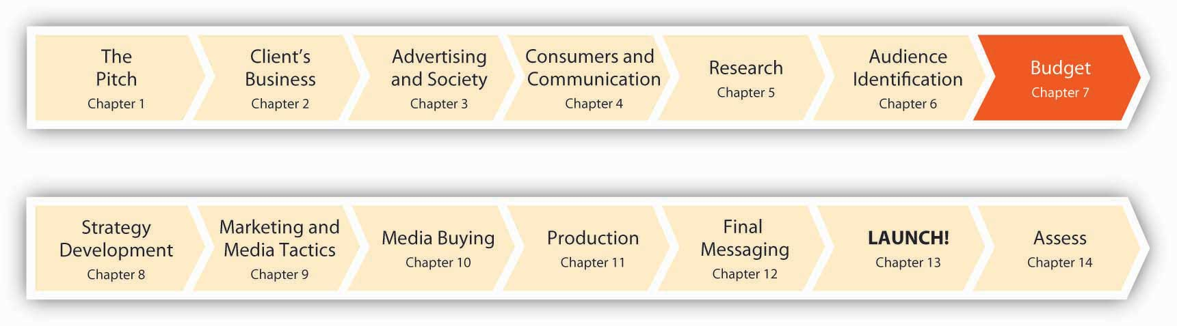
Before the SS+K team could set off to develop their marketing recommendations, Catherine Captain had to set a budget for their efforts. It was important for Russell and Amit to understand the parameters of the work at hand; creative, media, and promotional recommendations would be vastly different for a $2 million effort versus a $20 million effort.
Once they were informed of the blanket budget to cover all SS+K related initiatives, it was up to them to work with Catherine to recommend the best way to make every dollar sing. But before the budget is split up, the client has to determine the total. As the VP of Marketing, Catherine had to request a certain amount of money from the board of msnbc.com—and justify why she wanted it. In the ad biz, there’s no such thing as a free lunch.

7.1 Budgeting Methods

LEARNING OBJECTIVES
After studying this section, students should be able to do the following:
- Recognize the two primary top-down budgeting methods.
- Identify the pros and cons of the top-down budgeting methods.
- Recognize the two primary bottom-up budgeting methods.
- Discuss budget allocation and the importance of timing in budgeting.
Budget decisions are affected by conditions both internal and external to the client. One key external influence is the overall economic condition of the country and how this affects the client’s industry. Even the most inspired advertising may not motivate consumers to open their wallets in troubled times like now. We see this situation now quite clearly, for example, in the automotive industry, as the stock market and credit crises have made money scarce, and consumers are pressed to pay higher prices for gasoline, home heating, groceries, and other necessities. It’s not surprising, then, that automotive advertising spending in the United States dropped to $1.99 billion in the first quarter of 2008. That sounds like a lot of money (and it is!)—but it’s down more than 14 percent compared with the same time a year before. As one industry executive observed, ad spending is “sinking as fast as new car sales.” When times are tough, nothing is sacred: Even Tiger Woods’ nine-year relationship as a fixture in General Motors’ advertising got the axe as the industry tries to slash its costs. ^{[1]}

Top-Down Budgeting
In top-down budgeting, top management sets the overall amount the company will spend on promotional activities for the year. This total amount is then allocated among all of the advertising, PR, and other promotional programs. How does top management arrive at the annual promotional budget? Typically, they use a percentage-of-sales method, in which the budget is based on the amount the company spent on advertising in the previous year and the sales in that year.

Percentage-of-Sales Method
The percentage-of-sales method is the ratio of the firm’s past annual promotional budget divided by past sales to arrive at the percentage of sales. That percentage of sales is then applied to the expected sales in the coming year to arrive at the budget for that year. For example, if the company spent $20 million on advertising last year and had $100 million in sales, the percentage of sales would be 20 percent. If the company expects to achieve $120 million in sales the following year, then 20 percent of $120 million is $24 million, which would be the budget for advertising that year.
Figure 7.2 Percentage-of-Sales Method
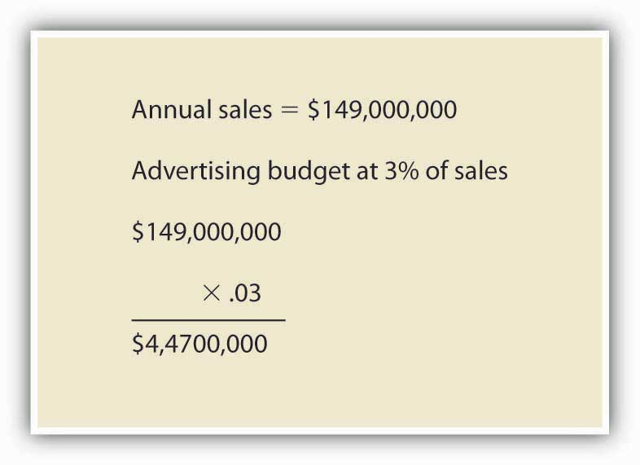
Wall Street analysts sometimes look at changes in the ad-to-sales ratio as a sign of the health of a company. For example, Procter & Gamble’s ad-to-sales-ratio slipped from 10.7 percent in 2004 to 9.9 percent in 2006. Those declines came as P&G faced growing margin pressure from rising commodity costs. Some analysts see strong ad spending as an investment in growth or a sign that a company is having no trouble meeting its earnings targets, so they want to see an ad-to-sales ratio that is consistent or increasing. ^{[2]}

Industry Averages Method
Some companies use industry averages (published by trade associations) as a guide to set their promotional budget. Ad-to-sales ratios vary widely depending on the industry. For example, health services companies had one of the highest ad-to-sales ratios for 2006, at 18.7 percent. Other industries with high ad-to-sales ratios are transportation services (14.2 percent), motion pictures and videotape productions (13.7 percent), food (11.9 percent), newspapers (11.1 percent), and broadcast television stations (10.7 percent). In contrast, computer and office equipment had an ad-to-sales ratio of 1.2 percent, while computers and software wholesale had only a 0.2 percent ad-to-sales ratio. ^{[3]}
Sometimes a dramatic increase in ad spending by one competitor in an industry spurs others to follow suit. For example, in 2007 German insurance giant Allianz more than quadrupled its annual global advertising budget to 225 million euros after competitor Zurich Financial Services launched a large-scale global awareness campaign. ^{[4]} Similarly, the auto insurance industry saw overall ad spending jump more than 32 percent in just two years when GEICO increased its ad spending 75 percent in 2004; this spurred competitors to increase their ad budgets as well. Progressive Insurance spent $265 million in 2006, up from $201 million in 2004, and State Farm likewise plans to increase spending, which topped $270 million in measured media in 2006. ^{[5]}
Spending on certain segments of the promotional budget, such as on coupons, is very much driven by competitor spending levels. Consumer packaged goods companies like P&G and Unilever claim not to like couponing schemes as a promotional activity. Indeed, P&G looked into eliminating coupons in 1997 due to declining newspaper circulation and usage. But companies are tied to using coupon promotions. If one company alone decides to forgo couponing, they face losing cost-conscious consumers to the competition. If companies try to work together to scale back on couponing, they might be accused of violating antitrust regulations. As a result, spending on the media side of couponing was up 26 percent in 2006, reaching $1.8 billion, even though consumer use of coupons was down 13 percent during the same time period. ^{[6]}

Pros and Cons of Top-Down Methods
The advantages of top-down approaches are their speed and straightforwardness. The disadvantage is that the methods look to the past as a guide, rather than to future goals. Just because a company spent $40 million on advertising the previous year doesn’t mean that figure is right for next year. Also, budgets tied to sales figures mean that a company’s promotional budget will decrease if sales decrease—but in fact increasing the promotional budget may be precisely what is needed in order to remedy declining sales.

Bottom-Up Techniques
Alternatively, some companies begin the budgeting process each year with a clean slate. They use bottom-up budgeting techniques, in which they first identify promotional goals (regardless of past performance) and allocate enough money to achieve those goals.

Objective-Task Method
The objective-task method is the most common technique of bottom-up budgeting. Companies that use this method first set the objective or task they want the promotion to achieve. Next, they estimate the budget they will need to accomplish that objective or task. Finally, top management reviews and approves the budget recommendation.
For example, champagne maker Moët & Chandon set its objective “to grow the whole market” in the United States. ^{[7]} That is, Moët will use advertising to increase consumption of champagne throughout the year, not just over the holidays. Moët based its objective on research that compared champagne consumption in the United States to that in other countries. “The average U.S consumer drinks half a glass of champagne a year, the average British consumer drinks half a bottle and the average French consumer drinks three bottles. There’s clearly room for growth,” said Stuart Foster, director of business development at Moët-Hennessy USA. ^{[8]} Moët more than tripled its U.S. ad spending in 2006 to $9.5 million from $2.8 million. Reflecting the objective, the company ran its advertising in the summer rather than just around the holidays.
Similarly, Danone Waters is increasing its ad spending in the United Kingdom in 2008 in an effort to increase bottled water consumption among British consumers. Danone Waters is increasing its spending by 15 percent, compared to Moët’s tripling of ad expenditures, which shows that there is no hard-and-fast rule about how much budget is needed to reach a given objective. ^{[9]}
Other objectives advertisers can set include acquiring new customers, retaining existing customers, or building the brand. The objective to acquire new customers often requires a bigger budget than the advertising the firm needs to retain existing customers.

Stage-Based Spending
Some companies use the product life cycle method, in which they allocate more money during the introduction stage of a new product than in later stages when the product is established. For example, Procter & Gamble allocated $15 million to advertising Dawn Simple Pleasures, a new liquid detergent product that comes with a separate air freshener attached to the base of the bottle. It allocated less money ($10–12 million) for Dawn Direct Foam, a product it launched two years prior. ^{[10]} The need to spend heavily to promote new products is especially strong for pharmaceutical companies when they introduce new drugs. Pharmaceutical companies need to get physicians to talk about their drugs and prescribe them.
In contrast, companies such as baby food manufacturers need to invest in strong promotion on a continual basis, because they get a new set of customers every year. “We provide strong consumer promotion support to drive trial, particularly in our baby segments, where we have a new group of consumers entering the market each year,” said Randy Sloan, executive vice president and general manager at Del Pharmaceuticals, which is the number one advertiser in teething pain relief, children’s toothpaste, and adult oral pain products. ^{[11]}

SS+K Spotlight
Since msnbc.com’s fiscal year runs from July to June, Catherine Captain and all other department heads must start submitting their budget requests in March so that the board can determine their budgets before the next fiscal year starts. They use a bottom-up strategy based on objectives, but sales are also a vital part of determining what the final spend will be.

Budget Allocation and Timing
In addition to deciding how much to spend, companies need to know when they will be spending the money.
Figure 7.3 msnbc.com Budget Allocation
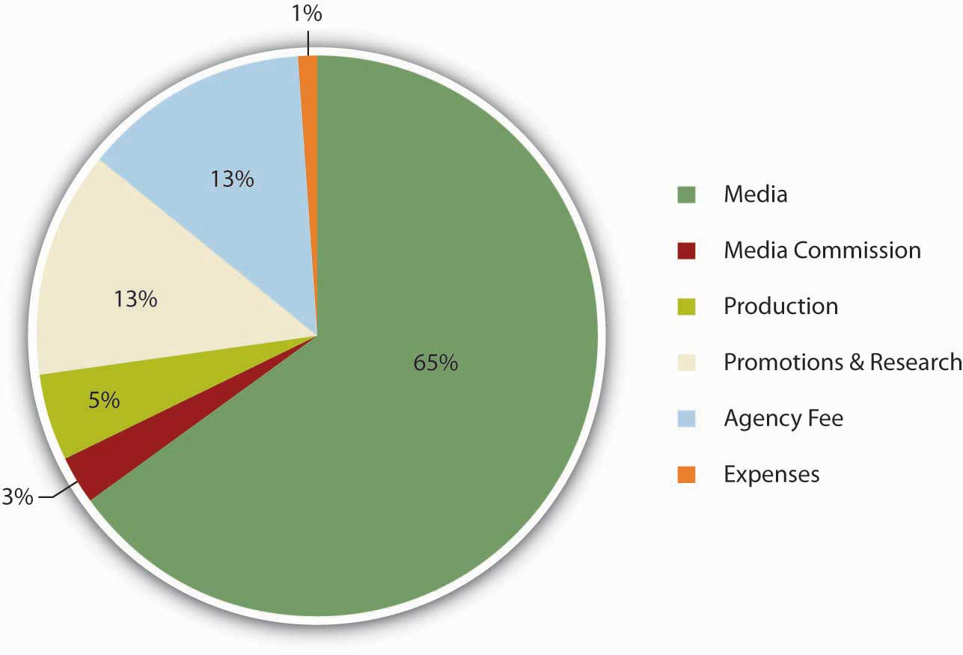
For some companies, the timing is smooth. As we saw with the Moët champagne example, the company will spend its budget throughout the year. Many other businesses step up their advertising in the weeks leading up to the Christmas holiday season. Others, such as beach apparel makers or home improvement companies whose work is done in warm weather, may concentrate their spending during a particular time of year.
Keep in mind that the budget needs to pay for more than just creating the ads and buying the media to run them. Consider a beachwear campaign for an apparel maker as an example. Although most of the campaign budget is spent in the second quarter on media buys to hit consumers with swimsuit ads as they gear up for summer, the ad agency has to allocate some of the money to laying the groundwork for this campaign. It will need to spend some money in the earlier part of the year to pay for market research, ad development, and testing. After the ads run, the last of the budget might go to assess the campaign’s effectiveness.
Other factors that contribute to budgeting:
- Media costs: For retailers, the holiday season is a popular time, so like all things supply and demand, media costs tend to go up during that time.
- Production costs: An incredible number of components contribute to making an ad, whether it’s TV, Web banner, or print, and the cost can vary widely, which is important to consider when you build a bottom-up budget.

SS+K Spotlight
While a lump sum budget had been approved for SS+K to spend, Catherine Captain and msnbc.com had to be responsive to their internal revenue situations. In other words, if they weren’t hitting other advertising sales objectives, they were not going to be ready to pull the trigger on the disbursement of millions of dollars.
Figure 7.4Budget Snapshot of the Elements and Timing for the msnbc.com Campaign
SS+K outlined each element of the production and when the agency would have to have the client’s money fully committed and available to spend. Part of the account management team’s responsibility is to manage the schedule by which everyone gets paid for her part in a production.

KEY TAKEAWAY
Clients use a variety of methods to determine their advertising budgets. One basic distinction is between top-down and bottom-up methods. Top-down approaches are easier; they basically use last year’s expenditures as a starting point. However, they also are more simplistic and may be self-defeating because they wind up allocating more money to promote products that are doing well at the expense of products that are doing poorly—when just the opposite adjustment may make more sense. Bottom-up approaches start by specifying the particular objectives a firm has for a brand and then estimating how much it will cost to meet those objectives. Budget-setting is more complicated than just tallying up what it costs to make and place advertising; the client also has to consider the resources an agency will need to conduct research, develop an advertising strategy, and measure how well the strategy worked so it can tweak the approach in the future if necessary.

EXERCISES
- Compare and contrast top-down budgeting with bottom-up budgeting.
- Describe when advertisers should use the percentage of sales and industry averages methods for budgeting.
- Describe when advertisers should use the objective-and-task and stage-based spending methods for budgeting.
- Describe and explain the factors that contribute to proper budget allocation and timing.

[1] Quoted in “Auto Ad Spending Down, Except Digital,” eMarketer, July 23, 2008,http://www.emarketer.com/Article.aspx?id=1006426&src=article1_newsltr (accessed July 23, 2008); Rich Thomaselli, “GM Ending Tiger Woods Endorsement Deal,” Advertising Age, November 24, 2008, http://adage.com/article?article_id=132810 (accessed November 28, 2008); http://adage.com/article?article_id=46288& search_phrase=shona%20seifert.
[2] Jack Neff, “P&G Rewrites its Definition of ‘Ad Spend,’” Advertising Age, September 3, 2007, 3.
[3] Kate Maddox, “Ad Spending Up in ’05, ’06,” B to B, August 8, 2005, 17.
[4] “Allianz Plans €225m Global Branding Blitz,” Marketing Week, May 3, 2007,http://goliath.ecnext.com/coms2/gi_0199-6503373/Allianz-plans-225m-global-branding.html (accessed February 1, 2009).
[5] Mya Frazier, “Geico’s $500M Outlay Pays Off,” Advertising Age, July 9, 2007, 8.
[6] Jack Neff, “Package-Goods Players Just Can’t Quit Coupons,” Advertising Age, May 14, 2007, 8.
[7] Jeremy Mullman, “Moët, Rivals Pour More Ad Bucks into Bubbly: Champagne Makers Try to Create Year-Round Demand,” Advertising Age, September 3, 2007, 4.
[8] Jeremy Mullman, “Moët, Rivals Pour More Ad Bucks into Bubbly: Champagne Makers Try to Create Year-Round Demand,” Advertising Age, September 3, 2007, 4.
[9] Jeremy Mullman, “Moët, Rivals Pour More Ad Bucks into Bubbly: Champagne Makers Try to Create Year-Round Demand,” Advertising Age, September 3, 2007, 4; “Danone Waters Plans to Increase Spend by 15%,” Marketing, July 25, 2007, 4.
[10] Vanessa L. Facenda, “Procter Dishes out 3-Tiered Dawn Attack,” Brandweek, September 24, 2007, 4.
[11] Quoted in “A Targeted Approach Creates a Powerhouse,” Chain Drug Review, June 4, 2007, 34.

7.2 Share of Voice (SOV)

LEARNING OBJECTIVE
After studying this section, students should be able to:
- Describe share of voice (SOV) and its role in creating budget objectives.

How Loud Are You?
Share of voice (SOV) is the relative fraction of ad inventory a single advertiser uses within a defined market over a specified time period. It measures how you are doing relative to competitors and relative to all the ads within your given space. It tells you the total percentage that you possess of the particular niche, market, or audience that you are targeting. The obvious way for a client to attain high SOV is to buy a lot of ad space. Another way is to have competitors that don’t advertise very much; remember SOV is a measure of relative activity.
Figure 7.5 Share of Voice
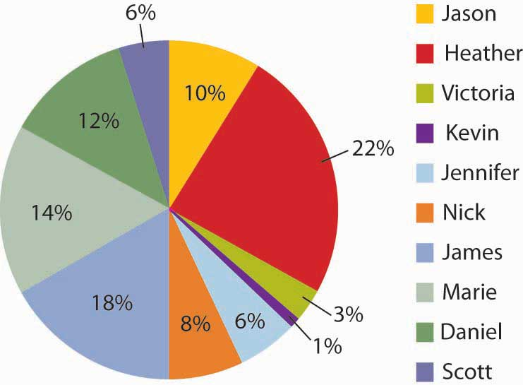
The share of voice concept can be demonstrated by the participation in a class. The students who participate the most relative to other students have a larger share of voice in the class. The same happens in advertising.
Online, Google uses a similar metric it calls Impression Share to represent the percentage of times your ads were actually shown in relation to the total number of chances your ads could have been shown, based on your keyword and campaign settings. ^{[1]}

SS+K Spotlight
As msnbc.com’s marketing budget is nowhere near those of its largest rivals like CNN or the New York Times, SS+K didn’t even think about attaining competitive SOV share in this campaign. However, since a major objective for the campaign was to increase awareness and impressions, the agency deliberately used tactics that resulted in large SOV on a particular day. For example, when they placed their ads on Web sites they would try to engineer a “homepage takeover” or a “roadblock,” meaning that all the available ad units on the homepage are dedicated to one advertiser.
In situations where big clients compete on a fairly even playing field (unlike SS+K’s “David and Goliath” situation with msnbc.com), share of voice is an important indicator of competitiveness. It reflects the extent to which your customers are being influenced by your ads versus those of rivals who also try to get their attention with similar messages. Long-term analysis shows that brands that increase their share of voice with powerful advertising stand a better chance of increasing their market share.
High SOV helps provide top-of-mind awareness and provides a company with a competitive advantage because this awareness allows it to dictate what criteria consumers use to evaluate products. ^{[2]} For example, in the last century (1994, to be exact) the heavy advertiser Pepsi introduced “freshness dating” on its products and convinced many consumers that it’s important to buy cans of soda that are less than a year old. ^{[3]} This campaign was pretty successful—even though in reality a very small percentage of soft drink inventory in a grocery store would linger on the shelves for that long. In the ad biz, it’s often true that “he who has the bucks, makes the rules.”

Using SOV
How much share of voice can you afford? How much would it cost to buy every minute of commercial time in the Super Bowl? You can’t afford to buy it all, but you can buy some fraction of it.
Attaining high SOV usually means spending more than your competitors. If your analysis suggests that your competitors spend $5 million on media buys, then you need to spend $5 million just to match them and achieve a 50% SOV. If the competition has cut back on spending (such as during an economic downturn like we’re now experiencing), then you might maintain your current level of ad spending and still garner a high SOV. If your company has many competitors or bigger competitors, you may find it impossible to outspend them to achieve a high SOV.

Dig Deeper
To promote its DVD of Hollow Man, movie studio Columbia Tri-Star asked its ad agency, Universal McCann Los Angeles, to reach as many consumers as possible with a relatively low budget. Like SS+K did for msnbc.com, the agency created a “roadblock” campaign on the top online portals, entertainment properties, and sci-fi sites over a few hours in one specific day. During a roadblock, the only ads that appear are those for that company. Thus, on one Friday during the lunch hour and during 6:00 p.m. to 9:00 p.m., the only ads shown on these sites were for Hollow Man, achieving 100% SOV for those hours.
Did this saturation strategy work? Several online vendors reported huge sales spikes of Hollow Man, and one vendor reported a 25% sales increase during the time the campaign was live. In addition, the DVD debuted in the number one position for sales and remained in the Top-Twenty Chart for three months. ^{[4]}

SOV for Small Companies
For small companies, share of voice is often not an appropriate metric because there are so many bigger competitors who will outspend the smaller company. The online roadblock tactic might be one way of achieving share of voice that is less expensive. Perhaps a better way to set budgets, however, might be to use the return on investment approach, as we’ll see next.

KEY TAKEAWAYS
Share of voice is a way to think about the impact one brand’s advertising has on its audience—relative to what its competitors are doing. Clients with reasonably equal resources can compare how active they are (i.e., how many messages the campaign sends out). Clients who are at a financial disadvantage have to be a bit more creative. Sometimes they prefer to concentrate their limited resources to get a bigger bang for the buck during a limited time period and forgo the opportunity to send out their messages at other times.

EXERCISES
- Explain the concept of share of voice (SOV) and its importance to the budgeting process.
- Discuss roadblocks and how they may be used to enhance share of voice (SOV).

[1] “Discover your Share of Voice with Impression Share Reporting,” Google AdWords,http://adwords.blogspot.com/2007/07/discover-your-share-of-voice-with.html, (accessed July 23, 2008).
[2] “Pepsi introduces freshness dating,” Chain Drug Review (April, 1994),http://findarticles.com/p/articles/mi_hb3007/is_199404/ai_n7964159, (accessed July 23, 2008).
[3] “Research Ensures Rewards,” Marketing Week (July 5, 2007), p33.
[4] Joseph Jaffe, “Dominate Online Share of Voice,” iMedia Connection (February 24, 2003),http://www.imediaconnection.com/content/1050.asp, (accessed July 23, 2008).

7.3 Return on Investment (ROI)

LEARNING OBJECTIVES
After studying this section, students should be able to do the following:
- Define and evaluate return on investment (ROI).
- Explain why return on investment (ROI) can make advertising accountable.
- List and discuss the keys to using return on investment (ROI) successfully in the pursuit of profit and channel effectiveness.

Did You Get What You Paid For?
Return on investment is the amount of profit an investment generates. In other words, did your action result in more (or less) than what it cost to implement? The ROI approach to budgeting looks at advertisement as an investment, not a cost. And like any investment, the company expects a good financial return on that investment. By making the investment in advertising, the company expects to see profits from that investment.
Figure 7.6
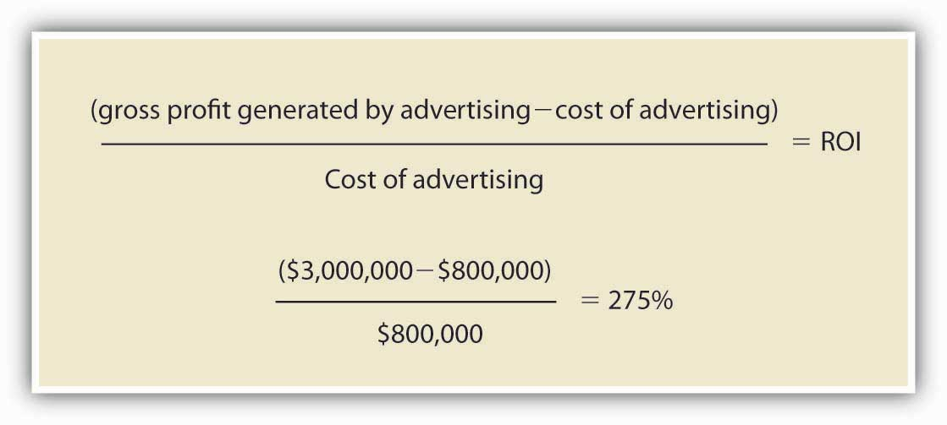
ROI is a way to determine the sales generated from advertising relative to the cost of the advertising.
The idea behind ROI is that for every dollar you spend on advertising, you get a dollar-plus-something of profit in return. The challenge with ROI is that it’s difficult to interpret and analyze the contribution of a specific ad, media channel, or campaign to overall profit. Is the profit coming from a short-term sales blip or is it contributing to longer-term profits?

Why ROI Is Important
ROI is the language of business. Although many marketing people traditionally evaluate a campaign’s success in terms of intangibles like brand awareness, top management insists on more tangible results: ka-ching! Advertisers face increasing pressure to translate the results of what they do into ROI terms. If they succeed, they can assure the bean counters that if they’re given a certain amount of budget, they will earn the company x percent more. But it’s not so easy to quantify the effects of ad messages, and it never has been. One well-known quote (so well known it’s practically a cliché) that has at times been attributed to Henry Ford, retailing executive John Wanamaker, and others sums up this dilemma: “I know that half of my advertising works—I just don’t know which half.”

Dig Deeper
How many people watch TV commercials, and how effective are these spots in influencing actual purchases? These are vitally important questions—especially because the networks set their rates for advertising based upon how many people see their shows. To date there still is no foolproof way to deliver these metrics, and it’s the source of a lot of controversy in the advertising industry.
The dominant measurement system is the Nielsen Television Ratings that the networks have relied upon since the earliest days of television. The Nielsen Company collects these measures by recruiting a panel of consumers who keep a diary of what they watch and by so-called set meters that it connects to members’ TV sets to transmit data about which channels get selected. These methods suffer from obvious problems—for example, our memories about what we watch often are distorted and biased, and just because a set is tuned to a channel doesn’t mean anyone is actually watching. Nielsen is working hard to update its technology with People Meters that individual members of the household use to record their viewing behaviors. GfK AG’s Mediamark Research Inc. also is developing a pager-size media-measurement device. And, to keep pace with consumers’ changing habits, Nielsen has started to measure out-of-home viewing (in bars, dorms, and other locations) as well as the usage of digital video recordings like TiVo. Nielsen is also working on a new measurement system it calls Anytime Anywhere Media Measurement. This system will track a group of sample viewers—but it will monitor their usage of several different media including the Internet, mobile devices like iPods, and traditional television. ^{[1]}
The company that comes up with a truly reliable system to measure how consumers interact with media (and the advertising they contain) will be worth its weight in gold. One new research firm called TRA (True ROI Accountability for Media) is trying another strategy: it merges data from people’s cable set-top boxes with consumer-purchase databases, such as the information stores gather from frequent-shopper cards. For instance, a company could see whether households that watched an ad for its toothpaste later bought that brand of toothpaste. In a test of its system, TRA is using data from cable boxes to measure second-by-second viewership of TV programs and commercials in three hundred thousand households in Southern California, and it aims to sign up more than one million U.S. households across the country in the near future. ^{[2]}
A different approach hopes to use cell phones to measure what consumers listen to and see. The startup firm Integrated Media Measurement Inc. has developed software that enables specially adapted cell phones to take samples of nearby sounds, which it then identifies by comparing these to a large database. The company claims that this technology can track exposure to television, radio, CDs, DVDs, video games, sporting events, audio and video on portable gadgets, and movies in theaters. These are some of the questions the company hopes to answer: ^{[3]}
- How often are TV shows watched outside the home?
- Which songs prompt listeners to change radio stations?
- Which movie trailers get viewers to go to the theater?
- Which technology will prevail?
Stay tuned…

ROI Is the Real Goal (SOV Is Only the Means to an End)
At the end of the day, then, share of voice is only a means to the end. Ultimately, advertisers want consumers to purchase what they make, not just think their ads are awesome. If the money spent on advertising never generates any returns, then what is the point—other than to improve the bottom lines of ad agencies and enrich the portfolios of creative directors? As Gavin Ailes, business director at The Search Works in the United Kingdom, explained, if a company gets two dollars back for each dollar they invest, “that’s great, they shouldn’t really worry too much whether they have ‘share of voice’ or whatever among a particular group.” ^{[4]}

ROI Makes Advertising Accountable
An Institute of Practitioners (IPA) report entitled Marketing in the Era of Accountability is based on the IPA’s database of effectiveness awards case studies. The report found that advertising campaigns that set hard objectives, such as to “improve profits,” are more effective than those that focus on intermediate goals, such as degree of brand awareness. Fewer than 20 percent of companies evaluate their communications campaigns on the basis of their effect on profits, however, because it is easier to measure an intermediate metric than an ROI metric. ^{[5]}

SS+K Spotlight
As msnbc.com set its goals for the branding campaign, the client had to identify what metrics (measures of effectiveness) would be most meaningful to their mission. All marketers ultimately aim to increase revenue for their business as a result of marketing efforts. Every element of a campaign has accountability to perform or meet that goal; otherwise it’s not likely to appear again.
With the first round, msnbc.com decided to invest in some short-term vehicles—Web ads and click-through rates—to determine ROI. They also invested in some long-term vehicles such as the screensaver and the NewsBreaker online game we’ll check out later.

Keys to Using ROI
Using ROI effectively depends on several factors, including visibility, the difference between revenue and profit, channel effectiveness, and taking a long-term perspective.

Visibility: Can You See the ROI?
Some firms are in the enviable position of seeing a return on their investment more directly than others. For example, Domino’s Pizza can see the results of its advertising almost immediately—a TV ad immediately spurs calls to its outlets as people order the ExtravaganZZa Feast the spot featured. As the chain’s marketing director explained, “The time it takes from initial consideration to consumption can be less than an hour. We can see the impact of a TV ad almost immediately.” ^{[6]}
Online advertising is also amenable to rigorous ROI measures. Watching impressions, counting click-throughs, and using cookies let advertising managers know how many people saw an ad, clicked on the ad, and bought from the ad. Web traffic can be tracked, and advertising spending can be aligned to sales. ^{[7]}

Dig Deeper
As difficult as the ROI of traditional advertising vehicles is to measure, word of mouth is even harder to measure. As online content chatter on blogs and Web sites continues to mushroom, advertisers need to measure just what consumers are saying about their products and how active they are in spreading the word about viral marketing campaigns or other online promotions. Buzz Metrics, a subsidiary of the Nielsen Company, offers marketers research services to help advertisers understand how CGM (consumer-generated media) affects their brands. Nielsen’s Buzz Metrics search engines identify online word-of-mouth commentary and conversations to closely examine phrases, opinions, keywords, sentences, and images people use when they talk about a client’s products. The company’s processing programs then analyze vocabulary, language patterns, and phrasing to determine whether the comments are positive or negative and whether the authors are men, women, young, or old to more accurately measure buzz. BuzzMetrics’ BrandPulse and BrandPulse Insight reports tell advertisers who is talking about their products online and what they say about the ads they’re seeing. ^{[8]}

ROI Requires More Profit, Not Just More Revenue
Ideally, payback should be about profit, but many companies confuse added profit with added revenue. To avoid these mistakes, clothing manufacturer VF Corp (whose brands include Lee, Wrangler, Nautica, and The North Face, among others) spent two years and millions of dollars studying consumer responses to its marketing efforts while seeking to determine which of its brands have gotten the best ROI from advertising. “We are convinced we can be more effective by having a better understanding of marketing return on investment and will get paid back on our investment several times over,” said Eric Wiseman, president/COO at VF.
In 2006, VF spent about $325 million on advertising across all its brands. The Nautica brand is already reaping the benefits of VF’s ROI research. The company increased Nautica’s marketing budget the next year. “Our budget is up and we are moving the mix around,” said Chris Fuentes, vice president of marketing at Nautica. “We’ve looked at each element of our marketing—magazines, newspaper, outdoor, sponsorship, public relations—[and] we can isolate what is working. We’re understanding now what is driving consumption and building brand equity.”
The research helped the company decide that Nautica’s advertising budget should be increased because the advertising was providing a good return on investment. What’s more, the research helped Nautica pinpoint which of its campaigns were most effective in bringing that return. Nautica is using that information to decide how to allocate its advertising budget. Nautica uses an integrated marketing program of print, outdoor, and Internet advertising. The research showed that newspaper ads generated underachieving results, so Nautica will spend less on them, but it will boost its Internet presence to target young men for its new N series jeans. Nautica spent $20 million on ads in 2006.^{[9]}

ROI for Channel Effectiveness
ROI can also help manage an advertising campaign as effectiveness measures help identify which specific media platforms deliver the best bang for the buck. Nautica relies on its ROI research to drive budget allocation among different campaigns, allocating more to those that have provided the best return in the past. For example, Nautica’s sponsorship of the AVP Pro Beach Volleyball Tour produced good results. So, in 2007, Nautica increased its presence there, adding on-court billboards and a scoreboard bug on the TV screen, and having announcers and pro Misty May outfitted in Nautica apparel.

Dig Deeper
One promotional channel that’s been getting a lot more attention in recent years is POP (point-of-purchase) advertising—ad messages that shoppers see when they are physically located in a purchasing environment. Like traditional advertising, it’s hard to determine how effective these messages are—though we know that in some categories (e.g., grocery) many shoppers don’t make their final decisions until they’re wheeling their carts through the aisles (never go food shopping when you’re hungry!).
A major new initiative called P.R.I.S.M. (Pioneering Research for an In-Store Metric) is attempting to quantify the impact of these messages. Participating companies include Procter & Gamble, Coca-Cola, ConAgra, General Mills, Kroger, Walgreens, Wal-Mart, 3M, Walt Disney, Kellogg, Miller Brewing, and even Nintendo. Ad agencies OMD and Starcom MediaVest Group, as well as multiple retailers, are also involved. The measurement model predicts consumer reach by category or area of the store, by retail format, and by day of the week, delivering unprecedented insight into the store as a marketing channel.
The consortium’s research team began working on the theory that, by predicting in-store traffic, then determining what marketing communications are in the store, it could calculate the “opportunities to see” a specific communication. By using existing statistical models that factor out duplicate impressions (accounting for multiple “visits” to the area by the same people) a measurement for consumer reach could be calculated for specific locations in the store. Initial tests have been promising. The CEO of Procter & Gamble recently predicted, “P.R.I.S.M. will transform how we think about in-store consumer communications and behavior.” ^{[10]}

Avoid Overemphasis on Short-Term ROI
Most advertising ROI metrics tend to focus on short-term profits from the immediate response to an ad. This emphasis is appropriate in some contexts; for example, that’s one of the big advantages of direct marketing, because the firm can immediately trace the impact of a mailing or e-mail blast and decide right away if it boosted orders.
On the other hand, brand-building campaigns produce a low ROI in terms of short-term profits, but they are crucial for the long term. In these cases managers may need to adopt a broader field of vision and be patient, even if they are bleeding red right now. For example, one company discovered that every dollar the company spent on TV advertising yielded only eighty cents back in short-term sales. Executives were thinking of chopping the TV budget, but the general manager said, “Just because print and promotion activities have the highest ROI, doesn’t mean they should get the majority of the money. Print only accounts for a small fraction of total sales, and while TV has a lower ROI, it’s responsible for a huge amount of ongoing sales.” ^{[11]} This reasoning shows that the bigger picture must be taken into account when managers make budget decisions. Making this case can be a daunting task for advertising agencies, especially when their clients are under pressure to show profitable returns to their shareholders.

KEY TAKEAWAY
At the end of the day, it’s all about ROI. Ad agencies and other promotional companies are coming under increasing pressure to show specifically how their activities deliver value to the client—by quantifying how much financial return the client receives in exchange for the money it spends to advertise. Showing ROI is difficult when many campaigns are more about building long-term awareness and loyalty than prompting immediate purchases (sales promotions, online advertising, and direct marketing are better able to link specific messages to specific results). However, there is a silver lining: this greater discipline forces advertising agencies to be more accountable—and in the process perhaps change the mindset of managers who tend to view advertising as a cost they need to minimize rather than as an investment in the brand’s performance.

EXERCISES
- Explain the concept of return on investment (ROI) and its importance to the budgeting process.
- Give two examples of how industry uses return on investment (ROI) to measure how consumers interact with media.
- Explain how return on investment (ROI) makes advertising accountable.
- List and describe four keys to using return on investment (ROI) successfully.

[1] Emily Steel, “Who’s Watching Those Webisodes? As TV Programs Fan Out to Cellphones and Beyond, a Race to Measure Audience,” Wall Street Journal, October 11, 2006, B4.
[2] Stephanie Kang, “Couch to Supermarket: Connecting Dots,” Wall Street Journal, February 11, 2008, B7.
[3] Don Clark, “Ad Measurement Is Going High Tech: Explosion of Media Offerings Complicates Finding whether Message is Getting Through,” Wall Street Journal, April 6, 2006, B4.
[4] Quoted in Sean Hargraves, “Made to Measure,” New Media Age, June 21, 2007, 21.
[5] “Marketing Theory: Everything You Know Is Wrong,” Marketing, June 13, 2007, 28.
[6] Quoted in “The Marketing Society Forum—Is a Focus on ROI Hindering Marketing’s Effectiveness?” Marketing, June 20, 2007, 24.
[7] “The Self-Assured Industry,” Marketing Week, June 14, 2007, 28.
[8] Keith Schneider, “Brands for the Chattering Masses,” New York Times Online, December 17, 2006, http://www.nytimes.com/2006/12/17/business/yourmoney/17buzz.html(accessed December 17, 2006); Nielsen Buzzmetrics,http://www.nielsenbuzzmetrics.com/products (accessed April 14, 2008).
[9] Quoted in Sandra O’Loughlin, “VF Designs Dynamic Future for Lee, Wrangler, Nautica: ROI Study Spurs Aggressive Marketing Plans at $7B Company,” Brandweek April 9, 2007, 16.
[10] Quoted in David Goetzl, “P&G CEO Endorses In-Store Marketing Measurement,” Marketing Daily, February 25, 2008, http://www.mediapost.com/publications/index.cfm?fa=Articles.showArticle&art_aid=77117 (accessed February 25, 2008); “The P.R.I.S.M. Project: Measuring In-Store Reach,” In-Store Marketing Institute, September 2006,http://www.instoremarketer.org/?q=node/5779 (accessed July 23, 2008).
[11] Quoted in Randy Stone, “When Good Returns Mean Anything But,” Brandweek, April 9, 2007, 20.

7.4 Managing a Budget
Now that you understand the importance and implications of marketing investments, it’s important to set up your budget specific to the needs of the campaign and the client. From Figure 7.3 "msnbc.com Budget Allocation" we know that msnbc.com had to monitor its spending by month and by category (agency fee, production, media, promotions, etc.). This budget was set up to reflect the contract between SS+K and msnbc.com that spelled out the categories and the amounts of the client’s money that the agency was entitled to spend.
The open collaboration and understanding of financials is key to the success of any business partnership. Both sides are responsible for staying in budget, and the agency is specifically responsible for justifying anything it spends for any purpose to a client. Former Ogilvy and Mather executives Shona Seifert and Thomas Early learned this lesson the hard way. In 2005, both were convicted and sentenced to prison for their roles in overbilling one of the agency’s clients, the Office of National Drug Policy. Seifert also was ordered to write a code of ethics for the entire ad industry as part of her sentence. ^{[1]}
There are a few key pieces to managing the budget: bids, estimates, invoices, and actuals. A bid is the estimated cost that a vendor will charge for a service. In some cases, the agency will have an exclusive partnership, and only one bid is needed. In other cases, a producer will take bids from multiple potential vendors or partners in order to understand the scope and price of that service.
Once the agency collects the bids, it will recommend the partner to the client. The formal acceptance of costs is the estimate. It is generated from the producer or accounting department. The agency outlines the job, a description, and the costs associated with the job. A job number is assigned to every estimate, and this job number and cost are inserted into the budget.
The agency invoices the client, and the client then pays the agency on the agreed-upon schedule. Sometimes jobs are billed at 100 percent of an invoice. Another common practice is to bill 50 percent of an invoice up front and 50 percent upon completion. It is important for the account manager to establish a system that works both for the agency and for the client when it comes to billing.
Actuals are the final cost of a job upon completion. In the SS+K/msnbc.com budget tracker that Figure 7.3 "msnbc.com Budget Allocation" shows, the bid is indicated in italics, the estimate is indicated with no treatment, and actuals are indicated in bold. This helps the agency and the client understand the money flow and make future spending decisions accordingly.

KEY TAKEAWAY
The open collaboration and understanding of financials is critical to the success of any business partnership. Both agency and client are responsible for establishing and maintaining the budget. The agency is specifically responsible for justifying anything it spends for any purpose to a client. The key components that an agency must manage are bids, estimates, invoices, and actuals.

[1] Matthew Creamer, “Shona Seifert Sentenced to 18 Months in Prison,” Advertising Age, July 14, 2005, http://adage.com/abstract.php?article_id=46288 (accessed February 1, 2009).

7.5 Exercises

TIE IT ALL TOGETHER
Now that you have read this chapter, you should be able to determine how the various budgeting methods can be applied to marketing and advertising:
- You can identify the two primary top-down budgeting methods.
- You can list the pros and cons of the top-down budgeting methods.
- You can identify the two primary bottom-up budgeting methods.
- You can evaluate the usefulness of the bottom-up budgeting methods.
- You can describe the usefulness and necessity of share of voice (SOV) when creating budget objectives.
- You can define and evaluate return on investment (ROI).
- You can explain why return on investment (ROI) makes advertising accountable.
- You can list and discuss the keys to using return on investment (ROI) successfully in the pursuit of profit and channel effectiveness.

USE WHAT YOU’VE LEARNED
- It’s not exactly new news that cosmetic companies are interested in what’s going on in Hollywood or in who’s wearing their makeup. It is news, though, when the company that’s interested is Avon. In our mothers’ generation, Avon’s business model emphasized personal contact, consumer parties, online and hard-copy catalogs, and word-of-mouth advertising as the primary formats for attracting consumer attention.
Under the leadership of CEO Andrea Jung, for the past decade Avon has been venturing into more mass media-driven ways of promoting and marketing its product lines. The “Just Another Avon Lady” campaign featuring Olympic athletes and the “Let’s Talk” campaign were among the first such efforts. More recently, Hollywood stars Reese Witherspoon and Patrick Dempsey are promoting Avon products in print ads and acting as spokespersons to the press. Will this new “sizzle” help the sagging brand? Time will tell.
Research recent events at Avon (see http://www.avon.com) and review their new strategies and advertisements for reaching consumers. Construct a new communication plan that will increase the company’s share of voice (SOV). Explain how metrics can be used to monitor Avon’s SOV progress. Evaluate Avon’s chances for success in increasing SOV if they adopt your plan.
- All of the budgeting methods presented in the chapter have advantages and disadvantages. Many of the disadvantages occur when the budgeting method is misapplied or used in the wrong circumstances. There appears to be no safe and sure way to decide which budget method is most appropriate. The “school of hard knocks” tells us that budgeting is as much of an art as it is a science.
Research a company of your own choosing and make a “best guess” about the budgeting form being used for advertising and promotional expenditures. Why do you think the company chose its budgeting method? Next, take each of the top-down and bottom-up budgeting methods described in the chapter and determine if any or all of the methods would be more appropriate for your chosen company. Comment on how you conducted your investigation and research process, how you made your “best guess,” and why the company should consider your budgeting advice. Discuss your findings with peers.

DIGITAL NATIVES
Do you Twitter? An increasing number of consumers do. According to the company’s Web site (http://www.twitter.com), “Twitter is a service for friends, family, and coworkers to communicate and stay connected through the exchange of quick, frequent answers to one simple question—what are you doing?”
There are various ways to “tweet” (send a Twitter message): use the Web site, instant message, and text message via cell phones. If a consumer chooses to use the Twitter Web site to make connections, he or she can microblog or information burst friends and acquaintances with up to 140 characters (short thoughts only). Such questions as “Where are you?” “What are you doing?” and “Where can we meet?” seem to be the most popular. This may all seem just like just another “texting” service, but Twitter is betting that consumer users will find new ways to make the “Twitter” experience special and more customized.
After researching the Twitter service and the implications for marketing and advertising of such services, assume the role of a creative director in an advertising agency and devise a plan for showing potential advertising clients how to use Twitter to advance their “share of voice (SOV)” objectives. Your plan should indicate new and creative ways to bring advertising client messages to consumers using the “texting” and “Twittering” formats. Discuss your ideas with peers and forecast the future of Twittering as a means of distributing advertising information and communication.

AD-VICE
- A company is trying to decide whether it should use the percentage-of-sales method or the objective-and-task method for budgeting its advertising expenses and costs. What factors should the company consider when making this choice? Be specific.
- M&Ms has just introduced a new dark chocolate M&M that it hopes will add to the company’s bottom line. The company has decided to use a stage-based spending approach as its advertising budgeting method. Critique this method as it might be applied to the M&M dark chocolate product launch. What critical factors do you think might be important for the company to consider if it uses the stage-based spending approach?
- After reviewing chapter materials in Figure 7.4 "Budget Snapshot of the Elements and Timing for the msnbc.com Campaign" evaluate the budget health of the msnbc.com campaign. What information did you consider? What comparisons did you make? Explain your thought process and how you made your evaluation. Comment on information that you would like to have to make a better evaluation.
- Given what you have read so far, how can msnbc.com make better use of share of voice (SOV) to reach its goals and objectives? What roadblocks would you recommend (if any)? What is the connection (if any) between share of voice (SOV) and return on investment (ROI)? Comment.

ETHICAL DILEMMA
According to information in the chapter, “return on investment (ROI) makes advertising more accountable.” Advertisers spend vast sums to further their communication objectives. Studies have indicated that advertising campaigns that set hard objectives (e.g., to improve profits) are more effective than campaigns that focus on intermediate or short-term goals (e.g., brand awareness or increased daily sales of product). Strangely, however, only about 20 percent of companies use return on investment or contribution to profit as important indicators of communication success. Why don’t more companies consider bottom line profits when evaluating success? The simple answer is that it is easier to measure an intermediate metric than an ROI metric.
Take a position that considers the ethics of accountability. Position One: Communication and delivery of emotional message objectives should not be tied directly to profits because of the difficulty of tracing profits back to specific emotional messages. Position Two: In an era of accountability, all messages should be more rational and have profit enhancement as their fundamental purpose.
Pick one of the two positions and support your position. Be prepared to defend your position among peers.

Chapter 8Create a Strategy: SS+K Puts Its Research to Use as the Agency Creates the Brief
Figure 8.1 Eight Months to Launch!
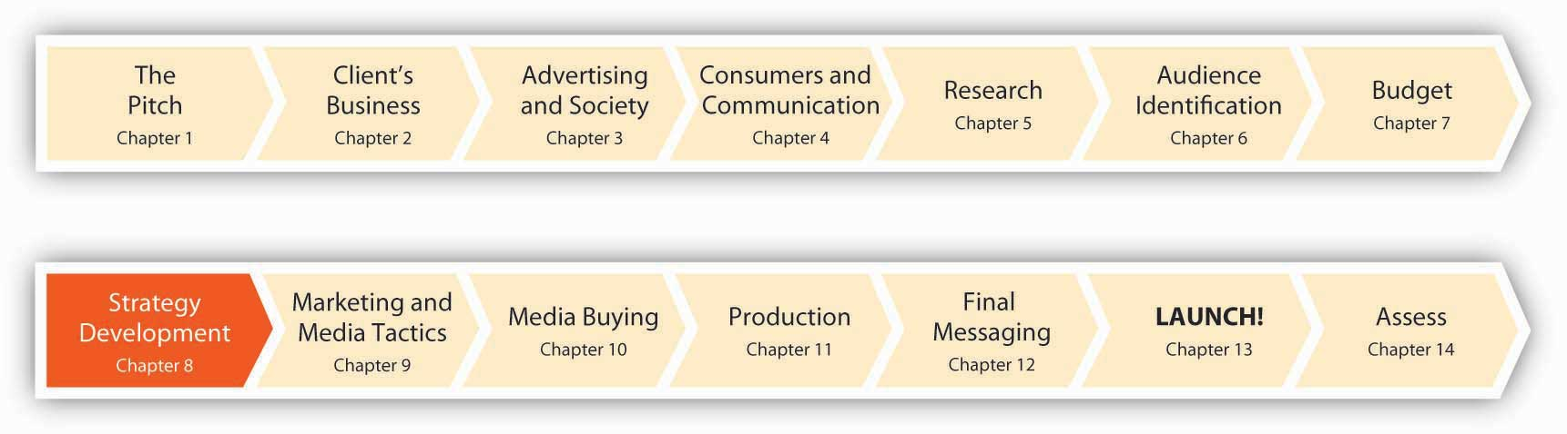
We are now eight months prior to the public launch of the msnbc.com campaign. The team at SS+K and Catherine Captain from msnbc.com have studied their customers. They have spent a considerable amount of time breaking down their prospective audience into segments. They have begun to identify where the competition is positioned and where there may be opportunities to serve a segment of customers better.
Now the work really begins. We must devise a strategy for this campaign. This will lead us into establishing our overall marketing strategy, and more specifically the strategy to position msnbc.com in this crowded marketplace.
Get ready. We only have eight months to Launch! It’s going to be a wild ride!

SS+K Spotlight
No false starts: “If this didn’t go well, there would be no more marketing as msnbc.com.”
When Catherine Captain left her job as USA Today’s Director of Marketing Research in April 2006 to become the VP-marketing for msnbc.com, she declared, “I have left the number one print newspaper in the country to join the number one online news site in the country. Who could ask for more?”
The aptly named Captain did ask for more—quickly, for she realized that a rapidly changing online news industry was threatening the market dominance msnbc.com had enjoyed for over a decade. Within less than a year of assuming her new post, Captain had requested and secured a $7 million marketing budget and had chosen strategic communications firm SS+K to oversee development of the online news giant’s first marketing campaign. Catherine’s challenge was clear.
Planning Is Everything. Although it’s tempting to just jump in and create some cool commercials, in reality the advertising you see or hear is just the tip of the iceberg. As Catherine at msnbc.com knows all too well, there are plenty of competitors out there who also can do cool advertising. Devising a strategy requires careful thought about your strengths and weaknesses. In addition, the only thing we can count on is that things change: a company must take stock of its environment and monitor what consumers think of it over time so it can anticipate changes instead of waiting to be surprised by them. By the time changes take place, it’s too late to react to them effectively. So, by strategy we mean a detailed plan that specifies overall objectives the client wishes to reach based upon a realistic assessment of its environment and what it is capable of achieving, as well as its general approach to reaching those objectives.

8.1 The Power of Branding

LEARNING OBJECTIVES
After studying this section, students should be able to do the following:
- Define branding and branding strategy.
- Identify the characteristics of a solid branding strategy.
- Explain the concepts of brand equity and value proposition.
- List and discuss the benefits of branding from the advertiser’s and buyer’s point of view.
What does your product or service mean to consumers?
Catherine and her team realized that the meaning of msnbc.com in the minds of their customers was not as strong as they desired. In essence, the Web site did not have a brand positioning that was distinctive, or as distinctive as they wanted. This section will discuss the power of brands. We’ll learn why creating that distinct positioning of your product or service, and often your entire company, is so vital.

Video Highlight
Rob Frankel on Branding
Rob Frankel, a branding expert, talks about what it takes for a brand to be successful.
Branding is a way to distinguish your product or service from others using a trademarked name or logo. Brands have been around for centuries. Early craftsmen put their marks on their wares to identify who made them, and artists have long signed their artwork. Since that time, however, branding has expanded well beyond just differentiation through marks and logos. Modern brands such as Apple, Nike, Tommy Hilfiger, and Wal-Mart now communicate meaning through attributes such as accountability, consistency, and even personality traits that their names have become associated with. These meanings translate to monetary value for the firm because their brand names acquire value—consumers willingly pay a premium to buy a product carrying a respected brand name as opposed to a similar product that carries an unknown brand name.

Figure 8.2
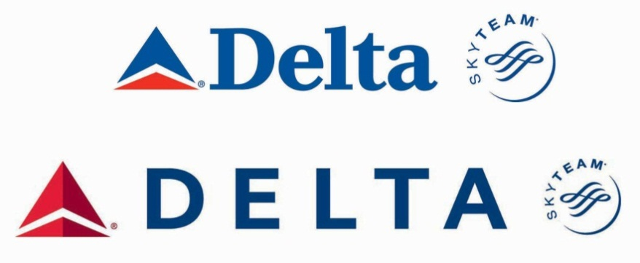
A brand logo is a key component of corporate identity. SS+K’s client Delta Airlines relies upon its well-known triangular logo to inspire a feeling of familiarity among consumers.
Developing a branding strategy creates a clear picture of the values your product or service represents. Why is that so important? The answer is simple, yet profound: People don’t buy things because of what the things do. They buy things because of what they mean. There are many MP3 players out there that do just as good a job as an iPod, but they don’t convey the same image to consumers. So, one result of a solid branding strategy is to create a barrier to entry so that competitors will find it difficult to persuade loyal consumers to abandon their favorite product for a newcomer.

Characteristics of a Solid Branding Strategy

Accountability
Brands impose a sense of accountability on the maker of a product. If you buy an Acme shoe and it performs poorly, you’re unlikely to buy Acme shoes again. On the other hand, if you’ve had a good experience with Acme, you’re likely to buy its shoes again and perhaps its socks, shirts, or golf clubs as well. In this way, the brand is a shorthand way of signaling quality that simplifies decision making for customers. People who know and like a given brand are more likely to buy it again.

Consistency
Brands don’t have to be high end to command loyalty; they just need to communicate a consistent meaning to consumers. That might mean projecting an image of quality, but it can also mean being associated with consistently low costs (e.g., Wal-Mart), trendy fashion (e.g., Juicy Couture), or a particular lifestyle (e.g., Whole Foods Market). A brand thus serves to express key properties of the products the company produces.

Brand Personality
Just as people have personalities, so do brands. Personality refers to the traits that a person exhibits. The person may not exhibit those characteristics all the time, but they tend to exhibit them regularly. A brand personality is a set of traits that people attribute to a product as if it were a person.

Dig Deeper
Identify a brand that claims each of these personality traits. How much do you and your classmates agree on each of these choices?
- self-confident
- sincere
- serious
- wholesome
- hip
- romantic
- rugged
- sophisticated
- athletic

Creating a Corporate Image
Corporations often engage in image advertising to enhance the public perception of the firm in the eyes of its most important constituencies—typically the firm’s customers, employees, and local communities. Although these campaigns aim to promote the company’s public identity rather than sell a specific product, a corporation’s image is intimately tied to its brand personality. The image of the firm reflects on the image of its brands.
In 2007, for example, Dow Chemical Company allocated over $25 million for a corporate ad campaign it called “the human element.” ^{[1]} The campaign was meant to appeal to local communities (who may or may not welcome Dow into their backyards), as well as legislators, journalists, environmentalists, employees, and shareholders. The idea behind the campaign is to show what the “human element” can do to solve some of the world’s problems, such as countering climate change and providing clean water, decent housing, health, safety, and an affordable and adequate food supply. Dow’s goal for the campaign is “to be acknowledged as the largest, most profitable, and most respected chemical company in the world.” Its CEO, Andrew Liveris, will consider the campaign a success “when a Dow employee in a bar anywhere in the world can tell the guy next to him where he works and get the response, ‘Oh, Dow. That’s good.’”

The Holy Grail: Brand Equity
Brand equity is the extent to which a consumer holds strong, favorable associations with a brand and is willing to pay more for the branded version of a product. Differentiation, accountability, consistency, and personality all support brand equity by creating a clear sense of the brand’s value proposition: the clearly identifiable benefit it provides relative to competing brands. As Roger Adams, senior vice president–CMO of Home Depot, said, “If you go to a grocery store or department store, there are brands on the shelf that have fundamentally the same function and one is 20 percent more than the other one. But people are paying that because there’s a belief in the brand or there’s an experience with the brand that builds trust, or they know if there’s a problem they can get service, that type of thing. And people do it every day.…That’s pretty much what brand marketing is about.”

Dig Deeper
Identify your five favorite brands. What makes them special? How do they differ from other, similar products you might choose instead? Interview a set of friends about their brand preferences and determine how much their preferences agree with each other. How do you explain what you found?

Summary: Benefits of a Brand
The benefit of a brand for advertisers is higher profitability: it is less expensive to attract repeat buyers than to find new customers. Moreover, satisfied buyers may pay a higher price for a trusted brand.
Brands have benefits for the buyer:
- Signals known properties (quality, performance, cost, etc.)
- Simplifies decision making
- Simplifies repeat purchase with a memorable name or logo
Brands have benefits for the manufacturer:
- Offers legal protection (through trademarks)
- Creates a barrier to entry for competitors
- Translates to financial benefits (both for the company’s bottom line and to impress Wall Street)

KEY TAKEAWAY
The power of branding derives from brand differentiation, accountability, consistency, and personality. Utilizing these principles helps to establish valuable brand equity.

EXERCISES
- List the common traits that a brand’s personality might include. Create an example to illustrate how some of the traits might be included in an ad.
- Summarize the benefits of a brand. Create one benefit list for the buyer and one benefit list for the advertiser/maker of the brand.

[1] Rance Crain, “Dow’s Corporate Ads Have Great Chemistry, but Will Respect Follow?” Advertising Age, August 6, 2007, 13.

8.2 Describe Where You Are: A Strategic Framework

LEARNING OBJECTIVES
After studying this section, students should be able to do the following:
- Describe the strategic framework that can be used to solve problems.
- Discuss how to conduct a situation analysis to understand problems and opportunities.
- Explain the function of a brand audit.
- Discuss the SWOTs and apply them to the solution of a problem.
Now that we understand the value of brands, it is time to get down to the business of strategy creation. Plan now, or regret it later! Here’s what an advertising strategist needs to do:
- Identify Your Situation. What are your strengths, weaknesses, threats, and opportunities?
- Define Where You Want to Go: Set Objectives. What do you want your marketing and advertising to accomplish?
- Outline How You Want to Get There: Create a Strategy. What is your plan to accomplish these objectives?
Fundamentally, our goal is to take a thorough internal look at our product, service, and firm. We must be objective. This is hard. Catherine joined msnbc.com and immediately began to understand the product itself and the brand. She must summarize where the current offering is positioned, identify where she wants it to be positioned, and then create an overall strategy to connect those dots. Getting this part right makes the rest of the challenge (and this book) easy. Getting it wrong…

Situation Analysis
Before you can decide where to go, you need to understand where you are (the current marketing situation or environment). Use secondary and primary research as discussed in Chapter 7 "Decide What You Can Afford to Say: msnbc.com Sets the Budget" to inform your assessment of the full situation. The situation analysis is an important tool to help you with this process.

Competitive Situation
A situation analysis begins with a review of the client’s industry and of the competitors vying for the consumer’s attention and dollars. For example, a situation analysis might reveal that some companies in the industry may not actually be competitors; buyers of Hyundais are unlikely to be buyers of BMWs as well. It may also reveal indirect competition in an industry. Southwest Airlines, for example, tries to price its airline tickets low enough to compete with buses and automobiles.
msnbc.com understood its competitors to reach beyond just other online news sites such as CNN.com or NYTimes.com. Its competition also included news aggregators or portals such as Google News as well as broader and new information sources such as Digg and Gawker.

Customer Situation
The situation analysis also evaluates the potential customers (prospects) for your product. This might include estimating the potential population of customers, demographic changes (such as aging Baby Boomers), potential sales per customer, trends in willingness to pay, and so on. Note that for consumer goods companies, the “customer” may be either the end consumer or the retailer. Thus, Wal-Mart is a major customer for consumer goods companies like Procter & Gamble.
As we learned in the section in Chapter 6 "Segment, Target, and Position Your Audience: SS+K Identifies the Most Valuable News Consumer" on segmenting the audience, msnbc.com started understanding its audience as a broader group of online news users. As the research progressed, it learned about msnbc.com lovers and news junkies—users who need more and more stimulation from what they read in order to be satisfied—ultimately leading to the definition of the News Explorer as the most valuable audience for the upcoming branding campaign.

SS+K Spotlight
Target identification: “What was it about explorers and addicts and junkies that sets them apart from the rest of us?”
In order to develop authentic, relevant communication with a target audience, you need to understand who they are. Think about trying to categorize the vast numbers and types of people who might prefer msnbc.com. Then overlay that image with all the different regular uses for the site—news, entertainment, research, passing time—and the task of defining a target consumer can seem mind-boggling. Demographics alone don’t sketch an adequate picture of the intended audience. As discussed inChapter 6 "Segment, Target, and Position Your Audience: SS+K Identifies the Most Valuable News Consumer", instead of targeting a group bounded by readily identifiable markers such as socioeconomic class, age, or gender, SS+K wanted to discover how its audience might be unified by a mindset.

Economic and Cultural Trends
Finally, the situation analysis examines overall economic and environmental trends that may affect a company’s marketplace situation. Economic growth or recession affects total demand for a product. Fewer people buy expensive houses when companies are downsizing. Foreign exchange rates may change the costs or make the company more competitive in foreign markets because the dollar may be worth less in another country—as a result it costs more dollars to manufacture the product elsewhere. Changes in costs can affect both prices and profits. For example, a drop in technology costs might cause a company to lower the prices on the goods it produces, possibly reducing profits. By contrast, a rise in fuel costs might force a company like Delta Airlines to raise its prices; if the company can’t increase prices enough to make up for the additional costs, its profits will decline. Changes in the cultural environment also exert a huge impact on a company’s fortunes. For a news Web site like msnbc.com, for example, the number and types of people who visit the site is influenced by the penetration of Internet access in different areas, the lure of alternative online platforms like virtual worlds or even Twitter, and the number of people who begin to use their cell phones as their primary “screen.”

Brand Audit
A brand audit helps a company understand the health of its brand, identify areas of additional value, and improve brand equity. A firm should conduct brand audits regularly—at least yearly—to ensure that the brand stays relevant, unique, and strong.
The story of Nortel, a telecommunications equipment maker, offers an example of the importance of a regular brand audit. Nortel was struggling during an industry downturn and an accounting scandal. Its chief competitor, Cisco Systems, had an advertising budget almost six times the size of Nortel’s. Nortel’s new chief marketing officer, Lauren Flaherty, decided it was time to undertake a global brand audit to get a feel for how customers, employees, and shareholders perceived Nortel and what the company needed to do to reshape its brand.
Before the audit, Flaherty met with marketing executives throughout the company to assess Nortel’s marketing communications capabilities, as well as the capabilities of its ad agency and public relations firm. “The first priority is to understand, by target audience, what is the communications challenge with each constituency,” she said. “We will create a very systematic blueprint for who we communicate with, how we communicate, and the whole marketing mix.” ^{[1]} Nortel’s audit allowed the company to get a more realistic feel for its market position so that its advertising could more precisely communicate its value proposition.

SS+K Spotlight
msnbc.com’s brand audit highlights:
On the surface, the marriage of Microsoft’s technology with NBC’s content looked like a happy one, but beneath the surface there was confusion. Many of msnbc.com’s people defined the brand based on their role at the organization. As discussed in the Chapter 5 "Know Your Audience: SS+K Learns All About msnbc.com, Inside and Out" section on research and the msnbc.com stakeholder interviews, the technology side of the organization (the people who make the site function) identified more heavily with Microsoft, while employees who worked on the news side identified more with the NBC brand. By defining the brand based on their roles at msnbc.com, they lacked a cohesive umbrella definition, and as a result the organization wasn’t yet able to articulate its meaning to the outside world. Additional points contributed to the lack of clarity:
- msnbc.com is laden with brands: MSNBC cable TV, specific NBC TV program brands like The Today Show, branded personalities like Brian Williams, and brands they do not own but host on the site, such asNewsweek. Add to this mix the connection to MSN, and there was plenty of complexity and confusion regarding just what msnbc.com consists of.
- MSNBC cable has run a distant third in the twenty-four-hour news channel race. As a result, it hasn’t endowed msnbc.com with the brand equity afforded its rivals like CNN and the New York Times, which have strong cross-channel representation.
- The association with NBC News lends an important credibility and character to the site, but broadcast news channels in general have failed to attract users in large numbers to their Web versions. The success of msnbc.com hadn’t depended on drawing users to TV news online, and its future did not lie in repurposing broadcast news.

SS+K Spotlight
SS+K conducted a situation analysis for its client, msnbc.com. It was vital for the agency to understand how people thought about the news service—especially compared to its major competitors. What products did it deliver well? What kind of personality did it have? The documents below reflect some of the agency’s findings.
Identifying a competitive opportunity. The picture was a bit muddy: although the marriage between Microsoft and NBC made the news service unique, there was confusion about the best way to tell the client’s story to consumers. Was the site about cutting-edge technology or unique content? Should it focus on breaking news or on in-depth feature stories?
Further probing with consumer focus groups, however, revealed an opening. When asked to compare the client’s personality to other news Web sites, people described msnbc.com as more friendly, colorful, and younger—if the site came to life, they thought it would be the characteristics that popular news anchor Katie Couric represented. This was a more positive personality description than the groups gave for the serious demeanor of CNN.com (who would have characteristics of an Englishman) or of the nondescript Yahoo! + Google News (whose traits would be like a traffic cop!). As a result, msnbc.com saw an opportunity to position itself as entertaining news.
Further probing revealed that people regarded msnbc.com as less biased than other news sites—either to the left (CNN.com) or to the right (Fox News). Compared to CNN.com, people felt that msnbc.com offered more variety, emotion, and potential to discover interesting things. In other words, the competition provided plenty of information, but not content that excited the imagination. At last, here was an advantage SS+K could run with: let’s think of the core customer as a News Explorer who enjoys the experience of discovering and unearthing new pieces of news and information from what he or she reads.

SWOT Analysis: Strengths, Weaknesses, Opportunities, and Threats
Agencies typically synthesize the results of situation analyses and brand audits into a SWOT analysis, which organizes internal and external factors affecting the product or business into separate categories for study. A SWOT analysis gives a company a quick overview of its competitive situation and helps it decide which actions to take that will address trends in the environment in ways that are consistent with its capabilities.

Internal Situation: Strengths and Weaknesses
This refers to strengths and weaknesses inherent to the product or business itself. A financial firm’s strengths might include a stable financial position or its strength or expertise at operating overseas. Weaknesses could include bureaucratic inertia or slowness to develop new products.

External Situation: Opportunities and Threats
In contrast, opportunities and threats describe factors that lie outside the product or business. For example, aging Baby Boomers could be an opportunity to the makers of Tempur-Pedic mattresses that promise a more comfortable night’s sleep. For a bicycle firm like Schwinn, on the other hand, aging Boomers might be a threat, since people are likely to bicycle less as they grow older.
Figure 8.3 Step 3: SWOT Analysis
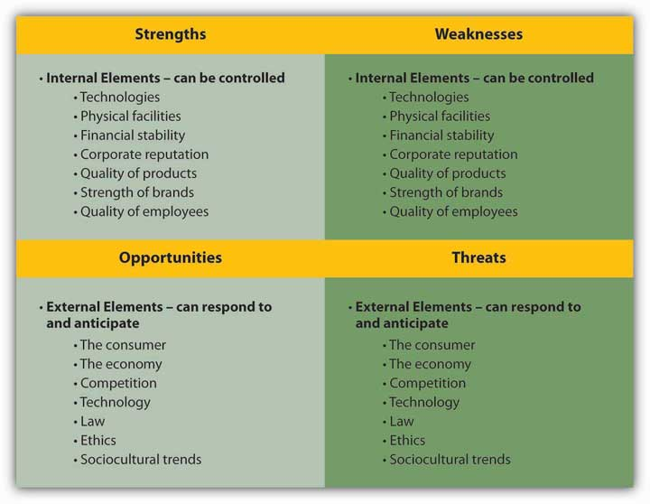
A SWOT analysis identifies internal elements (strengths and weaknesses) and external elements (opportunities and threats).

Figure 8.4 Example of a SWOT analysis for Ikea
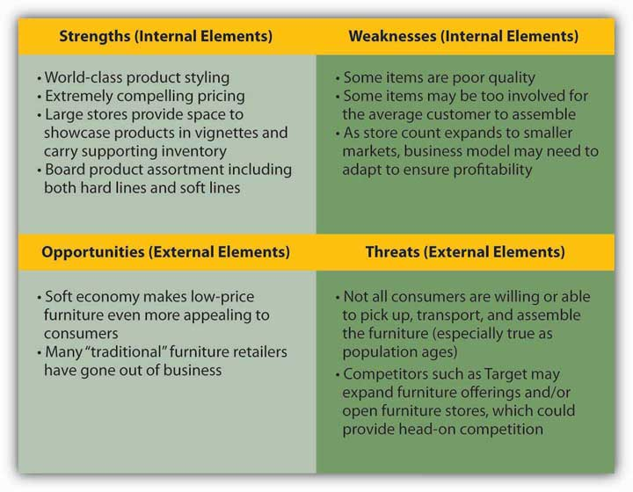

KEY TAKEAWAY
Know where you are before you decide where you’re going. Conduct an honest SWOT analysis to identify good and bad aspects of your situation.

EXERCISES
- Describe what happens during situation analysis. Explain each of the various situations that are investigated.
- Discuss each stage of the SWOTs process. How do you identify a competitive opportunity?

[1] Kate Maddox, “Nortel CMO Begins Global Brand” B to B, May 8, 2006, 3.

8.3 Define Where You Want to Go: Set Objectives

LEARNING OBJECTIVES
After studying this section, students should be able to do the following:
- Distinguish between marketing objectives and advertising objectives in a strategy.
- Explain the DAGMAR model for setting objectives.

Marketing Objectives
Objectives state what outcomes will be achieved, while strategy defines how each objective will be achieved. Once you understand the marketing environment, the next step is to develop specific marketing objectives. Marketing objectives state what the marketing function must do so that the company can achieve its overall business objectives (such as growth, expanding its market share, or increasing profits). Marketing-related objectives are specific to the firm’s brands, customer segments, and product features. These might include “Grow sales of product X by 30 percent over the next twelve months” or “Increase market share among affluent consumers aged forty-five to sixty-five.” Samsung, for example, sells fourteen product categories in more than two hundred countries, which yields 476 category-country combinations. Samsung collects data systematically on each combination and uses that brand data to set better marketing objectives by country and product. ^{[1]}

Advertising Objectives
Advertising objectives are the specific communication tasks that an advertisement seeks to achieve. These tasks include trial (informing the consumer about a product), continuity (reminding the consumer of the product), and brand switching (persuading the customer to change from one brand to another). Often, the advertising objectives are tied to the product’s life cycle. For example, trial is usually employed at the start of a product’s life cycle to encourage customers to try the product. A firm pursues continuity objectives when a product is mature in order to remind current customers to continue buying the product. Brand switching, or switchback, occurs at later stages of the life cycle—particularly the rejuvenation phase, when the company highlights new product features or lowers the price of the product.

DAGMAR Objectives
The DAGMAR model (Defining Advertising Goals for Measured Advertising Results), developed by Russell Colley, is a way to set objectives and measure the results of advertising. Colley stated that the process of achieving an advertising objective can be broken down into four phases:
- Awareness. Consumers must first be made aware that a particular brand or offering exists (“I’ve heard of it”).
- Comprehension. Consumers must understand what the offering is and how it will benefit them (“I know what it is”).
- Conviction. Consumers must decide to want to buy the product (“I want it”).
- Action. Consumers must actually buy the product (“I’ve bought it”).

Communications Objectives
The DAGMAR model states that advertising objectives must be concrete and measurable. That is, you want to have a precise statement of the message to communicate to the target audience and have a way to measure whether the intended message has been communicated properly. The measurement can be straightforward. For example, if your objective is that people perceive your product as the healthy alternative, you can measure the objective by asking shoppers whether they think your product is healthier than the competition.

Creative Objectives
The creative objectives deal with the form and content of the advertising. They define key elements of the message (what you want to say), emotional tone (how you say it), and production objectives (what the ad looks like). For example, the creative objective might specify that the advertising will reinforce existing aspects of the brand personality, modify old perceptions of the brand, or instill new brand characteristics.

Media Objectives
Media objectives define the who, where, and when of the target audience in the context of an overall marketing plan and budget. Note that media objectives don’t state which media will be used, because how you reach the audience is part of setting a media strategy. Elements of media objectives can include:
- Who: target audience objectives
- Where: geographic objectives
- When: timing, scheduling, reach, and frequency objectives
- Marketing coordination: sales promotion objectives
- Money: media budget objectives
You’ll learn more about how these objectives are put into motion in Chapter 9 "Choose Your Communication Weapons: SS+K Decides Upon a Creative Strategy and Media Tactics" and Chapter 10 "Plan and Buy Media: SS+K Chooses the Right Media for the Client’s New Branding Message".

Dig Deeper
Identify a TV commercial you’ve seen in the last month. Conduct an unofficial DAGMAR analysis for it: to what extent does it meet the criteria of creating awareness, comprehension, conviction, or action?

KEY TAKEAWAYS
Now that you have read this section, you should be able to understand the power of branding and how to construct a strategic framework for solving problems:
- You have reviewed the power of branding and its relationship to brand differentiation, accountability, consistency, and personality.
- You can explain the concept of brand equity.
- You can recognize the benefits of branding for advertisers and buyers.
- You can describe the strategic framework for solving problems.
- You can explain the function of a brand audit.
- You can apply SWOT (strengths, weaknesses, opportunities, and threats) analysis to a marketing situation.
- You can construct advertising and marketing objectives that can be applied to your plans and strategies.
- You can create advertising and marketing strategies that provide direction to creative teams.
- You can create a creative brief that describes the intricacies of the proposed advertising strategies and how those strategies can be implemented by the creative team.

EXERCISES
- Describe the differences between marketing objectives and advertising objectives in formulating a marketing and promotion plan.
- List and discuss the four phases of the DAGMAR model.
- Compare and contrast creative objectives and media objectives.

[1] Thomas Davenport and Jeanne Harris, “Competing with Multichannel Marketing Analytics,” Advertising Age, April 2, 2007, 16.

8.4 Decide How You’ll Get There: Create a Strategy

LEARNING OBJECTIVES
After studying this section, students should be able to do the following:
- Create a marketing strategy that demonstrates correct usage of the marketing mix.
- Create an advertising strategy that demonstrates how creative and media strategy are combined to solve an advertising problem.

Marketing Strategy
A marketing strategy consists of the activities a company must take to achieve its marketing objectives. For example, one step it must take is to decide on the appropriate mix of the Four Ps:
- Product definition. What features should the product have? What should the product packaging look like? Should there be accompanying support services, such as maintenance?
- Pricing strategies. How much are customers willing to pay for the product? What should be the selling price for retailers and wholesalers?
- Promotion strategy. What methods will the company use (e.g., advertising, PR, direct sales) to reach the target market? What is the goal of each promotion—to entice new customers, to boost repeat sales, to increase sales volumes?
- Place (distribution) strategies. Will the product be sold directly to consumers (such as via the Web) or through retailers and wholesalers? For decades, airlines sold tickets through travel agencies, but now most of them sell e-tickets over the Web. This distribution strategy saves the airlines money (by eliminating commissions to travel agents) and lets customers buy tickets any time of the day or night.

Advertising Strategy

Creative Strategy
Creative strategy defines what the advertiser’s message will say and how it will say it. Being creative does not mean simply being clever or unique—the advertisement must communicate the intended message to the target audience.

Media Strategy
Media strategy matches the potential customers of a product with users of specific media. For example, a media strategy might attempt to find out if members of the target market prefer to watch TV, listen to the radio, or read magazines. It may also try to determine which TV programs, radio broadcasts, or magazines the target market prefers.
The media strategy must be well timed to ensure that ads are produced or commercials are filmed in time for their airing. Other important timing decisions include determining how long the advertising campaign will run and how many times to expose the audience to the ad during the product-purchase cycle.

KEY TAKEAWAYS
Determine where you are with respect to the situation facing the company (internal analysis) by constructing a situation analysis, a brand audit, and a SWOT (strengths, weaknesses, opportunities, and threats) analysis.
Decide where you want to go (your desired positioning) by establishing advertising and marketing objectives that can be applied to your plans and strategies.
Create advertising and marketing strategies that provide direction to the creative team. The creative team is assembled to bring the product or service’s message to the target markets.

EXERCISES
- Briefly discuss each of the four variables (Four Ps) that must be considered when constructing a marketing strategy.
- Compare and contrast creative strategies and media strategies.

8.5 The Creative Brief

LEARNING OBJECTIVES
After studying this section, students should be able to do the following:
- Create a creative brief that demonstrates the Big Idea and is applied to an advertising opportunity.
- Describe and evaluate the asymmetric communications brief.
How do you communicate your strategy to your creative team?
The fruits of your labor are now turning into a real plan and a real document. After learning about the Four Ps and branding, and after identifying your current positioning and more desired positioning, you are ready to put words and actions into motion.
In this final section of this chapter, you will learn about SS+K’s and msnbc.com’s official plan: the creative brief. Preparing a creative brief is a collaborative process between the client (msnbc.com) and the agency (SS+K). Of course, a creative brief is never truly finalized; it is a living document that needs to be constantly reexamined for overall market appropriateness.

The Brief
The creative brief is a document that outlines the information and objectives to inspire the creative idea. Creative briefs may take different forms and include a variety of elements, including describing what the advertising is trying to achieve, identifying the main idea to be communicated, and outlining the target audience for that idea.
Proposing the Big Idea requires client agreement that the idea is right. Thus, both the advertising agency and the client must agree upon the final brief. The best briefs are written by account planners collaboratively with input from the client, account team, and creative director. One of the key functions of the SS+K brief is to come up with a single essential thought that summarizes the idea that will convince consumers to do what it is that the communication aims to do. Every agency has a proprietary brief template it uses to spell out the types of content it will need to include, such as specifying the audience, the product features, media placement ideas, and key point.

Figure 8.5 Anatomy of a Creative Brief
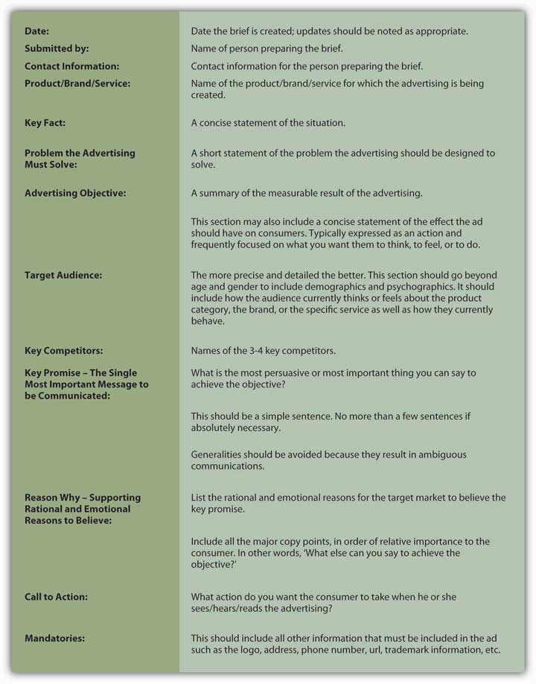
Briefs provide a foundation that allows all decision makers to provide initial input and subsequently gauge how well the chosen communication ideas, from advertising to media and PR, stay true to the strategic plan. In this way, clients rely on creative briefs as much as copywriters and art directors do.
SS+K uses only one brief, and the creative director has input on that brief. Other agencies may use different briefs for different purposes depending on the needs of the client. For example, a retailer may have a brief for its national campaign, and other briefs for local ads that may have different emphases. It is important to remember that there is no standard brief across the advertising industry, but most of the information found on briefs is fairly similar.
The first step in the SS+K brief is to use consumer and brand truths to establish the client’s noble purpose. The noble purpose expresses the brand’s “true north,” its reason for being on the earth. It is single-minded, concise, and written in such a way as to excite the imagination of the reader.

SS+K Spotlight
Marty Cooke is a partner and chief creative officer of New York–based SS+K. When he joined the agency, he’d already had substantial creative experience in some of the most influential advertising agencies in the world. He brought with him a defining vision for how creative solutions would be different at SS+K.
Figure 8.6 Noble Purpose Worksheet
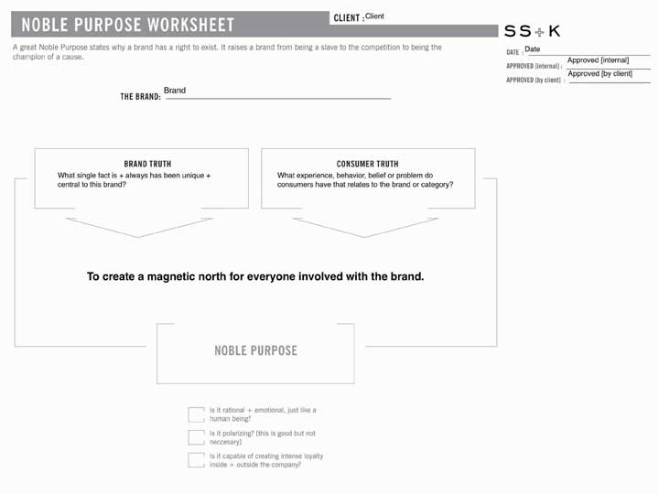
The noble purpose worksheet is the first step in synthesizing the client’s purpose for existing.

Figure 8.7 The Communications Brief
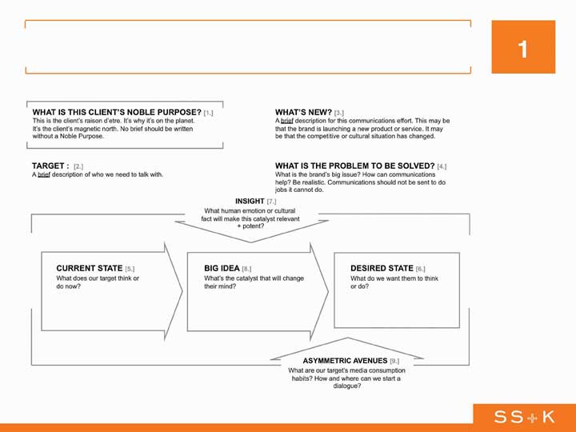
Once SS+K identifies the noble purpose, the agency develops what it calls an “asymmetric communications brief.” This document summarizes the consumer’s current state and spells out what the agency needs to do to show him or her how the client’s product or service will improve upon this state.

SS+K Spotlight
The manifesto: “Catching lightning in a bottle.”
Agency creative teams typically develop creative executions immediately after receiving the brief. SS+K, however, takes an interim step between the development of the brief and the execution of the campaign. SS+K copywriter Sam Mazur was asked to capture the essence of the branding in a conceptual piece of work that is not an advertisement. This is a tricky proposition. If it is effective, the manifesto is a useful tool for explaining the thinking of the marketing team. On the other hand, if the piece generates too much enthusiasm, the agency may find itself in the position of trying to explain the difference between an expression of the brand and an advertisement for the brand.
Figure 8.8
The Manifesto. The communications brief in turn inspires what SS+K calls its “brand manifesto.” It is often both a written and a visual statement used to help internal and external audiences understand what the brand stands for. It is not a marketing campaign or a reflection of what the final advertising material will look like.

KEY TAKEAWAY
This section described how to devise a creative brief that more fully describes the intricacies of the proposed advertising strategies and how the creative team can implement those strategies.

EXERCISES
- Describe the components and purpose of a creative brief. What are the differences between the creative brief and the creative director’s brief?
- Use a step-by-step or model approach to characterize the asymmetric communications brief. Explain the difference between the noble purpose and the asymmetric communications brief. What is the main advantage of using this form?

8.6 Exercises

TIE IT ALL TOGETHER
Now that you have read this chapter, you should be able to do the following:
- You can define branding and brand strategy.
- You can identify the characteristics of a solid branding strategy.
- You can explain the concepts of brand equity and value proposition.
- You can list and discuss the benefits of branding from the advertiser’s and buyer’s points of view.
- You can describe the strategic framework that can be used to solve problems.
- You can discuss how to conduct a situation analysis to understand problems and opportunities.
- You can explain the function of a brand audit.
- You can discuss the SWOTs and apply them to the solution of a problem.
- You can distinguish between marketing objectives and advertising objectives in a strategy.
- You can explain the DAGMAR model for setting objectives.
- You can create a marketing strategy that demonstrates correct usage of the marketing mix.
- You can create an advertising strategy that demonstrates how creative and media strategy are combined to solve an advertising problem.
- You can create a creative brief that demonstrates the Big Idea and is applied to an advertising opportunity.
- You can describe and evaluate the asymmetric communications brief.

USE WHAT YOU’VE LEARNED
- Have you seen the new Smart car? If you have, you are probably part of the buzz that has been heard recently about this new concept car that has made it to the streets. The car seats two, is available in three different models, and costs between about $12,500 and $17,000. The most significant fact about the Smart car is that it gets about forty-five miles per gallon. That fact alone has become central to Smart car’s initial introduction to the driving public. Has “small” finally become better than “large, extralarge, and supersize”? The manufacturer of the Smart car is betting on it. Investigate the Smart car. Once this is done, construct a SWOT (strengths, weaknesses, opportunities, and threats) analysis for the Smart car. Evaluate the car’s likelihood of success.
- Is there a Chick-fil-A in your neighborhood? If there is, you’ve probably eaten at one of the fastest-growing food franchises in the southern United States (see http://www.chickfila.com). Chick-fil-A has a unique approach to running their business. Using the company’s Web site and search engines, your task is to investigate the Chick-fil-A organization in order to conduct a situation analysis. During your investigation be sure to comment on the perceived competitive situation, customer situation, and economics and costs that impact or affect the company and its industry. Once you have completed your situation analysis, conduct a brief brand audit of Chick-fil-A. What are your conclusions about Chick-fil-A and its business model? Discuss your audit and opinions with peers.

DIGITAL NATIVES
Most young adults have had some experience with MySpace or other Web communication sites. Security issues aside, millions of people are communicating in previously unheard-of ways via the Internet. One area of concern, however, is how to protect younger communicators from the dangers of an open Internet. Many parents of preteens have banned them from popular more adult social networking Web sites. A relatively new social networking Web site, however, has been designed with the preteen in mind. Stardoll (http://www.stardoll.com) provides a mechanism for preteens to communicate and chat with other preteens via a “MeDoll” that can be dressed and accessorized from a long list of celebrity avatars.
Go to the Stardoll Web site and familiarize yourself with its components. Your challenge is create a short creative brief to promote this Web site. The objective of the communication is to attract more viewers and participants. Present your brief in class if time permits.

AD-VICE
- Describe the role that Catherine Captain plays in the SS+K Spotlight feature in this chapter. Assess her communication skills. Illustrate a positive skill and a negative skill that she seems to possess.
- Pick one of your favorite brands and summarize its history in the marketplace. As you research your favorite brand, comment on any brand strategies that you notice. Comment on your brand’s perceived brand personality, brand equity, and viability.
- Pick any brand and apply the summary benefits of branding to your choice. Remember to discuss the benefits of branding to both the buyer and the advertiser or maker of your brand.
- Pick any company and create a new product for them to manufacture. Following the guidelines in the chapter, create a situation analysis of the firm and of your new creation. Examine the differences between the two “situations.” Should the company make your product? Explain.

ETHICAL DILEMMA
According to information presented in the Digital Natives section, preteens and teens can go to a monitored Web site and participate in a communication community that is structured just for them. The Web site (http://www.stardoll.com) advocates protection for its viewers and participants from controversial topics, visuals, and conversations that plague more adult-oriented Web sites.
One of the purposes of this Web site appears to be the protection of its young participants from more adult-oriented content and exploitation. Examine the Web site and its policies. From an ethical point of view, assess the Web site and its capabilities for protecting its visitors. Can the organization’s implied protection promise be delivered? Summarize your thoughts.

Chapter 9

Choose Your Communication Weapons: SS+K Decides Upon a Creative Strategy and Media Tactics
Figure 9.1 Six Months to Launch!
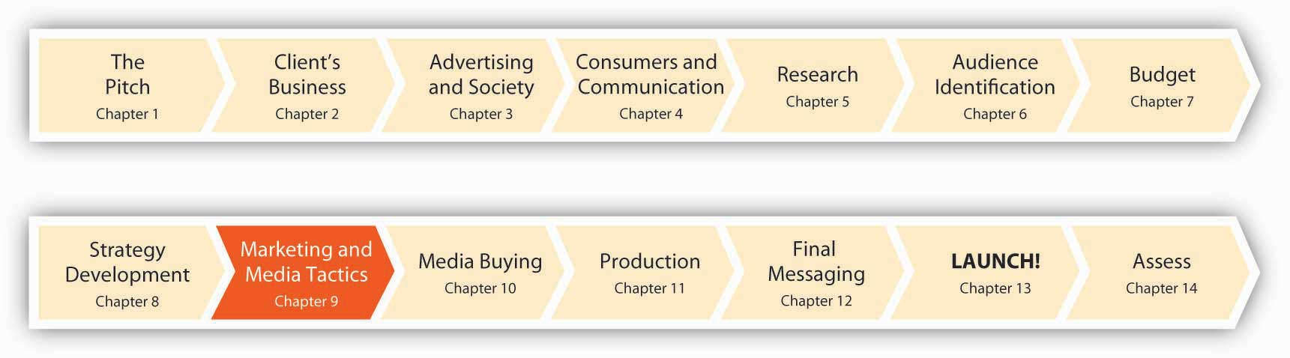
The advertiser’s toolbox is a deep one, and it’s expanding by leaps and bounds. Indeed, the problem often is to figure out which tool—or even better, combination of tools—will work best to solve a specific strategic issue. In the old days (say, fifteen to twenty years ago), agencies tended to have one approach that they used over and over for every client. Good at doing TV commercials? Shoot them for everyone. Specialize in outdoor? Roll out the poster boards. But yesterday’s “hammer in search of a nail” approach won’t cut it anymore.
Today it’s more common for agencies to think about themselves as being not so much in the advertising business as in the communications business. Sure, that’s just a word change—but the implications are huge. This switch is a constant reminder that we need to consider any way to communicate with customers that makes sense for that particular segment—and there’s often more than one way to skin a cat.
The integrated marketing communications perspective emphasizes the careful, strategic blending of many diverse elements to be sure that the client’s message touches the customer in the same way regardless of where this interaction occurs. That sounds like plain common sense, but you’d be surprised how often it’s a problem—especially in an industry where a client might give its advertising business to one agency, hire a separate firm to handle its public relations, and have still another conduct sales promotions.
Most major agencies today practice the integrated marketing approach in some way, often by starting new divisions to handle areas they didn’t tackle before, or buying (or allying with) smaller, specialized shops that are already experts. The client is ultimately accountable for managing its agencies in a way that supports its overall communications vision. For example, SS+K worked with msnbc.com’s search agency 360i to support the integrated branding campaign. (You’ll learn more about the way they worked together soon.) Marketers are the people most conscientious about coordinating all of the messages that customers receive, but they rely on their agencies to be vigilant about this as well. So, let’s summarize what an integrated perspective emphasizes:
- Use, and especially coordination, of all promotional tools available to support a communications strategy. These include sales promotions, public relations, personal selling, and direct marketing, as well as advertisements.
- Identification of the tools over and above traditional advertising at your disposal. These might include placing branded billboards in videogames, dressing actors in costumes and having them take to the streets as “brand ambassadors,” or perhaps sending IMs to kids on their cell phones.
- Creation of a coordinated promotional plan. Such a plan starts by specifying communications objectives and then details how to reach each of these.
- Maximization of resources. Especially for small businesses, maximize available resources even when they are scarce. Repurposing ads and utilizing connections are strategies that maximize resources.

SS+K Spotlight
All of us are better than each of us.
The point of strategic communication is to use the best tools available to effect the desired change in the marketplace. SS+K, like some other agencies, no longer draws hard-and-fast distinctions among functions such as advertising, promotions, direct marketing, and digital and public relations. SS+K’s goal is to achieve synergy among all the efforts that emanate from the msnbc.com brand—to choose the best tools for the job, not the ones that are most expected or familiar.
Compared to the “silos” that pervade some agencies, agency creative director Marty Cooke sees more value in combining disciplines than isolating them:
“The basic core idea of SS+K…is to get the different disciplines of communications, writers, art directors, designers, planners, strategy people, researchers, public relations guys, public affairs guys, digital people, direct mail people, whoever else you need, around the table, the biggest brains you can get and let the sparks fly. And that’s been kind of the magic of this place ever since we started it, and it’s worked out very well.”—Marty Cooke, Agency Creative Director

9.1 Integrated Marketing Communications: United We Stand

LEARNING OBJECTIVES
After studying this section, students should be able to do the following:
- Describe the integrated marketing communications perspective.
- List the various forms of marketing programs that are united by integrated marketing communications.
The punk band Paramore is getting noticed; the group from a small town in Tennessee sold more than 350,000 copies of its recent second album “Riot!” and it’s packed the house on the Vans Warped Tour. Part of the band’s appeal is the cult following for lead singer Hayley Williams (and legions of young girls imitating her shaggy blonde and orange hairstyle). But the group’s success is also due to a new business model in the music industry, where musicians work with their label to coordinate a marketing campaign that includes album sales, concert tickets, and merchandise. This model is called multiple rights or“360” deals; the biggest to date is Madonna’s recent $120 million package with the concert promoter Live Nation. Lordi, a Finnish metal band, has its own soft drink and credit card, and the Pussycat Dolls opened a Dolls-themed nightclub in Las Vegas. ^{[1]} Welcome to the new look of integrated and cross-channel marketing.
Integrated marketing communications unites all forms of marketing programs aimed at a target audience, including magazine ads, TV commercials, coupons, an opportunity to win a sweepstakes, a display at the store, and a visit from a company sales rep. There’s good reason to integrate: by coordinating the messages across all the communication tools, a company will speak to its customers and potential customers in a single, unified voice. This unified voice creates a more powerful and memorable message than disjointed efforts produce.

Dig Deeper
When Unilever introduced its All Small & Mighty detergent, it used a traditional ad campaign (TV and print) to make the point that the new detergent is concentrated, packed in a smaller bottle to create a smaller ecofootprint while delivering the same results. In addition, Unilever handed out samples from a bus; it made the bus noticeable by draping it in laundry. Anyone who spotted the bus could also send a text message to enter a sweepstakes. Unilever also projected “videoscapes” onto buildings and did a product placement on The Ellen DeGeneres Show, in which the studio audience did their laundry. ^{[2]}
Campaigns that utilize multiple media platforms make a lot of sense, especially in today’s media environment. The simple truth is that consumers increasingly rely on a greater mix of media for news, entertainment, and product information. According to a late 2007 survey, 55 percent of consumers who watch TV watch some type of video on devices other than their TV sets, including their computers, mobile phones, and digital media players (e.g., iPod). Not surprisingly, video watching on these alternative devices is more popular among younger consumers (66 percent) than older ones (36 percent). ^{[3]}

Audio Spotlight
Joe Kessler
http://app.wistia.com/embed/medias/b837825e42
Joe Kessler, SS+K partner and director of the agency’s L.A. office, speaks about the evolution of integrated marketing—how it was practiced in the past (referred to as IMC) and the mistakes that agencies continue to make now.
Creating integrated marketing communications requires deciding what kind of campaign the client needs and identifying the best tools to deliver on those objectives. The integrated program will include anything from advertising, consumer sales promotion, and trade promotions to public relations, personal selling, direct marketing, and more. The messaging works across platforms, and is also referred to as cross-platform marketing. Let’s look at each of these in turn.

KEY TAKEAWAY
Traditional agencies tend to focus on what they do well, but customers touch clients’ products in many ways. An integrated perspective recognizes the value and efficiency of carefully planning and coordinating all of the communications tools—from glitzy TV commercials to employees’ uniforms—that impact the impression the client makes in the marketplace.

EXERCISES
- Describe the integrated marketing communications perspective and comment on its usefulness to advertising professionals.
- Explain how the SS+K advertising agency seems to differ from other advertising agencies with respect to communications and media focus.

[1] Jeff Leeds, “The New Deal: Band as Brand,” New York Times Online, November 11, 2007,http://www.nytimes.com/2007/11/11/arts/music/11leed.html (accessed November 11, 2007).
[2] Sarah Heim, “The Spin Cycle,” Adweek, July 23, 2007, 22.
[3] Jack Loechner, “Over Half of Connected TV Viewers Also Watch on Alternative Devices,”http://www.mediapost.com/publications/index.cfm?fa=Articles.show Article&art_aid=73291 (accessed January 2, 2008).

9.2 Elements of the Promotional Mix: The Advertiser’s Trusty Tools

LEARNING OBJECTIVES
After studying this section, students should be able to do the following:
- List and describe each of the elements of the promotional mix.
- Characterize the various forms of sales promotion.
- Describe the purpose of public relations.
- Characterize the tools used to implement PR objectives.
- Discuss how personal selling can be used effectively in the promotional mix.
- Discuss the value of direct marketing in the promotional mix.
- Explain the concept of database marketing and how it can benefit advertisers.
- Explain the benefits of using customer relationship management (CRM) in the marketplace.
We’ve already learned about the Four Ps that go into the marketing mix; these are the tools marketers use to create a value proposition for their idea, product, or service in the marketplace. When we drill down to the crucial P of Promotion (the reason you’re reading this book), you won’t be surprised to learn of an equivalent set of tools that advertisers use (either singly or, more often, in concert) to communicate the important elements of that value proposition. We call these tools the promotional mix.

Sales Promotions
A sales promotion is activity intended to produce some short-term change in behavior. This can range from a cents-off coupon that motivates a customer to buy a box of cereal today to a sales contest that inspires an employee to sign up as many customers as he can by the end of the month.

When the Target Is Consumers
Sales promotions targeted to consumers encourage purchase or build interest in a product during a specified time period. The key element of sales promotions is its limited-time nature. Consumer sales promotion tools include the following:

Price or Value Discount Promotion Tools
Price or value discount promotion tools include coupons for packaged-goods products like deodorant. These offer cents off the price and have an expiration date of a few months out, encouraging immediate purchase. Similarly, pizza delivery companies located near colleges typically have special deals at the start of the semester to entice new customers.
In addition to coupons companies place in newspapers, send by mail (or by mobile phone), or offer on a Web site, a marketer may offer a temporary price reduction at the store or offer a rebate. Unlike a coupon, which gives the discount immediately upon purchase, a rebate refunds part of the purchase price to the consumer after the consumer fills out and returns a form along with a sales receipt to the company.
Bonus packs deliver more product without more cost, such as 20 percent more nuts in a canned nut mix, or 33 percent more liquid soap for the same price. Some companies offer bonus packs twice a year as a way to reward customers with special offers. Other companies time their bonus packs to economic cycles. “Whenever there is a downturn in the economy, we do very well with bonus packs and opening price shampoos like Suave, VO5 and Jheri Rhedding,” said Larry Vick, divisional merchandise manager for ShopKo. During difficult economic times, people are careful with their money and like to buy products that offer more of the good for the same amount of money. ^{[1]} Hint: With all of the economic woes surrounding us, the coupon business is a pretty nice place to be right now.

Visibility-Increasing Promotion Tools
A premium is a free item you receive if you purchase another item. Sexy Hair Concepts, for example, offered free styling gel with purchase of their shampoo or conditioner during the “Girls Night Out” days at Beauty Brands retail stores. In some cases, the premium may directly encourage future product sales, such as the Campbell’s Soup Cookbook containing new recipes that just happen to call for additional soup flavors.
Contests and sweepstakes offer the opportunity to win an exciting prize like a vacation to Hawaii or a $1,000 shopping spree. The difference between the two is that a contest is a test of skill, whereas a sweepstakes is simply based on luck. For example, a contest may ask consumers to bake a cake using the brand as an ingredient, whereas a sweepstakes simply requires filling out the entry form.
By law, sweepstakes cannot be tied to a purchase, which means that any consumer can be eligible to win the prize if they fill out the entry form. Therefore, it’s best to use sweepstakes to build awareness of your brand, not to drive immediate sales. The sweepstakes should be cleverly tied to your brand. For example, if your product is canned pineapple, a sweepstakes with the grand prize of a trip to Hawaii makes sense. If your product is motor oil, a sweepstakes in which the grand prize is a chance to be on a NASCAR pit crew team is more relevant and effective than winning a lunch date with Hannah Montana (Danica Patrick is another story). Sweepstakes also offer an opportunity to generate publicity (discussed below) during a time when you are not introducing new products.

Volume-Increasing Promotion Tools
Sampling is a popular (though expensive) promotional tool. Food and beverage companies often provide free samples to consumers to give them a chance to try a new product for free. More than one college student has feasted for free by timing strategic visits to stores like Sam’s Club that provide tastes of new food items. Sometimes the packets will be a smaller trial size, such as two packets of Celestial Seasonings tea rather than a box; other times the sample will be full size, like a cup of Silk yogurt. In the example we mentioned previously, Unilever handed out free samples of its new detergent. Sampling intends to increase future sales volume by acquiring new customers for the product.
Loyalty programs reward consumers for their frequent, continuing purchase of a product. Frequent flyer programs such as the United Airlines Mileage Plus program offer free miles to their customers with each flight they purchase. The more miles they fly per year, the bigger the bonus mileage. For example, customers who fly fifty thousand miles or more per year get double bonus miles (a hundred thousand miles or the equivalent of four free airline tickets in the United States) for the miles they’ve purchased. These loyalty programs offer additional perks, such as shorter lines, to their loyal customers. Restaurants or coffee shops often have punch cards that reward customers with a free coffee or sandwich after the purchase of nine coffees or sandwiches.

When the Target Is Trade Partners (Employees, Distributors, and Retailers)
As consumers we probably don’t see many of the more aggressive promotions that companies sponsor. Trade promotions are for a company’s employees or for channel partners such as retailers or wholesale distributors who help get the product in the hands of the ultimate customer.
Trade promotions fall into two main categories: discount promotions and industry visibility. Discount promotions offer the trade partner a reduced cost on the product or help to defray the partner’s advertising expenses. The goal is to encourage the partner to stock the item and bring attention to it. Promotions that increase industry visibility, on the other hand, focus on creating enthusiasm and excitement among salespeople and customers.

Discount Promotions
Merchandising allowances are price breaks the manufacturer offers to its channel partners when it reimburses the retailer for in-store support of a product, such as a special off-shelf or end-of-aisle display of the product. For example, when Volvo wanted to double the sales of its certified used vehicles, it offered dealers a $200-per-vehicle cooperative advertising allowance.
Case allowances are a discount the manufacturer offers to the channel partner based on the volume of products it buys during the deal period. The greater number of products the partner buys, the greater the discount.

Visibility-Increasing Promotions
Industry trade shows are events at which manufacturers showcase their products, often in elaborate, attention-getting booths or through giveaway samples and product information. Distributors and retailers learn more about a company’s products and can ask questions or experience the product directly. The manufacturer, in turn, collects business cards and sales leads on potential partners. For example, to draw customers into its booth at fluid industry shows, ITT (a company that manufactures fluid technology systems) built a water fountain branded with ITT and placed a sixty-by-eighteen-foot, three-dimensional banner at the entrance to the convention hall. ^{[2]}

Dig Deeper
The trade show industry generates billions of dollars a year and affects the economies of many other sectors such as travel and hospitality. Some major trade shows dwarf the size of small cities when they’re running; shows like MAGIC (menswear apparel) and CES (computers and technology) easily attract over a hundred thousand attendees. In a typical (2009) show, CES features twenty-seven hundred exhibitors spanning thirty product categories. Approximately twenty thousand new products will launch at this event. ^{[3]} Trade shows are a major expenditure for companies; the typical mid- to large-size firm spends well over half a million dollars each year to display at shows. That’s a lot of free T-shirts, tote bags, and sore feet by the end of the day.
Despite the appeal of these shows where freebies, parties, and networking (and the occasional drunk conventioneer) abound, there are alternatives to these massive schmoozefests. As travel costs continue to escalate along with concerns about the sizeable carbon footprint that a hundred thousand people create when they converge on convention sites like Las Vegas, some industries are starting to experiment with virtual trade shows that you attend from your desktop. Both IBM and Cisco are proponents of this alternative.
Some of these virtual shows are accessible via Web sites that give you access to hundreds of exhibitors, job listings, and so on. Others are even more adventurous; they are held in virtual worlds where your avatar can wander among aisles of exhibitors, look at new products, dialogue in real time with company representatives, even taste the free hors d’oeuvres (well, maybe not quite yet). Startup companies like Unisfair are moving aggressively into this virtual space.
One of the biggest advantages of a virtual trade show is that the exhibitors can track the behavior of potential customers who visit the show. Since attendees are anonymous, they won’t be intimidated by pushy salespeople, so they’re free to stay or leave when they choose. ^{[4]}
Check out Unisfair (http://www.unisfair.com) and sample some virtual trade show environments. What’s your verdict—is this a viable substitute for that Vegas junket you’re hoping to glom onto?
Incentive programs, also known as push money, give salespeople or channel partners free trips, cash bonuses, or other gifts as a reward when they sell the manufacturer’s product. For example, Revlon may give incentives to manicurists to recommend Revlon products to their clients.
Promotional products are the “swag” that companies give out, stuff like free pens, polo shirts, coffee mugs, and key chains emblazoned with a company’s logo. The purpose is to keep the brand top of mind by keeping it visible in the channel partner’s daily life. The most effective promotional products are ones that are attractive and convey a positive message about your product or services. They often keep a brand or company top of mind because the logo is hard to miss when you use or wear the premium. To get an idea of the mind-boggling array of swag that’s available out there, visit The Gifts & Premiums Manufacturers Directory at http://www.globalsources.com/suppliers/Gift-Premium/3000000151985.htm. And you thought scoring a free pen was a major coup!

Public Relations
The purpose of public relations (PR) is to build good relationships with the advertiser’s publics, namely consumers, stockholders, legislators, and employees. We define PR as “communication that attempts to earn public understanding and acceptance of the firm by stressing the practices, policies, and procedures of an individual or the organization. This can be accomplished by identifying donations to charitable organizations, sponsorship of esteemed causes or events, contributions to individual, community, or societal well-being, and so on.” ^{[5]}
Although it’s difficult to agree on a definition (depending who in the industry you ask), public relations frequently focuses on identifying and making public noteworthy information about clients, or creating newsworthy events for the purposes of heightening their clients’ public profiles. Traditionally, communications professionals have perceived public relations differently from advertising, which is persuasive, controlled content paid for by an identified sponsor. To the contrary, PR messages are not purchased and placed, or ultimately controlled, by clients. If news or information pieces originating with PR sources ultimately make it into the public discourse, it is presumably because the items warrant attention on their own merits and the original source of the information—the public relations professional—is obscured.
Today, distinctions between the disciplines are less clear-cut: frequently, advertising agencies are instrumental in trying to cultivate social networks and free, word-of-mouth exposure for their clients. Guerrilla marketing, like events staged by public relations professionals that “ambush” consumers with messages in places they’re not expecting to encounter them, can be effective ways of attracting highly valued news coverage for clients. Advertising agencies initiate and exploit consumer-generated content that is used for commercial purposes, thereby relinquishing control of the creative product in the process, much as PR professionals do when they issue press releases for editors to reformulate for their audiences. Some agencies take advantage of the relative anonymity of the Internet to develop positive chat and “consumer” reviews about their clients’ products—the source of content promoting products is not always clearly linked to an agency source, as public relations sources are seldom identified as the source of stories featuring their clients.

Press Release
One core tool of public relations is the press release, which can be anywhere from a paragraph to several pages long. The press release is a report of an event that the marketer (or the marketer’s PR agency) writes and distributes to the media in hopes that they will write about or feature the event. Related to the press release is the video news release (VNR), which describes the event via video rather than words. The topics covered by press releases are wide ranging, but the common thread is that they are topical and newsworthy, such as announcing a new product, new research, or timely helpful information to consumers, such as romantic getaway ideas a travel company publishes ahead of Valentine’s Day.
Press releases always conclude with contact information for the marketer and sometimes the PR company. This key piece is so that reporters can call for more information or an interview. A popular disseminator of press releases is PR Newswire; go to http://www.prnewswire.com to see the latest news releases.

Media Event
A company will often preannounce a forthcoming media event to garner attention for a product introduction, new channel partner, or major change in strategy. The goal is to give the media time to create background stories and bring reporters and news crews to the event to ensure the broadest possible audience. For example, when Apple brought the iPhone to the United Kingdom, it told the press that Steve Jobs, the company’s CEO, would be making an announcement at Apple’s London store in the heart of the city’s main shopping district.

Publicity
Public relations often aims to generate publicity, which is unpaid communication about an organization that appears in the media. The success of a PR campaign is measured in terms of impressions—the number of times a company is mentioned in the media. For example, Ben & Jerry’s ice cream created the world’s largest baked Alaska for Earth Day 2005. It placed a 1,140-pound, four-foot-tall dessert made from Ben & Jerry’s Fossil Fuel flavor in front of the Capitol in Washington, D.C., to symbolize the environmental damage that drilling in the wildlife preserve would cause. The program cost only $40,000 but generated more than thirty million media impressions. The publicity program reinforced Ben & Jerry’s brand as a socially conscious, green company while bringing attention to its ice cream products. ^{[6]}

Dig Deeper
A publicity campaign for a late-night cartoon show backfired when it aroused fears of a terrorist attack and temporarily shut down the city of Boston in 2007. To promote the Cartoon Network TV show Aqua Teen Hunger Force (a surreal series about a talking milkshake, a box of fries, and a meatball), an agency placed prominent blinking electronic signs with hanging wires and batteries on bridges and in other high-profile spots in several U.S. cities. Most depicted a boxy cartoon character giving passersby the finger. Bomb squads and other police personnel required to investigate the mysterious boxes cost the city of Boston more than $500,000—and a lot of frayed nerves. ^{[7]} Can you identify other publicity stunts that ended badly? Or (as the saying goes) is it true that “there’s no such thing as bad publicity” if the stunt calls attention to the client?

Crisis Management
As the Cartoon Network found out, publicity can cut both ways. Sometimes negative events happen to the company and the media reports these in great and glaring detail. Product defects, a serious accident at a company facility, management malfeasance, or major layoffs can tarnish the reputation of the firm. A company must be prepared to deal with such negative publicity.
Once the negative story is out there, there’s nothing you can do except minimize the damage. That calls for crisis management. During such a time it’s important to present your side of the story as clearly as possible and to demonstrate integrity as you correct any mistakes. The best way to do this is to have a single spokesperson talk with the media. This may mean “locking the business down” by asking everyone on the staff not to comment on the news story but to refer the question to the spokesperson so that the message is consistent and accurate. The most trustworthy spokesperson for the company is usually its CEO, because such high-level attention will show that the CEO stands behind the company.
When U.S. toy brand Mattel was forced to recall eighteen million toys after Chinese-made products were shown to be potentially unsafe, Mattel’s CEO, Bob Eckert, explained what went wrong, apologized, accepted responsibility, and took action. During the time of crisis, it’s crucial for the CEO or spokesperson to be upfront, direct, and very proactive. In addition to holding a press conference, Eckert filmed a separate online video apology. In his statements, he sympathized with parents, saying, “I’m a parent of four kids as well.” Mattel also took out full-page ads in major newspapers: the New York Times, the Wall Street Journal, and USA Today. Finally, Mattel’s Web site posted comprehensive recall details and explained how to receive a free replacement toy of equal value. Posting a response on their Web site is a faster way for companies to get the message out than might be possible through traditional media. ^{[8]}

Personal Selling
Personal selling involves direct interaction between a company representative and the customer. The main advantage of personal selling is the ability to tailor the message to the customer in real time, responding not only to their questions but also to their body language and tone. This type of direct contact lets the salesperson address customer concerns, sometimes even when the customer hasn’t voiced them aloud. Salespeople in fashion retail stores are ready (or at least they should be) with advice on how to accessorize an outfit or to help in deciding among outfits. Personal selling is even more important in products that are complex and require significant customer education or custom configuration. A sales force is a key part of medical products sales, information technology and solutions sales, or other complex products and services selling.

Team Selling
Personal selling can also be done through an outside network of sales reps. For example, Barefoot Parties sells loungewear, accessories, and gifts for women through at-home parties held by its sales agents. Agents get bonuses based on the amount of income the party generates in addition to a minimum base commission of 20 percent from the party sales. ^{[9]}
Some products and services are so complex and intertwined that a team sales approach is needed, in which the selling is handled by a team of salespeople, technical specialists, field engineers, and supply chain specialists who coordinate the timetable from order to production to delivery. Telecommunications equipment provider Lucent uses this kind of team approach, pairing supply chain executives with sales reps on the sales team. Technical specialists work with the customer to design a cell phone network, for example. In one case, Lucent created a CDMA (Code Division Multiple Access) cell phone network for a customer in India. The network included over fifty switching centers, twenty-five hundred base stations, and three hundred thousand circuit pack and cables. Such complexity demands a team sales approach.

Sales Force Automation (SFA)
Marketing information systems and CRM systems often include tools to help the sales force. Sales force automation (SFA) includes a myriad of functions such as contact management, sales quote automation, sales order information, and reporting functions. The tools use CRM and other data to maximize the productivity and effectiveness of the sales force. For example, salespeople who use a service like Salesforce (http://www.salesforce.com) can keep track of their sales leads and construct their call schedules to be most efficient, while their managers can track their performance and identify bad and good performers easily.

Downsides of Personal Selling
The disadvantages of personal selling are its high labor costs and the corollary: it’s difficult to reach large numbers of people when you try to speak them to one-to-one. Also, the information communicated may vary from the intended message. Sometimes salespeople, in an effort to “get the sale” or “go the extra mile” for their potential customer, may bend the rules in a way that’s detrimental for the company, such as by promising a delivery date that forces the company to pay extra in expediting costs or overtime in an effort to meet the promised date. Worse, a company might suffer bad publicity as a result of a salesperson’s unethical actions.

Direct Marketing
Direct marketing refers to sales communications delivered directly to individual customers through e-mail, direct mail, and telemarketing. The goal is to use information about individuals in order to present them with messages relevant to their needs and interests. The growth of consumer databases and improvement of technology and methods (such as advanced modeling and segmentation strategies) has led to increased use—and increased success—of direct marketing. For example, in the United States in 2006 direct marketing generated incremental sales of $1.93 trillion, which was 10 percent of the GDP. Each dollar spent on direct marketing yields, on average, an ROI (return on investment) of $11.65, compared to an ROI of $5.29 for traditional advertising.^{[10]}
How does direct marketing fit into an integrated campaign? One application is to send a direct mail piece (usually a letter or package) to a targeted list of customers inviting them to visit a Web site where they can receive further information. For example, Pitney Bowes Mapinfo (a company that provides software and services to help business executives make location-based decisions, such as site selection) mailed executives one-half of a CD to drive the message that without the dimension of location, their analysis is not complete. The mail piece gave executives a Web address from which they could download a free white paper to learn more about location intelligence. Mapinfo combined the direct mail piece with banner ads on business-publication Web sites (such as BusinessWeek [http://www.businessweek.com], Forbes [http://www.forbes.com], CNNMoney [http://money.cnn.com], and MSNMoney [http://moneycentral.msn.com]) to drive executives to the white paper. The result? Mapinfo received more than three thousand white paper downloads, of which more than 70 percent were senior management executives; more than thirteen hundred opt-ins to receive e-mail communications from MapInfo; and more than two hundred registrations for Mapinfo’s webinar. ^{[11]}
In another example, Babcock & Jenkins, a direct-marketing agency, developed an integrated campaign for Sun Microsystems. The campaign included direct mail, e-mail, telemarketing, and online marketing to drive potential new Sun customers to a Web site where they could register to win prizes in a sweepstakes. The campaign was a B2B (business-to-business) campaign in which Babcock & Jenkins helped Sun deliver leads to its channel partners (namely the resellers who sell Sun systems). The campaign generated 120 percent more registrations than expected. The success was due in part to demographic profiling that identified potential customers and why they buy, and then used an integrated campaign to reinforce the messages and reach customers in different ways. “We use an approach we call connected strategy,” said Denise Barnes, president of Babcock & Jenkins, “integrating direct mail, e-mail, telemarketing, banners, newsletters, print, microsites, events, podcasts, webcasts and social media into one-to-one communications for our clients.”^{[12]}

Dig Deeper
One of the issues direct marketing raises is that of violating people’s privacy and of controlling a flood of offers that can be sent en masse to consumers, defeating the purpose of targeted, individual communications. The Direct Marketing Association (DMA) helps stem the tide of unwanted phone calls and e-mail (spam) through initiatives like e-mail authentication and by giving consumers the option to remove themselves from mailing lists (https://www.dmaconsumers.org/cgi/offmailing) or from prescreened credit card offers (by calling 1-888-5optOut). What rights to privacy (and to not being disturbed at dinnertime) do consumers have? What happens to direct marketers who violate those rights?

Database Marketing
Many sophisticated advertisers understand that it makes sense to keep track of their customers—and perhaps even those who aren’t their customers (at least yet!). Database marketing is a system of marketing that collects information from consumers and then uses it to build a long-term relationship with a customer. Today this strategy underpins many promotional tools, especially those that have an element of direct communications with the customer, such as personal sales and direct marketing. Databases contain customer names, addresses, purchase profiles, psychographic and demographic details, purchase patterns, media preferences, credit ratings, and other information that helps a company target and create the right message and offer for each customer. This data can come from sources such as internal sales data, online opt-in registrations, loyalty program data, contest forms, third-party database sellers, and public government records (e.g., home sales).

Customer Relationship Management (CRM)
For this reason, database marketing has evolved to be calledcustomer relationship management (CRM). CRM uses the specific information about individual customers to create more effective marketing communications specific to them. For example, if you know that an individual customer has a ten-year-old child, you can target her with offers relevant to children in that age group, Or, if you know that the customer has bought Lunchables, you can send her a coupon to stimulate a repeat purchase or to cross-sell a related product.

Loyalty Programs
Loyalty programs that reward customers for continuing to purchase from the company make extensive use of CRM. For example, the retailer Brookstone uses its loyalty program to recognize customers who have purchased from its store, catalog, or Web site before (using an e-mail address, phone number, or membership number to recognize the customer). Brookstone records every sales transaction across every channel (whether at the store, online, or through a catalog) and rewards the customer with credits based on how much they have purchased from the company. Customers can apply these credits toward future purchases; this cements their relationship with the company. ^{[13]}

Behavioral Targeting
For better or worse, technological advances make it easier and easier for marketers to track us and our preferences very precisely. As we saw when we discussed target marketing, one hot trend is behavioral targeting, which refers to presenting people with advertisements based on their Internet use. For example, Microsoft combines personal data from the 263 million users of its free Hotmail e-mail service—the biggest in the world—with information it gains from monitoring their searches. When you sign up for Hotmail, the service asks you for personal information including your age, occupation, and address (though you’re not required to answer). If you use Microsoft’s search engine it calls Live Search, the company keeps a record of the words you search for and the results you clicked on. Microsoft’s behavioral targeting system will allow its advertising clients to send different ads to each person surfing the Web. For instance, if a twenty-five-year-old financial analyst living in a big city is comparing prices of cars online, BMW could send her an ad for a Mini Cooper. But it could send a forty-five-year-old suburban businessman with children who is doing the same search an ad for the X5 SUV. ^{[14]}
Going a step further, CBS recently announced that it is testing a system that customizes the ads you’ll see on your cell phone based on your location. Its CBS Mobile unit is teaming up with the social networking service Loopt, which allows its subscribers to track participating friends and family on their mobile phones. ^{[15]} In the (near?) future, you might well find ads popping up on your cell phone from stores you are literally walking past on the street. Yes, they are watching you…

Dig Deeper
A 2006 survey found that 57 percent of the consumers it polled say they are willing to provide demographic information in exchange for a personalized online experience. And three-quarters of those involved in an online social network felt that this process would improve their experience because it would serve to introduce them to others who share their tastes and interests. However, a majority still express concern about the security of their personal data online. ^{[16]}
How big a problem is this—and are consumers getting more or less concerned about potential invasions of privacy as behavioral targeting strategies proliferate? How do you feel about sharing your online behavior with advertisers?

KEY TAKEAWAY
Advertisers have many tools to include in the promotional mix they design for a client; these include sales promotions, public relations, personal selling, and direct marketing. No one tool is perfect; each has strengths and weaknesses, and often the tools are most effective when they’re combined. For example, an ad campaign for a new movie can be paired with a sales promotion in partnership with a retailer—like when Burger King featured its “Which Spidey Suits You?” scratch-and-win game pieces on specially marked menu items.

EXERCISES
- List and describe each of the elements of the promotional mix.
- Identify which of the sales promotion tools can be personalized and customized, which reward customers for frequent patronage, and which reward distributors for sales performance.
- Define public relations and demonstrate how marketers can use PR to meet communication objectives.
- Explain the importance of “impressions” in gaining publicity.
- Explain the role played by personal selling in the promotional mix.
- Describe the role of direct marketing in increasing an organization’s promotion return on investment (ROI).
- Discuss how database marketing can be used to further promotional mix objectives.

[1] Liz Parks, “Value-Priced Bonus Packs Revive Limp Hair Care Segment.” DSN Retailing Today, April 22, 2002, 19.
[2] Kate Maddox, “The Future Looks Bright, with Marketing Expanding and Online Exploding,” B to B, December 11, 2006, 28.
[3] International CES, http://www.cesweb.org/exhibitorDirectory/default.asp (accessed July 12, 2008).
[4] Janet Meiners, “Trade Shows Go Virtual,” Marketing Pilgrim, November 16, 2007,http://www.marketingpilgrim.com/2007/11/trade-shows-go-virtual.html (accessed July 12, 2008); http://www.unisfair.com (accessed July 12, 2008).
[5] Quoted in Stephen J. Grove, Les Carlson, and Michael J. Dorsch, “Comparing the Application of Integrated Marketing Communication (IMC) in Magazine Ads Across Product Type and Time,” Journal of Advertising 36, no. 1 (Spring 2007): 37.
[6] “Ben & Jerry’s: A Green Pioneer,” Advertising Age, June 11, 2007, S-8.
[7] Suzanne Smalley and Raja Mishra, “Governor, Mayor Livid as Boston Ad Stunt Spurs Chaos,” Boston Globe, January 31, 2007,http://www.boston.com/news/local/massachusetts/articles/2007/01/31/governor_mayor_livid_as_boston_ ad_stunt_spurs_chaos/ (accessed February 13, 2009).
[8] Donna Goodison, “Weathering Toy Recall Crisis,” Boston Herald, August 16, 2007, 32.
[9] Tim Parry, “Get in on the Party,” Merchant, January 1, 2007, n.p.
[10] Direct Marketing Association, The Power of Direct Marketing: ROI, Sales, Expenditures and Employment in the US, 2006–2007 Edition (New York: DMA, 2006).
[11] “Pitney Bowes Intelligently Plots Strategy for MapInfo,” B to B, August 13, 2007, 28.
[12] Kate Maddox, “Babcock & Jenkins Focuses on Database-Driven Marketing; Runner-up Direct Agency of the Year,” B to B, October 9, 2006, 30.
[13] Connie Robbins Gentry, “Personal Recognition: Multichannel Retailers Market One-On-One to Loyal Shoppers,” Chain Store Age, January 2007, 78.
[14] Aaron O. Patrick, “Microsoft Ad Push Is All about You: ‘Behavioral Targeting’ Aims to Use Customer Preferences to Hone Marketing Pitches,” Wall Street Journal, December 26, 2006, B3; Brian Steinberg, “Next Up on Fox: Ads That Can Change Pitch,” Wall Street Journal, April 21, 2005, B1; Bob Tedeschi, “Every Click You Make, They’ll Be Watching You,”New York Times Online, April 3, 2006,http://www.nytimes.com/2006/04/03/business/03ecom.html (February 10, 2009); David Kesmodel, “Marketers Push Online Ads Based on Your Surfing Habits,” Wall Street Journal on the Web, April 5, 2005,http://online.wsj.com/article/0,,SB111202090636790858,00.html? mod=mm_hs_advertising (February 10, 2009).
[15] Laura M. Holson, “In CBS Test, Mobile Ads Find Users,” New York Times Online, February 6, 2008, http://www.nytimes.com/2008/02/06/technology/06mobile.html(accessed February 10, 2009).
[16] “Consumers Willing to Trade Off Privacy for Electronic Personalization,” Marketing Daily, http://www.mediapost.com (accessed January 23, 2007).

9.3 Create the Promotional Plan

LEARNING OBJECTIVES
After studying this section, students should be able to do the following:
- Create a promotional plan by following the suggested execution steps.
- Describe how small businesses can use integrated or cross-channel promotional planning to meet their objectives.
Like a traditional advertising strategy, before you craft an integrated strategy, it’s important to be clear about what you hope to achieve, how much you can afford to spend to achieve it, and what the promotion will say.

What, Who, Where—and How Much?
We have to be able to answer these four basic questions before we move forward:
- Objectives for the promotion: What measurable change do you wish to achieve?
- Budget: How much do you intend to spend?
- Messaging strategy: What do you plan to say? Who is the target of the message?
- Media strategy: Which channels do you plan to use?
An integrated promotional plan needs to address these four questions. To see how this works in the real world, let’s look at how Kellogg’s developed such a plan for its Special K cereal brand. First, the company set sales objectives, which included targets for existing products as well as for new launches. Then, Kellogg’s promotion team worked with its ad agency to define the messaging strategy. The focus was on losing weight and maintaining that weight loss by using Special K products. Then, the question was how to implement the strategy and how to allocate the client’s promotional budget to each part of the plan. The team divided the campaign into a series of initiatives timed to different seasons, and it earmarked a specific amount to spend on each initiative:
- The campaign started with a “Special K Challenge” to lose six pounds in two weeks. This part of the campaign drew in new customers to the brand. The campaign launched to coincide with New Year’s resolutions to lose weight.
- In spring, the agency launched a new campaign it called “Are You Beach Ready?” This campaign featured a beach towel and bag as a premium.
- The third campaign in the series began in the fall, this time with a “Drop a Jean Size!” theme, giving customers a free pair of jeans in an instant-win sweepstakes when their weight loss goal was achieved.
- In winter, Special K urged consumers to lose the pounds with a free-in-mail personal training DVD.
- Throughout the year, coupons were put onto Special K packages. The coupons boosted multiple purchases. Print ads in publications targeting women (fashion and parenting magazines) and TV commercials during programs with high female viewership supported ongoing brand awareness.
The integrated campaign worked well: Special K saw growth across all of its product lines, with double-digit growth for the brand for the year. Special K exceeded its targets for existing products as well as new products. “Integration is the key to consumer engagement,” said Marta Cyhan, Kellogg’s VP-worldwide promotions. “The goal of promotion is to build the brand while motivating consumer interaction.” ^{[1]}

Raisin’ Awareness: How the CRMB Executed Its Plan
Now that we’ve looked at all the elements in turn, let’s put it all together to see the execution of an integrated marketing campaign. We’ll use the example of the California Raisin Marketing Board (CRMB), whose goal is to promote California raisins.

Set the Objectives
The first step was to set the objectives for the campaign. The target audience was women with children at home. The CRMB began with research, which showed that moms—and adults in general—were aware of health-related issues but felt they were too busy to always eat healthy foods. The CRMB could capitalize on this opportunity to promote raisins as a healthy, easy snack for moms and kids alike. With this objective in mind, the CRMB set three specific goals for the campaign:
- To create a personality for raisins that would appeal to the target audience
- To generate excitement among trade partners (food service operators, manufacturers, supermarkets) to offer raisins and raisin-based products
- To raise awareness and demand for raisins among the target audience
The CRMB hired ad agency MeringCarson to design an ad campaign. MeringCarson developed different concepts and then tested these concepts through focus group research. The research revealed that the most effective campaign was one that spoke to the target audience as women, not just mothers. “One campaign in particular featuring serene images of women consuming raisins as a part of their daily lives struck a responsive chord,” said Greg Carson, partner and Creative Director of MeringCarson. “Consumers loved the use of peaceful colors and imagery and the messages of health and empowerment embodied in the ads.”

Define and Execute
With the concepts and copy strategy complete, CRMB next devised the integrated brand promotion plan, which included print, online, PR, and sweepstakes.
- The print campaign included ads in women’s magazines as well as trade publications aimed at foodservice, industrial, and retail sectors.
- The online campaign included the launch ofhttp://www.LoveYourRaisins.com using the same artwork as the print ads and providing additional information (like recipes and nutrition facts) as well as a free newsletter that provides timely seasonal recipes using raisins.
- Sweepstakes included a back-to-school sweepstakes that consumers can enter at http://www.LoveYourRaisins.com to win a three-night, two-day trip to a major theme park in Florida or California for a family of four. Other sweepstakes included a weekend spa getaway at Miramonte Resort and Spa, along with a free on-the-go bag featuring the advertising artwork and filled with a plush California raisins character, California raisin samples, a compact mirror from the spa, relaxation lotion, and a refrigerator magnet to keep raisins top of mind.
- The public relations campaign featured Valerie Waters, a celebrity fitness trainer, who acted as a spokesperson for California raisins during her satellite and radio media tour. Each sweepstakes was announced by a press release. Press releases aimed at trade publications discussed the health benefits of raisins and announced industry news such as CRMB’s sponsorship of new raisin pie categories in the American Pie Council’s Crisco National Pie Championships. ^{[2]}
While registering for the sweepstakes, moms could get a premium such as a free California Raisin lunch bag filled with a California Raisin plush toy; California Raisin snack packs, water bottle, and magnet; and tips from Valerie Waters.
In Chapter 13 you will see msnbc.com’s fully integrated and launched campaign.

Integrated Campaigns for Small Businesses
How does a small business, say one that has less than six figures to spend on an ad campaign, advertise successfully against competitors with $20 million to spend annually? The point is not how much you spend, but how well you spend it on a set of well-coordinated marketing communications.

Pool Resources with Associations and Loyal Customers
One way to extend the reach of a small budget is to pool resources through a trade association. For example, small whiskey distilleries pool their ad money through the Distilled Spirits Council of the United States. Similarly, the California Raisin Board is an association of raisin growers throughout California; we’ve already seen how effective this group is. Using word of mouth is another key strategy: loyal customers become de facto brand ambassadors who spread the word to others. Third, develop Web initiatives that allow people to interact with the brand. Small companies rely on creative ideas to generate curiosity and conversation that will draw free publicity.

Go Small and Local
Another low-budget option is to sponsor local or niche events. Red Bull energy drink drove its growth by sponsoring niche extreme sports that traditional big-budget corporate sponsors ignored. Finally, companies that make products can consider conducting local tours of their factories or facilities as a way to introduce new customers to their products, become a tourist destination, and build publicity around that.

KEY TAKEAWAY
A strategy requires several pieces: First, set objectives for the promotion—and be sure to specify measurable changes you hope to achieve so you can determine how successful your strategy is. Second, set a budget (be realistic). Third, devise a messaging strategy where you decide what you want to say and to whom. Finally, identify your promotional mix, being sure it fits the target customer you’ve decided you want to reach (don’t just pick the media you’re used to, or the ones that are “sexy,” if these aren’t the best fit to your customer). Even small businesses can implement an IMC strategy, but they have to be more creative when they harness local communications platforms to tell their story.

EXERCISES
- List and describe the integrated marketing communications planning steps used in the California Raisins promotional plan.
- Explain how small businesses can use integrated marketing communications planning to enhance their promotional planning ability.

[1] Kathleen M. Joyce, “Motivating Out of the Box.” Promo, November 1, 2006, n.p.
[2] Kim Bedwell, “Consumer Marketing: California Raisins Launch New Campaign,” Agri Marketing 44, no. 9 (November–December 2006): 37.

9.4 Exercises

TIE IT ALL TOGETHER
Now that you have read this chapter, you should be able to determine how to choose the best media weapons to solve communication and advertising problems:
- You can identify the integrated marketing communications (IMC) perspective and comment on its usefulness.
- You can list some ways advertising agencies use the integrated marketing communications approach.
- You can describe SS+K partner Joe Kessler’s thoughts on the evolution of integrated marketing communications and media choices in the marketplace.
- You can identify and describe the tools of the promotional mix.
- You can characterize the various forms of sales promotion and how they can be best used to solve problems.
- You can describe the purpose of public relations and characterize the tools used to implement PR objectives.
- You can discuss how personal selling can be used effectively in the promotional mix.
- You can compare and contrast direct marketing and database marketing as means to enhance relations between the company and its customers.
- You can create an IMC promotional plan by following the execution steps described in the chapter.

USE WHAT YOU’VE LEARNED
- You may not be a NASCAR fan, but this fast-paced sport is hoping to catch your attention in the days ahead. NASCAR is an aggressive marketing and promotion organization (see http://www.nascar.com) with an ever-expanding fan base. This expanding fan base is changing the face of NASCAR and its races. Some say that a NASCAR event today is like going to a “celebrity night out.” Most NASCAR purists, on the other hand, believe that NASCAR is all about cars, cars, and more cars. After seven years of research and design experimentation, NASCAR has unveiled its “Car of Tomorrow” and believes that this speedy but safer car will help advance the popularity of NASCAR even more in the next decade. Considering how NASCAR must appeal to loyal fans and find new ones, design an integrated marketing communication (IMC) promotional plan that would help to spread NASCAR’s message about its new car to its markets. Be sure to specify the various elements of the promotional mix that you would recommend to NASCAR. Do research on NASCAR and its rise in the sports world before designing your IMC plan.
- Integrated marketing communications (IMC) help advertisers attack communication problems from a variety of points of view. This multimedia approach has been applied to communication by many advertising agencies over the past few years. One challenge for IMC planners, however, is the U.S. Hispanic market. Broadly defined, the Hispanic market includes those of Spanish, South American, Mexican, and Caribbean descent. As the number one minority in the United States, Hispanics comprise a market that is diverse with respect to preferences and lifestyles. Many in this market still speak Spanish (or native country dialect) as their primary language.
Investigate the Hispanic market by going tohttp://www.demographics.com or a favorite search engine. After you have reviewed marketing and advertising efforts toward this target market, propose an IMC promotional mix that you believe would be ideal for carrying a shopping mall’s message to Hispanics. The basic message would be “Come to the Mall—We’re Here to Serve Your Needs.” The shopping mall believes that as they attract Hispanics, sales and profits will increase. Discuss your promotional mix plan with peers.

DIGITAL NATIVES
When you think of Hershey’s, you think of chocolate, right? You might be surprised to know that industry professionals see Hershey’s as a marketing and advertising machine. This is somewhat surprising, given that Hershey’s shunned advertising of any kind for years. Today, however, Hershey’s has embraced a multifaceted approach to its communications, marketing, and advertising. One of these facets is its interactive Web site (see http://www.hersheys.com). After reviewing the basic structure of the Hershey’s Web site, click on the “promotions” button on the opening page. Once you have done this, you will see all the current Hershey’s promotions. Review each of these promotions. Take each highlighted promotion and describe what you believe to be: (a) the primary market for the promotion, (b) the promotional mix tools that would be most useful to the promotion, and (c) an assessment of Hershey’s chances of success for the promotion. Discuss your findings with peers.

AD-VICE
- Assume that you are a proponent of using integrated marketing communications to solve communications problems. Prepare a short two-page paper that could be used to support your position. Next, looking at an integrated media approach from the perspective of someone who advocates a traditional mass media approach for solving communication problems, attack the ideas you just formulated. Summarize the arguments against integrated campaigns. Discuss your findings with peers.
- Assume that you have just been given a $10 million budget to spend on sales promotional tools. The purpose of your budget is to convince consumers to begin to use reusable grocery bags when shopping for food. This environmental initiative is favored by most grocery chains. The bags (if purchased) would be sold for one dollar at grocery stores. Outline your plan for changing consumer preferences in this area. Be sure to consider all of the sales promotional alternatives as you formulate your plan. Designate how much money should be spent for your designated tools. Share your ideas with peers.
- Guerrilla marketing is becoming more popular as costs of promotions continue to increase. Public relations (PR) specialists have learned to use this unique form of marketing because of its low cost and highly creative nature. Your task is to design a guerrilla marketing effort that will introduce a new flavored bottled water to the Asian market in San Francisco. Initial distributors would be convenience stores, street vendors, and neighborhood vending machines. Be specific in what you would plan to do and how much you think it might cost. Share your plan with peers.
- Many universities and colleges have turned to database marketing to help target student populations. Describe how your university could use database marketing to reach potential freshmen students. Be sure to indicate how these students would be found and eventually reached by the university’s or college’s efforts.

ETHICAL DILEMMA
The Direct Marketing Association (DMA) is an advocacy organization whose intent is to encourage the ethical use of direct marketing to solve advertising and communication problems. The association’s task is not easy, given the ethical tension between members of the industry and consumer advocacy groups. Many of the complaints about invasion of privacy, high pressure tactics, and false information are directed against the direct marketing industry. Visit the DMA Web site at http://www.the-dma.org. Examine how the DMA addresses ethics complaints and advocates for the industry. What ethical issues do you think were adequately addressed by the DMA? What ethical issues do you think still need to be resolved? How would you rate the organization’s effectiveness based on what you have seen and read? Discuss your findings with your peers.

Chapter 10Plan and Buy Media: SS+K Chooses the Right Media for the Client’s New Branding Message
Figure 10.1 Four Months to Launch!
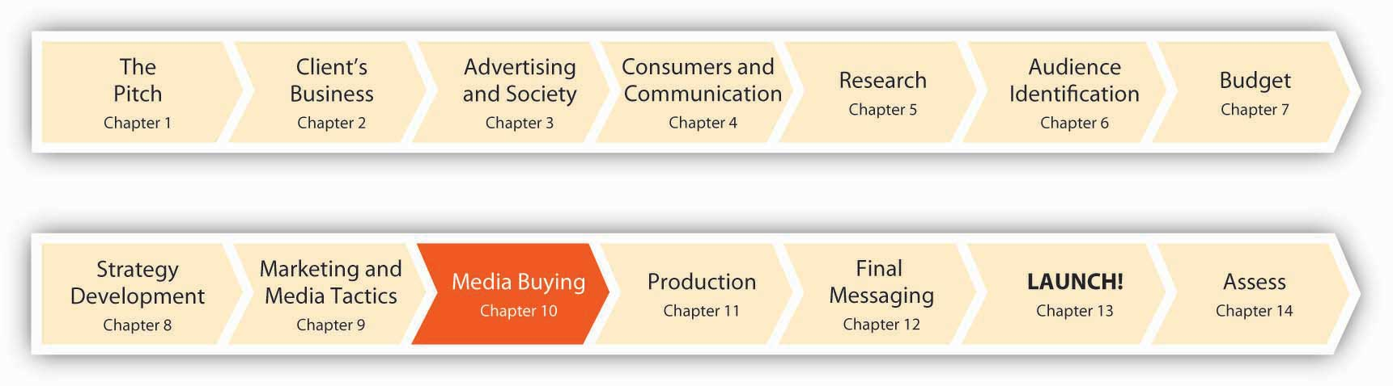
Advertisers like msnbc.com face tough choices. An ever-growing portfolio of media offers the promise of reaching different consumers in different contexts and at different times. The tools available to us range from an 8.5-by-11-inch ad tacked to your classroom wall by one of your fellow students who wants to sell his used textbooks (good thing we don’t need those anymore in our new “Flat World!”) to a high-tech mystery game where thousands of people text, IM, or Twitter one another with clues to help each other figure out the message.
SS+K and msnbc.com were ready to start pairing the objectives of the campaign with tactics they would use to achieve these, so they engaged a partner agency called The Media Kitchen to help. The Media Kitchen is the media arm of creative shop Kirshenbaum Bond and Partners, which is owned by the holding company MDC Partners (which also owns the innovative ad agency Crispin Porter + Bogusky). The basic philosophy at The Media Kitchen is to evaluate the research and information about the target audience—the news consumers that SS+K has dubbed News Explorers—and then decide which vehicles fit best. The first thing TMK had to do was to obtain demographic and media usage information about the News Explorers in order to understand where SS+K could find them. Once the agency understood more about which media these people relied upon, its planner would be able to coordinate the campaign’s messages and make media choices to ensure that the right people would see or hear these messages. After all, if an ad plays in the forest and nobody hears it, is it an ad?

Figure 10.2
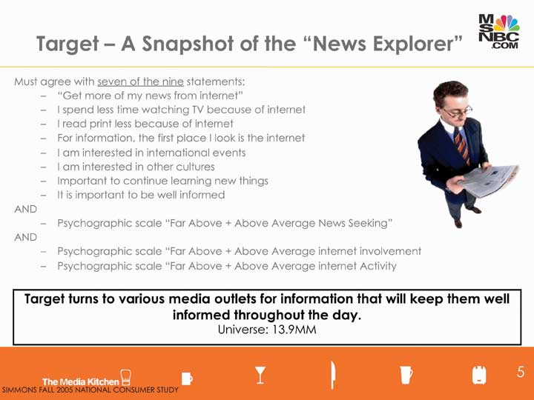
The Media Kitchen used data from a survey like the ones we discussed in Chapter 6 "Segment, Target, and Position Your Audience: SS+K Identifies the Most Valuable News Consumer", conducted by Simmons Market Research Bureau, one of the leading authorities on consumer behavior. They used this information to develop a profile of its target consumers and to match that profile with the target’s media habits. These are the criteria The Media Kitchen used to describe the News Explorer segment in the Simmons database.
Choosing the right media mix means understanding the primary advantages and disadvantages of each media format, from magazines to IMs. Media planning is the process of selecting which media vehicle to use, as well as when and where. Before we talk about how we mix and match media to meet our campaign objectives, let’s review the options and discuss some of the pros and cons of each.

10.1 Traditional Advertising Media

LEARNING OBJECTIVES
After studying this section, students should be able to do the following:
- Define media mix and media planning.
- List and characterize the various forms of traditional advertising media.
- Compare and contrast print media versus broadcast media.
- Describe the usefulness of out-of-home media, sponsorships, and direct-response media for carrying advertising messages.

Print Media

Newspapers
Information-dense ads. Newspapers are well suited to deliver complex messages like pharmaceutical ads. The vehicle lets the advertiser present in-depth information at less cost than would be possible on TV or in linear media like radio or quick-glance billboards. What’s more, readers are used to getting in-depth information from the newspaper, so the ad fits into that style. The print ad provides room to present the information and provide all the supporting reasons. Also, the consumer can keep the print ad for future use or reference.
Local. Newspapers work well for local reach—you can target newspapers by region. This also lets you tie the ad to action. The local ad can tell consumers exactly where and when to get the product.
Declining and aging readership. On the other hand, newspaper circulation continues to fall as existing readers age and younger consumers choose to get their news from the Internet. Daily circulation decreased 2.1 percent and Sunday circulation fell 3.1 percent, according to the spring 2007 report from the Audit Bureau of Circulations.

Magazines
Specificity. Magazines can be more finely targeted because many of them address readers who share very specific interests, such as Cat Fancy, Guns & Ammo, or Cosmopolitan. Others attract a well-defined demographic readership; for example, airlines’ in-flight magazines boast an affluent audience. The median household income for adults who read United Airlines’ Hemispheres magazine or American Airlines’ American Way magazine is $147,000, according to Mendelsohn Media Research. The average reader of these magazines is a forty-five-year-old highly educated businessperson—someone very desirable for advertisers of technology, travel, and real estate products to reach. There’s a good chance many of these travelers will pick up the magazine at some point during the flight. ^{[1]}
National reach. Whereas newspapers are local, magazines have national or international reach. Some magazines, such as Time, also print regional editions to support regional demographic differences and more targeted advertising.
Multiple impressions per copy. Magazines last longer than newspapers and are often passed from person to person (magazines often cite this number of pass-along impressions to justify charging higher prices to advertisers). The targeted nature of magazines, the good visual quality of their images, and the high credibility of the medium means that the ads are likely to reach and influence the right audience.
Long lead time. On the other hand, the production and distribution schedules of magazines require months of lead time. A monthly magazine slated to stay on newsstands through the end of December may have been printed in early November with a deadline for ad copy in September. This reduces the medium’s flexibility to respond to market changes.
High cost. A general-audience magazine typically charges more than $100,000 for a full-page four-color ad. Costs can grow if the advertiser wants guaranteed placement (e.g., near an article with the same theme as the product) and even more for ads on the back cover or directly inside the cover page. Moreover, advertisers often need to buy ads in multiple magazines to reach a wide audience. Despite the costs, ad spending in consumer magazines increased 4.6 percent in 2006. ^{[2]}
Figure 10.3
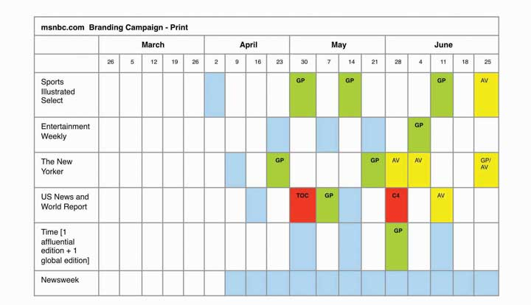
The print portion of the media plan that The Media Kitchen put together for msnbc.com: The different colors represent different sizes and placements—for example, blue represents a full-page placement, and red is a full-page placement near the table of contents of that publication.

SS+K Spotlight
When it came time to launch the msnbc.com branding campaign, the team strongly considered magazine print media.

Broadcast and Radio

Network TV
Mass audience. TV attracts mass audiences, and network TV is the highest-exposure medium every hour of the day, according to “The Middletown Media Studies: The Media Day,” a study of consumer media habits by Ball State’s Center for Media Design. At least 30 percent of the study’s participants were exposed to TV programming during the day, and at times as many as 70 percent were watching. The study also found that consumers watch TV and use the Internet more than ten times as often as they read newspapers and magazines. ^{[3]}
Very creative visual medium. TV supports dynamic content and creative storytelling. Advertisers can demonstrate the product and show the faces of the characters in the ad to convey both emotion and information.
The leading medium and growing revenues. Ad bloggers and ad experts have predicted the demise of traditional TV spots for years. Yet TV ad spending rose 5.3 percent in 2006, according to TNS Media Intelligence, and accounted for nearly 44 percent of all advertising spending in 2006. In addition, Nielsen Media Research reported that consumers spent more time watching conventional TV in 2006 than they did in 2005. They increased their viewing by twenty minutes a week. “Some people assume that in this digital era, somehow TV is not as important as it once was,” said Advertising Age editor Jonah Bloom. “Nothing could be further from the truth. Mass audiences are harder than ever to get together.…TV is set to become more measurable and even more relevant and even more important in the marketing landscape.” ^{[4]}
Aging viewers. On the other hand, younger consumers spend less time watching TV, so this medium is steadily aging. Consumers younger than thirty-five spend more time on the Internet than they do watching TV, according to a study by New York-based Jupiter Research. This trend is only going to increase as more video content from sites like Hulu, YouTube, and iTunes migrates to online formats.
High cost. TV advertisements have high production and placement costs. A thirty-second ad on a popular prime-time network program can cost $250,000 each time it runs. Companies also spend more to create, produce, and pretest TV ads. A-list celebrity spokespeople and high-end special effects add to the costs. It can cost 350,000 to create a professional thirty-second spot, although small business can often create ads for much less.
Ad-skipping. Whether they take a bathroom break, hit the skip button on their TiVo, or turn to the Internet for a few minutes, consumers pay less and less attention to commercial breaks in the programs. Expensive thirty-second ads may be playing to almost no one. To combat this, advertisers are turning to branded entertainment such as inserting the product into the scenery, dialog, or plot of the show. We’ll talk about that important new trend later.

Cable/Satellite TV
Cable offers specificity. Whereas network TV attracts a mass audience, cable TV lets advertisers pick demographic segments. Companies can target women with ads on the Oxygen or Lifetime cable networks. Well-heeled male audiences tune in the Golf channel while a younger male demographic hangs out on channels such as Sci-Fi. The Food Network and Travel Channel represent natural choices for advertisers in those respective arenas.
Figure 10.4
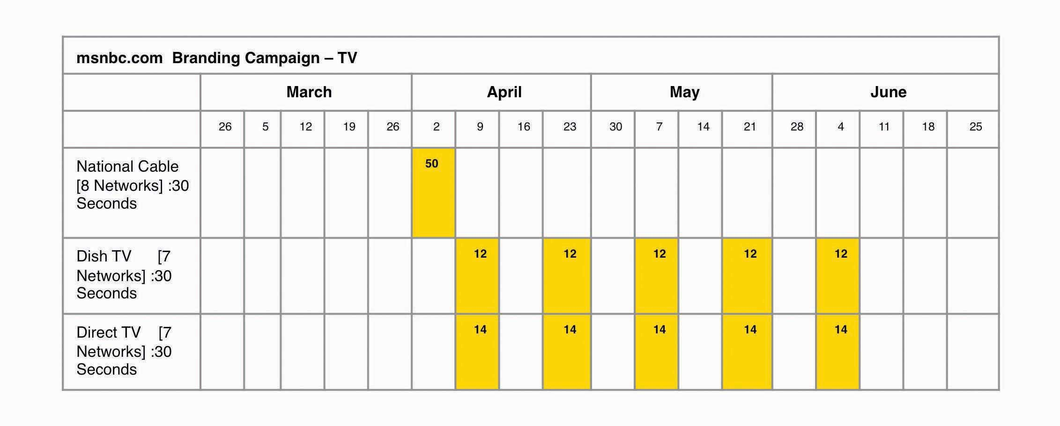
The television plan that The Media Kitchen put together had a heavy push the first week of the launch on select cable networks: BBC America, Comedy Central, Discovery, ESPN, ESPN 2, Food Network, History Channel, and National Geographic. The remainder of TV time was via satellite.
Local distribution through cable. Cable providers offer more targeted opportunities than do the national networks or even local broadcasters. Cable operators sell ad slots for local ads that can be targeted to specific sections of a city or even to specific neighborhoods. This lets the advertiser pay for the media impressions that matter.

Radio
Breadth. Radio reaches 232 million listeners during the week, according to figures from Arbitron’s RADAR 93 June 2007 Radio Listening Estimates. Drive-time radio aimed at commuters remains popular with marketers. Conventional radio (as opposed to satellite radio and other subscription audio) continues to be the medium of choice for 75 percent of all drivers.
Local. Smaller, local retailers use radio to keep their name top of mind. For example, Bishop’s Promart hardware store advertises on five radio stations in its Ithaca, New York, market area. On talk radio and easy-listening stations, the retailer runs ads it targets to more upscale customers and advertises grills and heaters. The store runs ads for house painting materials, however, only on country radio, because of its generally lower-income audience. “The upscale customer is probably going to hire out their painting. So we try to focus on people who are going to be doing it themselves,” explained Bishop’s Promart owner Forest Putney. Putney also gets involved in occasional promotional events, such as the annual backyard giveaway hosted by one of the local radio stations. He says it is a good opportunity to advertise in the community to maximize name recognition. ^{[5]}
Cost effective. Research has found that the best radio ads can have as much impact as the average TV ad, yet at a fraction of the cost.
Shrinking listener base. Although millions do listen to radio, the number is not growing. Cell phones and iPods compete for the ears of radio listeners, and other listeners are switching to commercial-free satellite radio. Then, too, even when people are listening to ads, they may not be paying attention.
Second-class citizen. Another disadvantage of radio is that ad agencies see it as a medium of secondary importance and often assign their junior people to work on the campaigns. “There is a crisis in radio creativity within the world of full-service agencies,” said Stephen Donovan, the managing director of radio agency Radioville. “There tends to be an inherent snobbery towards the medium. Unless you’re lucky enough to have someone who loves radio working on your brief, it’s more likely it will get dumped with the junior creatives.” ^{[6]}

SS+K Spotlight
SS+K’s client My Rich Uncle used radio as part of a campaign to get parents to think about other options when they consider taking out a student loan. They intercepted the target audience of parents during the time period when students apply for college and for the loans to pay for it (assuming they get in).

Audio Clip
My Rich Uncle “Lost and Found” Radio Spot
http://app.wistia.com/embed/medias/179900cc9a
The spot “Lost and Found” ran in over twenty markets across the United States as part of a campaign that ran from June through September 2008.

Out-of-Home
Billboards, bus stops, and point-of-sale displays provide a way to reach people as they go about their daily lives. And advertisers keep finding new places, such as ads that cover entire buses, go on airline tray tables, cover bathroom walls, and shine down on sidewalks. New technologies such as computer-driven flat-screen displays now enable dynamic, interactive ads that respond to passersby. Place-based media like The Airport Channel transmit messages to captive audiences in public places, such as the waiting areas in doctors’ offices, hospitals, and airports.
Place-based video screens are now in thousands of shops, offices, and health clubs across the country, including stores like CompUSA, Best Buy, Borders, Foot Locker, and Target. The Wal-Mart TV Network has more than 125,000 screens in 2,850 Wal-Mart stores, and patients who wait in over 10,800 doctors’ offices watch medical programming and ads. NBC Universal has its shows on screens installed in office building elevators and on United Airlines flights. ^{[7]}
As traditional advertising canvases like TV and newspapers get painted in, agencies search for new places to put their messages. It seems as if no space is beyond reach; in recent years we’ve seen ads pop up in front of public urinals, on rockets, imprinted on flowers, and even on sheep (yes, one enterprising company in the Netherlands puts ad messages on blankets that adorn grazing sheep). In the spirit of “advertising abhors a vacuum,” now several airlines fill the white spaces on their boarding passes with ads that include coupons and dining recommendations. ^{[8]}
And now, some retailers can even follow you around the store to deliver more up-close and personal messages: A new technology called RFID (radio frequency identification) tracks customers as they make their way through the aisles. So a shopper might receive a beep to remind him he just passed his family’s favorite peanut butter. ^{[9]} What’s the next frontier? At least one sighting has already been reported for an ad at a cemetery—for a dating service. ^{[10]}
Highly contextual. Out-of-home ads can be situated for maximum impact in terms of both whom the ad reaches and when it reaches them. To find health-conscious consumers, Jennie-O targeted health clubs. The company put ads in twenty-five hundred health clubs across the United States, locating them near water fountains and in locker rooms. Attention-getting headlines included “Make your pizza lean,” encouraging the use of turkey. The ads put the brand in front of exercising Americans—who frequently go to the grocery store after their workout.
Reach. Outdoor ads can be used to visually saturate an area at a relatively low price. 1-800-Flowers blanketed major metropolitan areas with ads for Valentine bouquets. “You couldn’t be in a city like New York without seeing it,” said Steven Jarmon, vice president of brand communication and partnership marketing for 1-800-Flowers.com. ^{[11]}
Frequency. Outdoor campaigns “interact with so many consumers at numerous touch-points during the day, which is important,” according to Jodi Senese, executive vice president of marketing at CBS Outdoor, New York. A month-long billboard might provide more than twenty exposures for daily commuters. ^{[12]}
Short exposure duration. Unfortunately, many forms of outdoor advertising only catch a few seconds of attention as people drive or pass by the ads. Such ads need a simple, engaging image and just a few words of copy. For example, 1-800-Flowers ads for “Happy Hour Bouquets” featured flowers arranged in vases shaped like margarita or martini glasses. The ads were so visual that they made an immediate impact. Results: Happy Hour sales grew 274 percent during the Valentine’s Day period, compared to Christmas (which is the third-largest selling season for flowers), prompting CEO Jim McCann to call the outdoor effort “[our] most successful floral campaign ever.” ^{[13]}

Figure 10.6
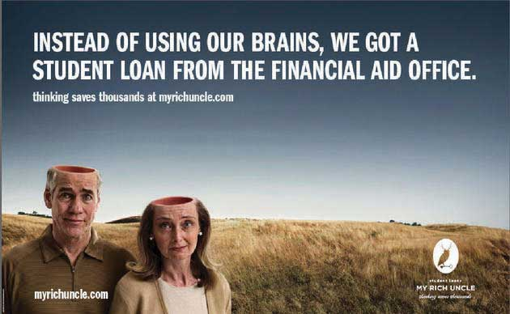
Part of SS+K’s campaign for My Rich Uncle included an out-of-home buy in Dallas. Here is one of the billboards from that campaign.
Uncertain (and unappreciative) audience. The actual audience of out-of-home advertising is hard to measure and hard to segment. The people who see an ad on the side of an urban bus might be homeless or they might be millionaires. Moreover, some people dislike out-of-home advertising, feeling that it creates visual clutter or gives them no escape from commercials.

Sponsorships
Some companies generate publicity by sponsoring an event, team, or sports arena. The company provides funding or some other material help to the event (such as food) in exchange for being mentioned as the event’s sponsor during the event and in the promotional material about the event.
Large exposure. Sponsorship provides large audience exposure and repeat brand impressions. Coors’ sponsorship of the NFL guarantees that the brand is mentioned numerous times during each game, along with a logo or brand image.
Favorability by association. The Coors deal lets the brewer use all NFL and team logos in its marketing. This transfers the goodwill of the fans from their sport to Coors. Coors hopes that fans will support the beer the way the company supports the sport.
Lack of messaging. Although sponsorship reminds viewers of the brand, it offers little opportunity to convey detailed brand messages or to present a unique selling proposition (defined below).
High cost. In 2005, Coors Brewing Co. signed a deal to pay $500 million over five years to be the official sponsor of the NFL, a 67 percent increase from its previous deal.
Clutter of competing sponsorships. Coors might sponsor the NFL, but Pepsi’s name might be on the stadium while one of the teams is sponsored by Gatorade. Coors is the official sponsor of the league, but rival Anheuser-Busch has individual deals with twenty-eight teams at an estimated cost of $30 million annually. In other cases, the event sells so many sponsorships that no single sponsor gets much play.
In addition, there is always the pitfall of ambush marketing: You pay a premium to be an “official sponsor” of an event, but your competitors advertise there as well and give the impression that they also are underwriting it. This is a big issue at the Olympics; for example, the 2008 Beijing Games had twelve global sponsors who together paid almost a billion dollars for bragging rights. China tried to crack down on other companies that used the five-ring logo or sold unauthorized versions of the mascot. These ambushes have a long history: at the 1996 Games in Atlanta, Nike placed advertisements near the stadiums and established a “Nike village” even though it was not an official sponsor. Visa Inc. sponsored the 1994 Winter Olympics in Lillehammer; American Express ran a campaign saying Americans did not need a “visa” to travel to Norway. ^{[14]}

Direct Response
Direct response methods are forms of communication addressed to specific recipients so that the sender can track whether or not the person took action after receiving the message.
Segmentation and customization. Extensive databases and lists mean that advertisers can pick who they want to contact and tailor the message to that group. Public and private commercial data sources let advertisers know and pick the audience. A direct marketer can know how much a consumer paid for their house (public land records), what kind of car they drive (motor vehicle records), and which clubs they belong to or charities they support (donor lists).
Immediacy. Direct response offers just that—people can respond directly to the advertisers’ pitch by returning a reply card, saying yes to a telemarketer, or clicking a link on an e-mail.
High cost per impression. Both direct mail and telemarketing have a high cost per impression due to physical production and labor costs, respectively.
Intrusiveness. Many consumers feel inundated by direct marketing and resent it.
Popular forms of direct response include:
Telemarketing. Although the telephone offers the most interactive channel to reach consumers, many despise it for its intrusiveness. The fact that there are over 149 million phone numbers on the FTC’s National Do Not Call Registry, which has only existed since 2003, shows the breadth of the public’s dislike for getting unwanted sales calls in the middle of dinner.
Direct mail. Direct mail is tangible—people can hold it, interact with it, even smell it. New printing techniques support customization. Advertisers can also include physical premiums such as fridge magnets or software disks. But a full mailbox may mean that much of it is simply thrown away unopened. Worse, consumers are beginning to see mail as wasteful and bad for the environment.
E-mail. E-mail supports customization—a company can tailor each e-mail to each recipient. For example, an airline can notify an individual customer about airfare deals from her home town. E-mail, however, suffers from the taint of spam. Nine out of ten e-mail messages are spam (unsolicited e-mail sent to multiple addresses), creating a different kind of pollution. Increasingly, consumers want tougher action to eliminate spam.^{[15]} The CAN-SPAM Act of 2003 is a step in eliminating unwanted spam, and marketers must abide by the rules laid out in that act, including supplying an opt-out button, relevant subject lines, a physical address, and a warning if content is explicit.

Dig Deeper
General Motors is known for its TV ads and NFL sponsorship, but it also makes use of direct mail. For example, GM sent out five million personalized cards by mail to customers who’d bought GM cars between 1998 and 2004. The list of customers was generated from dealer databases. The card gave customers a $10 credit toward any needed repair. The campaign generated $15 million in revenue solely from the coupon-generated visits. On top of that was the incremental benefit: when people are getting their car repaired, they wander around the showroom and look at the new models. So the secondary effect of the cards is that one in a hundred people may decide to buy a new car while getting their old one repaired. ^{[16]}

KEY TAKEAWAY
Traditional media include print, TV, radio, out-of-home, sponsorships, and direct mail. Each platform is useful depending on a campaign’s objectives and budget. For example, network television lets you speak to many people at once (though not quite as many as in the past), but you need deep pockets to use it.

EXERCISES
- List and characterize the traditional advertising media.
- Compare and contrast the print media against the broadcast media.
- Describe the usefulness of out-of-home, sponsorships, and direct-response media in reaching target markets.

[1] Matthew Schwartz, “In-Flight Magazines Take Off for B-To-B; Advertisers Take Opportunity to Reach Captive Audience,” B to B, January 15, 2007, 3.
[2] Gregg Cebrzynski, “And Now a Definitive Statement on the Future of Marketing and Media: Who Really Knows?” Nation’s Restaurant News, April 9, 2007, 14.
[3] Gregg Cebrzynski, “Taking on the Media Circus,” Nation’s Restaurant News, July 9, 2007, 33.
[4] Quoted in “What to Expect from This Year’s Upfront,” Advertising Age, May 14, 2007, S-18.
[5] Quoted in “Radio Ads Generate the Right Customer Frequency for Bishop’s,” Hardware Retailing 193, no. 4 (October 2007): 26.
[6] Quoted in “Is There a Crisis in Radio Creativity?” Campaign, March 30, 2007, 19.
[7] Louise Story, “Away From Home, TV Ads Are Inescapable,” New York Times Online, March 2, 2007, http://www.nytimes.com/2007/03/02/business/media/02adco.html(accessed February 24, 2008).
[8] Michael Bush, “Airlines Stamping Ads onto Boarding Passes: Messages Will Include Coupons, Local Restaurant Picks,” Advertising Age, July 15, 2008,http://www.adage.com/article?article_id=129637 (accessed July 15, 2008).
[9] Jeremy Wagstaff, “Eyes on You, the Shopper,” Wall Street Journal Online, July 31, 2003,http://www.wsj.com (accessed July 28, 2008).
[10] http://dailyyeah.com/tag/graveyard-advertising (accessed July 26, 2008).
[11] Quoted in “The Results Issue,” Brandweek, July 23, 2007, 28.
[12] Quoted in “The Results Issue,” Brandweek, July 23, 2007, 28.
[13] Quoted in “The Results Issue,” Brandweek, July 23, 2007, 28.
[14] Robert Woodward, “Olympic Sponsors Steeled for Ambush,” Reuters, June 4, 2008,http://www.reuters.com/article/newsOne/idUSL2975740220080604 (accessed July 26, 2008).
[15] “Direct Marketing: Quality Replaces Quantity,” Marketing Week, August 30, 2007, 33.
[16] “The Results Issue,” Brandweek, July 23, 2007, 28.

10.2 New Media

LEARNING OBJECTIVES
After studying this section, students should be able to do the following:
- List and characterize the new media forms.
- Explain how word-of-mouth (WOM), viral, and buzz marketing can be used by advertisers.
- Discuss how marketers and advertisers can use virtual worlds to bring messages to consumers.
- Review how social media and social networking sites can be used to advocate brands and brand messages.
It was very important to SS+K and msnbc.com to explore nontraditional and new ways to reach the News Explorer. The msnbc.com target audience is very tech savvy, so aligning the msnbc.com brand with the latest forms of communication was critical. The agency knew that it had to embrace new media in addition to traditional platforms.
New media covers a spectrum of nontraditional methods to communicate with customers. These fall into two categories. First, new communication channels are new technologies (e.g., the Internet, cell phones, and computer games) that support the potential for advertising. Second, new promotional techniques let companies move away from the traditional “advertisers speak, consumers listen” model.

New Communication Channels

Online Advertising
Online advertising includes a spectrum of text, still-image, animated graphics, streaming-video, and interactive advertising on the Web. Advertisers create their ad and then find a Web site or service to host the ad. The ad might show on the Web site as a separate pop-up window or as a banner embedded in the content of the site or running down the side of a Web page. The site might display the ad at certain times of day, a certain number of times, or in certain contexts. For example, search ads let advertisers associate their ad with the keywords that Web users enter into search engines like Google and Yahoo!.
Online advertising is relatively inexpensive, which means that small businesses can afford it. However, search ads can get pricey because bidding for coveted keywords can be fierce. For example, asbestos lawsuit attorneys bid $150 for each click-through from searches for the term “mesothelioma.”
Stickiness—keeping consumers at your site—is an important component of good design. For example, the SciFi Channel keeps fans of Battlestar Galactica engaged by letting fans see the inner workings of the show. Executive producer Ronald Moore posts concept art, scripts, and outtakes on the Web site. “From the beginning, I wanted a very open policy; let’s put as much on the Internet as we can,” he said. Moore supports viewers who want to download parts of the show, right down to letting fans edit their own versions of the show. ^{[1]}
Online ads support both specificity and tracking. “We can see what sites, pages, types of ads perform the best,” said Kathleen Cunningham, president of Advanced Marketing Strategies. She has found that the best way to use the Internet for client companies is to get e-mail addresses volunteered by customers of IKEA, for instance, and then put out occasional e-mails to them about in-store deals. “The trick is to not bombard them with e-mails,” Cunningham said. ^{[2]}
Unfortunately, online is a very fragmented media outlet due to the tens of millions of Web sites in existence. Although more and more consumers are spending more and more time online, their time is being subdivided, making it hard to reach a mass audience.

SS+K Spotlight
Figure 10.8
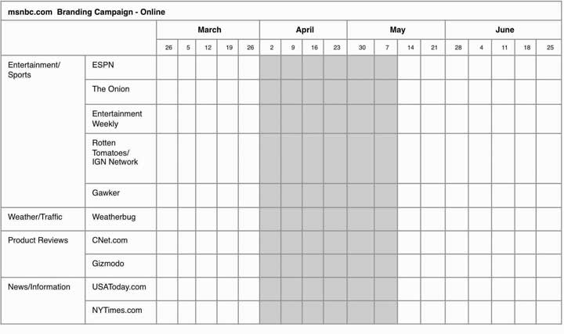
In order to maximize the effectiveness of the msnbc.com campaign, SS+K and The Media Kitchen planned a big online presence for the launch phase of the effort on these categories of interest to the News Explorer and the respective sites within those categories.

M-Commerce
Mobile commerce refers to the growing trend of reaching consumers through their cell phones and wireless PDAs. For example, Absolut brand vodka partnered with Free411, an ad-supported directory-assistance service. Free411 is just like the phone company’s service, except that it’s free. Each time the service’s forty-five thousand users called to get the number for a club or bar, they first heard a fifteen-second spot for Absolut’s new Pears vodka. Callers were then offered a drink recipe that would be text messaged to their cell phones to give to their bartender. Nearly two thousand callers said yes, which was roughly 4 percent of the total call volume. (That’s actually eight times the average response rate for such an offer.) The cost of the promotion was under $50,000. ^{[3]}
Cell phone advertising is still in its infancy in the United States, but it’s much more common in some other countries, especially those where a large number of people carry Web-enabled phones—in some parts of Europe this proportion is as high as three-fourths of the population. Some advertisers are skeptical about the future of m-commerce because they feel that many consumers will resist the practice of seeing a lot of ad messages clog up their phones. One recent survey reported that only 18 percent of American respondents said they were receptive to the idea of watching ads in exchange for free mobile content. But 37 percent of Europeans like the idea. And large numbers of respondents said they visited a Web site or requested more information about a product after seeing a mobile ad. ^{[4]}
The pace of cell phone advertising is likely to pick up as more people get used to the idea of accessing content (other than IMs) on their mobiles. Already, major phone companies including Verizon Communications and AT&T have signed deals to distribute programming—including Saturday Night Live clips and user-generated video—to cell phone customers along with ads to support this effort. Expect to see further integration of viewing platforms; even now AT&T is working on a system to coordinate digital purchases so that when a customer buys a movie on his laptop, it’s instantly available for streaming to his cell phone and on-demand on his TV. ^{[5]}
In addition to using cell phones to send broad-based ad messages, the coupon business is due for a radical makeover as mobile couponing takes off. Today cell phone users can sign up to receive mobile coupons that offer discounts on products ranging from CDs and DVDs to fast food. To cash in the coupons, consumers show their cell phone screen that displays the coupon to a store cashier. Virgin Megastores, Hollywood Video, Domino’s Pizza, and Quiznos Subs participate in this program, and about one million people have signed up for the service. ^{[6]}
Picture this scenario: you’re strolling down the street and as you pass a Starbucks your trusty phone beeps and invites you to stop in to receive a discounted Grande Vivanno Chocolate Banana smoothie. Sound far-fetched? For now, yes—but probably not for long. The exciting evolution of GPS technology creates the capability for advertisers to beam coupons to phone users depending on their location. In one early test of this method, Coupon CBS partnered with the social networking service Loopt, which already allows its subscribers to track participating friends. Ads appear on two Web sites tailored for mobile devices, CBS Mobile News and CBS Mobile Sports. People who choose to participate might see an ad from a business within a block or two of where they live. ^{[7]}

SS+K Spotlight
Melinda Moore
SS+K’s VP of Marketing from the Los Angeles office, Melinda Moore, talks about prospective mobile ideas for msnbc.com.
http://app.wistia.com/embed/medias/af2077461b
Melinda discusses mobile marketing.

Product Placement
In the 2008 season finale of CSI: NY one of the show’s characters asks the detectives to gather on a sophisticated videoconferencing system to discuss a shooting. But it wasn’t just any system—one of the other investigators elaborates, “She wants everybody on a TelePresence call.” This happens to be a system that Cisco sells—and it has a way of showing up prominently in TV shows, including 24 and Heroes, as well as in movies like You, Me and Dupree and I Am Legend. ^{[8]} Product placement, where a show’s story line incorporates a branded product, is a strategy to reach consumers on a traditional medium. This technique is now quite common in TV shows and movies, but it even pops up in Broadway shows and the occasional novel.
This practice is so commonplace (and profitable) now that it’s evolving into a new form of promotion we call branded entertainment, where advertisers showcase their products in longer-form narrative films instead of brief commercials. For example, SportsCenter on ESPN showed installments of “The Scout presented by Craftsman at Sears,” a six-minute story about a washed-up baseball scout who discovers a stunningly talented stadium groundskeeper. ^{[9]}
The inclusion of branded products in shows is not new; the first recorded instance dates to 1896, when an early movie shows a cart bearing the brand name Sunlight (a Lever Brothers brand) parked on a street. ^{[10]} Perhaps the greatest product placement success story was Reese’s Pieces; sales jumped by 65 percent after the candy appeared in the film E.T. ^{[11]} As was the case with Reese’s Pieces, new products can get a huge boost if they happen to show up in a popular media vehicle (just ask all the authors whose books hit the bestseller list because Oprah recommended them). The startup accessories company Bag Borrow or Steal Inc. discovered this to its delight when the movie version of Sex and the City was released. Carrie Bradshaw’s assistant, played by actress Jennifer Hudson, admits to her that she “borrows” her pricey handbags from Bag Borrow or Steal instead of buying them. ^{[12]}
Getting a plug is nothing new. What is new, however, is that product placement has evolved from a practice of convenience (directors like to include actual products as props to enhance realism) to a deliberate and lucrative business practice. A typical placement deal between Staples and NBC illustrates how this works: when the office products retailer introduced a new paper-shredder called the MailMate in 2006, it engaged a company that specializes in placements to handle this part of its media strategy. The company made a deal with the producers of The Office to include the product in two episodes of the hit show. In one show, the character Kevin Malone shreds paper with the MailMate; in the second, the character Dwight Schrute leaves the company and takes a job at Staples. To emphasize the small size of the paper shredder, it sat on Kevin’s desk. To show how sturdy it is, he shredded his plastic credit card with the device. And the episode closed with Kevin shredding lettuce to make a salad; when a colleague asked where he got the salad, he replied, “Staples.” ^{[13]}Nothing subtle about that placement.
Unless the FCC severely clamps down on this practice, it’s probably here to stay—unless (or until) such blatant messaging suffers from the problem it’s designed to address: advertising clutter. As the number of placements continues to grow, advertisers may discover they’ve created a monster that’s no longer very effective. In the first quarter of 2008, here are the leaders in the number of branded products that appear during the show, according to Nielsen Media Research: ^{[14]}
- The Biggest Loser (NBC): 3977 placements
- American Idol (Fox): 3291 placements
- The Apprentice (NBC): 1646 placements

Dig Deeper
Seeing real brands pop up in TV dramas, sitcoms, or reality programs is no longer notable—but how about on a news program? The Fox affiliate in Las Vegas made a deal that gets news anchors to sit with cups of McDonald’s iced coffee on their desks during the news-and-lifestyle portion of their morning show. Is this a conflict of interest? According to the account supervisor at the ad agency that negotiated the deal, “If there were a story going up, let’s say, God forbid, about a McDonald’s food illness outbreak or something negative about McDonald’s, I would expect that the station would absolutely give us the opportunity to pull our product off set.” ^{[15]}What do you think—does this form of product placement cross the McLine?

Advergaming
Product placement is also slowly but surely making its way into videogames. Computer gaming is an $18 billion business. Advergaming brings real-world brands into the game. Many advergaming executions resemble outdoor advertising in the game—game makers sell posters and billboards in the game’s virtual world. The advertiser takes advantage of the computer game manufacturer’s distribution to get its ads seen. And, because gamers pay upwards of $50 for the game, they’re likely to play it over and over.
The problem with ads in commercial games is that many players are too immersed in the game to notice them. For that reason, advertisers such as Burger King create purpose-built advergames. These types of games use the advertiser’s branded mascots, themes, and venues to make the brand a key element of the game. Purpose-built advergames “let you have complete control over your brand message since you’re the one making the game,” said Darren Herman, the cofounder of IGA Worldwide. “But the biggest problem with advergames is in their distribution. Most companies don’t have the resources of, say, a Burger King, to do that correctly. For every successful advergame—like Burger King’s—there’s a ton of failures, usually due to distribution. How do you get your game out there and who do you get it to?” ^{[16]}
Herman raises a valid point, but videogames seem poised to become a distribution platform in their own right. As gaming becomes more of a mainstream activity, we can expect to see more advertising targeted to players. While many media planners still have a stereotype of a typical gamer as a greasy-haired teenager who eats a lot of cold pizza, the reality is that 40 percent of gamers are women, and the average age of game players is thirty-five. And 65 percent of American households play computer and video games.
As the tip of the iceberg, MTV recently announced that the sequel to its popular Rock Band game (Rock Band 2, not surprisingly) will include a track from the first Guns N’ Roses album in more than a decade. As a music industry executive observed about the potential of videogames to sell music products, “These games absolutely have an impact because the opportunity to hear these songs on radio is dwindling. This is becoming an important piece of the marketing puzzle.” ^{[17]}

WOM/Viral/Buzz
One new communication model seeks to get consumers and the media talking about the product, brand, or campaign. Rather than pay for every media impression, advertisers influence their customers to work with them to create media impressions. Word of mouth (WOM) causes people to share stories about the product, brand, or campaign. Every water cooler conversation about the ad creates an impression.
Viral marketing gives people a reason to recruit their friends and family to the product. For example, friends-and-family cell phone programs give subscribers an incentive (free minutes) to recruit people they know. Viral campaigns challenge agencies to create truly remarkable ads, online games, or Web sites—remarkable enough that people will want to share them with their friends. For one noteworthy example, check out Burger King’s notorious Subservient Chicken that agency Crispin Porter + Bogusky developed (http://www.subservientchicken.com).
Buzz creates newsworthy events—a thirty-second story on the major news networks for an eccentric promotion is worth far more than buying thirty-second ads on those channels. To identify the spark that ignited the fire of buzz marketing, perhaps we need look no further than to The Blair Witch Project, a horror movie that was made for $22,000 and earned $248 million at the box office. How did this low-budget production pull this off? The answer is the buzz campaign that began long before the film was released. While the story of a group of young people who get massacred in the woods was fiction (sorry to burst the bubble), the producers cleverly perpetuated the idea that the movie was a true documentary. By the time the film actually was released, it had built an avid following.
Some of the veterans of that effort also have pioneered a form of viral marketing the industry calls alternate reality games, where fans interact with the company as they try to solve a puzzle. In one of the best-known executions (that these same producers created), carmaker Audi staged a heist of an A3 from Audi’s Park Avenue showroom in New York City. It enticed millions of consumers to solve the mystery. As consumers joined in the chase, they were exposed to the car’s unique features and attributes. The buzz seemed to translate to behavior, too, as sales increased during the three-month campaign.^{[18]}
More recently, some gamers were surprised to discover the unnamed force behind The Lost Ring, an online game with an Olympics theme. The game kicked off when fifty people received packages with an Olympic-themed poster and a clue pointing them to TheLostRing.com Web site. At the site, a video presented scenes of a woman waking up in a field with “Trovu la ringon perditan”—an Esperanto phrase—tattooed on her arm. As players searched for clues to solve the mystery, they eventually discovered that none other than McDonald’s, in partnership with the International Olympic Committee, was behind the game.^{[19]}

Virtual Worlds
The Internet has spawned numerous virtual worlds in which people take the form of avatars (digital representations of themselves) as they play, interact, and virtually live in an online space. Some communities, such as Linden Lab’s Second Life, mimic real life with 3-D graphics that give people a chance to live a different identity (or several) online. Many users choose elaborate characters, either fantasy figures or idealized men or women with exaggerated “attributes.”
Numerous companies have set up shop in one or more of these virtual worlds. In some cases (as in advergaming) they simply advertise their product on virtual billboards. For example, billboards in Second Life advertise the Honda Acura RDX. Clicking on the billboard gives the user a virtual copy of the car that they can drive around Second Life and even use in racing games in the online world. In other (typically more successful) cases the brand becomes part of the world, as when avatars who receive virtual Nikes actually get the ability to run faster in the virtual world.
Currently well over a hundred virtual worlds are operating live or are in development. The research firm Gartner predicts that by the year 2011, over 250 million people will be involved in these immersive digital environments. U.S. firms spent an estimated $15 million on advertising in virtual worlds in 2006. This figure is expected to reach $150 million by 2012.
To date, virtual worlds have received a lukewarm reception by advertisers. Some early campaigns fizzled because they failed to generate interest among virtual world inhabitants—simply putting up a billboard just won’t do it for most avatars. In other cases, disappointed clients didn’t see the kinds of numbers they are used to getting from real-world campaigns that might touch millions of people. This platform is still in its infancy, so many consumers don’t even know yet that it exists.
This is a very short-sighted perspective: virtual worlds will most likely continue to mature and evolve into a major media platform over the next five or ten years. Major media companies, including MTV Networks and Disney, continue to invest millions of dollars as they develop their own virtual worlds. Media planners who doubt the staying power of these platforms need look only to the next generation of consumers, who already are logging serious time in their own virtual worlds. Habbo Hotel (based in Finland) targets thirteen- to eighteen-year-olds and boasts over 100 million registered users worldwide and over 8.5 million unique users each month. Gaia Online attracts more than 2 million unique visitors each month; $300,000 of the members log in for an average of two hours per day. You heard it here first: virtual worlds are the future of advertising.

Consumer-Generated Media (CGM)
What if you could get your customers to make your ads for you? In a twist to the old practice of using customer testimonials, companies are giving customers the power and the tools to make their own ads, a phenomenon known as consumer-generated media (CGM). The rise of PC video and image editing tools means that millions have the ability to create content. For example, snack-maker Doritos posted media clips online for consumers to tweak and make a commercial for the product, with the winning commercial being aired during the Super Bowl. The company received over a hundred entries. ^{[20]}
Other companies, like McDonald’s, found user-created video on YouTube. “The whole idea behind the ‘I’m lovin’ it’ campaign is that it’s from the consumers’ point of view, and what better way to show that than with these two guys who did their own video? Since our target has a very keen bull** meter…it gives a different perspective on McDonald’s, making it seem [less] corporate,” said Chris Arnold, creative director for Arnold Worldwide, who handles some McDonald’s work in New York and purchased the rights to make the video into a spot for McDonald’s. ^{[21]}
But what if some ads insult the brand? When Chevy let consumers make ads about its new Chevy Tahoe, some consumers created ads attacking the large SUV’s gas-guzzling ways. But Chevy didn’t remove the negative submissions, because it showed that the brand could take a good-natured teasing and stay open to customer’s opinions. Besides, everyone knows there are trolls on the Internet, so negative content is often ignored. Chevy Tahoe found that despite (or because of) the full range of ads, consumers did visit the site and did visit the car dealers’ showrooms in response.
Of course, there are limits to what’s acceptable. For example, liquor makers need to promote sensible drinking habits, which homemade videos may not convey. “For the liquor industry, any user content has to meet regulations and standards,” said Mike Church, media director for Diageo PLC, which owns brands Smirnoff and Guinness, among others. ^{[22]} Procter & Gamble, the nation’s largest advertiser, invites viewers to help decide what is acceptable: it set up an option on its main consumer toll-free line in response to a drive from a coalition, dubbed Enough Is Enough, that was urging the company to stop sponsoring hip-hop programs on MTV and BET laced with profanity and scenes the group believes degrade and objectify women. Another option asks callers to weigh in on the story line for its soap opera As the World Turns, which includes passionate kisses between daytime TV’s only gay couple. ^{[23]}
When the inmates take over the asylum, there’s bound to be resistance: a lot of advertisers aren’t happy about giving up control of their brand messages. According to results of a survey released by Accenture, media and entertainment executives see the ability and eagerness of individuals to create their own content as one of the biggest threats to their business. As the saying goes, however, when it comes to CGM, “you’re either on the train or under it.” Surveys show that in a typical month about half of all online users either create user-generated content (UGC) or read items posted by others. And the phenom is even bigger among youth (but you knew that): three-quarters of users eighteen to twenty-five are reading or writing UGC. ^{[24]} Indeed, one survey conducted in late 2007 reported that almost half of millennials (people aged thirteen to twenty-four) agreed with the statement “With all the technology available, I actually consider myself to be a ‘broadcaster’ of my own media.”^{[25]}

Dig Deeper
A new PepsiCo promotion for its Mountain Dew brand illustrates the new perspective on involving consumers as partners in a campaign and taking this initiative into a virtual world. Indeed, the promotion is aptly named “DEWmocracy.” The campaign includes a story-based game that features a live-action short film (directed by actor Forest Whitaker, who also provides a voice-over). Upon logging on to the site, http://www.dewmocracy.com, players are sent to a virtual world, where they are invited to join one of three teams. A video lays out a vision of a world where corporate profits rule over all; players need to fill a “magic gourd” (i.e., a bottle) to “restore the soul of mankind.” Players move into different chambers, where they select the flavor of their drink, its color and marketing characteristics. The gamers eventually will be given the opportunity to persuade the company to produce their drink in the real world. An executive boasted, “To the best of our knowledge, a brand has never given consumers this much control. We felt that the best way to fully engage consumers would be to give them the power to create a new product.”

Social Media
Virtually everyone who reads this book is well acquainted with social media; in fact, you’re using one form of it now, since the book is “open” to users. This term refers to the many new platforms that combine technology with community to allow users to contribute their own content and to react to what other users post. Social media applications will attract over one billion broadband users globally within five years (yes, we said billion). ^{[26]}
Some familiar forms of social media include e-mail, IMs, blogs, wikis, and podcasts. Popular applications include Wikipedia, MySpace, LinkedIn, Facebook, and Twitter, with new ones arriving almost daily. Even big companies are moving to the new communication technologies and models. Many major advertisers are shifting their media mix to include social media, especially those that want to speak to young people. For example, Frito-Lay cut its prime-time network ad spend by about 20 percent to $30.1 million in 2006, as it focused more attention on Internet and viral platforms. ^{[27]}

Blogs and Online Reviews
Customer reviews are the most prevalent source of online content. For example, research finds that 81 percent of shoppers who spend more than $500 online each month use product reviews when they make buying decisions. The authors of reviews are known as brand advocates. A senior executive at Yahoo! estimates that 40 percent of the online buying population are advocates, and their communications with other buyers are extremely influential. Yahoo! finds that three-fourths of brand advocates versus one-third of nonadvocates use social media several times a week. When PetCo launched an advertising campaign that incorporates user-generated reviews, the company found that it got a 500 percent increase in its click-through rate, that crucial number that tells an online advertiser how many people click on a link to learn more about the advertised product. ^{[28]}
Many of these user-generated reviews (warts and all) appear on blogs (short forWeb log). A blog is a Web site an individual maintains, usually with commentary about a specific topic to which others can respond. Increasingly these forums add sophisticated graphics, including video capability, so that video blogging allows individuals to present any kind of visual or written material to the blogosphere (the universe of blogs).
How widespread is the practice of blogging? In 2008, over half of all U.S. Internet users read at least one blog per month, and analysts project this number will rise to two-thirds of all users by 2012. Advertising spending is growing to match this increase; in 2008 U.S. spending in blog formats was $411 million, and this number will grow to $746 million by 2012. ^{[29]}
In addition to the sheer numbers involved, blogs are catching advertisers’ attention because of the diversity of consumers who participate. For example, more than one-third (35 percent) of all women in the United States aged eighteen to seventy-five participate in the blogosphere at least once a week. Three in ten female blog readers said they made a decision to buy a product based on information they found in a blog post—and the same number said they decided not to buy something based on a blogger’s thumbs-down recommendation. ^{[30]} The director of external relations for P&G baby care affirms this trend saying, “It’s official: Mom bloggers are the new influencers…the company is elevating them to the level of celebrities, mainstream media and health professionals in terms of influencer importance.” ^{[31]}

Social Networking
You would have to be living in a deep hole not to be aware of the impact of social networking sites, especially the twin powerhouses MySpace and Facebook or more specialized sites like the business networking platform LinkedIn. This term describes online communities of people who share interests, activities, or relationships—and who typically are interested in following the activities of other members.
Despite their huge popularity (who do you know who doesn’t have either a Facebook or MySpace page?), until recently advertisers struggled to figure out how they could use these platforms to talk to consumers. The sites’ owners didn’t make this easy, because they tightly controlled access to outside application developers. That stance is changing—MySpace now lets advertisers directly manage their branded profiles on the site. MySpace continues to monitor brand profiles for content. ^{[32]}
Facebook is ramping up its involvement with the advertising community as well. The company signed a deal in 2008 with Microsoft to let it provide Web search services and associated advertisements directly on the site—at least on the American portion of the social network. Microsoft already sells and manages display advertisements on Facebook, but the additional search function could allow the software giant to catch up to Google (which provides search on MySpace) and Yahoo! (which does the same for Bebo) in the search business. More than twenty-nine million people actively use Facebook in the United States; soon they will see Microsoft’s Live Search box on Facebook pages. ^{[33]}

The Dark Side of Social Media
New media is still a baby in the media world, so there’s a lot of trial and error going on out there (as well as some dirty diapers). Although many marketers may have theories about what should work, the nature of new media means that these theories largely are untested. Consumer acceptance, response, and cost effectiveness can all be unknown. In some cases advertisers find themselves in uncomfortable territory, such as when their online banner ad inadvertently appears on a pornographic site, a Web page belonging to a hate group, or a blog critical of the advertiser.
Privacy issues, combined with the fact that consumers have only so much free time, also could damp the boom in social networking on the Web. “Nobody has 5,000 real friends,” says Tim Hanlon, senior vice president of Denuo Group, a media and advertising consulting firm owned by Publicis. “At the end of the day it just becomes one big cauldron of noise.” For marketers, he says, that will mean the sites will be much more effective as a consumer research tool than as a venue to peddle products. ^{[34]} Log onto your Facebook page to see what your friends have to say about that.

KEY TAKEAWAY
New media offers the advertiser a chance to be a pioneer and to push the company’s brand in new directions. These platforms lets brands stay hip and fresh to reach younger audiences and to create buzz when news outlets cover the innovation. And because the new media are untried, they may be cheaper on a per-impression basis than traditional media. But handle with care.

EXERCISES
- List and characterize the new media forms. Describe each of the elements of the promotional mix.
- Explain how online advertising and m-commerce are vital to the success of e-commerce efforts.
- Explain the concept of product placement and why it is a valuable new media advertising tool.
- Characterize word-of-mouth (WOM), viral, and buzz marketing.
- Explain why advertisers are interested in consumer-generated media (CGM).
- Describe how social media and social networking are impacting advertising media decisions.

[1] Quoted in “Inside the Mind of a Cyclon,” Fast Company, November 2007, 27.
[2] Quoted in Mark Larson, “Digital Format Presents Rubik’s Cube of Challenges to Advertisers,” San Diego Business Journal, July 9, 2007, 14.
[3] “The Results Issue,” Brandweek, July 23, 2007, 28.
[4] Eric Pfanner, “Marketers Have Eyes on the ‘Third Screen,’” New York Times Online, March 22, 2007, http://www.nytimes.com/2007/03/22/business/media/22adco.html(accessed February 10, 2009).
[5] Amol Sharma, “Phone Giants Roll Out ‘Three Screen’ Strategy: Video Programming and Ads to be Served on TV, Cell Phones, Web,” Wall Street Journal, June 26, 2008, B7.
[6] Stephanie Kang, “Coupons Gain New Market on Cell Phones,” Wall Street Journal, September 11, 2007, B8.
[7] Laura M. Holson, “In CBS Test, Mobile Ads Find Users,” New York Times Online, February 6, 2008, http://www.nytimes.com (accessed February 6, 2008).
[8] Stephanie Clifford, “Product Placements Acquire a Life of Their Own on Shows,” New York Times Online, July 14, 2008, http://www.nytimes.com (accessed July 14, 2008).
[9] Nat Ives, “‘Advertainment’ Gains Momentum,” New York Times Online, April 21, 2004,http://www.nytimes.com (accessed July 28, 2008).
[10] Stuart Elliott, “Greatest Hits of Product Placement,” New York Times Online, February 28, 2005, http://www.nytimes.com (accessed February 28, 2005).
[12] Simona Covel, “Bag Borrow or Steal Lands the Role of a Lifetime: Online Retailer Hopes to Profit from Mention in ‘Sex And The City,’” Wall Street Journal Online, May 28, 2008, http://Online.Wsj.Com/Article/Sb121184149016921095.Html?Mod=2_1567(accessed May 28, 2008).
[13] Stephanie Clifford, “Product Placements Acquire a Life of Their Own on Shows,” New York Times Online, July 14, 2008, http://www.nytimes.com (accessed July 14, 2008).
[14] Amy Schatz and Suzanne Vranica, “Product Placements Get FCC Scrutiny: Concern Focuses on Rise in Use by Advertisers, Disclosure to Viewers,” Wall Street Journal, June 23, 2008, B3.
[15] Quoted in Stephanie Clifford, “A Product’s Place is on the Set,” New York Times Online, July 22, 2008, http://www.nytimes.com (accessed July 22, 2008).
[16] Quoted in Paul Hyman, “Burger King Has It Their Way with Advergame Sales,”Hollywood Reporter, February 7, 2007,http://www.hollywoodreporter.com/hr/content_display/features/columns/playing.../e3i19a1b95e867baa 55b5c3c3c6d5061b53 (accessed February 10, 2009).
[17] Quoted in Robert Levine, “Planned Guns N’ Roses Deal Underscores Power of Video Games to Sell Songs,” New York Times Online, July 22, 2008, http://www.nytimes.com(accessed July 22, 2008).
[18] Douglas Quenqua, “The Vampires are Coming, but Only After Months of Warnings,”New York Times Online, July 15, 2008, http://www.nytimes.com (accessed July 15, 2008); Alison Lange Engel, “The Best of the Buzz: A Judge Shares Highlights from the Buzz Awards Submissions,” Adweek, September 11, 2006, 22.
[19] Stephanie Clifford, “An Online Game so Mysterious Its Famous Sponsor is Hidden,”New York Times Online, April 1, 2008, http://www.nytimes.com (accessed April 1, 2008).
[20] Sonia Reyes, “Packaged Foods” Adweek, April 30, 2007, SR19.
[21] Quoted in “The Results Issue,” Brandweek, July 23, 2007, 28.
[22] Quoted in “Brand Building in the Digital Age: A Dizzying Array of Choices,”Knowledge@Wharton, April 11, 2007, http://www.knowledge.wharton.upenn.edu(accessed July 28, 2008).
[23] Jack Neff, “P&G Lets Consumers Act as Media Planners: Asks Customers to Weigh in on Gay Kissing and Hip-Hop Programming,” Advertising Age, April 29, 2008,http://www.adage.com (accessed April 29, 2008).
[24] Karl Greenberg, “Study: Half of Online Users Create or Read UGC,” Marketing Daily, May 15, 2007, http://www.mediapost.com (accessed May 15, 2007).
[25] “Attitudes of US Internet Users toward Digital Entertainment, by Age, October 2007,” eMarketer, January 7, 2008, http://www.emarketer.com (accessed January 7, 2008).
[26] Martin Olausson, “The People’s Revolution: Implications of Web 2.0 and Social Media Applications,” Strategy Analytics, November 30, 2007,http://www.strategyanalytics.com/default.aspx?mod=ReportAbstractViewer &a0=3690(accessed February 13, 2009).
[27] Sonia Reyes, “Packaged Foods,” Adweek, April 30, 2007, SR19.
[28] Emily Burg, “Leverage User-Generated Content to Boost Brands,” Marketing Daily, March 13, 2007, http://www.mediapost.com (accessed March 13, 2007).
[29] Lisa Stone, “Compass Partners 2008 Social Media Benchmark Study: Blogging Mainstream, ‘Reliable’ for Fun, Advice and Information,” Blogher,http://www.blogher.com/blogher-compass-partners-2008-social-media-benchmark- study-blogging-mainstream-reliable-fun-advice-a (accessed February 13, 2009).
[30] “2008 Social Media Benchmark Study,” BlogHer/Compass Partners,http://www.blogher.com/blogher-compass-partners-2008-social-media-benchmark- study-blogging-mainstream-reliable-funadvice-a (accessed July 28, 2008).
[31] Jack Neff, “P&G Relies on Power of Mommy Bloggers; Giant Calls Them the ‘New Influencers,’” Advertising Age, July 14, 2008, http://adage.com/digital/article?article_id=129580 (accessed July 14, 2008).
[32] Abbey Klaassen, “MySpace Tool Allows Marketers to Manage Their Own Profiles; Brands Will be Able to Gain a Presence on the Social Network More Efficiently and Keep Creative Control,” Advertising Age, April 21, 2008, http://www.adage.com (accessed April 21, 2008).
[33] Brad Stone and Miguel Helft, “Microsoft Seeks an Ad Friend in Facebook,” New York Times Online, July 25, 2008,http://www.nytimes.com/2008/07/25/business/media/25adco.html?ref=media (accessed February 10, 2009).
[34] Suzanne Vranica, “Ad Houses Will Need to Be More Nimble; Clients are Demanding More and Better Use of Consumer Data, Web,” Wall Street Journal, January 2, 2008, B3.

10.3 Media Strategy

LEARNING OBJECTIVES
After studying this section, students should be able to do the following:
- List and describe the four forms of message objectives.
- Demonstrate how media planning is accomplished.
- Identify and explain the media planning analysis tools.

Message Objectives
Message objectives take four forms that generally parallel the adoption life-cycle of the product:
Awareness is the first step in introducing a new product or brand to consumers or introducing an existing product to a new population of consumers.
Association means giving the consumer a clear, memorable reason to buy the product—associating the brand with a relevant quality. This reason is known as the unique selling proposition (USP), and is usually just one short sentence. For example, when FedEx first introduced its overnight package delivery service, its USP spelled out, “When it absolutely, positively has to be there overnight.”
Reminder messages help the consumer recall the brand and remember to buy the product again. Reminder is used for more mature products, especially seasonal ones. For example, 1-800-Flowers’s outdoor strategy works because “flowers aren’t something we contemplate frequently,” said Jodi Senese, executive vice president of marketing at CBS Outdoor. ^{[1]}
Persuasion tries to convince consumers of a mature product category to switch brands.

Media Planning
Media planning is the process of choosing one or more media vehicles to reach the target audience and achieve the message objectives. This means deciding which media vehicle to use, when to use the media vehicle, and where to use the media vehicle.
Planning decisions include audience selection and where, when, and how frequent the exposure should be. Thus, the first task for a media planner is to find out when and where people in the target market are most likely to be exposed to the communication. This is the aperture, the best “window” to reach the target market.

SS+K Spotlight
SS+K, msnbc.com, and The Media Kitchen worked through a few iterations of media plans before they settled on the final buy. As the lead agency, SS+K was responsible for ensuring that the paid media, nonpaid media, PR, and asymmetric efforts all contributed to the goals set out for the campaign.
Figure 10.10
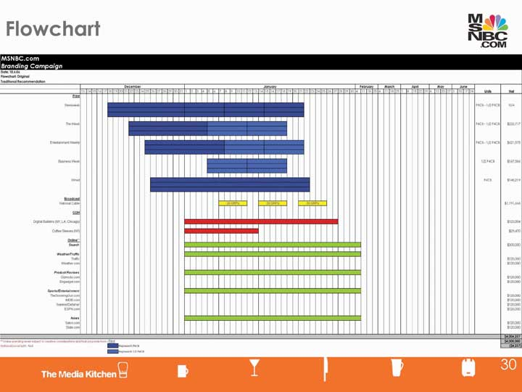
One of The Media Kitchen and SS+K’s proposed media plans for the msnbc.com campaign. The different colors represent the different media and when they will launch.

Dig Deeper
Media Negotiations
Within the media agency, there are a few key people responsible for the planning and implementation of the campaign. The media planner strategically lays out the plan with standard media rates in the budget line. Once the plan is approved, the media buyer negotiates the rates and costs with the media sales representative. The media sales representative negotiates on behalf of the media, whether it be a rep from the Wall Street Journal, ESPN, or Rotten Tomatoes.
During the negotiation process, rates can change based on how much the advertiser will commit to, how long they will commit the funds, and other factors that support the business relationship. One thing that comes out of this for the advertiser is “added value.” Added value can be additional pages or runs in a particular medium; it can also be a survey or access to a medium’s database.
A common place for these negotiations to take place is the media upfronts. Starting in spring, media outlets will host parties and meetings with various media buyers, planners, and advertisers. Networks share their programming in order to excite advertisers about where their ads can air in the future.

Market Coverage
Media vehicle choice is driven by market coverage, which is the extent to which a given media vehicle reaches the target audience. For example, local newspapers, radio stations, billboards, and direct mail campaigns are cost effective when they target a population that lives in a specific region, whereas national newspapers, TV, and online are better for nationwide campaigns. Specialized magazines and online media are particularly useful for target consumers who have specific interests. Online media also offers the advantage of real-time tracking—you know instantly whether consumers are clicking through to your site and how much time they spend at the site.
Market coverage tells advertisers what a specific vehicle can do for them, but that doesn’t mean that any one vehicle can do the whole job. Often, a media plan requires multiple media to achieve the advertiser’s goals. The media schedule outlines the planner’s best estimate of which media will be most effective to attain the advertising objective(s) and which specific media vehicles will do the most effective job.
When she creates the media schedule, the planner considers factors such as the match between the demographic and psychographic profile of a target audience and the people a media vehicle reaches, the advertising patterns of competitors, and the capability of a medium to adequately convey the desired information. The planner must also consider factors such as the compatibility of the product with editorial content. For example, viewers might not respond well to a lighthearted ad for a new snack food during a somber documentary on world hunger.
When she analyzes media, the planner assesses advertising exposure, the degree to which the target market will see an advertising message in a specific medium. Media planners speak in terms of impressions, the number of people who will be exposed to a message that appears in one or more media vehicles. For example, if fifty million people watch American Idol on Fox, then each time an advertiser runs an ad during that program, it gets fifty million impressions (clue: that’s a lot). If the advertiser’s spot runs three times during the program, the impression count would be 150 million (even though some of these impressions would represent repeated exposure to the same viewers).
Reach refers to the percentage of the target audience that is exposed to any of the media vehicles in the media plan during a specified time period. Choosing the media vehicle with highest reach means that more people will be exposed to the campaign. For example, if a media plan targets the roughly five million women who are eighteen to twenty-five years old, then a reach of fifty means that 50 percent, or 2.5 million, of the target audience will see at least one of the media vehicles in the media plan. Reach only counts viewers once. If a person sees the same ad multiple times in one medium, or even if they see the ad in different media, it still counts as only one person for the purposes of calculating reach.
A related term, frequency, refers to the average number of times that target consumers are exposed to the media plan. Frequency is important if the advertiser believes that consumers need multiple exposures to the campaign before buying the product or taking action. Achieving both broad reach and high frequency is very expensive—doubling the reach and doubling the frequency at the same time requires buying more than four times as many media impressions.
Say that a media planner wants to be sure her advertising for the Rockstar energy drink effectively reaches college students. She learns that 10 percent of the target market reads at least a few issues of Wired each year (that’s reach). She may also determine that these students on average are likely to see two of the ten ads that Rockstar will run in Wired during the year (that’s frequency). Now, she calculates the magazine’s gross rating points (GRPs) by multiplying reach times frequency, which in this case allows her to compare the effectiveness of Wired to that of alternative media vehicles. By using this same formula, the planner could then compare this GRP number to that of another magazine or to the GRP she would get if she placed an ad on TV or sponsored a Maroon 5 concert tour on college campuses.
Although some media vehicles deliver superior exposure, they may not be cost efficient. More people will see a commercial aired during the Super Bowl than during a 3:00 a.m. rerun of an old Will Ferrell movie. But the advertiser could run late-night commercials every night for a year for the cost of one thirty-second Super Bowl spot. To compare the relative cost effectiveness of different media and of spots run on different vehicles in the same medium, media planners use a measure they call cost per thousand (CPM). This figure reflects the cost to deliver a message to one thousand people. CPM allows advertisers to compare the relative cost effectiveness of different media vehicles that have different exposure rates.
Table 10.1 Cost Per Thousand Example
Cost per thousand (CPM) Calculation
CPM =
ad cost × 1,000
circulation
Cost of 4-color ad in Sports Illustrated = $320,000  Circulation of Sports Illustrated = 3,150,000 | CPM for Sports Illustrated ad =  $320,000 × 1000 = $101.59  3,150,000  To reach 1,000 Sports Illustrated readers
A media vehicle’s popularity with consumers determines how much advertisers must pay to put their message there. Television networks are concerned about the size of their audiences because their advertising rates are determined by how many viewers their programming attracts. Similarly, magazines and newspapers try to boost circulation (that explains all the free issues you get) so they can charge higher rates to their advertising clients.

SS+K Spotlight
Part of the media planning process includes keeping track of your target reach and frequencies so that you can measure success at the completion of the campaign.
See the results from msnbc.com’s effort later in Chapter 14 "ROI: msnbc.com Decides if the Campaign Worked".

Buying Eyeballs: Length of Ads and Scheduling Strategies
Size matters: ad space costs money, so advertisers think carefully about the size of ads. Larger or longer ads cost more but provide more in terms of space to tell a story and exposure to catch the consumer’s eye. A double-page magazine ad is more noticeable than a half-page ad. Short or small ads allow more frequency, more reach, or a longer campaign—an advertiser can afford to buy many more impressions in many more media vehicles with a small ad.
Historically, TV advertisers only bought sixty-second spots. But allocating the budget to thirty-second or fifteen-second spots improves the advertiser’s reach. The company can reach more people and get a better reach frequency at a lower cost. Shorter spots may direct viewers to a Web site where they can get additional information. Still, sometimes longer is better. In radio, advertisers have found that longer ads work better than short ones: spots of forty-five seconds or more were more effective than shorter spots. ^{[2]}
Media planners rely upon three basic scheduling patterns:
Continuity scheduling means spreading the media spend evenly across the duration of the campaign.
Flight scheduling alternates periods of heavy advertising with periods of no advertising. For example, Moët brand champagne traditionally uses flight advertising; it schedules the bulk of its advertising around the holidays and year end.
Pulse scheduling is a combination of continuity and flight scheduling. With pulse scheduling, advertisers maintain an ongoing low level of advertising to remind the consumers of the brand, interspersing heavy advertising around particular times of the year.

The Media Mix
Often one vehicle can’t accomplish all the goals of the campaign. For instance, no single vehicle might have the market coverage needed for the desired reach. Or it may be too expensive to achieve the desired frequency. Furthermore, some media vehicles lack the needed reach, are too expensive for the desired frequency, or are not effective for some aspects of the campaign. TV is expensive but lets the advertiser tell a good story about a new product. Magazines and print can reach specific demographics and deliver persuasive information. Billboards and other out-of-home vehicles are cheap and provide the reach and frequency to strengthen brand awareness and remind consumers of the product.
New media can stimulate buzz that spreads the message further. A recent report based on data from three thousand panelists in six major markets found that multiplatform advertising increases reach over individual platform advertising in a nonadditive way; in other words, the whole is greater than the sum of the parts. When consumers are exposed to the same ad message on multiple platforms, the campaign’s effectiveness gets a bigger boost in awareness or intention to buy. ^{[3]}

Dig Deeper
With not a lot of money to spend, the California Avocado Commission (CAC) created an integrated campaign to “reach the consumer wherever he or she might be—in the car, at work, at home, in the grocery store and at restaurants—with the ‘Irresistible California Avocado’ message,” said Jan DeLyser, CAC’s vice president of marketing. “All of the elements worked together to build brand awareness and strengthen demand for California Avocados.” The CAC used a combination of radio spot advertising, outdoor advertising, online banner ads, trade communications, public relations, POS (point-of-sale) materials, and a dedicated Web site.
To encourage retailers to put up an in-store display, CAC provided them with the POS materials. Retailers could then enter their display in a retailer-only challenge. Every qualified entry automatically received a $20 Amazon.com gift card, and five randomly selected grand prize winners were awarded an Apple 30GB iPod. Dozens of stores participated.
Results: the campaign generated millions of impressions and over a hundred thousand consumer entries to its game show–style “California Avocado Irresistible Challenge” to win a 2007 Toyota Prius. ^{[4]}
As media vehicles proliferate and consumers divide their time between TV, magazines, outdoor activities, computer games, etc., advertisers feel the need to diversify their media mixes. “You are going to see us more and more fragmented in our spending,” said Jim Stengel, P&G’s (recently retired) chief marketing officer. “We are spending a lot more on interactive and a lot more on mobile as that makes its way around the world. The trend of the past five years will continue, which is that TV advertising will go down as a percentage of our spending, and we will continue to move money to where the consumers are. The interesting news in all of this is that consumers are spending more time with media than ever. If the content is good, consumers will spend an awful lot of time with media.” ^{[5]}

SS+K Spotlight
SS+K pulls together its launch plan: the msnbc.com campaign aimed to reach News Explorers in ways that would get them to pay attention to the brand. The campaign combined elements of the paid media plan that were designed to increase reach and impressions above with elements of product enhancement (new logo, site design, screensaver) and nonpaid media (public relations, new and interesting asymmetric ideas).

Figure 10.11
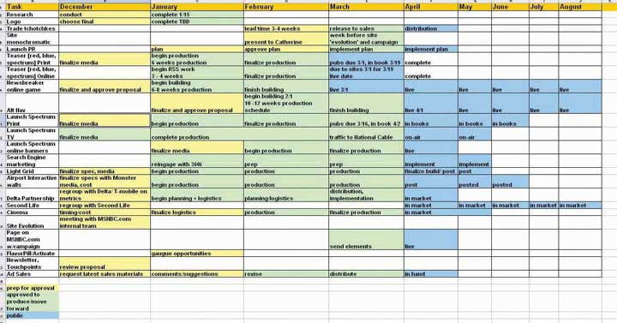
SS+K’s launch plan for the msnbc.com campaign. Notice the many “moving parts” involved in coordinating paid media that we learned about in this chapter and other elements, including public relations (Chapter 9 "Choose Your Communication Weapons: SS+K Decides Upon a Creative Strategy and Media Tactics"), logo (Chapter 8 "Create a Strategy: SS+K Puts Its Research to Use as the Agency Creates the Brief"), and asymmetric ideas (Chapter 8 "Create a Strategy: SS+K Puts Its Research to Use as the Agency Creates the Brief"). It was important for the first branding campaign to have a big push in order to create noise in the marketplace.

KEY TAKEAWAY
Media planning is the process of choosing one or more media vehicles to reach the target audience and achieve the message objectives. In most cases the best plan combines several media platforms to ensure that the message breaks through advertising clutter. Media planners assess the characteristics of different media including their cost and effectiveness to decide upon an optimal mix. They use standard measures such as reach and frequency to compare apples and oranges (e.g., TV and billboards), though the increasing use of new media makes this comparison more difficult because industry standards have not yet evolved.

EXERCISES
- List and describe message objectives.
- Demonstrate how media planning is done by advertising professionals.
- Define and discuss impressions, reach, frequency, gross rating points (GRPs), and cost per thousand (CPM).

[1] Quoted in “The Results Issue,” Brandweek, July 23, 2007, 28.
[2] Radio Ad Effectiveness Lab, “Radio Effectiveness and Execution,” March 2004,http://www.rab.com, by paid subscription (accessed February 12, 2009).
[3] “Cumulative Value of Multi-Platform Advertising,” Center for Media Research, July 17, 2008, http://www.mediapost.com/ (accessed July 17, 2008).
[4] Quoted in “California Avocado ‘Irresistible Challenge’ Attracts Nearly 400K Web Hits,”Progressive Grocer, October 10, 2007, 1.
[5] Quoted in Geoff Colvin, “Selling P&G,” Fortune, September 18, 2007,http://money.cnn.com/magazines/fortune/fortune_archive/2007/09/17/100258870/index.htm?postversion=2007090511 (accessed September 18, 2007).

10.4 Exercises

TIE IT ALL TOGETHER
Now that you have read this chapter, you should be able to determine how to choose the right media for client messages:
- You can define media mix and media planning.
- You can list and characterize the traditional advertising media.
- You can compare and contrast the print media against the broadcast media.
- You can describe the usefulness of out-of-home media for carrying advertising messages.
- You can recognize the strengths and weaknesses of integrating sponsorships into a promotional mix.
- You can list and describe three forms of direct-response media.
- You can list and characterize new media forms.
- You can explain how advertisers might use new communication channels to solve advertising and marketing problems.
- You can characterize word-of-mouth (WOM), viral, and buzz marketing.
- You can explain how marketers and advertisers can use virtual worlds to bring messages to consumers.
- You can describe consumer-generated media (CGM) and its uses to advertisers and marketers.
- You can explain how social media and social networking sites can be used to advocate brands and brand messages.
- You can list and describe message objectives.
- You can demonstrate how media planning is accomplished.
- You can identify and explain the media planning analysis tools presented in the chapter.

USE WHAT YOU’VE LEARNED
- Whether you use Amway products or not, you’ve most likely heard of this direct marketing organization. In 1999 Amway changed its U.S. name to Quixtar as a means to deal with increasing complaints and accusations that it was running a pyramid marketing scheme. The name change didn’t work, and Amway is now attempting a contemporary rebranding of its old Amway name. For more information on the company and its current promotions seehttp://www.amway.com for details.
Assume that your advertising agency has just been hired by Amway to rebrand the corporate name and provide a positive response strategy to address critics’ concerns. Develop a media strategy and plan for your rebranding idea. Outline your response strategy. Discuss your ideas and plans with peers.
- Are you wearing a cool timepiece? Watches in all shapes and forms can be found in our society. One issue that is troubling to watch designers and manufacturers is the trend among youth to reject watches in favor of getting their time updates from cell phones or other personal data assistants. One company that is trying a unique approach to attract the fashion-conscious youth element is Xezo (seehttp://www.xezo.com for information). This company specializes in solid silver watches and timepieces, writing instruments, and eyewear.
Assume that your advertising agency has just been hired by Xezo to develop a “new media” campaign that will extend beyond their present media choices (e.g., magazines and Web site). Review the “new media” options and recommend a “new media” plan for the company. Describe the target market that is the focus of your plan. What message do you think the company should use if they were to follow your recommendation? Discuss your “new media” plan and message with peers.

DIGITAL NATIVES
Doing research on traditional and “new” media is not an easy task. How can advertisers and their ad agencies find up-to-date information on media rates and deadlines from media across the country? One of the most popular information sources for advertising professionals is Standard Rate and Data Service (SRDS). According to information provided by the SRDS Web site, “The SRDS database of media and information is the largest and most comprehensive in the world.”
Go to the SRDS Web site at http://www.srds.com and review the information provided. Choose one of the information sources provided and see what you can find on media rates. Be sure to check out the information directed to students and educators. Once you have completed your review, summarize how you might be able to use this resource to find information on media rates. Lastly, using a search engine, see what other data services might be available to investigate media rates. Review and then compare and contrast a few of the more interesting alternatives you found. How does SRDS stack up against its competitors?

AD-VICE
- Go to your local newspaper’s Web site. Once there, assume that you are an advertiser seeking to place an advertisement with the paper. Attempt to find the advertising rates, size restrictions, availability of color, and any other useful information for placing an ad. Evaluate your search experience. Evaluate the attractiveness of the newspaper’s rates.
- Go to at least one television and two radio station Web sites. Once there, assume that you are an advertiser seeking to place an advertisement with the television station and the chosen radio stations. Attempt to find the advertising rates, special advertising discounts, availability, market coverage, and demographic reached. Evaluate your search experience. Evaluate the attractiveness of the television and radio rates.
- Assume that you are applying for a marketing management job in direct marketing. The interviewer asks you the following questions: “If you were to take your list of friends, what would be the best way to reach them with a direct marketing message? How would you get their attention with the message?” The interviewer then says, “If you can be creative and answer my questions, you have a future in direct marketing.” Answer the interviewer’s questions and explain briefly what you have learned about direct marketing through this exercise.
- Using the “new media” described in the chapter, construct a media plan for introducing a new line of skateboards that allow the boarder double the surface speed of the skateboard. A new wheel design is the secret to the skateboard’s astonishing speed. Discuss your plan with peers.

ETHICAL DILEMMA
As indicated in the chapter, “Product placement is also slowly but surely making its way into videogames. Advergaming brings real-world brands into the game.” On the surface this seems like a natural extension of product placements that we see every day in our TV programs, movies, and online surfing adventures. Adult gamers would think it unusual if the street scenes where high-speed chases and gun battles took place didn’t have billboards and signs that advertised real products. Should product placements in youth-oriented video games have stronger standards?
Assume one of two roles: (a) You are a proponent of product placements in video games, or (b) You are an opponent of product placements in video games. Develop an effective argument for your position. Remember that your argument must address the ethics of using product placements in youth-oriented games. Discuss your argument with peers. Debate the opposition.

Chapter 11Execute on All Platforms: SS+K Goes into Production Overdrive
Figure 11.1 Three to Five Months to Launch!
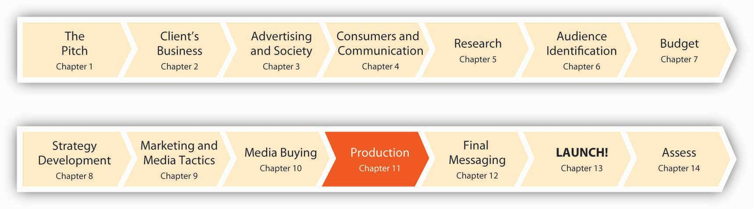
The process of execution determines how the message will look, read, or sound in its final form. Does it convey the right tone and attitude? Is it suited to its medium, be it print, TV, radio, outdoor, online, or alternative media? Each media vehicle offers advantages over the other vehicles on specific dimensions and requires the campaign team to create a message that takes advantage of that media vehicle’s strengths. For example, television is a cool medium(despite the “hot” images you might watch on it) because it requires a passive viewer who exerts relatively little control (remote-control “zipping” notwithstanding) over content. In contrast, print is a hot medium. The reader is actively involved in processing the information and is able to pause and reflect on what she has read before moving on. ^{[1]}
In this chapter, we’ll revisit the media platforms that advertisers like msnbc.com can use in their campaigns; this time we’ll dive a little deeper into some of the factors that make each platform work or not. Then, we’ll have a look at some of the metrics (measures of effectiveness) advertisers use to figure out if what they did actually worked—or if they just looked pretty.

[1] Herbert E. Krugman, “The Impact of Television Advertising: Learning without Involvement,” Public Opinion Quarterly 29 (Fall 1965): 349–56.

11.1 Execute on Media Platforms

LEARNING OBJECTIVES
After studying this section, students should be able to do the following:
- Define the execution process.
- List and characterize the various media platforms available to the advertiser.
- Describe the role music plays in the execution process.
- List the factors that impact the effectiveness of radio ads.
- Describe the similarities and differences between online advertising and other media advertising.
- Explain how search engine marketing (SEM) and search engine optimization (SEO) are related to behavioral targeting.
- Discuss the concept of branded entertainment and its usefulness to marketing and advertising.

SS+K Spotlight
Before diving into the many elements of the new branding campaign, SS+K had to crack the creative code and come up with the concept of the campaign. Sam and Matt worked off of the brief we showed in Chapter 10 "Plan and Buy Media: SS+K Chooses the Right Media for the Client’s New Branding Message" and proposed three options for msnbc.com.
Amit organized an internal meeting in preparation for the client creative meeting. There, the team reviewed each of the creative approaches that Matt and Sam presented and ensured that everything was “on brief” or “on strategy”; this means that it communicated in a way that would motivate the News Explorer to check out msnbc.com.
Then Joe Kessler and Amit, Matt, and Sam held the initial creative meeting with Catherine Captain and a few members of her executive team—Charlie Tillinghast (president of msnbc.com) and Jennifer Sizemore (editor-in-chief of msnbc.com). The SS+K team presented three campaign options. You can see each of these in the figures below.

Figure 11.2
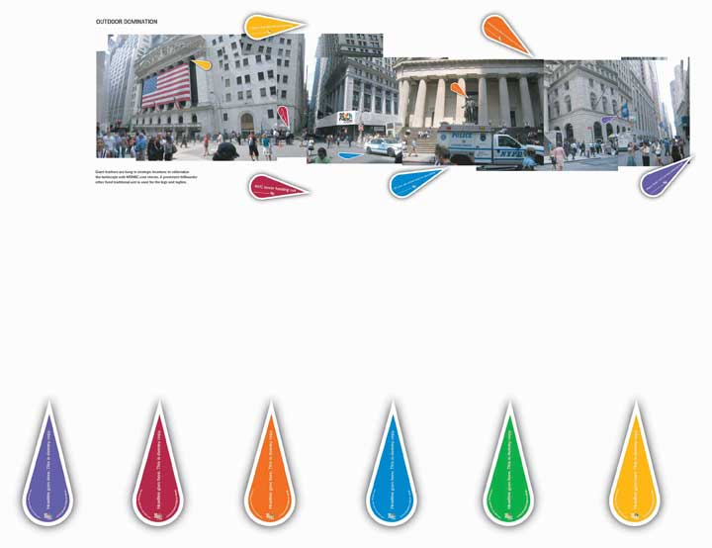
One campaign option presented was called “Feathers”; it used the feathers from the iconic NBC peacock to represent different stories going on around us.
Figure 11.3
Another campaign option was called “Chameleon”; it tapped into the insight of being many colors or knowing many things for situations like the ones depicted in the ads.
Figure 11.4
The other campaign option was called “Spectrum”; it utilized a spectrum of colors to represent the depth and breadth of stories available on msnbc.com.
Also, as you’ll notice in Figure 11.4, SS+K proposed an update to the previous msnbc.com logo. Matt Ferrin started with the idea of a pinwheel to visually communicate the ideas of the full spectrum. This idea generated discussion about changing the client’s logo (never an easy decision) to make it part of the new branding effort.
Can you guess which campaign the team decided to use? If you were the client, which would you choose, and why?
Now that the campaign creative approach was decided (as you learned in Chapter 9 "Choose Your Communication Weapons: SS+K Decides Upon a Creative Strategy and Media Tactics"), and the media planning was done (as you learned in Chapter 10 "Plan and Buy Media: SS+K Chooses the Right Media for the Client’s New Branding Message") it was time to start planning the full production.
Once msnbc.com had the strategy laid out with SS+K, it was time to start producing the materials for the media that had been bought, as well as materials for other marketing efforts outside of unpaid media, which we’ll cover later. The team was also hard at work on the new logo. In developing the new logo, Matt and Sam worked very closely with the design team at SS+K led by Alice Ann Wilson.
Figure 11.5
Here are some different graphic elements and fonts the team explored.
Figure 11.6
Figure 11.7

Figure 11.8
The client’s new logo incorporates a Web-friendly updated image.
The team also needed to develop a set of brand guidelines. These guidelines, established and approved by the agency and the client, dictate how the brand should behave, look, and feel. All communication must stay consistent in order for the brand to project a clear image in consumers’ minds rather than confusing them with different messages about the brand’s identity.

Print
Print advertising works well for factual information, especially complex messages and topics that the consumer wants to investigate, such as health-related messages. The best executions are those that we specifically develop for print, especially when the message requires us to lay out detailed, logical arguments in favor of our cause or brand.

Newspapers
Pharmaceutical company Pfizer, maker of the Nicorette brand of smoking cessation products, works hard to refine its print executions. Ben Peters, Pfizer’s Nicorette sector marketing manager for UK/Ireland/Central and Eastern Europe/Russia, explained the elements of successful print execution: “Key learnings that we have found at Pfizer include making sure the core message is communicated, that the reader is engaged quickly and can easily read the supporting text. The execution must also be placed in an appropriate section within the newspaper.” ^{[1]} Engaging the reader quickly means a catchy headline that grabs attention. To reinforce the brand even among readers who are simply scanning the pages, the branding element should be prominent within the ad.
Newspaper ads that work well provide news value, blending into the newspaper medium. “Great ads combine headline, layout, illustration and copy with a creative dynamic to add news value and talk in my language,” claims Jerry Hill, executive vice president of Initiative. ^{[2]}
SS+K, The Media Kitchen, and msnbc.com agreed that newspaper wasn’t the best medium for this particular branding campaign. The print production manager at SS+K, Jeannie O’Toole, was part of this discussion. Because the color blocks used in “Spectrum” are so distinctive, Jeannie advised that re-creating the art on newsprint would not be adequate. Newsprint absorbs ink so well it causes a phenomenon referred to as dot gain and the ink has a greater chance of bleeding outside its designated boxes. These issues could result in an unclear communication: each of the color boxes represents a story, so if the ad isn’t executed properly, it will just look like a bunch of fuzzy boxes and the story will be lost.

Dig Deeper
As newspapers confront declining readership rates among young people, some of them are hedging their bets as they develop online versions. Since people increasingly access their news on the road, some see the future of newsprint as real estate on a cell phone screen. However, it’s not a simple matter to transfer a newspaper page to a much smaller reading area—the fine print becomes unintelligible. Information needs to be presented in more compact “bytes” rather than in prose-length paragraphs. For this reason, a new niche is opening as providers spring up to create mobile versions of newspapers. One such company is Verve Wireless; it provides mobile versions of four thousand newspapers. It recently developed an iPhone application for the Associated Press that allows a user to scan the day’s headlines, send articles to friends, and save articles to read later. Publishers can upload local ads to their cell phone sites, and the service can deliver targeted ads to specific readers who have searched for articles in past editions of the (mobile) newspaper. ^{[3]} Is this the future of today’s hard-copy newspaper?

Magazines
Executing advertising in magazines requires not just good copywriting but also clever use of powerful images. The visuals that get people’s attention often offer some element of surprise. One of the photos considered the best in the history of advertising was created by the Saatchi and Saatchi agency to encourage use of contraceptives. It featured the photo of a man—pregnant—with the caption, “Would you be more careful if it was you that got pregnant?”
Magazines support higher resolution images and better color reproduction than do newspapers. Thus, good execution of magazine ads involves a tight link between the art and copy. For example, the headline, “And you think seat belts are too confining?” makes a powerful statement when it’s coupled with a photo of a covered dead body strapped tightly to a gurney.

A Picture Is Worth a Thousand Words—If It’s the Right Picture
Subject matter, composition, color, and lighting all play a role to create the proverbial thousand words that an image can convey. These principles apply to camera angles on still images in print as well as on billboards or in moving images like TV.
Among the key decisions creatives make on a photo shoot is the camera angle onto the subject. The angle of the camera establishes a relationship between the viewer and the image. If the camera angle is straight on, the viewer is in a position of equality with the person or object in the image. If the camera looks down on the image, it suggests that the character or object is in a subservient role relative to the viewer. Conversely, a camera angle looking up at the character or object puts the viewer into the less dominant role. When the Burton Snowboard Company started to sell gear for women, the company redesigned its Web site after it got negative feedback from female riders who complained that the images made them look like snow bunnies. Now, it shoots female models from the bottom looking up, which makes them look more empowered. ^{[4]}
Framing also plays a role in our reaction to and interpretation of the image. A close-up puts us in an intimate or personal relationship with the image, whereas a long shot represents an impersonal relationship. Similarly, a frontal angle involves us with the character, whereas an oblique angle detaches us from the character. Burton Snowboard framed the product shots in its men’s section feature to feature tighter shots of the gear itself, since Burton’s research showed that males are interested in the board’s technical details. ^{[5]}
The art director is responsible for selecting the image that will be used in the print communication (and all communication for that matter). An image can either be bought or shot. Stock photo agencies like Getty Images are an example of a resource where art directors can search a database to see if the image they have in mind for an ad already exists. If it does, the art director works with the art buyer at the agency to secure the rights to use that image.
If the image doesn’t exist in stock, a photo shoot is recommended. The art buyer reviews and selects different photographers or visual specialists to present to the art director. The art director evaluates their portfolios and may have a few meetings with the different photographers to determine their comprehension of the creative vision. Once a photographer is selected by the art director, the associated costs are compiled by the art buyer. The account manager is responsible for keeping the client involved in the status of the project and staying within budget.

TV
As a medium, TV is powerful because it combines elements that can’t be used in print or radio alone. Art directors can blend words with images—real or animated—and music. TV can demonstrate products, but it also can create moods via graphic images and sounds. Coordinating all these elements requires multiple participants on the agency side to manage the creative process, storyboards, and copywriting, as well as a producer to oversee all the activities related to the broadcast production.
Producing the TV commercial often requires hiring a production company, which will have its own director in charge of film, a producer in charge of the production crew on each shoot, a production manager who oversees logistics like dressing rooms and food service, a camera department, an art department, and editors who create the final commercial, or “spot,” in postproduction through cutting and joining frames and audio. There are different considerations that the producer must manage depending on whether the spot is live action or animation. Live action also involves casting, auditions, wardrobe, talent contracts, and so forth. Animation projects may not involve a traditional “shoot,” but as the production process is very exacting, it is important for all producers to manage the steps of the process and for account managers to identify the correct points of client approval.
Another very important function of producing television spots is sound. Dialogue between characters in a spot is one main sound, and VO or voice-over is another common sound element used in television spots. A voice-over is used sometimes as an announcer and sometimes as a legal blip at the end of a spot.
The music supervisor oversees the sound design, the music, and the mix. Sound design refers to the audio elements that enhance the story being told by the visual. These elements are specific to frames or movements within the spot. Music is a background track that runs throughout a commercial spot. The purpose of this sound is to create and reinforce the emotional tone throughout the communication. The mix or final mix blends the married elements of dialogue or VO, sound design, and music so that the desired story is achieved. Executing well in TV requires great attention to all these details.

Radio
Executing well in radio requires strong copywriting. “The mistake that people make is in thinking that radio is just sound without any visuals,” said Paul Brazier, executive creative director, Abbott Mead Vickers BBDO. “In truth, radio is one of the most visual mediums that demands discipline and tightness of communication. Radio script writing teaches you about tone of voice and forces creatives to think visually.” Sound effects reinforce the images copy creates. The “PSST!” of a beer bottle being opened or the reverberating sound effect of a stadium sound system helps pull the listener into the ad’s storyline.^{[6]}
Executing well in radio also means paying special attention to music. Indeed, the music itself can be part of your brand (such as NBC’s three-tone sound trademark, heard for many years at the beginning of NBC TV shows when the peacock logo was displayed). Some companies simply license a current hit or a classic song to convey a feeling. Although it’s true that music gets attention and creates an emotional conduit, licensing an existing song has three downsides:
- Consumers already have preexisting connections with the song that may not fit with your brand or may add unneeded baggage that distracts from the brand.
- If the artist falls out of favor, the money you’ve invested linking your brand to the artist is threatened (e.g., singer Michael Jackson’s endorsement of Pepsi lost value when he admitted he doesn’t drink soda; his troubles with the legal system didn’t help either).
- Your target audience may tire of the tune.
To avoid these downsides, some companies feel it’s worth the money to commission original music to uniquely suit the brand. Rather than being an add-on, the music becomes a branding tool in itself. Original music can grow with the brand as needed. It can also be written with specific ethnicities or demographics in mind while it maintains the core theme.
Two companies understand the strategic role of music particularly well. McDonald’s’ “I’m Lovin’ It” tagline and audio logo has become a powerful mnemonic device for brand recognition. McDonald’s Chief Marketing Officer Mary Dillon believes that “marketers who do not understand the power of music will quickly be left behind.” And the TBWA/Chiat/Day agency has created a unique and distinctive sonic personality for Infiniti that perfectly matches the cars themselves. The original music and sound, which is unlike any other brand’s jingle, creates a very contemporary feel. ^{[7]}
Research on effective versus ineffective radio ads identifies these factors as having the greatest impact: ^{[8]}
- Number of words (more is better, all else being equal)
- Brand mentions (more is better; early in the ad is better)
- Number of different ideas (more than four or five is bad)
- Execution format (straight announcement and “sing-and-sell” were weakest)
- Simple duplication of a TV soundtrack (not good)
- Duration (spots of forty-five seconds or more are more effective)

Dig Deeper
Fans of R&B singer Chris Brown may have noticed a brief reference to an old chewing-gum jingle in his hit song, “Forever,” when he sings, “Double your pleasure/double your fun.” They found out why when the Wm. Wrigley Jr. Co. revealed in a press conference that the song actually is an extended version of a new commercial jingle that the singer wrote to promote Doublemint gum. The ad agency Translation Advertising signed three different performers to update the company’s chewing gum brands with new jingles: in addition to Brown, R&B singer Ne-Yo does his own version of Big Red’s “Kiss a Little Longer” jingle, and Dancing With the Stars regular Julianne Hough recorded a twangy version of Juicy Fruit’s “The Taste Is Gonna Move Ya.” The Wrigley campaign shows how the deep the ties run between advertising and the music industry—and how much deeper they’re getting. As the head of the agency noted, the strategy was to connect the song with the jingle from the start: “By the time the new jingle came out, it was already seeded properly within popular culture.” ^{[9]}

Outdoor
Outdoor advertising has been around since the late 1800s, when posting “bills” on wooden boards led to the birth of the term “billboard.” Today, the out-of-home category includes not only the roadside billboards but also “car cards” in public transportation; in-store displays; and displays in airports, sports arenas, transit shelters, and ski areas—even on rocket ships!

Billboards: More than Just a Big Print Ad
Although a billboard seems like a magazine ad that’s just printed on a mega scale, that’s not the case. Billboards use more images and less copy than do print ads. Executing well on billboards means creating a visual image or short phrase that gets the message across quickly—literally in the blink of an eye.
One key characteristic of outdoor advertising is that it is situated in a fixed context: a physical environment that provides room for the ad to connect to or play with. Billboards are not restricted to their rectangular spaces, like print or TV ads; they can burst out into space. For example, a Bic Shaver billboard shows the shaver seemingly trimming the surrounding grass. Adidas created a larger-than-life David Beckham billboard that has him lunging to catch a soccer ball across the highway. The Adidas billboard stretched across above the highway, with traffic from one side seeing Beckham from the front and traffic from the opposite direction seeing him from the back. These types of billboards are referred to as “spectaculars,” because they are just that!
Outdoor advertising is branching off in new directions as billboards morph into stages that let onlookers interact with them. As an example of how outdoor advertising can go viral, a recent commercial for Oreo revolves around passersby who react to the sight of an elevator done up as one of the cookies repeatedly dunking itself into a glass of milk when it descends. The spot got a lot of attention on YouTube.
Some of these attempts may backfire or fail to deliver a clear message as they push the envelope. A Chevrolet billboard that used real pennies was stripped clean within thirty minutes. In Singapore, advertisers painted an extra yellow safety line on a train platform with the name “Wonderbra” on it, leaving commuters to figure out the message (that the bra’s lifting qualities were so forceful that wearers would have to stand back). A recent outdoor campaign for Right Guard in London is a contender for biggest flop (at least for now): teams of actors invaded subway cars with tiny video screens in the armpits of their shirts. Whenever one of them reached up to grab a strap while riding the train, a commercial for Right Guard played in the face of a “lucky” fellow strap-hanger.^{[10]}

Enter the Digital Billboard
Technology is transforming the humble billboard in fascinating ways. Digital billboards change messages instantly. They can also be Bluetooth-enabled. For example, billboards in the London subway let passersby download selections from the latest Coldplay album. Other billboards, in shopping malls, have virtual footballs teed up that passersby can “kick” on an interactive floor display. These new technologies let consumers interact with—and be immersed in—outdoor advertising as never before. This floor technology is similar to an interactive projection that inspired the msnbc.com interactive movie game NewsBreaker Live.
Jack Sullivan, senior vice president of out-of-home media at Starcom, sees this trend increasing as the population becomes even more wireless. “Consumers are out there with downtime on the streets. If you can get them to play, to interact with your sign, you are being invited into that decision maker’s lifestyle and they are opting in to share their personal time with you; it hopefully is having a heck of a lot more impact and is leading to increased sales.” ^{[11]}

Dig Deeper
As SS+K discovered, movie theaters are a prime venue to reach consumers, and (like it or not) it’s common for commercials to appear before the feature. Now, a company called Cinescent is testing a system that pumps out the scent of an advertised brand along with the video. The first execution occurred recently in Germany for Nivea; a sixty-second spot showed a typical sunny beach scene and then suddenly the scent of Nivea sun cream was released along with the Nivea logo on the screen with the words, “Nivea. The scent of summer.” This test made quite an impression: exit polls showed a 515 percent rise in recall for the Nivea ad compared with moviegoers who saw the spot without the odor. ^{[12]} This kind of creative execution seems to make sense—though there are some advertisers who should probably avoid the temptation to pump smells people associate with their products into crowded places (we’re talking to you, Nike).

Point-of-Purchase (POP)
Point-of-purchase (POP) advertising is designed to drive immediate—and usually impulse—purchases. Effective POP messages appear as close as possible to the time and place when the consumer makes the purchase decision. The message must either provide news about the product or offer a price incentive.
Just as billboards are going digital, so are POP displays. Digital technology adds value to POP because it lets the message change hourly, daily, or weekly—whenever the advertiser chooses. This lets advertisers keep the message fresh and new.
Digital POP also lets advertisers use motion or animation to attract the consumer’s eye or to time offers to suit the time of day or even the weather. “The cliché example is to offer soup on cold days and ice cream on hot, but it can be infinitely more clever than that,” said Angela Walters of Eye Shop, a company that designs digital POP systems. ^{[13]}

Online
In many ways, online advertising blends the properties of the other media while it adds unique characteristics of its own. Executing in the online medium means drawing on the lessons of other similar media, while taking advantage of its unique capabilities.

How Online Ads Are Similar to Other Media
Billboards: Online advertising borrows from billboard sensibilities because it relies more on images and less on verbose copy. A banner ad is like a billboard on the information superhighway.
TV: Online ads are like TV commercials in that they can show moving images that tell a story or create dynamic visual interest. With the rise of broadband, advertisers also can use full-motion video. But executing video for a Web ad is different from regular TV in that the low resolution and frame-rate of images forces the production to avoid overly detailed and fast-moving scenes.
Print: Online text ads, such as Google’s AdWords, have similar executional issues as do print ads, especially small classified ads. The advertiser has but a few words in which to interest and motivate the viewer.
POP: Online ads share executional qualities of POP ads in that well-executed online ads trigger the impulse to click through and respond to the advertised product or service. These messages also offer the immediacy of POP ads in that both ad forms encourage the consumer to put the items directly into her shopping basket.

SS+K Spotlight
The team’s research clearly showed that the News Explorer would most likely be found online. SS+K worked with BEAM Interactive to create new and dynamic Web-based ads that would resonate with this wired consumer and support the msnbc.com brand.

How Online Ads Differ from Other Media
Interactivity: The biggest difference between online ads and other advertising forms is the ability to interact with the ad. In some online ads, even the act of moving the mouse can cause the ad to change in response. Interactive ads let viewers access more information, tell the advertiser about themselves, interact with the product in simulations, or be entertained by a game. Executing for interactivity means crafting an invitation to the viewer to interact with the ad, creating a user interface or game play that is both simple and engaging, and developing an interactive space that reflects the values of the brand (e.g., a youthful game versus a serious, informative presentation).
Specificity: Online advertising permits great specificity in terms of who sees the ad and in what context. The use of cookies tells site owners and advertisers who views the ad. Many registration-based sites collect key demographic data such as the user’s address, age, interests, and browsing history. The use of this information in planning online media is called behavioral targeting. The ability to “buy” keywords means that advertisers can target very narrow contexts. Executing well in interactive media means picking the target demographic and choosing keywords that reflect the type of customer you seek.
Another element of the msnbc.com campaign wassearch engine marketing (SEM) andsearch engine optimization (SEO). Interactive agency 360i worked with msnbc.com to internally optimize the site setup so that search engines could find data more easily, thus resulting in higher natural search results, which are the results of a Web search that are not sponsored. 360i also ran the SEM campaign by identifying keywords specific to msnbc.com, the new brand, and timely news. These paid search results show up in the “sponsored” section of search engines.
To keep advertising dollars from bleeding away from their newspaper pages, dailies have moved online themselves, putting up Web sites with news and information to attract online readers and advertisers. But simply posting a full-page print ad on the newspaper’s Web site doesn’t work. “People don’t want to see a flat ad on the Internet,” said Kathleen Cunningham, president of Advanced Marketing Strategies. “They want it interactive with multiple pictures.” ^{[14]}
One solution to building in interactivity is the new genre of advertising we have called branded entertainment, where the ad seamlessly integrates a product into a piece of entertainment. BMW pulled this off masterfully with its series of Internet movies several years ago. BMW’s agency GSD&M was inspired when they discovered that 85 percent of Beemer drivers visited the company’s Web site before they bought a car. The campaign team hired eight top film directors to make short films featuring BMW cars. The films were a great success—they were viewed ten million times in the first year—and two million people registered on the BMW site after watching them. In addition, 60 percent of those who registered on the site opted in to receive e-mails.
One of the best BMW movies, entitled Hostage, worked so well because it put emotion to work for the brand. It built the image of the brand in the mind of the consumer by putting the driver into a heroic role of a modern-day gunfighter who saves the day with the help of his BMW Z4. The movie worked because the car wasn’t simply a product placement—it was the instrument of the story. If the car weren’t so fast or didn’t have superior handling, it wouldn’t have let the driver triumph. One of the series’ producers remarked, “The BMW brand is in there as a character, but these aren’t really commercials. We think it’s the way lots of things will go in the future. More product placement than advertising.” When consumers were tested after seeing the movie, they perceived the BMW brand as: “a leader in innovation” and “dominating the luxury car category” and “an exhilarating driving experience.” ^{[15]}

Alternative Media
The total spending on alternative media in 2006 was $387 million, which is a small fraction of the total spent on all advertising. How effective these media are remains to be seen, although it’s clear that they are attracting attention. One of the challenges for alternative media is simply finding new places to advertise. “We never know where the consumer is going to be at any point in time,” says Linda Kaplan Thaler of the Kaplan Thaler Group, a New York ad agency, “so we have to find a way to be everywhere.” New alternate media vehicles include Chinese take-out cartons and pizza boxes, school buses that play kid-friendly radio ads, and tray tables on airlines.
Marketers constantly experiment with novel ways to reach audiences that get harder and harder to reach. Procter & Gamble created a new medium when it printed trivia questions and answers on its Pringles snack chips with ink made of blue or red food coloring, whereas a company called Speaking Roses International patented a technology to laser-print words, images, or logos on flower petals. ^{[16]}
School buses and airplanes boast “captive” audiences—the consumers who are there almost can’t help seeing or hearing the ad. Walt Disney has even ventured into the doctor’s office, advertising its “Little Einsteins” DVDs for preschoolers on the paper liners of examination tables in two thousand doctors’ offices. US Airways sells ad space on its motion-sickness bags—although we’re not sure if a passenger using the bag is the best target for an ad, unless it’s for a product like Pepto-Bismol or Dramamine. Some supermarket eggs show up stamped with the names of CBS TV shows on their shells. However, these innovative executions risk alienating people if they become too intrusive. “Got Milk?” billboards at some San Francisco bus stops emitted the aroma of chocolate chip cookies; they prompted enough complaints from citizens that the city asked the California Milk Processing Board to turn off the smell. ^{[17]}
As we’ve seen, mobile advertising continues to evolve as a message platform. Recently, several companies introduced innovative technologies to make this medium more effective for the growing army of iPhone users (85 percent of whom already access the mobile Internet). For example, a firm called JumpTap launched technology that allows an advertiser to place an “Action” icon within an ad that appears on the phone; this in turn allows users to launch video (via YouTube), audio, maps, and Web sites. Universal Pictures promoted the movie The Mummy with mobile ads that included a trailer of the flick and a tool to find local showtimes. ^{[18]}

Dig Deeper
If you’ve got $10,000–15,000 eating a hole in your pocket, you can even put your own illuminated personal ad or a corporate logo on your tire rims. Check out the bling athttp://customwheel.com/custom_wheels/product_info.php/products_id/1687.

KEY TAKEAWAY
Each media platform possesses unique characteristics; some executions work better on one than another. Print (especially newspaper) works best to present factual information, while TV, magazines, and billboards are image intensive. Online works best when the advertiser builds in a great deal of interactivity; many advertisers still make the mistake of transferring a static print ad to a Web site. Alternative media options continue to evolve and can be a great way to break through the clutter of traditional media. However, advertisers risk crossing the line when their messages become too obtrusive.

EXERCISES
- Discuss the differences between cool and hot media.
- Discuss when print advertising makes the best executions.
- Describe the key decisions creatives make on a photo shoot.
- List and discuss the key functions in producing a TV commercial.
- Characterize the downsides of licensing music for commercials.
- Discuss how technology is changing billboards.
- Explain how online ads are similar and different from other media ads.

[1] Alasdair Reid, “Newspaper Advertising—The Creative Potential: What Makes a Great Newspaper Ad,” Campaign, January 20, 2006, 32.
[2] Alasdair Reid, “Newspaper Advertising—The Creative Potential: What Makes a Great Newspaper Ad,” Campaign, January 20, 2006, 32.
[3] Claire Cain Miller, “A Means for Publishers to Put a Newspaper in Your Pocket,” New York Times Online, July 28, 2008,http://www.nytimes.com/2008/07/28/technology/28verve.html (accessed July 28, 2008).
[4] Rebecca Gardyn, “Granddaughters of Feminism,” American Demographics (April 2001): 43–47.
[5] Rebecca Gardyn, “Granddaughters of Feminism,” American Demographics (April 2001): 43–47.
[6] Quoted in Martin Pazzani, “Making the Most of Music,” Advertising Age, June 11, 2007, 21.
[7] “Those Who Get It—And Those Who Just Don’t,” Advertising Age, June 11, 2007, 21.
[8] “Is There a Crisis in Radio Creativity?” Campaign, March 30, 2007, 19; Radio Ad Effectiveness Lab, “Radio Effectiveness and Execution,” March 2004, http://www.rab.com, by paid subscription (accessed February 12, 2009).
[9] Quoted in Ethan Smith and Julie Jargon, “Chew on This: Hit Song is a Gum Jingle,” Wall Street Journal, July 28, 2008, B1.
[10] Stephanie Clifford, “Summer Silliness Brings a Pizza Field and a Giant Oreo,” New York Times Online, August 1, 2008,http://www.nytimes.com/2008/08/01/business/media/01adco.html (accessed August 1, 2008).
[11] Quoted in Tony Case, “Take it Outside: A Surge in Interactive Out-Of-Home Messages Revitalizes the Oldest Ad Medium,” Brandweek, November 6, 2006, 16.
[12] Emma Hall, “What’s That Smell in the Movie Theater? It’s an Ad,” Advertising Age, July 24, 2008, http://www.adage.com (accessed July 28, 2008).
[13] Quoted in “Viva La Revolution: The T-Shirts Read Born to Shop; Indeed, Shopping’s Been Called a National Pastime,” AdMedia, August 2007, 28.
[14] Mark Larson, “Digital Format Presents Rubik’s Cube of Challenges to Advertisers,”San Diego Business Journal, July 9, 2007, 14.
[15] Quoted in Aaron Barnhart, “The Internet Driving Machine; BMW Films Web Site Makes the Most of Ultimate Product Placement,” TV Barn, June 19, 2001,http://blogs.kansascity.com/tvbarn/2001/06/the_internet_dr.html (accessed July 29, 2008).
[16] “Read My Chips? Pringles Has Plans to Print Jokes, Trivia on Its Potatoes,” Wall Street Journal on the Web, May 20, 2004, C13; David Serchuk, “A Rose with Another Name,” Forbes, December 27, 2004, 52.
[17] Louise Story, “Is There No Escape? In Their Efforts to Grab Consumers’ Attention, Advertisers Seem Determined to Fill Every Available Space,” New York Times, April 2, 2007, 6.
[18] Mark Walsh, “iPhone Spawns New Ad Networks,” Online Media Daily, July 25, 2008,http://www.mediapost.com/publications/?fa=Articles.san&s=87317 &Nid=45412&p=407056 (accessed July 25, 2008).

11.2 How Do We Know What Worked? Evaluating Ad Executions

LEARNING OBJECTIVES
After studying this section, students should be able to do the following:
- Summarize how advertisers evaluate ad executions.
- Explain how copy research is conducted.
- Illustrate how pretesting and posttesting of advertisements takes place.

Recall and Recognition
Executing advertising effectively requires that consumers notice the ad, recall the brand, and remember it favorably when they make a purchase decision. Recall means that viewers can remember and retell the specific marketing messages to which they were exposed. Recognition means they recognize the brand or message when they see or hear it again, even if they can’t recite it from memory.
Because marketers pay so much money to place their messages in front of consumers, they are naturally concerned that people will actually remember these messages at a later point. It seems that they have good reason to be concerned. In one study, fewer than 40 percent of television viewers made positive links between commercial messages and the corresponding products, only 65 percent noticed the brand name in a commercial, and only 38 percent recognized a connection to an important point. ^{[1]}
Ironically, we may be more likely to remember companies that we don’t like—perhaps because of the strong negative emotions they evoke. In a 2007 survey that assessed both recall of companies and their reputations, four of the ten best-remembered companies also ranked in the bottom ten of reputation rankings: Halliburton Co., Ford Motor Co., General Motors Corp., and Exxon Mobil Corp. In fact, Halliburton, with the lowest reputation score, scored the highest media recall of all the sixty companies in the survey. ^{[2]}
Metrics related to recall and recognition ignite controversy even among agencies themselves. For example, Carat Insight uses recognition techniques rather than recall. Mary Jeffries, the agency’s head of evaluation, explains: “Most research techniques have relied on consumers’ ability to remember advertising messages and they then use this as a proxy for effectiveness. This means that media such as radio, outdoor, press, cinema and online suffer terribly, as they do not get recalled. Our belief is that ads can work even if you can’t spontaneously recall them. This is why [we] use a recognition technique, which is a more accurate measure of likely exposure to advertising than recall.” Carat Insight provides a service it calls integrated communications evaluation (ICE), which uses recognition techniques and statistical modeling to identify the relationship between media channels and creative executions. ^{[3]}
In contrast, Intermedia Advertising Group is a research firm that measures advertising effectiveness by monitoring the TV-viewing population’s ability to remember an ad within twenty-four hours. The firm assigns a recall index to each ad to indicate the strength of the impact it had. In one recent year, while ads with well-known celebrities like Britney Spears, Austin Powers, and Michael Jordan had very high recall rates, three of the top five most remembered ads starred another (and taller) celebrity: Toys “R” Us spokesanimal Geoffrey the Giraffe. ^{[4]}
Under some conditions, these two memory measures tend to yield the same results, especially when the researchers try to keep the viewers’ interest in the ads constant. ^{[5]} Generally, though, recognition scores tend to be more reliable and do not decay over time the way recall scores do. ^{[6]} Recognition scores are almost always better than recall scores because recognition is a simpler process and the consumer has more available retrieval cues.
Both types of retrieval play important roles in purchase decisions, however. Recall tends to be more important in situations in which consumers do not have product data at their disposal, so they must rely on memory to generate this information. ^{[7]} On the other hand, recognition is more likely to be an important factor in a store, where retailers confront consumers with thousands of product options (i.e., external memory cues are abundantly available), and the goal is simply to get the consumer to recognize a familiar package. ^{[8]}

SS+K Spotlight
SS+K and msnbc.com also wanted to be able to measure the effects of the first effort. All parties agreed that given the size of the audience and the budget, the expectation was not to convert a huge number of people but rather to articulate the brand to the target audience. Michelle Rowley and John Richardson led the research effort by enlisting a firm called Russell Research to conduct surveys before the launch and then again after the launch to be able to understand any changes. Catherine Captain’s research background also came in quite handy here, as all agencies worked together to set up the appropriate parameters. We’ll reveal the results of this research in Chapter 14 "ROI: msnbc.com Decides if the Campaign Worked".

The Stopping Power of Creative Ads: Are They Effective, or Just Cool?
Other agencies maintain that above all, the ad must get noticed. And very creative ads do get noticed—they break through the clutter. Ads that win creative awards have twice the “stopping power” of regular non-award-winning ads. They get your attention. Moreover, award-winning ads create buzz. Even after two decades, people still talk about Apple’s “1984” ad.
But, although they are more entertaining, creative ads also can confuse the very people they’re intended to persuade. Sometimes a clever ad can be too hip for its own good. Research on award-winning ads finds that consumers are more likely to say “I couldn’t tell what that brand had to do with what was said and shown.” This means that executions may require tweaks (which copy testing can guide) so that the ads are able to generate sales for the brand as well. ^{[9]}
Cheer up: advertisers do not have to simply sit back and hope for the best. By being aware of some basic factors that increase or decrease attention, they can take steps to increase the likelihood that product information will get through. An advertiser who wants to wake people up can: ^{[10]}
- Use novel stimuli, such as unusual cinematography, sudden silences, or unexpected movements. When a British online bank called Egg Banking introduced a credit card to the French market, its ad agency created unusual commercials to make people question their assumptions. One ad stated, “Cats always land on their paws,” and then two researchers in white lab coats dropped a kitten off a rooftop—never to see it again (animal rights activists were not amused). ^{[11]}
- Use prominent stimuli, such as loud music and fast action, to capture attention. In print formats, larger ads increase attention. Also, viewers look longer at colored pictures than at black-and-white ones.

New Ideas Support New Brand Launches
Attention-getting ads are particularly valuable when the communication objective is to help launch a new brand by boosting awareness and generating buzz. Apple’s “1984” ad is a case in point; the classic spot elevated the Apple brand from simply a utilitarian message (how a computer makes you productive) to an icon representing an attitude and point of view. Before the breakthrough “1984” ad, Apple’s TV commercials used slice-of-life and problem-solution frameworks. The “1984” commercial—shown only during the Super Bowl—created huge buzz for its allegory and cinematic distinctiveness. It created a position for Apple as revolutionary, liberating—much more strongly than a recounting of Macintosh’s user-friendly features would have done.

Copy Research
Copy research provides evidence that your ad gets the audience’s attention and delivers a message that motivates the consumer to consider buying your product or service. The overall effectiveness of an ad is a combination of three variables:
- Attention: Entertainment value is a major predictor of attention-getting power, but if consumers don’t see the connection of the ad to the brand, the ad won’t lead to a sale.
- Branding: Communicating an idea or feeling that the consumer already has about the brand confirms the value of reminder advertising. Even better is advertising that communicates a new idea or a new feeling, but one that still fits the brand in the eyes of the consumer. This kind of advertising helps consumers to see the brand in a new light, to think about it in a new way.
- Motivation: Finally, an effective ad makes the viewer want to take action and buy the product. Pretesting asks the test subject whether they are more likely to buy the product now or in the future.

Pretesting and Posttesting
Copy research involves two phases: pretesting and posttesting. Pretesting takes place before the campaign starts. Posttesting takes place after the campaign, to evaluate the effectiveness of the copy in communicating its message.
The idea behind pretesting is to verify that the product claims and technical aspects of the ad resonate with the target audience. Pretesting also identifies weak spots within an ad campaign. Pretesting can also be used to edit a longer commercial into a shorter one, or to select images from the spot to use in an integrated campaign’s print ad. ^{[12]} This process often involves asking consumers to place the ad into one of these categories based on their perception of the brand:
- Reinforcement: The ad fits the way I already think and feel about the brand.
- Augmentation: The ad gives me a new idea or feeling toward the brand, and I can see how it fits the brand.
- Dissonance: The ad does not fit the brand at all. ^{[13]}

Copy Testing: Comparing Appeals
A related term, copy testing, refers to testing one type of execution over another, or one kind of product feature, benefit, or price over another. Copy testing is done before launching the campaign to fine-tune the ad to be most effective.
Copy research involves assessing that the consumer noticed the ad, was able to recall the brand name, learned something about the brand, and became favorably disposed to trying or buying the product. Companies like Ameritest, Anderson Analytics, and Millward Brown specialize in providing copy testing and related research to ad agencies and advertisers.
The Starch test, the product of a research service founded in 1932, is a widely used commercial measure of advertising recall for magazines. This service provides scores on a number of aspects of consumers’ familiarity with an ad, including such categories as “noted,” “associated,” and “read most.” It also scores the impact of the component parts of an overall ad, giving such information as “seen,” for major illustrations, and “read some,” for a major block of copy. ^{[14]} Factors such as the size of the ad, whether it appears toward the front or the back of the magazine, if it is on the right or left page, and the size of illustrations play an important role in affecting the amount of attention readers give to an ad.

Dig Deeper
Believe it or not, only 7 percent of television viewers can recall the product or company featured in the most recent television commercial they watched. This figure represents less than half the recall rate recorded in 1965. We can explain this drop-off in terms of such factors as the increase of thirty- and fifteen-second commercials and the practice of airing television commercials in clusters rather than in single-sponsor programs. ^{[15]}
Television commercials tell a visually compelling story with moving pictures. During a TV commercial, the audience’s feelings change as they move through the film. Copy research company Ameritest calls this the “flow of emotion” and uses it as a measurement device based on frame-by-frame testing. This technique involves taking a deck of photographic images—created by grabbing key frames from the commercial—that represent the visual content of the ad. Consumers sort the images into a one-to-five scale from “very negative” to “very positive” feelings. The number of frames in a test varies with the visual complexity of the ad rather than its length. A typical thirty-second commercial will break down into about ten to thirty frames for viewers to evaluate. The resulting sort by the consumer shows how (or whether) their emotional response changed during the commercials. Frames can also test whether the commercial prompted the viewer to think about the brand (on a one-to-five scale from “did not make me think” to “made me think a lot”). ^{[16]}

Creativity versus Safety
Many creatives believe that testing a campaign will drain the creativity from the campaign—that the only messages audiences will “approve” will be those that are safe and predictable, and hence, boring. Advertising legend David Ogilvy, however, disagreed. Near the end of his career he commented, “Most creative people detest research, and I’ve never understood why.…In my day, I used research very often to give me the courage to run campaigns that were risky.”
In fact, copy research can actually give you the evidence to go with a radical or risky idea that company executives might not have approved otherwise. Boring ads that don’t tell the consumer anything new aren’t very effective. The most effective ads are those that stretch the meaning of the brand in the mind of the consumer. That is, the consumer learns something new about the brand, or the ad pushes the frontier of the brand. An effective ad is neither too far removed from the brand nor too staid.

KEY TAKEAWAY
The harsh reality is that consumers don’t remember the large majority of advertising messages they see or hear. And if they do recall an ad, this doesn’t mean they’ll associate the image with the brand. Even slight differences in the elements of an ad influence its effectiveness (for example, the colors or fonts in a print ad). Careful pretesting increases the odds that a message will accomplish its objective. Copy research provides evidence that your ad gets the audience’s attention and delivers a message that motivates the consumer to consider buying your product or service. Advertisers typically try to determine if people can recall an ad’s contents, or at least recognize it when they see or hear it again. Both measures have their supporters; overall recognition is used more widely. Novel or innovative ads are most effective when the objective is to create buzz or brand awareness, but more straightforward executions do a better job when the objective is to deliver information or move consumers from one well-known brand to another.

EXERCISES
- Define recall and recognition.
- Explain how the stopping power of creative ads can be increased.
- List and describe the three variables that contribute to overall ad effectiveness.
- Explain pretesting and posttesting.
- Describe how a Starch test is conducted.

[1] “Only 38% of T.V. Audience Links Brands with Ads,” Marketing News, January 6, 1984, 10.
[2] Ron Alsop, “News, Ads Shape Corporate Images,” Wall Street Journal Online, January 31, 2007, http://online.wsj.com, by paid subscription (accessed October 15, 2007).
[3] “Marketing League Table,” Marketing, September 5, 2007, 35.
[4] Vanessa O’Connell, “Toys ‘R’ Us Spokesanimal Makes Lasting Impression: Giraffe Tops List of Television Ads Viewers Found the Most Memorable,” Wall Street Journal Interactive Edition, January 2, 2003.
[5] Richard P. Bagozzi and Alvin J. Silk, “Recall, Recognition, and the Measurement of Memory for Print Advertisements,” Marketing Science 2 (1983): 95–134.
[6] Adam Finn, “Print Ad Recognition Readership Scores: An Information Processing Perspective,” Journal of Marketing Research 25 (May 1988): 168–77.
[7] James R. Bettman, “Memory Factors in Consumer Choice: A Review,” Journal of Marketing (Spring 1979): 37–53.
[8] Mark A. Deturck and Gerald M. Goldhaber, “Effectiveness of Product Warning Labels: Effects of Consumers’ Information Processing Objectives,” Journal of Consumer Affairs 23, no. 1 (1989): 111–25.
[9] Charles Young and Larry Cohen, “Creative Awards vs. Copytesting,” Quirk’s Marketing Research Review, April 2004.
[11] Elaine Sciolino, “Disproving Notions, Raising a Fury,” New York Times on the Web, January 21, 2003, http://www.nytimes.com/2003/01/21/business/media/21ADCO. html?ex=1234501200&en=eafd1f9635946454&ei=5070 (accessed February 10, 2009).
[12] Charles E. Young, The Advertising Research Handbook (New York: Ideas in Flight, 2005), 27–30.
[13] Charles E. Young, “Finding the Creative Edge: Research as Flow,” Admap, December 2006.
[14] Adam Finn, “Print Ad Recognition Readership Scores: An Information Processing Perspective,” Journal of Marketing Research 25 (1988): 168–77.
[15] “Terminal Television,” American Demographics (January 1987): 15.
[16] Charles E. Young and John Kastenholz, “Emotion in TV Ads,” Admap, January 2004.

11.3 Exercises

TIE IT ALL TOGETHER
Now that you have read this chapter, you should be able to determine how to execute on media platforms:
- You can define the execution process.
- You can list and characterize the various media platforms available to the advertiser.
- You can compare and contrast the print media against the broadcast media with respect to ability to solve creative problems.
- You can describe the role music plays in the execution process.
- You can recognize the downside of licensing music for advertising purposes.
- You can list the factors that impact the effectiveness of radio ads.
- You can characterize outdoor advertising and some of its new technologies.
- You can describe the similarities and differences between online advertising and other media advertising.
- You can explain how search engine marketing and search engine optimization are related to behavioral targeting.
- You can discuss the concept of branded entertainment and its usefulness to marketing and advertising.
- You can summarize how advertisers evaluate ad executions.
- You can explain how copy research is accomplished.
- You can illustrate how pretesting and posttesting of advertisements takes place.

USE WHAT YOU’VE LEARNED
- The big winner at the 2008 Summer Games in Beijing, China, was the American “swimming machine” Michael Phelps. Phelps has won fourteen Olympic gold medals in swimming, and eight of those came in the 2008 games. Phelps has signed endorsement deals with companies such as Visa, Speedo, Omega, Hilton, and AT&T. According to Facebook, more than 750,000 people have declared themselves to be fans of Mr. Phelps.
Examine the various mass media reviewed in the first part of the chapter for execution characteristics. After learning more facts about Mr. Phelps and his skills, devise a media mix that would make the best use of Mr. Phelps’s endorsement for any of the given companies listed previously (pick one company). What do you believe is the key to effective execution in Michael Phelps’s case? What should potential advertisers guard against in using Michael Phelps to endorse products? What do you think the future holds for Michael Phelps as an advertising spokesperson and personality? Share your comments and findings in a class discussion.
- The Outdoor Advertising Association of America Inc. is the place to go to get information on the outdoor industry and its campaigns (seehttp://www.oaaa.org). The OAAA is famous for donating time and energy to help with social causes that are in the public interest. Go to the organization’s Web site and review the current public service campaigns. Pick one of these campaigns and critique the execution effort. Be sure to examine the creative itself, prospective target audiences, and locations of the message boards. After examining the information, assess the usefulness of outdoor advertising in public service advertising. What do you think should be added or withdrawn from the industry’s and the OAAA’s effort? Discuss your conclusions in class.

DIGITAL NATIVES
Daniel Starch was one of the advertising industry’s first researchers. He developed the famous Starch test that has been used to test advertising effectiveness. The Starch test is still in existence today. Using Google or another search engine, research Daniel Starch and his famous readership effectiveness test (see http://www.starchresearch.com). Using the information you find, compare the Starch test with other advertising readership effectiveness tests you will find mentioned during your general search. Summarize your findings on Starch and other sources of readership effectiveness. What are the similarities and differences between the tests? Which one do you think has the most potential for advertising research? Explain. Bring in an example of the Starch test to class (it can be downloaded from most search sources).

AD-VICE
- Find a nationally advertised product that uses both broadcast and print advertising. Collect (or describe) samples of the product’s advertising from both the broadcast and print media. Briefly describe which of the general media formats provides the best execution of the product’s advertising. Explain your position. Be specific in your justifications.
- Assume that you have just been hired to devise a new outdoor advertising campaign for Coca-Cola; design (or characterize) two ads for any Coca-Cola product for the outdoor medium. One ad should be for the standard outdoor poster. The other ad should be for some new technological form of outdoor advertising (such as mentioned in the chapter). Critique your creative effort. Which execution is best? Why?
- Describe how keyword searches can be used by advertisers to find the “right customers.” Find an illustration that you believe uses your keywords to alert an advertiser to your potential interest in particular products. Comment and explain. Discuss your findings in class.
- As indicated in the chapter, the overall effectiveness of an ad is a combination of three variables. List and describe these three variables. Pick a print ad and demonstrate how these three variables can be used to determine the effectiveness of the ad. Explain your assumptions and conclusions. Discuss the ad and your evaluation in class.

ETHICAL DILEMMA
Do you think it’s a good idea to place “cookies” on a consumer’s computer? The use of cookies tells Web site owners and advertisers who views the ad. Nothing wrong with that—right? After all, many registration-based sites collect key demographic data such as the user’s address, age, interests, and browsing history. This information, however, allows the organization to use online media for behavioral targeting. As mentioned in the chapter, the ability to “buy” keywords means that advertisers can target very narrow contexts. Again, there seems to be nothing wrong with this approach to marketing. So where might the ethical dilemma reside?
Critics point out that cookies are data sources that just “keep on giving.” Many consumers complain that cookies never go away and are the source of endless viruses. This little back door into the consumer’s purchasing habits, preferences, and demographics has become a big issue. Consumers with health problems (e.g., cancer), risky behavior (e.g., sky diving), addictions (e.g., alcohol or smoking), or alternative lifestyle choices claim that cookies allow them to be profiled and discriminated against by product, health, and insurance companies. In some instances, the U.S. government even uses this technology to track consumer actions and preferences.
Investigate the use of cookies and organizational policies that are intended to protect consumer information (see company Web sites for disclosure and privacy statements). Take a stance: (a) Cookies are harmless and help marketers target the correct market with messages and don’t significantly invade privacy; or (b) Cookies are harmful, invade privacy, lead to discriminatory practices, and should be banned. Summarize your stance. Participate in a minidebate in class.

Chapter 12

Make the Message Sell: SS+K Ensures that All Components Tell the Brand Story
Figure 12.1 Two Months to Launch!
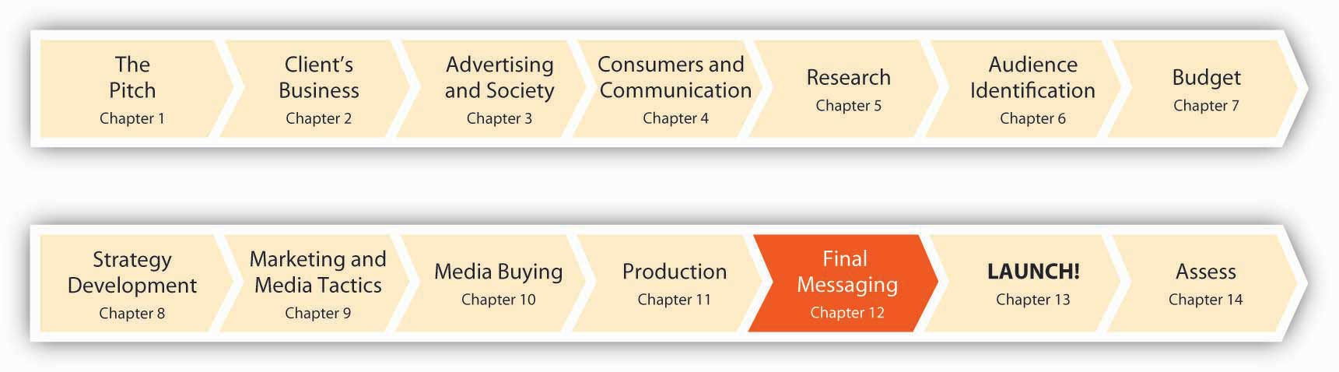
You’ve done your homework. You understand your audience, you’ve identified the objectives and strategy for your campaign, and you know what media you’ll use to reach your target consumers. You’re almost there—but you’ve still got to decide how to say what you want to say.
Should you focus on reason or appeal to the heartstrings? Should you spell out the arguments or show visually why your idea, product, or service is worth a serious look? Sometimes a picture is worth a thousand words; other times it’s just a pretty picture. Usually, you need both words and images to get your ideas across, so you need both copywriters and art directors to do their magic. In this chapter we’ll take a look at some of the options the advertiser has available to make it sell.

12.1 Keys to Superior Advertising

LEARNING OBJECTIVES
After studying this section, students should be able to do the following:
- Define relevance and resonance.
- Explain why having an emotional connection is the common denominator for most successful ads.
- List and describe the five factors that constitute an ad’s likeability.
The keys to superior advertising are resonance and relevance. A great ad makes a deep impression that reverberates inside you and stays with you, while it creates a bond between you and the product. “Just do it.”

Relevance and Resonance
Relevance is the extent to which the images, ideas, concepts, and advertised product attributes overlap with the target’s needs, wants, values, context, or situation. Resonance is the extent to which these images, ideas, concepts, and advertised product attributes connect more deeply in the target’s heart and mind. Let’s look at a few examples of how the two factors work together and then dig into more detail about how exactly to make a message sell.

Example: Household Challenge Meets Household Humor
Say your client is a bank that wants to promote its home mortgage product—an especially tough proposition in this era of foreclosures and banking scandals. The objective of the message is to show that your mortgage terms won’t be as burdensome as the competition’s. How can you get this message across? It’s not the sexiest idea in the world, but then again, saving money does turn a lot of people on.
Ad agency Hall Moore CHI faced this challenge with its client NatWest, a British bank. Art director Richard Megson and copywriter Matthew Davis worked together to create an animated TV ad that showed a man struggling under the weight of a huge mortgage. He threw his burden into a washing machine and shrank it to manageable size. The message was simple and clear—the idea of shrinking a huge mortgage was appealing and relevant to the target audience of homeowners. ^{[1]} This execution delivers both relevance with its image of a large mortgage (as many consumers struggle with these today) and resonance as it graphically depicts the tempting process of shrinking one’s debt in the wash. If only it were that easy in real life!

Example: The Resonance of Personal Stories
Now let’s consider Adidas’ “Impossible Is Nothing” campaign. The campaign originally launched in 2004 to coincide with the Olympics. Ads featured great athletes of the day in clever integration with great athletes of the past. The visuals made it seem as though the athletes were interacting across the ages. For example, in the ad “Laila,” boxing great Muhammad Ali goes into the ring with his boxer daughter, Laila Ali. The two spar and Laila eventually lands a punch that sends her dad backwards into the ropes. The film of Muhammad was culled from two of his fights from the 1960s, while Laila was shot in front of a blue screen so the two images could appear together. ^{[2]} Although the athletes and the special effects were fun to watch, they were not driving home the message because, ironically, the events depicted in the “Impossible Is Nothing” ads were impossible. The impossible was made possible only via an optical illusion, and that didn’t resonate with the audience.
Fast-forward to 2007. This time, Adidas found a better way to express the idea of doing the impossible. Its new ads featured personal stories from athletes, both famous (David Beckham) and not so famous (Boston Marathon runner Kathryn Smolen). In the spots its agency 180 Amsterdam/TBWA created, the athletes told true stories of challenges that they had overcome—their own “impossible.” For Olympic swimming superstar Ian Thorpe, the challenge was an allergy to chlorine—an allergy that sidelined him until he gradually overcame it.
The athletes hand-draw a picture as they talk. The simple drawings are primitive; they remind us of childhood and thus echo the storyline. For example, twenty-two-year-old American sprinter Allyson Felix draws herself as a stick figure with legs that look like ski poles as she explains that kids taunted her with the name “chicken legs” when she started out as a little kid playing basketball. Later, she says, “I came out for the track team and kind of wanted to prove everybody wrong.” Next we see her as she wins an Olympic medal. “People putting you down can drive you to do things you didn’t even think you could do yourself,” she proclaims. ^{[3]} Although the drawings are animated by artists at Passion Pictures, the feeling is personal and human. As Jason Oke of ad agency Leo Burnett Toronto commented, “After watching these I get inspired and I actually get what it means to attempt something that everyone else thinks you can’t do.”
Just as an ad can resonate with a person, elements of an ad ideally work together to reinforce each other as the childhood stories and drawings of the Adidas campaign did. Another example is an ad for a diet strawberry cheesecake that pairs the luscious image of the cake with the words “berried treasure,” to evoke the connotation of hidden delights and richness that lies inside. The play on words requires some thought, which rewards viewers with satisfaction when they “get it” and strengthens the connection among all the elements—words, images, product, brand, and meaning.

Emotion, the Common Denominator
The common denominator among the most successful ads is that they create an emotional connection with the brand. They appeal to the heart, not just the mind.
A large-scale study that analyzed award-winning campaigns found that the most effective ones focus on emotional, rather than rational, appeals. ^{[4]} What’s more, the Gallup organization reports that customers who are “passionate” about a brand deliver two times the profitability of average customers.
We simply can’t take the emotional contact a company has with customers and the emotional impact of its brand for granted. For example, Procter & Gamble traditionally advertised its Pampers diapers on the basis of their performance in keeping baby dry. But, as Jim Stengel (recently retired), chief marketing officer at Procter & Gamble, said, “Our baby-care business didn’t start growing aggressively [in the early 2000s] until we changed Pampers from being about dryness to being about helping Mom with her baby’s development. That was a sea change.” ^{[5]} The lesson: wrap your practical products with an offer that appeals to emotions. People are more loyal to brands they “feel,” not just those they think about.
Of course, not all brands necessarily bring a tear to the eye—the point is to figure out just how the brand resonates with its audience and to develop messages that reinforce this relationship. One well-known branding consultant argues that there are three ways a brand can resonate: it can hit you in the head, the heart, or the gut: ^{[6]}
- Aveda hits the consumer in the head. The brand is smart, intriguing, and stimulating.
- Godiva hits the consumer in the heart. The brand is sensual, beloved, and trusted.
- Prada hits the consumer in the gut. The brand is sexy and cool, and you “have to have it.”

What Makes an Ad Work: It’s Like, Likeability
A large-scale study of prime-time commercials found that the likeability of a commercial was the best single predictor of its sales effectiveness. ^{[7]} The author noted that “consumers first form an overall impression of an advertisement on a visceral or ‘gut’ level. To the extent that this impression is positive they are likely to continue to process the advertising more fully.”
He found five factors that constitute an ad’s likeability:
- Ingenuity—clever, imaginative, original, silly, and not dull
- Meaningfulness—worth remembering, effective, not pointless, not easy to forget, true to life, convincing, informative, and believable
- Energy—lively, fast moving, appealing, and well done
- Warmth—gentle, warm, and sensitive
- Does not rub the wrong way—not worn out, not phony, and not irritating
So, at the end of the day, no matter how you do it, you want people to like your ads. That sounds like a “no-brainer,” though many advertising messages don’t achieve this simple objective. Why is it so important that people like your ad?
- Likeable commercials are less likely to be avoided (zapped).
- Likeability is the “gatekeeper” to further processing: once a likeable ad gets our attention, we’re more likely to think about the message it’s conveying.
- The positive feelings the ad evokes transfer from the advertisement to the brand.

SS+K Spotlight
Refer back to and the three campaign options SS+K presented to msnbc.com. Which of these do you think has the most emotional resonance for the News Explorer?

KEY TAKEAWAY
An advertisement can grab you in a lot of different ways—but it needs to grab you in some way. One way is to be relevant to your situation and needs; another is to be resonant with your desires. If nothing else, be sure people like your ad—it’s all downhill from there.

EXERCISES
- Explain why resonance and relevance are the keys to superior advertising.
- Discuss the “common denominator” that most successful advertisements have in common.
- List and characterize each of the five factors that constitute an ad’s likeability.

[1] “Simplicity Originality Relevance,” Precision Marketing, August 24, 2007, 17.
[2] Art Smith, “Achieving the Impossible: Adidas Seamlessly Marries Past Olympians with Their Contemporaries,” SHOOT, August 20, 2004, 18.
[3] Barbara Lippert, “The Impossible Dream: Super Athletes, Simple Drawings Make Adidas Ads Hypnotic,” Adweek, April 16, 2007, 44;http://www.adidas.com/campaigns/usiin/content.
[4] “Marketing Theory: Everything You Know is Wrong.” Marketing, June 13, 2007, 28.
[5] Quoted in Geoff Colvin, “Selling P&G,” Fortune, September 18, 2007,http://money.cnn.com (accessed October 12, 2007).
[6] Marc Gobé, Emotional Branding: The New Paradigm for Connecting Brands to People(New York: Allworth Press, 2001).
[7] Alex Biel, “Love the Ad. Buy the Product? Why Liking the Advertising and Preferring the Brand Aren’t Such Strange Bedfellows After All,” Admap, September 1990; Wendy Gordon, “What Do Consumers Do Emotionally with Advertising,” Journal of Advertising Research 46, no. 1 (March 2006): 2–10.

12.2 Types of Appeals: How Ads Generate Resonance

LEARNING OBJECTIVES
After studying this section, students should be able to do the following:
- List and discuss five advertising appeals that a creative team can use to structure advertising.
- Recall and explain the six categories of values that are universal in advertising.
- Understand how media and social networking sites can be used to advocate brands and brand messages.
All ads need some type of appeal—a psychological basis that motivates the viewer toward the advertiser’s goals. The creative team can choose from a variety of appeals to help structure the advertising. Let’s have a look at the most common ones.

Sex Appeal
Does sex sell? A sex appeal can be vaguely suggestive and subtle, or it can hit you over the head—like the Carl’s Jr. ad that shows a soapy Paris Hilton washing a car (as if she would ever wash her own car!). It’s important to consider cultural differences in gauging sex appeal, as some countries allow more exposure of skin or sexual situations than others. In the United States, a passionate kiss between man and woman is perfectly fine, whereas in India such a display in public could be punishable by a fine, three months of jail time, or both.
There’s no doubt that sex gets our attention—and companies often deliberately push the envelope. Yves Saint Laurent promoted its men’s fragrance M7 with a full frontal nude photo of former martial arts champion Samuel de Cubber in fashion magazines like the French edition of Vogue. “Perfume is worn on the skin, so why hide the body?” said the ad’s designer, Tom Ford. Some mainstream publishers, however, featured a cropped version of the ad. ^{[1]}Similarly, Abercrombie & Fitch used nude models in its quarterly magalog but ended up dropping the campaign after loud and sustained protests from feminist groups and groups like the National Coalition for the Protection of Children and Families. ^{[2]}
Given the potentially negative reaction, do sexual appeals work? Products for which sex appeals work best are those aimed at teen or college-age buyers or for products like wine, perfume, beauty products, and lingerie. Advertisers need to tread lightly and avoid the temptation to go all-out: although erotic content does appear to draw attention to an ad, a sex appeal runs the risk of alienating the audience. And ironically, titillating the viewer may actually hinder recall of the advertised product. In one survey, an overwhelming 61 percent of the respondents said that sexual imagery in a product’s ad makes them less likely to buy it. ^{[3]}
In 2007, Dial rebranded its Soft & Dri deodorant with a focus on the sexy rather than on the functional attributes of the deodorant. “We’re trying to take the brand to a more emotional and less functional area,” said Vanessa Kamerer, Dial’s brand manager for Soft & Dri. To revive the brand, Dial conducted research and learned that consumers associated Soft & Dri with soft and sexy. Kamerer thought this was an important advantage and distinction for the brand because most other brands in the sector focused on technology. Kamerer pointed out, however, that the brand had to be careful with the “sexy” positioning. “Sexy is a tricky one with women,” she said. “For a lot of women sexy can be trampy or slutty and that’s not what we wanted.” ^{[4]} She’s right: research shows that female nudity in print ads generates negative feelings and tension among female consumers, whereas men’s reactions are more positive.^{[5]} In a case of turnabout being fair play, another study found that males dislike nude males in ads, whereas females responded well to undressed males—but not totally nude ones. ^{[6]}
In some cases, the purpose of the nudity is simply to create buzz. In autumn 2007, actress Alicia Silverstone posed nude (though strategically covered) in a print and a thirty-second TV ad for activist group PETA (People for the Ethical Treatment of Animals), saying that she attributes her slim figure to not eating meat. Comcast Cable pulled the ad, however, saying that it was too racy.
A campaign by Scotch-maker Johnnie Walker was a bit more subtle; billboards in California featured a seductive “Julie” and the message, “My number is 213-259-0373. And I drink Johnnie Walker.” Drinkers who called the number heard a prerecorded female voice deliver a sales pitch and then an invitation to order Scotch by phone. During the eight months that the billboards were up in nineteen cities, 526,000 people called Julie (perhaps hoping for more than a sales pitch). This response sounds impressive. But did the campaign motivate callers to buy the brand? Unfortunately not. In fact, sales of Johnnie Walker declined 5 percent during the year of the campaign. ^{[7]}

Fear Appeals
Students who don’t read Launch! will never land a job when they graduate.
A fear appeal dwells upon the negative consequences that can result unless a consumer takes the recommended action. A recent advertising campaign for the Volkswagen Jetta took this approach; spots depict graphic car crashes from the perspective of the passengers who chatter away as they drive down the street. Without warning, another vehicle comes out of nowhere and brutally smashes into their car. In one spot, viewers can see a passenger’s head hitting an airbag. The spots end with shots of stunned passengers, the damaged Jetta, and the slogan “Safe happens.” The ads look so realistic that consumers have called the company asking if any of the actors were hurt. ^{[8]}
Advertisers often resort to fear appeals when they want to bring about a radical behavior change, such as driving responsibly, eating healthily, or quitting smoking. Other fear appeals use ostracism by others—due to body odor or bad breath or limp hair or yellowed teeth or using outdated products—to create feelings of insecurity that the consumer can overcome by doing—guess what? A British print ad for a deodorant depicts a geeky young guy with the caption: “Yo, Sewer Boy!” Subtle.
How well fear appeals work depends on how easy it is to comply with the ad’s message. A switch to a stronger, longer-lasting deodorant to avoid embarrassing stains is quite doable, and it is easy to see a benefit (if indeed the deodorant works). In contrast, fear appeals that discuss the negative consequences of smoking have to climb a higher hill because the behavior is extremely hard to change (despite good intentions) and it’s harder to detect the (long-term) health benefits. Sometimes the fear appeal is too strong and makes consumers tune it out, especially if the ad does not present a solution. Scare tactics may also backfire as people cope with the negative feelings or guilt the ad inspires by deciding the threat does not apply to them.
One famous TV commercial that relied on a heavy dose of fear was an ad for presidential candidate Lyndon Baines Johnson in 1964. The campaign showed a little girl counting daisy petals in a field, “1, 2, 3.…” Then, a voice-over started a countdown, “10, 9, 8…” leading to the image of a telltale mushroom cloud as an atomic bomb exploded. “These are the stakes,” the voice-over said, concluding with “the stakes are too high for you to stay home” while the screen displayed the words “Vote for President Johnson on November 3.” This classic spot stirred up voters’ fears about the heavy trigger finger of Johnson’s opponent, the conservative politician Barry Goldwater, and (analysts say) contributed to his huge defeat in the election.

Humor Appeals
“A guy walks into a bar.…” A humor appeal makes us laugh and feel good. But it’s often difficult to execute well, because people have to understand the humor and they have to get the link to the brand. Like sex appeals, sometimes the very humor that gets our attention distracts us from remembering the ad or from influencing our behavior.
It also helps when viewers don’t get offended; this can be an iffy proposition especially when ethnic or national stereotypes are involved. An outdoor ad in Belgium to promote the speedy new Eurostar train service from Brussels to London via the English Channel backfired when a group of British journalists discovered it. For some reason they didn’t appreciate a poster that showed a shaven-headed English soccer hooligan urinating into a teacup. For Belgians this imagery made sense because the fan’s pose mimicked a very famous Brussels landmark, the Manneken Pis statue. ^{[9]} The Brits didn’t appreciate the architectural reference.
One advantage of humor is that it reduces counterarguing; this occurs when a consumer thinks of reasons not to agree with the message. Because the comedy distracts us from our tendency to come up with reasons why we shouldn’t change our opinions, we are more likely to accept the message a humorous ad presents, as long as it does not insult or make fun of us (somehow laughing at the other guy is OK).
Humorous appeals are seldom used by banks, which tend to project a more staid image. That’s why Community Bank System decided to use a lighthearted campaign with the message “Bank Happy.” “We really wanted to find something different, something that was unbank-like and, if you look at those headlines and the disclosures, there’s humor built in,” said Hal Wentworth, the bank’s director of sales and marketing. The campaign was designed by Mark Russell and Associates and took five months to produce. How does the bank use humor? To establish the tie to happy experiences, one ad says, “The feeling you get when you eat chocolate. Now available in a bank.” It even brings amusement to the fine-print copy at the bottom of the page. Although most people skip this, the fine print in the “Chocolate” ad says, “If you’re reading this, you’re probably thinking there’s some kind of catch. Something that requires us to write more about it in the fine print. But there isn’t. Oh sure, we could go on and on about ourselves. Like how we’re committed to serving rural areas. And how most of our people have been working with us for years. And how all of our loan decisions are made locally by folks you’ve probably cheered with at soccer or baseball games. But we won’t. Instead, we’ll just tell you that when we say ‘Bank Happy,’ we mean it. We don’t want you to ‘Bank Reasonably Contentedly’ or ‘Bank Kinda Sorta Pleased.’ We want you to Bank Happy. And we’ll do whatever it takes to make that happen.” ^{[10]} These days, more people in the banking industry could probably use a good laugh.

Dig Deeper
Hillary Clinton and several other presidential candidates introduced humor into their political ad campaigns in late 2007. Surveys showed that the public thought humor was a good idea and a welcome change from negative ads. By the fall of 2008, candidates were practically becoming regulars on The Ellen DeGeneres Show, Late Night with David Letterman, The Tonight Show, and Saturday Night Live. People enjoy laughing, and it makes them more comfortable with the candidates. “Of course, the humor had better be funny,” added Rob Earl, of Watson, Earl & Partners. Nancy Newnan of Catapult Communications also welcomes jokes—within limits. “A dose of humor is always welcome, as long as they keep it in its place and not forget the importance of projecting the image of a world leader.” But not everyone wants punch lines from politicians. Humor is too subjective, said Alienware’s Juan Carlos Hernandez. “Humor…leaves a lot to the public’s interpretation, which at the end is negative because what I may think is not actually what the candidate was aiming for.” ^{[11]} What’s your take on this issue—does humor have a place in political campaigns, where the issues are serious and the stakes high? Should Comedy Central’s Jon Stewart and Stephen Colbert do campaign ads—or run for President themselves?

Logical Appeals
The logical appeal is a rational one; it describes the product’s features, advantages, and price. Although most of the appeals we’ve talked about so far have emphasized emotion, that doesn’t mean that logic has no place in ads. Indeed, advertising that provokes a strong emotional response without providing sufficient product information is unlikely to change behavior and increase market share. It breaks through the clutter but doesn’t necessarily induce people to buy. This is what the Center for Emotional Marketing discovered when it performed a meta-analysis that combined the results of eight separate research studies. The results held true across a range of consumer product categories from food and health and beauty to automotive and technology. ^{[12]}
Purely emotional advertising is memorable but doesn’t build business. The advertising connects with consumers, but it fails to make use of that connection with the credible information needed to change people’s minds. This is particularly true of humor appeals. A study conducted by McCollum/Spielman shows that 75 percent of funny ads have an attention response rating equal to or higher than average, but only 31 percent are actually more persuasive.
The solution? Advertisers need to strike a balance with campaigns that integrate product information and emotion. Logic and emotion work in concert to help consumers make decisions. ^{[13]} Effective advertising needs to convey both seamlessly.

Values Appeals
Finally, advertising can be relevant to consumers when it uses a values appeal; this type of message relates to people’s strong underlying beliefs about priorities in their lives and morality. A research team conducted a comprehensive study of values across thirty countries to identify universal values that people hold regardless of where they live. The researchers found six categories of values that are universal:
- Striver: Ambitious people who seek power, status, and wealth
- Fun-Seeker: Individualists who seek excitement, leisure, variety, and adventure
- Creative: Open-minded people who want freedom, fulfilling work, and self-reliance
- Devout: Spiritual people who are traditional, respectful, modest, and obedient
- Intimate: Supportive people who create strong, deep bonds with friends and family
- Altruist: People who want equality and justice for everyone in society and care about the environment
Certain countries exhibit a predominance of some of these values over others. For example, more than one-half of all Swedes are Intimates, which means that they emphasize social relationships as guiding principles in their lives. In contrast, 46 percent of Saudi Arabians identify Devout values as their guiding principles, while 52 percent of South Koreans are Strivers. Another study found that North Americans have more favorable attitudes toward advertising messages that focus on self-reliance, self-improvement, and the achievement of personal goals, as opposed to themes stressing family integrity, collective goals, and the feeling of harmony with others. Korean consumers exhibited the reverse pattern.
Creating advertising messages that resonate with your target audience means identifying and appealing to the values that motivate their behavior. For example, Taco Bell’s advertising campaign “Think Outside the Bun” appeals to Creatives who seek novelty and learning new things. In contrast, the “Night Belongs to Michelob” campaign appeals to Intimates who value romance and friendship. Finally, British Petroleum’s “Beyond Petroleum” campaign appeals to Altruists who value social responsibilities and preservation of the environment. ^{[14]}

Dig Deeper
Occasionally ad executions invoke a values appeal when they show how a product goes against a group’s values. This approach appeals to target consumers who are rebellious or nonconforming. To appeal to teenage viewers, the CW network launched a campaign to promote the TV show Gossip Girl that includes quotes from the Parents Television Council, an advocacy group that has criticized the show for its graphic inclusion of sex and drugs. One ad shows two of the underage characters together in bed, below a caption that reads “Mind-blowingly inappropriate!” ^{[15]}
It’s interesting to note that individuality is a value most closely associated with the Fun-Seeker segment. Countries that have a high percentage of Fun-Seekers in their population include the United Kingdom, Canada, Australia, and Germany. Creating a winning brand position in these countries might entail targeting the Fun-Seeker buyers with a brand that can offer an avenue to self-expression. In contrast, countries where individuality ranks lowest are the Devout-dominant countries of Indonesia, Egypt, and Saudi Arabia, where duty and faith outweigh personal expression. Self-expression appeals would not work well in those countries.

KEY TAKEAWAY
An advertising appeal is the psychological basis the agency uses to create relevance and resonance with the target audience. Common appeals include sex, humor, fear, logic, and values. There is no one perfect appeal; the advertiser needs to calibrate the characteristics of the consumers with the message to ensure that consumers aren’t turned off or don’t tune out the message because they don’t care for the appeal.

EXERCISES
- List and briefly describe each of the five appeals that an advertiser can use to connect with the target audience.
- List and describe the six categories of universal values.

[1] “YSL Goes Full-Frontal with Men’s Fragrance Ad,” October 18, 2002,http://news1.iwon.com/odd/article/id/275228%7Coddlyenough %7C10-18-2002::10:43%7Creuters.html (accessed August 7, 2008).
[2] David Carr and Tracie Rozhon, “Abercrombie & Fitch to End its Racy Magazine,” New York Times Online, December 10, 2003, http://query.nytimes.com/gst/fullpage. html?res=950CE2D71F3DF933A25751C1A9659C8B63 (accessed August 7, 2008).
[3] Rebecca Gardyn, “Where’s the Lovin’?” American Demographics (February 2001): 10.
[4] Constantine Von Hoffman, “Dial Corp. Tries Bringing ‘Sexy’ Soft & Dri Back: Rebranding Makes an Emotional Appeal to Women,” Brandweek, January 29, 2007, 9.
[5] Michael S. LaTour, “Female Nudity in Print Advertising: An Analysis of Gender Differences in Arousal and Ad Response,” Psychology & Marketing 7, no. 1 (1990): 65–81.
[6] Penny M. Simpson, Steve Horton, and Gene Brown, “Male Nudity in Advertisements: A Modified Replication and Extension of Gender and Product Effects,” Journal of the Academy of Marketing Science 24, no. 3 (1996): 257–62.
[7] Randall Rothenberg, “Age Hasn’t Mellowed This Agency,” New York Times, April 13, 1990, D1.
[8] Brian Steinberg, “VW Uses Shock Treatment to Sell Jetta’s Safety, Ads Test a Risky Approach with Graphic Car Crashes; ‘Any of the Actors Hurt?’” Wall Street Journal, April 19, 2006, B4.
[9] Eric Pfanner, “Ad for New Train Service Strains European Taste,” New York Times Online, December 3, 2007, http://www.nytimes.com/2007/12/03/business/world business/03eurostar.html (accessed February 10, 2009).
[10] Quoted in Karen Krebsbach, “Community Bank’s ‘Bank Happy’ Sets Cheerful, Playful Tone,” US Banker 117, no. 7 (July 2007), 28.
[11] Quoted in Ken Wheaton, “Political Ads that Provide a Laugh?” Advertising Age, August 6, 2007, 4.
[12] Leslie Picot-Zane, “Is Advertising Too Emotional?” Brandweek, January 9, 2006, 18.
[13] Sang-Pil Han and Sharon Shavitt, “Persuasion and Culture: Advertising Appeals in Individualistic and Collectivistic Societies,” Journal of Experimental Social Psychology 30 (1994): 326–50.
[14] Simeon Chow and Sarit Amir, “The Universality of Values: Implications for Global Advertising Strategy,” Journal of Advertising Research 46, no. 3 (2006): 301.
[15] Brian Steinberg, “Need a Slogan? Ask Your Harshest Critic; CW Proudly Declares ‘Gossip Girl’ Is ‘Mind-Blowingly Inappropriate,’” Advertising Age, July 23, 2008,http://adage.com/mediaworks/article?article_id=129837 (accessed July 24, 2008).

12.3 Executional Frameworks: How Ads Generate Relevance

LEARNING OBJECTIVES
After studying this section, students should be able to do the following:
- Compare and contrast the five types of executional frameworks.
- Characterize “star power” and its usefulness to advertising.
An executional framework defines how the ad is structured. Executional frameworks get your interest, create the desire for the good or service, and motivate you to purchase it. Let’s look at five types of executional frameworks.

Lifestyle Framework
A lifestyle framework shows how the product fits into your life. For example, the “Denny’s Always Works” campaign emphasizes that the nation’s largest full-service family restaurant chain is open twenty-four hours and has a variety of meal choices that meet a range of unique dining needs. Each TV commercial opens with a consumer describing why Denny’s fits perfectly into his or her life. The ads are shot on a striking yellow background with simple, fun animation that accents what the person is saying. An actor portraying a Denny’s guest customer speaks, and then the spot closes with a close-up of delicious food footage. To show different lifestyles, one of the fifteen-second spots opens on a frazzled mom who is amazed that Denny’s breakfasts can fill up even her teenaged boys. “I didn’t think that was possible,” she says. Another fifteen-second spot features a young twenty-something guy saying how Denny’s extends his late night fun, because after the club scene winds down he can still get great food at Denny’s. ^{[1]}

Scientific Framework
A scientific framework uses research and evidence to show the brand’s superiority over other brands. This executional style is popular with pharmaceuticals or with food products or beauty products that distinguish themselves in terms of their health benefits. For example, when the German pharmaceuticals maker Beiersdorf relaunched its Nivea Baby line of skin care products in Europe, it put a greater emphasis on the line’s extensive dermatological testing. “Clinical tests have always been a standard in the development of Nivea Baby products,” said Ingo Hahn, Beiersdorf’s lab manager for skin care product development. “However, with rising expectations of parents regarding product safety and skin compatibility in baby care, we decided to put more emphasis on this fact with the brand relaunch in 2005, providing our consumers with even more insights in the extremely high standards of the Nivea Baby product safety policy.” ^{[2]}

Dig Deeper
Drug makers spend $30 billion per year on marketing in the United States—triple what they spent just a decade ago. Are the numerous drug commercials of “shiny, happy people” we constantly see on TV too emotional and not factual enough? The U.S. Food and Drug Administration suspects they are, and it plans to produce commercials for a make-believe blood-pressure medicine to test whether images in ads distract attention from required safety warnings. The FDA frequently issues warnings to pharmaceutical advertisers about ads that it says mislead consumers to believe that drugs are safer or work better than the evidence supports. Advertisers use a variety of techniques to convey the mandatory information about their products’ dangers. These range from recitations by actors dressed as doctors to the phrases that stream across an animated blue landscape in a commercial for Pfizer’s painkiller Celebrex. In a large-scale online study involving several thousand respondents, the FDA plans to create a number of ads for the fictitious medications that include different images and text on the screen while a narrator reads the risk information. Some of the visuals will focus on the benefits of the drug, to see if that diverts attention from the safety warnings. ^{[3]}

Spokesperson/Testimonial
Using a spokesperson/testimonial framework, a “man on the street” or a celebrity praises the product or service. The spokesperson who endorses the product need not be famous. A testimonial features an everyday consumer to whom the target audience can relate. This representative consumer praises the product or describes his experience with it. The framework implies that if the product worked for this person, it will work for you.

Star Power
In the case of the celebrity, the reasoning is that if a famous person believes the product is good, you can believe it, too. For the advertising to be effective, however, the tie between the product and the celebrity should be clear. When Louis Vuitton featured Mikhail Gorbachev in an ad in Vogue, the tie was not clear. Why would the association with the former Soviet leader who brought an end to Communism motivate a consumer to buy a luxury brand bag?
This framework is effective because celebrities embody cultural meanings—they symbolize important categories such as status and social class (a “working-class hero,” such as Peter Griffin on Family Guy), gender (a “tough woman,” such as Nancy on Weeds), or personality types (the nerdy but earnest Hiro on Heroes). Ideally, the advertiser decides what meanings the product should convey (that is, how it should position the item in the marketplace) and then chooses a celebrity who embodies a similar meaning. The product’s meaning thus moves from the manufacturer to the consumer, using the star as a vehicle.^{[4]}
For celebrity campaigns to be effective, the endorser must have a clear and popular image. In addition, the celebrity’s image and that of the product he or she endorses should be similar—researchers refer to this as the match-up hypothesis. ^{[5]} A market research company developed one widely used measure called the Q-score (Q stands for quality) to decide if a celebrity will make a good endorser. The score includes level of familiarity with a name and the number of respondents who indicate that a person, program, or character is a favorite. ^{[6]}
A good match-up is crucial; fame alone doesn’t work if people know someone but dislike him. The celebrity may bring the brand visibility, but that visibility can be overshadowed by controversy that the spokesperson can generate. That’s a lesson MasterCard learned when it hired Nick Lachey for its “Major League Dreams” promotion. Shortly before the launch of the campaign, nude photos of Lachey and his girlfriend, Vanessa Minnillo, surfaced. The buzz surrounding the photos and Lachey’s refusal to talk about them during an interview completely overshadowed the MasterCard brand and promotion. ^{[7]}It also helps when your spokesperson actually uses the product. The Beef Board faced negative publicity when its spokesperson, Cybill Shepherd, admitted she did not like to eat beef.
Because consumers tend to view the brand through the lens of its spokesperson, an advertiser can’t choose an endorser just based on a whim (or the person’s good looks). Consider Tupperware, which decided to mount an advertising campaign to support its traditional word-of-mouth and Tupperware party promotional strategies. The brand is sixty years old and harkens back to 1950s-style June Cleaver moms. In its attempt to stay relevant and up-to-date, the company looked for a modern image of the working mom. Rather than going with a spokesperson like Martha Stewart, who would reinforce the old image of Tupperware, the company chose Brooke Shields as their spokesperson. “We’ve seen her go from a model to an actress to a Princeton graduate…then be open with issues she’s had with depression,” said Tupperware Chairman-CEO Rick Goings. That, he said, meshed perfectly with the company’s new “Chain of Confidence” campaign, which is dedicated to building the self-esteem of women and girls. ^{[8]}

Dig Deeper
In the “old days,” a celebrity got paid to endorse an advertiser’s product. Today, it’s quite possible she got a piece of the company instead. Increasingly, stars insist on greater involvement with the brands they hawk. Rapper 50 Cent owned part of Energy Brands Inc., the maker of Vitaminwater, before Coca-Cola bought the company for a lot of money. He personally endorsed a drink called Formula 50 that the company named after him.
Ellen DeGeneres endorses Halo pet products—but this celebrity pet fanatic (she has two dogs and three cats) also owns about 15 percent of the company. As one of the executives involved with the company explained, “Most people see an awful lot of endorsements where there is no real connection between the celebrity and product. We wanted someone who would help get the Halo brand on the map and make us known to a broader audience.” DeGeneres agrees: “Me being famous will help this company grow.”
Should a spokesperson be required to divulge a financial interest in a company she endorses? ^{[9]}

Spokescharacters
Celebrities can be effective endorsers, but there are drawbacks to using them. As we previously noted, their motives may be suspect if they plug products that don’t fit their images or if consumers begin to see them as never having met a product they didn’t like (for a fee). They may be involved in a scandal or upset customers, as when the Milk Processor Education Program suspended “Got Milk?” ads featuring Mary-Kate and Ashley Olsen after Mary-Kate entered a treatment facility for an undisclosed health issue.
For these reasons some marketers seek alternative sources, including cartoon characters and mascots. After all, as the marketing director for a company that manufactures costumed characters for sports teams and businesses points out, “You don’t have to worry about your mascot checking into rehab.” ^{[10]} And researchers report that spokescharacters like the Pillsbury Doughboy, Chester the Cheetah, and the Snuggle Bear do in fact boost viewers’ recall of claims that ads make and also yield higher brand attitude. ^{[11]}
In the early days of advertising, product spokescharacters were simply still-life visuals, but the decreasing cost and increased power of computing has made animation much easier. Claymation California Raisins sing and dance, and the bald, muscular Mr. Clean comes to the rescue of a housewife in distress.
An avatar is an increasingly popular alternative to flesh-and-blood endorsers. This word is a Hindu term for a deity that appears in superhuman or animal form. In the computing world it means a character you can move around inside a visual, graphical world. Now, some advertisers turn to avatars that can come to life on Web sites and in virtual worlds like Second Life. The advantages of virtual avatars compared to flesh-and-blood people include the ability to change the avatar in real time to suit the needs of the target audience. ^{[12]} As one example of a company that designs avatars to represent brands or companies, check out http://www.sitepal.com.

Demonstration
A demonstration framework shows the product in use to illustrate its performance and effectiveness. Television and video are the best media for demonstrations. This framework is a favorite for cleaning products of all kinds (household, laundry, automotive) and to showcase the unique benefits of traditional products. Just think about all those crazy gadgets you see on TV infomercials—“It slices, it dices, it washes your car.…”
A new format for a traditional product also benefits from demonstration, such as the headache medicine HeadOn. This product’s advertising includes demonstration and (seemingly endless?) repetition of the slogan: “HeadOn, Apply direct to the forehead.” From a creative standpoint, the execution is mundane and campy, but someone is buying this stuff: the commercials have more than doubled sales. ^{[13]}

Slice-of-Life Framework
A slice-of-life framework presents everyday people in an everyday situation, like riding in a car with friends. Wal-Mart used this kind of execution in a commercial that showed a young family going on vacation. The bored kids torment each other in the minivan until they finally arrive in Orlando. The title card then explains what you’ve seen: “Wal-Mart saves the average family $2,500 a year. What will you do with your savings?” The value proposition is clear: shopping at Wal-Mart throughout the year will save you enough money for a vacation. The spot ends with the slogan: “Save money. Live better.” ^{[14]}
Andrea Learned, coauthor of the book Don’t Think Pink: What Really Makes Women Buy has found that when selling cars to women, slice-of-life frameworks are the most effective. The best car ads show average looking women and men in slice-of-life situations. “Women respond when an advertiser fits the car into consumers’ lifestyles instead of putting it on a sporty pedestal with overly gorgeous models,” she explained. ^{[15]}

KEY TAKEAWAY
An executional framework defines how the ad is structured. Like advertising appeals, different frameworks are appropriate to different advertising contexts. These include lifestyle, scientific, testimonial, demonstration, and slice-of-life.

EXERCISES
- List and briefly characterize the five executional frameworks that provide an advertisement’s structure.
- Describe why “star power” is important to the advertiser.
- Explain how an avatar can be used to connect with a target audience.

[1] “Denny’s New National Advertising Campaign Presents Real-Life Customer Dining Solutions,” Business Wire, June 26, 2006.
[2] Quoted in Christine Esposito, “Efficacy is Everything: Claims Sell Products,” Household & Personal Products Industry, October 2006, 51.
[3] Catherine Larkin, “FDA Hoping Fake Ads Help Monitor Real Ones,” Bloomberg, August 6, 2008, Bloomberg News, http://www.nj.com/business/ledger/index.ssf?/base/business-10/1217998570130990.xml&coll=1 (accessed August 6, 2008).
[4] Grant McCracken, “Who Is the Celebrity Endorser? Cultural Foundations of the Endorsement Process,” Journal of Consumer Research 16, no. 3 (1989): 310–21.
[6] Kevin E. Kahle and Lynn R. Kahle, “Sports Celebrities’ Image: A Critical Evaluation of the Utility of Q Scores” (working paper, University of Oregon, 2005).
[7] Cathy Yingling, “Beware the Lure of Celebrity Endorsers,” Advertising Age, September 24, 2007.
[8] Jack Neff, “How Tupperware Made Itself Relevant Again,” Advertising Age, June 4, 2007, 19.
[9] Quoted in Suzanne Vranica, “New Breed of Celebrity Endorsements,” Wall Street Journal, February 29, 2008, B3.
[10] Nat Ives, “Marketers Run to Pull the Plug When Celebrity Endorsers Say the Darnedest Things,” New York Times on the Web, July 16, 2004,http://query.nytimes.com/gst/fullpage.html?res=9C02E1D8143AF935A25754C0A9629C8B63 (accessed February 10, 2009).
[11] Judith A. Garretson and Scot Burton, “The Role of Spokescharacters as Advertisement and Package Cues in Integrated Marketing Communications,” Journal of Marketing 69 (October 2005): 118–32.
[12] Tran T. L. Knanh and Regalado Antonio, “Web Sites Bet on Attracting Viewers with Humanlike Presences of Avatars,” Wall Street Journal Interactive Edition, January 24, 2001; Brian Morrissey, “Taco Bell to Cast User Avatars in TV Spot,” Adweek, July 10, 2007,http://www.adweek.com (accessed July 12, 2007).
[13] Mya Frazier, “This Ad Will Give You a Headache, But It Sells,” Advertising Age, September 24, 2007.
[14] Bob Garfield, “Long-Awaited Wal-Mart Ads are Obvious…Yet Brilliant,” Advertising Age, September 17, 2007, 69.
[15] Quoted in Joan Voight, “The Lady Means Business,” Brandweek, April 10, 2006, 28.

12.4 The Creative Team

LEARNING OBJECTIVES
After studying this section, students should be able to do the following:
- Characterize the members of an advertising creative team.
- Explain how copywriters use various literary forms and devices to construct the advertising message.
Ads use both words and images—indeed, all the senses. Achieving this result requires close cooperation within the creative team between copywriting and art direction.

Copywriting
Copywriters create memorable and motivating text that will be spoken or written within the ad. Because short headlines and copy are generally more effective, copywriters must make each word contribute to the ad’s goals.

What’s in a Word?
The copywriter works with the art director to develop the concept for the ad. Copywriters must understand the meanings (both plain and hidden) behind words. For example, words like “new” are used a lot in ads because they capture our attention and pique our curiosity. Other words, such as “don’t miss” and “urgent,” arouse fear, while “how to” promises practical advice.
Words can convey facts, create musical poetry, re-create history, command action, plead, and paint pictures. Copywriting makes use of the language centers of the brain to instill emotion and create memories. “Fundamentally, I value a good combination of image and message in an eye-catching way. You want something that makes you say: ‘What’s going on here?’ The visual itself can be simple,” observes one marketing director. ^{[1]}
Copywriters also work on the pacing and sounds of words to reinforce the message and emotional tone. For example, Apple Computer’s three-word “Rip. Mix. Burn.” campaign used a staccato of short imperative verbs that resonate with a fast-paced youth culture and create a subtext that Apple’s computers let you do these tasks very easily and quickly.

SS+K Spotlight
Sam Mazur, the copywriter on the msnbc.com campaign, worked very closely with the art director, Matt Ferrin, on each concept. While they collaborated on the overall vision, the tasks required to complete that vision are clearly split. Sam would scour the msnbc.com headlines and pair them together; he and Matt would choose the brick colors for each; and Matt would set up the art layout accordingly.

Literary Forms and Devices
Advertisers structure commercials like other art forms; they borrow conventions from literature and art to communicate. ^{[2]} Two important structures are dramas and lectures (you’re certainly familiar with that one!). Alecture is like a speech; the communicator addresses the audience directly to inform them about a product or persuade them to buy it. In contrast, a dramais similar to a play or movie. Whereas an argument holds the viewer at arm’s length, a drama draws the viewer into the action. The characters only indirectly address the audience; they interact with each other about a product or service in an imaginary setting. Dramas attempt to be experiential—to involve the audience emotionally. In transformational advertising, the consumer associates the experience of product usage with some subjective sensation—like the feeling you get when you watch a silhouetted actor on TV dancing energetically to his iPod.
Advertising creatives also rely (consciously or not) on literary devices to communicate these meanings. For example, characters like Mr. Goodwrench, the Jolly Green Giant, and Charlie the Tuna may personify a product or service. Many ads take the form of an allegory; a story about an abstract trait or concept that a person, animal, or vegetable stands for.
A metaphor places two dissimilar objects into a close relationship such that “A is B,” whereas a simile compares two objects, “A is like B.” A and B, however dissimilar, share some quality that the metaphor highlights. Metaphors allow the marketer to activate meaningful images and apply them to everyday events. In the stock market, “white knights” battle “hostile raiders” using “poison pills” (unfortunately the knights don’t seem to be winning, at least for now) while Tony the Tiger equates cereal with strength. ^{[3]}

Art Direction
The term “art direction” goes beyond choosing or creating images that go into marketing communications. It is more encompassing and holistic; a good art director blends the elements of an ad into a powerful message that strongly resonates with the viewer.
The art director is the chief designer of the ad. She is responsible not only for creating the visuals but also for deciding how the message will communicate the desired mood, product qualities, and psychological appeals. In addition to the illustrations in an ad (photo, cartoon, drawing), the art director uses principles of design to unify the elements of the ad and direct our attention to the point of emphasis.
Art direction has grown in importance as advertising has become more visual. Pictures tell a story more quickly than words, and they let advertisers put the brand in a social context, which links the brand to certain “types” of people or lifestyles. According to Marie-Catherine Dupuy, vice chairman and chief creative officer, TBWA/France, “Art direction is crucial. You can find the best idea—but if it’s not well art directed, it’s killed. I say that even though I’m a former copywriter. For me, art direction is 80 per cent of the effectiveness. That’s also the place where artists from every side can express themselves and bring their full talents to the ad.” ^{[4]}

KEY TAKEAWAY
Copywriters and art directors turn intangible ideas into tangible realities. The messages they create that use words or images capture the essence of the advertising strategy and translate it into something that the target understands—and hopefully resonates with.

EXERCISES
- Describe the copywriter’s responsibility in advertising.
- List and describe the literary forms and devices that can be used in advertising.
- Describe the art director’s responsibility in advertising.

[1] Quoted in Alasdair Reid, “Newspaper Advertising—The Creative Potential: What Makes a Great Newspaper Ad,” Campaign, January 20, 2006, 32.
[3] Barbara B. Stern, “Medieval Allegory: Roots of Advertising Strategy for the Mass Market,” Journal of Marketing 52 (July 1988): 84–94.
[4] Quoted in Alasdair Reid, “Newspaper Advertising—The Creative Potential: What Makes a Great Newspaper Ad,” Campaign, January 20, 2006, 32.

12.5 Exercises

TIE IT ALL TOGETHER
Now that you have read this chapter, you should be able to determine how to choose the right media for client messages:
- You can identify and define the two keys to superior advertising.
- You can provide illustrations of relevance and resonance.
- You can explain why having an emotional connection is the common denominator for most successful ads.
- You can list and describe the five factors that comprise likeability of an ad.
- You can list and discuss five advertising appeals that a creative team can use to structure advertising.
- You can provide illustrations of the five advertising appeals.
- You can recall the six categories of values that are universal in advertising.
- You can compare and contrast the five types of executional frameworks.
- You can characterize “star power” and its usefulness to advertising.
- You can characterize the members of an advertising creative team.
- You can classify the various literary forms and devices used by copywriters to create advertisements.

USE WHAT YOU’VE LEARNED
- What’s your favorite energy drink? America’s consumers who want a boost without drinking coffee or cola have made energy drinks an energized product line for most beverage makers. Go into any convenience store and note the amount of shelf or refrigeration space that is devoted to these high-pep drinks. Most stores have at least one POS display for this drink category.
Which energy drink is number one? This obviously varies at any given point in time but it appears that Red Bull is the consistent leader in the industry, followed by Monster, Rockstar, AMP Energy, and Who’s Your Daddy, to round out the top five. With the popularity of the drink category we can expect more entries in the future. See any of the above products’ Web sites for more information on the appeals used to reach target markets.
Your assignment is to demonstrate how relevance and resonance have been used by the makers of energy drinks to make their product category a success. Use at least one manufacturer’s product as an illustration of your ideas.
- Tired of using your hands to type and text? Are you unsure that voice-activated controls of electronic devices and PCs really work? “Thought control” may have just solved your problems. Emotiv Systems specializes in creating systems that can be controlled by brain-computer interfaces or a computerized version of thought control. The company’s Epoc sixteen-sensor headset communicates wirelessly with a PC. The user is able to think a command and have that command activated on a computer. Since the device is tuned to an individual’s processing thoughts, security of thought protection seems to exist. See http://www.emotiv.com for more details on the technology and products.
Your assignment is to designate a target market for initial introduction of the product. Next, describe the appeal format that you think would be best for the Epoc headset to use to reach the designated market. Explain your appeal choice. Conclude your assignment by selecting an executional framework that is consistent with your chosen target market and appeal. Describe the ad you would construct from such choices.

DIGITAL NATIVES
Do you remember what a Q-score is? A Q-score is a way to measure the familiarity and appeal of a brand, company, celebrity, cartoon character, or television show. The higher the Q-score, the more likely the subject measured is familiar and appealing to viewers. See Wikipedia, Google, orhttp://www.qscores.com for more information on Q-scores and the “star power” behind them.
After exploring information about Q-scores via your online connections, select three to five subjects and obtain their Q-scores. If you are unable to find the scores for some of your subjects, either choose other subjects or estimate what you think the score might be (be sure to put “est.” after any such score). Once you have your Q-score list, match each of your subjects to at least one product line. Note how the Q-scored subject would be an asset to the advertising for that product line. Explain your rationale and justification for your picks. Discuss the findings of this assignment in class with peers.

AD-VICE
- Go to your favorite Web sites that contain advertising and find at least one example of relevance and resonance in the advertising. Explain why you believe your choices match for the two terms.
- Go to at least one favorite magazine and find an illustration of an advertisement that makes an emotional connection with its readers or viewers. Clearly explain how this connection is made. It is OK to use yourself as an example; however, be specific in your description of how the emotional connection was made. What magazine elements were used to make the emotional connection?
- Go to at least one favorite magazine and find an advertisement that would rate high on your likeability scale. Using the factors listed in the chapter that constitute the likeability of an ad, illustrate how well your ad embodies each of these five factors. Next, take an ad that you like somewhat, but not as much as your first choice. Illustrate how, by using the five factors, you could make the second ad more likeable. Explain your thinking and illustrations.
- According to this chapter, copywriters use literary forms and devices to structure commercials. Take the terms lecture, drama, allegory, metaphor, and simile and find examples of them in specific ads from magazines you read, television shows you watch, and online browsing and surfing experiences. List the phrase from the chosen ads and indicate why the phrase matches one of the terms. Please provide a brief description of the ad itself. Comment on the importance of word choice in copywriting.

Chapter 13

Launch! msnbc.com’s First-Ever Branding Campaign
Figure 13.1 Zero Months to Launch!
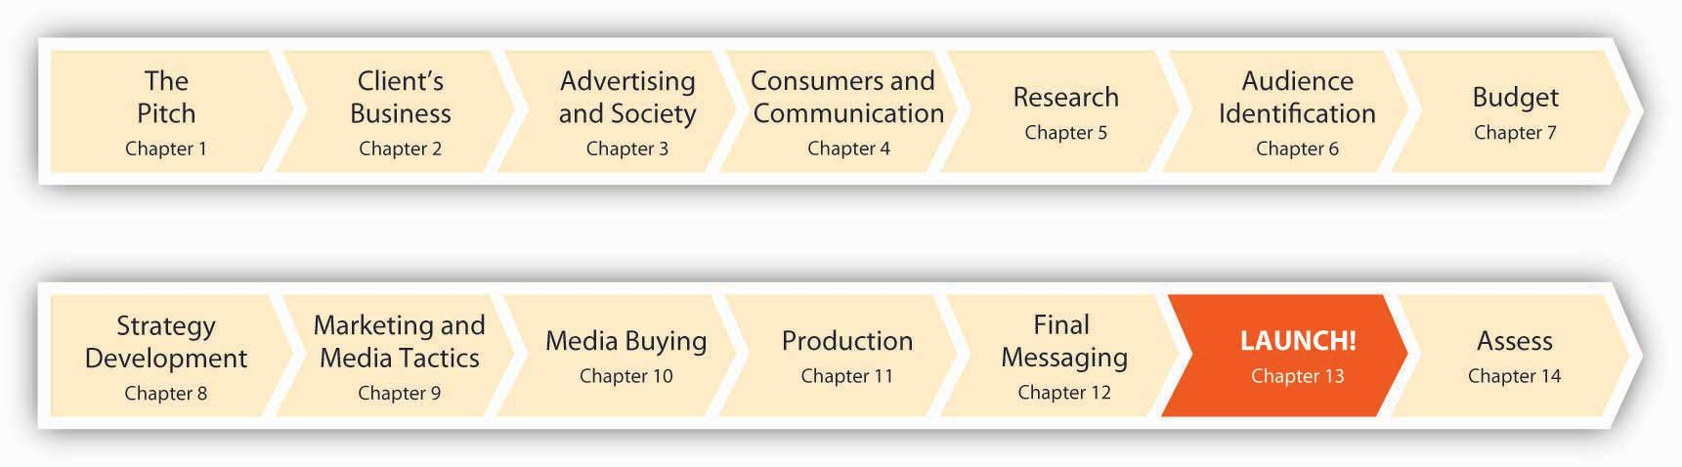
Once all the planning, preparation, and production was complete, it was time for the campaign to come to life. On April 2, 2007, the first-ever msnbc.com branding campaign launched to the public in TV, print, and online media. Think of this chapter as a campaign portfolio. It will show you the executions and take you through the exact sequence of events as SS+K introduced the “Fuller Spectrum of News” campaign.

13.1 msnbc.com: A Campaign Portfolio
The campaign consisted of many interrelated pieces. All of them tied back to the major campaign objective of building a solid and positive brand image for msnbc.com. SS+K and its partners accomplished this by designing multiple executions using multiple platforms, from conventional print to innovations including the first-ever in-cinema game that allowed the audience to participate in the execution.
In order to keep track of all these elements, SS+K referred to a status chart, a tool many agencies use to keep track of the progress of the many moving parts involved in a campaign. Status charts are tailored to specific account or campaign needs and are managed by the account management and project management teams.
Figure 13.2
The status chart for the week of March 13, 2007. This summarized multiple elements, the current status, and what needed to happen next in order to keep the project moving toward completion.
Here’s what all the pieces of the campaign looked like at launch.
The first part of the work centered on the logo.

13.2 Logo
Figure 13.3
The new msnbc.com logo was a key change in the brand. The new logo was more Web-centric, and the lowercase letters made it more welcoming to readers.
While part of the team concentrated on the creative production elements, Danielle and Katie focused in with Catherine and her colleague Gina Stikes on how to present the campaign to the press.
SS+K used a press release, as you learned about in Chapter 9 "Choose Your Communication Weapons: SS+K Decides Upon a Creative Strategy and Media Tactics", to disseminate information about the campaign launch. But even before that, the PR team had given the Wall Street Journal an exclusive or first chance to cover a story. The reporter interviewed Catherine as well as Marty and some other folks from SS+K so that on the same day the campaign launched, the world was reading about it.

13.3 Print
As you saw in the media plan we presented in Chapter 10 "Plan and Buy Media: SS+K Chooses the Right Media for the Client’s New Branding Message", SS+K ran print media in a variety of publications that appealed to the News Explorer.
Figure 13.4
The print executions feature the spectrum grid, with each brick representing a different story on msnbc.com. The colors that are knocked out from the spectrum are noted at the bottom as the colors and headlines are juxtaposed to tell the story of the full range of news on msnbc.com. SS+K produced all the print executions in house.
Figure 13.5
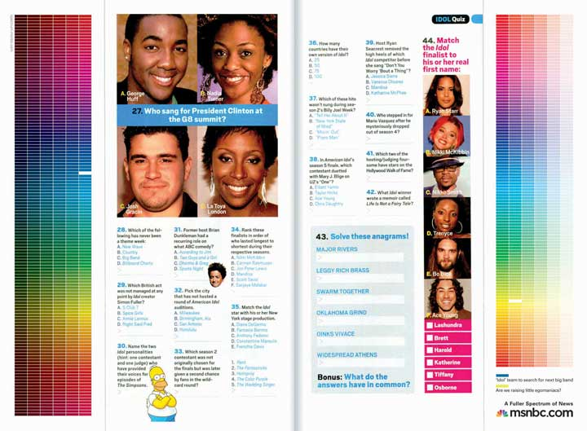
These one-third-page vertical ads were purchased to “hug” the editorial content in the middle of the page to show a strong connection between the content in the magazine and the content on msnbc.com.
In addition to full-page print ads within weekly magazines, the media buy can include other segments of a page. In the case of msnbc.com, The Media Kitchen bought one-third-page vertical ads on opposite sides. SS+K creatively used this buy to form “goalposts” around the page. Where possible, the editorial content of the page was taken into consideration when the team wrote headlines for the ads.

13.4 TV
Another important element of the launch campaign was the television spot. This spot is created with building the understanding of the target audience, the News Explorer, and creatively communicating the “fuller spectrum of news” concept in mind.
Television was an important medium in the launch campaign because part of the objective was to reach a mass audience. Although media is continually becoming more and more fragmented through sites and niche channels, television remains one of the most effective ways to reach many people at once.
A new bonus of creative materials created for TV is the growing popularity ofonline video. While some argue that each execution should be created specifically for the medium, others argue that repurposing (reusing existing clips in new ways) is a great way to get the most bang for your production buck.

13.5 Online Banners
The creative elements of the online campaign had to be engaging in order to deliver on the Big Idea of enjoying the journey (“Dive In. Swim Around.”), so the team set out to make interactive and engaging banners. The banners appeared on different sites from ESPN (http://espn.go.com) to The Weather Channel (http://www.weather.com), with unique messaging and links for each of those unique placements.
Figure 13.6
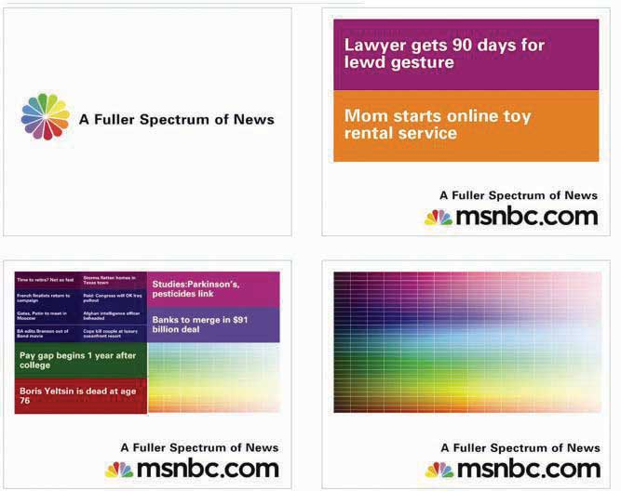
These banners, titled “Subdivide,” would split stories and color bricks when the mouse scrolled over the banner, ultimately resulting in the full spectrum. SS+K worked with BEAM Interactive on all the banners.

Figure 13.7
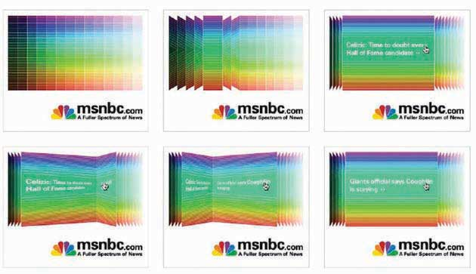
The banners titled “Page Flip” had one color category flip through a range of stories when initiated by the mouse.

Figure 13.8
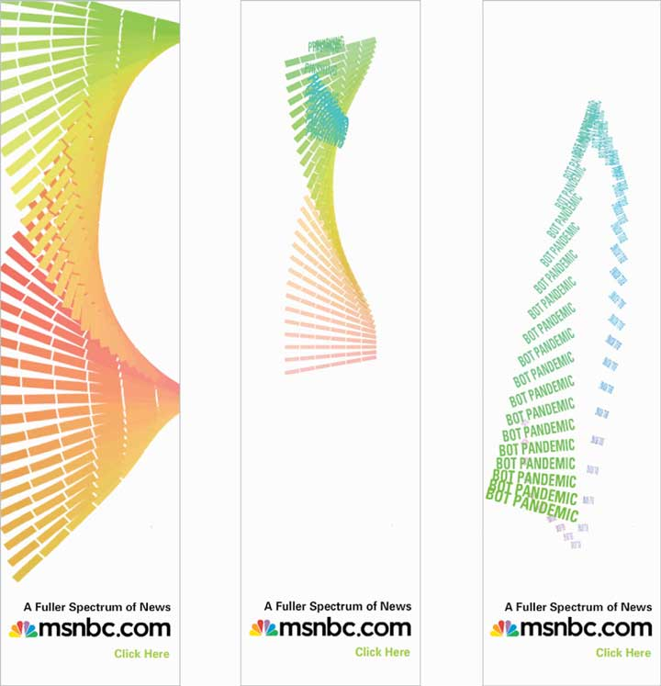
The “Helix” banners responded directly to a mouse-over by having the animation “follow” the direction of the mouse. The ad features rotating keywords that a user could click on.
Figure 13.9
The “Keywords” banner ads were built in Flash, rather than rich media, so they had an animation that would take a range of topics available on msnbc.com and slowly merge them into the spectrum.
The press started, and the initial paid launch elements ran heavily through the first six weeks. As they continued through the rest of the communications plan, more elements were introduced. The marketing elements were devices that, while introduced during the campaign, would live on after ads stopped running. You can still find these interactive elements by going to msnbc.com; there are even more of them since the first campaign launch in April 2007.

13.6 Screensaver
Figure 13.10
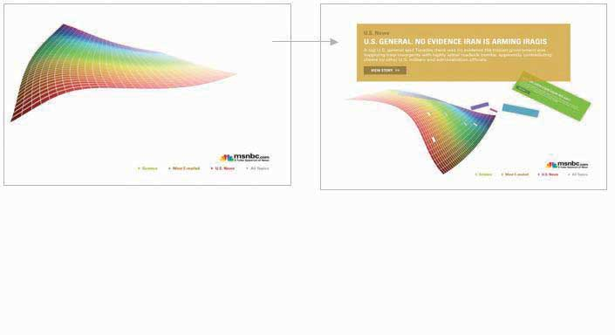
The NewsSkimmer screensaver pulls live RSS headlines from msnbc.com while the computer is sleeping. It is also fully customizable so the user can choose which feeds she wants to receive. SS+K worked with BEAM Interactive to produce the banners.

13.7 NewsBreaker Game
Another insight was that many News Explorers were casual game users. Because their demographics skewed a little older, SS+K recommended updating an old favorite. As a result, its new version of the classic “brick breaker” game used the treatment of the spectrum, in which each brick is a story, and made a game of collecting news while reaching the next level.
The game, which is RSS fed and was given the name NewsBreaker, was unveiled in April to time with the NewsSkimmer screen saver. Play the game yourself athttp://www.newsbreakergame.com.
Figure 13.11
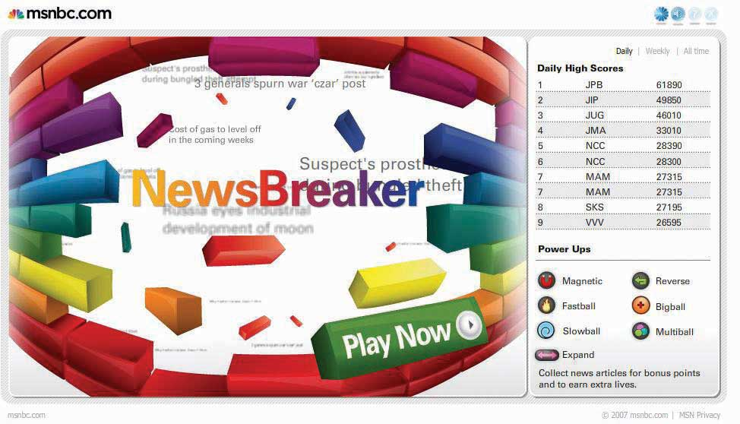
NewsBreaker game was designed to bring msnbc.com content to News Explorers in new and unexpected ways. SS+K worked with Fuel Industries to create this game.
As the advertising and marketing elements came to life, msnbc.com and SS+K were preparing to launch the riskiest element of the marketing campaign.
As leaders and innovators, it was important for msnbc.com to flex its leadership muscle when it came to understanding technology. The team didn’t recommend any element of the campaign that didn’t answer to one of the stated goals, and they dismissed a few asymmetric ideas due to those qualifications. But NewsBreaker Live became the anchor of the campaign, and ultimately msnbc.com created a new medium. The technology had only been proven on a small scale, and the crowd reaction was unpredictable. Would they hate it, or would they love it? Would they remember who it came from, or would they ignore it completely?

13.8 NewsBreaker Live
The final push of the campaign came in June with the launch of the first-ever in-cinema interactive audience game, NewsBreaker Live. The game premiered in Los Angeles before the movie Spider-Man 3 and then moved on to Philadelphia and White Plains, New York.
Figure 13.12
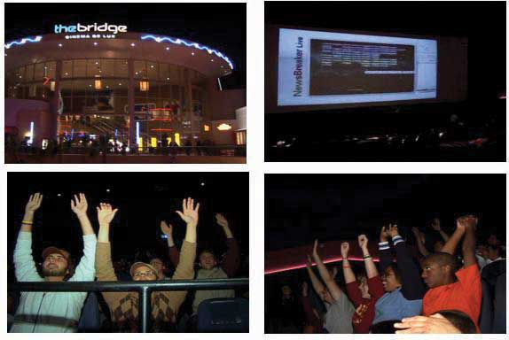
msnbc.com introduced the first-ever audience in-cinema game: NewsBreaker Live. SS+K worked with the Brand Experience Lab and The Bridge Cinemas to produce and present this game. Audience members control the action on the screen by waving their arms. See the YouTube demo athttp://www.youtube.com/watch?v=y6izXII54Qc.
The campaign centered on the overarching brand message, but there are also instances where you use your media buys to promote elements of your company or other marketing efforts. A few examples would be a flyer about an event or a newspaper ad about a sponsorship. Each print ad had the URLhttp://www.spectrum.msnbc.com.
Press coverage and management was ongoing throughout the campaign. It was led by Danielle Tracy and supported and implemented by Katie O’Kane and others.

13.9 E-mail Blast
Figure 13.13
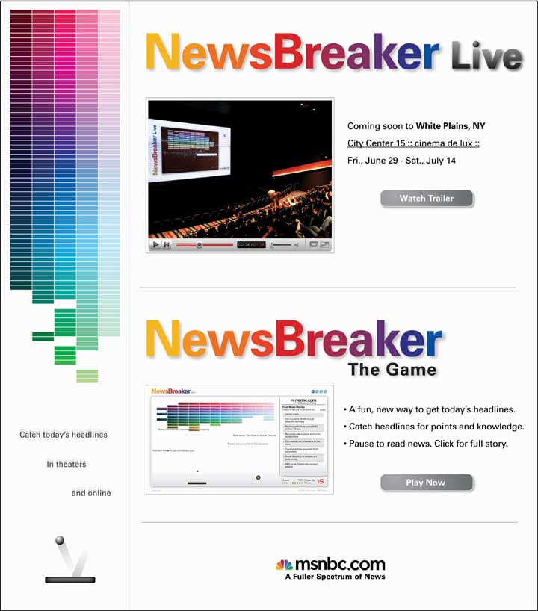
This e-mail blast was sent to the New Yorker’s list as part of an added-value for the print buy. It was geo-targeted to readers who would be able to attend NewsBreaker Live in White Plains, New York.
Late in the campaign SS+K utilized the e-mail blast to promote the NewsBreaker Live game as it appeared in White Plains, New York. Each print ad had the URLhttp://www.spectrum.msnbc.com.

13.10 Spectrum Home Page
Figure 13.14
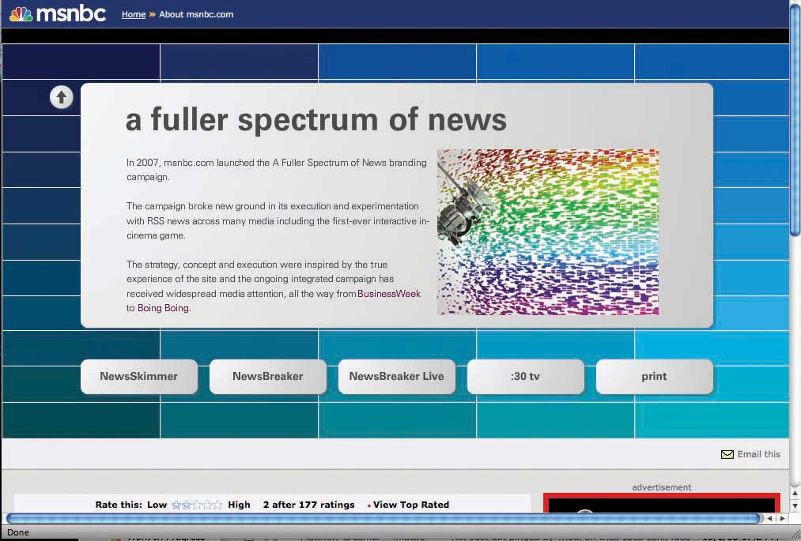
This page on the msnbc.com site, coined the “Spectrum Page,” is a destination for all elements of the campaign. Users can view TV spots, download NewsSkimmer, and play NewsBreaker all from one place.
Figure 13.15
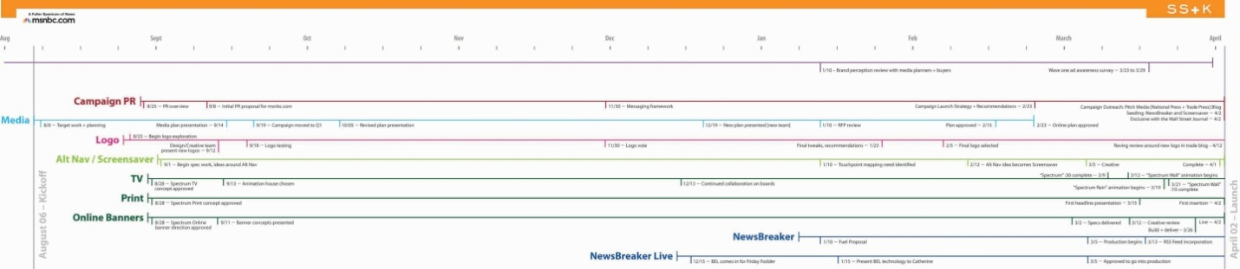
A full timeline of all the work that SS+K and msnbc.com did together from pitch to launch of the first ever msnbc.com branding campaign.

Chapter 14

ROI: msnbc.com Decides if the Campaign Worked
Figure 14.1 Three Months after Launch!
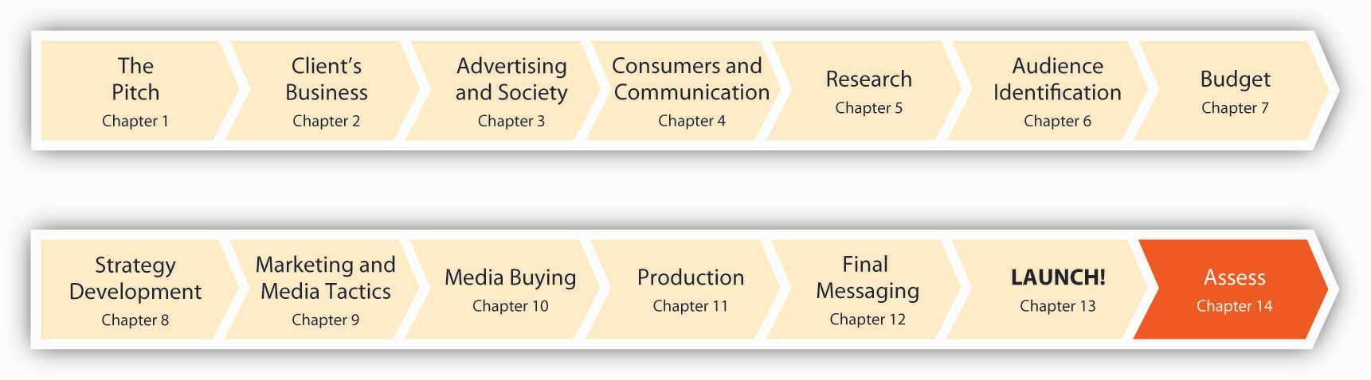
“Cool ad! But did it work?”
That’s the million dollar question (or often even more). Advertising serves many roles, from building awareness of a new acid jazz group to informing us of an asthma drug’s side effects. But at the end of the day, advertising is a call to action: it can be pretty, funny, sexy, or cute—but if an ad doesn’t sell the client’s product or service, or create the behavioral change a nonprofit hopes to achieve, it’s nothing more than an entry on an art director’s “reel” that may land him another juicy assignment.
SS+K is keenly aware of the need to show results. Its client msnbc.com is counting on the new brand-building campaign to start to move the brand building, awareness, and traffic needle. Did the agency succeed in this quest? Let’s find out.

14.1 ROI: Show Me the Money

LEARNING OBJECTIVES
After studying this section, students should be able to do the following:
- Define return on investment (ROI).
- Describe the value of using metrics to gauge the direct impact of a marketing communication.
- Define brand equity.
- Demonstrate how msnbc.com measured the ROI of the campaign using five parameters.
Advertising is “sexy,” no doubt. Especially in the “golden years” of the ad biz in the 1960s, as the hit TV series Mad Men depicts, it seems like the executives smoke and drink their way through the day while the poor souls in manufacturing or accounting do the heavy lifting. Anyone who actually works in advertising will readily tell you that the halo of glamour is a myth—but nonetheless that’s the stereotype many people (including some advertising and marketing majors) hold.
The reality is that advertising is hard work—and it’s an essential part of doing business. It’s also expensive. There’s no question (at least in our minds) that advertising returns considerable value to the client. But how do you prove that to the bean counters? Unlike most other areas of business, alas, it’s not always so easy to assess the value of advertising and marketing activities. How does the “warm and fuzzy” feeling an ad creates translate into cold hard cash on the bottom line?
As competition for sales, eyeballs, souls, or whatever unit is in play continues to escalate in virtually every category (both profit and nonprofit), advertisers are under pressure as never before to justify their existence. This challenge is compounded by the way a firm traditionally states its objectives: a marketing strategy typically uses vague goals like “increase awareness of our product” or “encourage people to eat healthier snacks.” These objectives are important, but their lack of specificity makes it virtually impossible for senior management to determine marketing’s true impact.

Return on Investment
Because management may view these efforts as costs rather than investments, advertising is often the first item to be cut out of a firm’s budget when money is tight (like today). To win continued support for what they do (and sometimes to keep their jobs), advertisers are scrambling to prove to management that they generate measurable value by aligning what their work achieves with the firm’s overall business objectives. ^{[1]} The watchword in business today is return on investment (ROI). In cold, hard terms: what did I spend, and what did I get in return?
(Gross Profit generated by advertising − Cost of advertising) / Cost of advertising = ROI
Figure 14.2
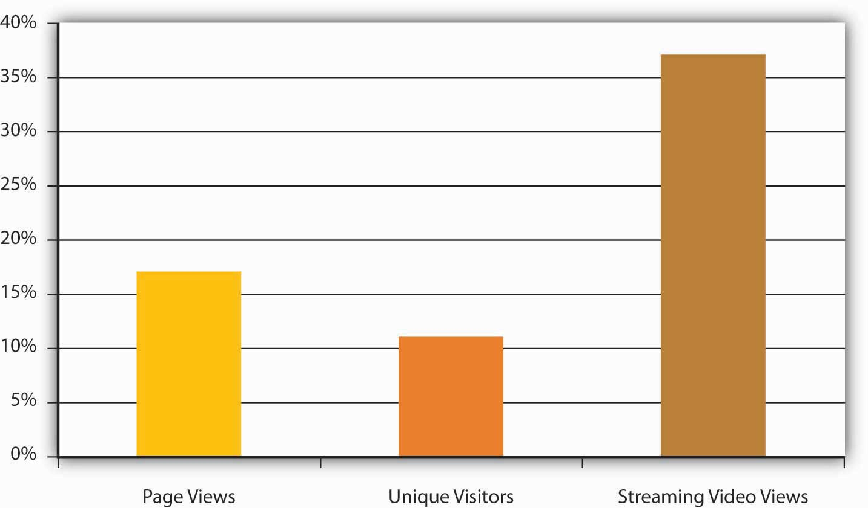
msnbc.com measured the metrics of page views, unique visitors, and streaming video views; all increased significantly as a result of the campaign.
The race is on to generate metrics—quantifiable measures that gauge the direct impact of a marketing communication. Businesses increasingly mandate that their divisions create scorecards (or “dashboards”) that allow senior management to monitor what actions they’re taking and to see how these efforts affect the bottom line. And they’re not just asking for proof that advertising moves products—increasingly they demand to see a link between tactical actions, such as specific promotions, on a firm’s market share and even on a firm’s overall financial value (as measured by market capitalization). ^{[2]}
This is no small task for advertisers, whose goals are often intangible and whose results may not be readily apparent in the next quarter. Another problem they face is the skepticism of many who hold the purse strings in companies; executives in other parts of the business may believe (rightly or wrongly) that a marketer never met a budget item she didn’t want. According to one study, six in ten financial executives believe their companies’ marketing departments have an inadequate understanding of financial controls, and seven in ten said their companies don’t use marketing inputs and forecasts in financial guidance to Wall Street or in public disclosures.
Marketers echo this pessimism; many acknowledge they have some distance to go before they understand (and quantify) the impact of what they do. In the same study, only one in ten marketer respondents said they could forecast the effect of a 10 percent cut in spending. Just 14 percent of marketing executives said senior management in their companies had confidence in their firms’ marketing forecasts. One of the analysts who conducted the study commented, “The thing that scared me most is that marketers don’t believe their numbers either.” ^{[3]}
The difficulties in quantifying marketing’s contribution to the bottom line—and the growing pressure from CEOs to do so—helps to explain why a recent BusinessWeek survey of the shelf life of top-level functional executives revealed that the average job tenure of a chief marketing officer (CMO) is the lowest among the areas—26 months, compared with 44 months for CEOs, 39 months for chief financial officers (CFOs), and 36 months for chief information officers (CIOs). The pressure to provide tangible results is intense. ^{[4]}
So when a company looks to shave costs to improve its return to stockholders, advertising is a particularly easy target for cost cutting because few companies have developed reliable ways to track or predict the ROI for such spending. Lacking such measures, management often computes an advertising budget strictly as a percentage of revenues, or they base it on the previous year’s budget. As any fan of advertising’s impact (those who remain) can attest, this logic is seriously flawed: if revenues are falling, it may be because you’re not advertising enough! The last thing you want to do is reduce your investment to inform the market about your product or service.

Metrics
How can advertisers make that case credibly? As we’ll see, it depends on the type of advertising they do and how they measure its results. Typical metrics for traditional advertising (i.e., magazine ads, TV, etc.) include these:
- Advertising awareness: How many people saw your ad and recognized the brand?
- Trial: Did more people try the product after they saw your ads?
- Qualitative evidence: Working mothers in four focus groups absolutely loved the ads.
- Sales volume: Did sales increase from the time period before the ad campaign to the time period after it? Warning: While it’s tempting to conclude that this is the only metric you need, this measure can be deceiving. You need to consider other factors:
  - What else was going on in the external environment that might have influenced this activity? The best ad campaign ever devised probably couldn’t move a lot of gas-guzzling Hummers today.
  - How much did you have to spend to get the results? You could sell a record number of Hummers (even today) if you priced them at $49.99—but do you want to?
A single best all-around ROI formula is the Holy Grail today, but in reality companies vary widely in the way they tackle this issue (the notable thing is that many are tackling it at all). Some rely on sophisticated statistical analyses while others are content to track general changes in sales trends or brand awareness. General Mills decides how much to invest in marketing and advertising by examining the historical performance of the brand as well as market research metrics on previous advertising effectiveness, growth versus competition, and other changes in the marketplace.
Another approach is to use the statistical technique called regression analysis, which identifies the amount of an effect we can attribute to each of several variables that operate simultaneously. One analyst calculates the percent of total sales attributable just to a brand’s existing sales momentum and brand equity (the value of a brand name over and above the value of a generic product in the same category). He determines brand equity by identifying the financial value the brand contributes compared to product value, distribution, pricing, services, and other factors. He calculates the short-term incremental impact of advertising on sales by looking at several years of sales data and creating a sales trend line. Waving his statistical magic wand, he then looks at whether a specific promotion results in incremental sales, or sales over what would we expect based on normal conditions.
Indeed, consulting firms such as Corporate Branding LLC and Interbrand, as well as a few big ad agencies like Young & Rubicam (Y&R), develop their own proprietary methods to arrive at a brand’s financial value. They track these values over time to help clients see whether their investments are paying off. Y&R’s Brand Asset Valuator is based on field research of consumers on thousands of brands. When the agency studied just what builds brand equity, it identified one crucial element: does the consumer believe the product is different in a relevant way—does the message offer a clear, memorable reason to buy the product, also known as a unique selling proposition (USP)? Y&R tracks how well various advertising campaigns differentiate brands and the degree to which they increase brand value as a result. ^{[5]}

SS+K Spotlight
The ROI for any campaign must relate to its original strategy. Every action the agency takes needs to tie back to the results it produced. As msnbc.com and SS+K planned out the elements of the campaign, the team aligned each element to one of the goals:
- Increase overall traffic to the site
- Increase awareness of the brand
- Establish a unique identity for the site
Then msnbc.com measured the ROI of the launch campaign with the following parameters:
Paid Media + Added Value: Media bought and negotiated added-value.
Earned Media: Any coverage or impressions that are not paid for but are earned through commentary, press, and so forth.
Engagement: Measures of engagement include time spent on the site and number of clicks to show how the consumer interacted with the brand message.
Awareness: Measure of consumers’ knowledge of a brand, or of a particular communication. As we saw in , when a consumer remembers a brand or message, this is recall. If a consumer recognizes a brand or message from a list, this is recognition.
Traffic: Using sophisticated tracking software and code, analysts can track the number of people who visit a certain site or page on a site. Thanks to cookies that get inserted into computers when we visit Web sites, repeat visits and other behavioral patterns can be uncovered as well.
These were the specific goals for the msnbc.com campaign and how they were measured:
- Increase in unique users: comparing April, May, June unique users in 2006 to 2007
- Increase in engagement with the brand:
  - An increase in use of features on the site, like page views and video streams
  - Creation of new tools and experiences that would engage users
  - Buzz generated by earned media
- Internal buy-in of the brand: in-depth interviews with key msnbc.com stakeholders before and after the campaign

Figure 14.3Total Impressions for Paid Media for the msnbc.com Campaign
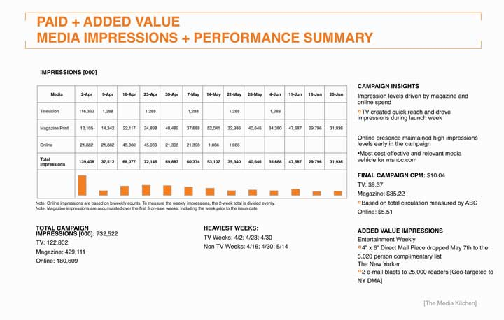

KEY TAKEAWAY
Return on investment (ROI) is the Holy Grail for advertisers, who face increasing pressure to demonstrate that their efforts contribute tangibly to a client’s bottom line. Demonstrating this financial value is a challenge, especially in cases where a firm’s objectives are long term or hard to quantify—for example when the goal is to build a favorable image for a brand over the long haul. Firms employ a variety of metrics to gauge ROI, but there is as yet no single magic formula that works to everyone’s satisfaction.

EXERCISES
- Explain why it is important to measure ROI (return on investment) in advertising.
- Discuss the metrics marketers use to measure the effectiveness of traditional advertising (e.g., magazine ads).
- List the five parameters msnbc.com used to measure the ROI of the launch campaign. Discuss the “new” metrics that some companies apply to advertising today.

[1] Jeff Lowe, “The Marketing Dashboard: Measuring Marketing Effectiveness,” Venture Communications, February 2003,http://www.brandchannel.com/images/papers/dashboard.pdf (accessed February 9, 2009); G. A. Wyner, “Scorecards and More: The Value Is in How You Use Them,” Marketing Research, Summer, 6–7; C. F. Lunbdy and C. Rasinowich, “The Missing Link: Cause and Effect Linkages Make Marketing Scorecards More Valuable,” Marketing Research, Winter 2003, 14–19.
[2] Cf. Roland T. Rust, Tim Ambler, Gregory S. Carpenter, V. Kumar, & Rajendra K. Srivastava, “Measuring Marketing Productivity: Current Knowledge and Future Directions,” Journal of Marketing 68 (October 2004): 76–89.
[3] Quoted in Bradley Johnson, “Survey Finds CFOs Skeptical of Their Own Firms’ ROI Claims: ANA Confronts Lack of Confidence at Marketing Accountability Conference,” Advertising Age, July 15, 2008, http://adage.com/article?article_id=129629 (accessed July 16, 2008).
[4] Ian Ayers, Super Crunchers: Why Thinking-by-Numbers Is the New Way To Be Smart (New York: Bantam, 2007); Jerry Adler, “Era of the Super Cruncher,” Newsweek, September 3, 2007, 42; “The Short Life of the Chief Marketing Officer,” BusinessWeek, December 10, 2007, 63–65.
[5] Kris Frieswick, “New Brand Day: Attempts to Gauge the ROI of Advertising Hinge on Determining a Brand’s Overall Value,” CFO.com, November 1, 2001,http://www.cfo.com/article.cfm/3001802/1/c_3046511 (accessed August 15, 2008).

14.2 ROI for Broadcast and Print Media

LEARNING OBJECTIVES
After studying this section, students should be able to do the following:
- Discuss the usefulness of the metric CPM (cost per thousand).
- Characterize the usefulness of network TV metrics for providing evidence of message usefulness.
- Recall the various radio day-parts.
- Distinguish among the three primary Starch scores.
- List and discuss the basic principles that increase a print ad’s likely impact on the reader.
Traditional (broadcast) media struggle to demonstrate a direct impact on the bottom line. These advertising messages reach many consumers at the same time, and these receivers also get bombarded by a multitude of competing ads and other stimuli that vie for their attention. It’s not easy to connect the dots between a single commercial (or even an entire ad campaign) and the purchases of thousands of people who may or may not have noticed the message in the first place.
As we’ve seen, it’s fairly easy for media planners to compute a metric that lets them compare the relative cost-effectiveness of different media and of spots run on different vehicles in the same medium. This metric is cost per thousand (CPM); it reflects the cost to deliver a message to one thousand people. Because it provides an apples-to-apples perspective, it’s very helpful to have this information in hand.
Unfortunately, CPM alone is not a great indicator of ROI: it tells us how good we are at getting our message to an audience but nothing about the impact that message has when it reaches the target. Let’s briefly review some of the other ways advertisers try to provide evidence that the messages they create actually generate value for the client and its stockholders.

Network TV
For some time now network television has been in a defensive posture as the industry struggles to justify its existence. Some skeptics predict the demise of this medium as an advertising platform because our society is too fragmented for it to be effective. Note: this criticism certainly doesn’t apply to direct-response TV (DRTV), where sales are directly linked to on-air programming or “call now” ads. When a shopping channel like QVC puts that unique cubic zirconium ring on the air, the network knows within minutes whether it’s a winner.
While an advertiser in the 1960s could be confident that he could reach a hefty proportion of the American public with a commercial on one of the three networks in existence at the time, today the (TV) picture is much different. Consumers can choose from hundreds of channels—when they’re not surfing the Web or listening to podcasts and MP3 files. Young people in particular are migrating away from TV and spending more time online—especially as programming that used to appear exclusively on TV becomes available as streaming video. To rub salt into the wound, viewers today can exercise control over what they see as they gleefully TiVo or DVR their way into commercial-free entertainment on their big flat-screen TVs.
For now, estimates vary widely—one study found that the average ROI of TV advertising is 0.54 to 1 for packaged goods and 0.87 to 1 for nonpackaged goods. According to this research, these media on average actually lose money for the advertiser! ^{[1]} Another estimate, by well-known media analyst Kevin Clancy, is a bit more sunny: he states that the average ROI of TV advertising campaigns ranges from 1 to 4 percent—still a small number, but at least it’s in the positive column. ^{[2]}
Traditionally the metric this industry uses is viewership ratings, particularly those Nielsen compiles. Again, these data have questionable relevance to ROI because they only show whether people watch the shows and not necessarily whether they use the commercial breaks to hit the bathroom or make a sandwich. And these ratings often get collected in a finite period of time—sweeps week—so networks pump up their schedules to attract as many viewers as they can during this window. There is widespread consensus among advertisers that the TV industry will need new audience metrics—other than reach and frequency information it uses to calculate CPM—to report commercial ratings.
To get a sense of the pessimism surrounding this industry, consider some results from a recent study by the Association of National Advertisers (ANA) and Forrester Research:
- Almost 70 percent of advertisers think that DVRs and video-on-demand will reduce or destroy the effectiveness of traditional thirty-second commercials.
- When DVRs spread to thirty million homes, close to 60 percent of advertisers report they will spend less on conventional TV advertising; of those, 24 percent will cut their TV budgets by at least 25 percent.
- Eighty percent of advertisers plan to spend more of their advertising budget on Web advertising and 68 percent of advertisers will consider (Web-based) search engine marketing.
- Advertisers are also looking at alternatives to traditional TV advertising, and almost half plan to spend more of their advertising budgets on emerging platforms (which we’ll address later) such as TV program sponsorships, online video ads, and product placement. ^{[3]}
With all that negativity, is network television dead? Don’t write its obituary yet. Although it’s undeniable that our world is a lot more fragmented than it used to be, there still are large-scale events that unite us and continue to command a huge mass television audience. These include the Super Bowl, the Olympics(with an estimated four billion viewers) and, of course, American Idol.
Advertisers also are getting more creative as they search for ways to draw in audiences—and entice them to stay for the commercials. For example, some are experimenting with bitcoms that try to boost viewers’ retention of a set of ads inserted within a TV show (we call this a commercial pod). In a typical bitcom, when the pod starts a stand-up comedian (perhaps an actor in the show itself) performs a small set that leads into the actual ads. ^{[4]}
Finally, the networks are taking baby steps toward getting more credit for viewership that occurs in places other than people’s living rooms. Our mobile society exposes us to television programming in bars, stores, hospital waiting areas, and dorm rooms—current ratings systems don’t reflect this. In early 2008 Nielsen fielded a new service it calls The Nielsen Out-of-Home Report; this is a cell-phone based service that provides metrics for television viewing that occurs outside of the home in bars, hotels, airports, and other locations. CNN has already started to use this service. In addition, the Nielsen Online VideoCensus will measure the amount of television and other video programming people view over the Internet. ^{[5]}

SS+K Spotlight
Figure 14.4
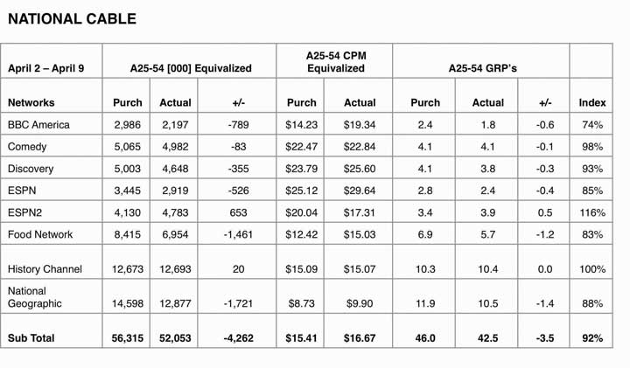
National cable metrics from the msnbc.com campaign show the planned CPM versus the actual CPM. ESPN2 and History Channel met or exceeded purchased impressions.
Figure 14.5
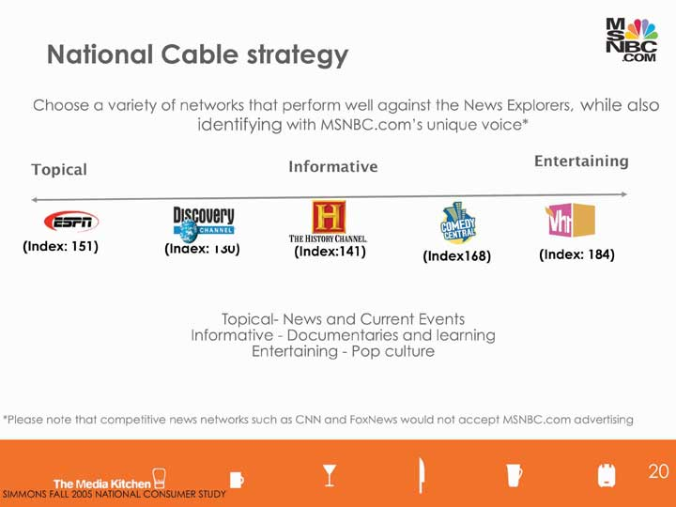
The channels SS+K chose for the msnbc.com campaign covered the range and interest of the msnbc.com News Explorer.
There was a unique advantage for msnbc.com; as part of the NBC and Microsoft families it could tap into these resources. The client was able to request in-kind media, which is placement on their properties at no media cost. The TV spots ran during launch week of the campaign.
Figure 14.6In-Kind Media Results from TV
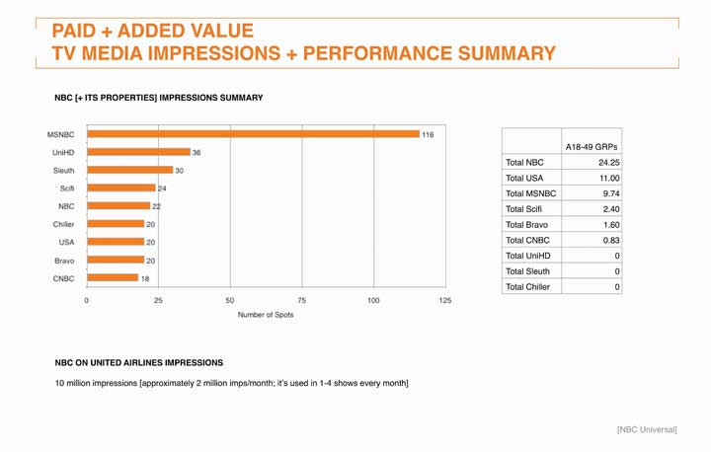
United Airlines ran the thirty-second msnbc.com spot on its in-flight television programs.
Figure 14.7
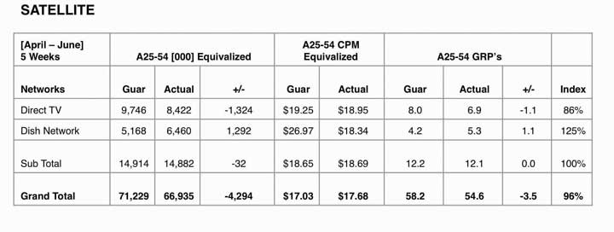
Satellite purchase was a strategic way for msnbc.com messaging to air on competitors’ networks. Dish Network exceeded purchased impressions.
Figure 14.8
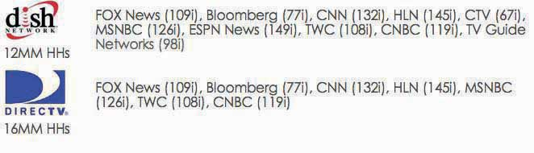
msnbc.com purchased a “news cluster” on the satellite networks, which allowed its brand messaging to appear on competitor channels. With cable, those networks would have likely declined to accept competitors’ advertising.

Dig Deeper
Cable television has prospered at networks’ expense because it is much more targeted—and a lot cheaper. Travel, cooking, science, history, weight loss: it’s all available to a well-defined audience that’s self-selected to be interested in ads that relate to these categories. Still, like its older brother, network TV, cable lacks precise metrics. In some cases an advertiser will take advantage of cable’s targeting capabilities to conduct an A-B test of a commercial. This means that it will show one execution to a select group of viewers who live in one part of a city and a different version to another group—and then examine the product’s sales in each region to identify any results. But this is still an indirect metric and is not routinely used.
MTV Networks—one of the biggest cable success stories—is trying to remedy that problem now. The network has contracted with a firm called Marketing Evolution to develop a system for its advertisers based on meeting benchmarks including awareness, relevancy, new purchase intent, purchase loyalty, and advocacy. Advertisers may still pay on a CPM basis, but also have the option to contract with Marketing Evolution to measure the success of their buys. ^{[6]} Time will tell if this new project will rock the metrics world.

Radio
Radio stations design their programming to attract certain listeners and then sell those listeners to advertisers in tiny increments. As with TV, advertisers look carefully at listener ratings to determine who and how many listeners their ad will reach on a given station—the leading industry ratings are provided by Arbitron. The company used to collect these data by asking listeners to keep a diary of the stations they listen to, but now it uses a Portable People Meter to automate the process and deliver more reliable results. ^{[7]}
A radio station has an ad time inventory of about eighteen minutes per hour, which it sells in increments of fifteen seconds, thirty seconds, and sixty seconds (:15s, :30s, and :60s). But not all minutes are valued equally. Audience size shifts dramatically throughout the day, and radio rates vary to reflect the change in the estimated number of listeners your ad will reach.
The radio industry divides up the time it sells in terms of day-parts:
- A.M. drive time, 6 a.m. to 10 a.m., has the most listeners. They tend to be highly receptive to learning about products (perhaps because they’re wired on their morning coffee!).
- Midday, 10 a.m. to 3 p.m.: This day-part offers fewer listeners, but they tend to be very loyal to a station. A good way to build brand awareness is to advertise at the same time each day with the same message.
- P.M. drive time, 3 p.m. to 7 p.m., also has a large number of listeners. They may be more inclined to buy what you’re selling than in the morning when they’re rushing to get to work.
- Evening, 7 p.m. to midnight, has fewer listeners but they tend to be highly loyal—they’ve made the conscious decision to switch on the radio rather than veg out in front of the TV.
- Late night lasts from midnight to 6 a.m. As you might expect, you’ll reach far fewer people at this time. But they may be more receptive to creative executions that capture their attention during those long, lonely hours. ^{[8]}

Print
The Starch test, as you learned in Chapter 11 "Execute on All Platforms: SS+K Goes into Production Overdrive", is a widely used metric that measures the performance of print advertising. Starch Research conducts quantitative research with magazine readers to identify what type of impact an ad had on them. ^{[9]} The service calculates these scores:
- Noted: The percentage of readers of the specific issue of a magazine who remember having previously seen the ad. This metric indicates whether the ad made an initial impact.
- Associated: The percentage of readers who can correctly associate the ad with the brand or product name.
- Read Most: The percentage of readers of the specific issue of the magazine who read 50 percent or more of the copy contained in the ad. This score shows how well the ad impacted the reader by engaging them with the copy.
Another metric that can be useful is pass-along readership. A magazine that readers share with others most likely displays a higher level of engagement, so it’s probably a good environment in which to place a relevant message. Research shows that readers have positive feelings about pass-along copies. Those who receive a magazine from others exhibit the same levels of recall and brand association for the issue’s ads as those who initially received the copy (plus, they get a “freebie,” so perhaps that puts them in a good mood). ^{[10]}
Figure 14.10
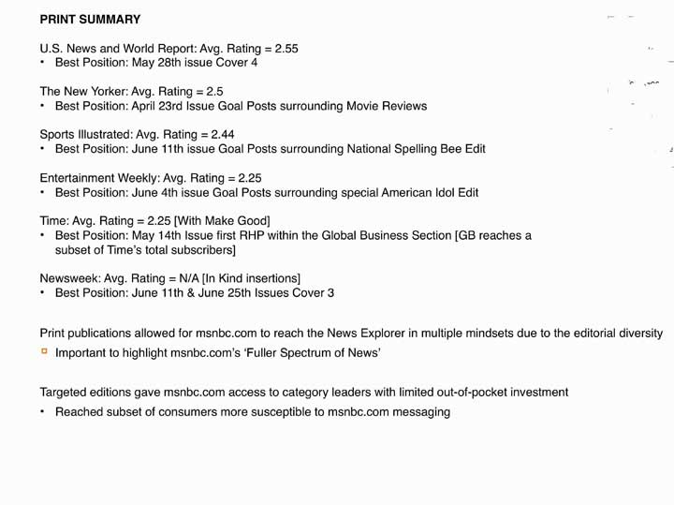
The Media Kitchen used this ratings system to measure placement levels for the print campaign.

Figure 14.11
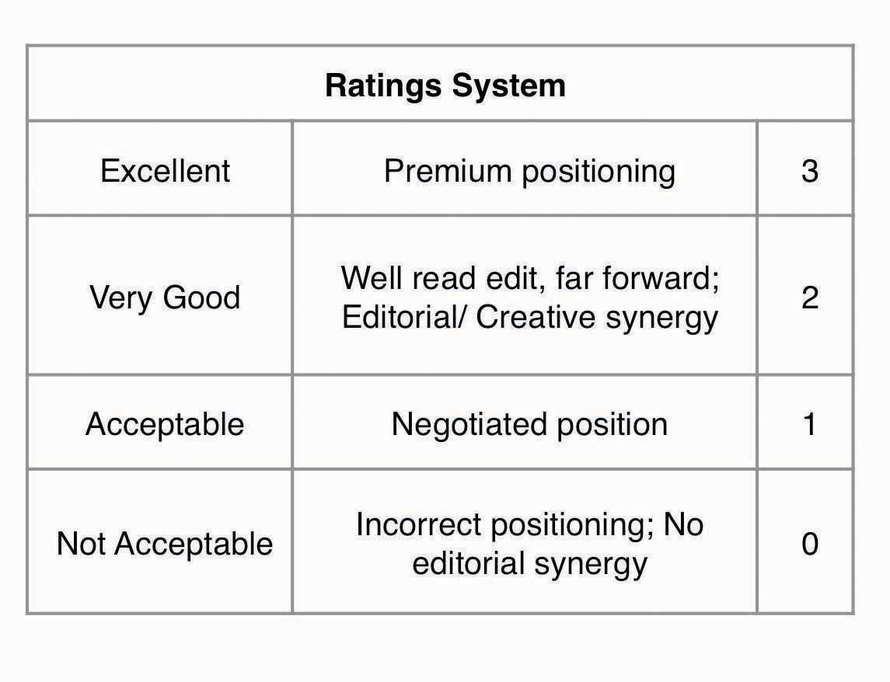
This is a summary of the ratings and positioning.
What makes a print ad effective? One recent study reported that we are far more likely to remember spectacular magazine ads, including multipage spreads, three-dimensional pop-ups, scented ads, and ads with audio components. For example, a Pepsi Jazz two-page spread with a three-dimensional pop-up of the opened bottle and a small audio chip that played jazz music from the bottle’s opening as well as a scratch-and-sniff tab that let readers smell its black cherry vanilla flavor scored an amazing 100 percent in reader recall. ^{[11]}
Unfortunately, that kind of multimedia treatment is very expensive; not every ad can mimic a Broadway production! Still, there are basic principles that increase a print ad’s likely impact on the reader:
- One popular dimension is the ad’s position in the magazine or newspaper. The industry refers to the ideal placement with the acronymFHRHP: first half, right hand page.
- Ads that appear in key cover positions (inside front cover, inside back cover, outside back cover) on average receive a Starch Noted score that is more than 10 percent higher than those that appear inside the magazine.
- Double-page spreads and bound multiple page inserts have significantly greater impact than full-page ads. Readers also are more likely to remember the brand name associated with the ad and to actually read the copy.
- A scent strip increases both the immediate impact of the advertisement and also the brand name association.
- Color has a significantly greater impact than monotone.
- Large advertisements on average have greater immediate impact than smaller ads.
- Sampling opportunities engage a reader with the product for a longer period of time. This strategy also shows that you are prepared to support your advertising claims.
- Placing an ad near editorial content that is relevant to the product enhances the ad’s impact. ^{[12]}

KEY TAKEAWAY
Traditional broadcast media platforms are under great pressure to demonstrate that they contribute to a client’s bottom line. Unfortunately, there’s no consensus regarding the single best way to do this—especially because these messages often intend to shape opinions or slowly evolve or reinforce a brand’s image over time rather than motivating an immediate purchase. For now, most metrics estimate the number and characteristics of consumers who get exposed to the message, while in some cases focus group or survey data based upon a sample of these people can suggest that these messages are likely to result in the desired action. Media companies in the television, radio, magazine, and newspaper industries continue to work on innovations that will allow them to show more direct results to advertisers who need to decide where to place their dollars.

EXERCISES
- Explain the metric cost per thousand (CPM) and how it’s used in advertising.
- Explain how network TV measures advertising effectiveness.
- Characterize radio day-parts and the different markets that match these day-parts.
- Describe how Starch scores are used to measure advertising performance.
- Identify the basic principles that increase a print ad’s likely impact on the reader.

[1] Bill Harvey, “ARF Engagement Recipe: Surprise, Utility and Emotion,” Next Century Media, http://www.nextcenturymedia.com/2006/03/arf-engagement-recipe- surprise-utility.htm, March 3, 2006 (accessed August 16, 2008).
[2] “How to Improve Marketing ROI: Free Kevin Clancy Web Seminar Offers Five Ways to Improve Marketing Performance,” The Copernicus MZine, November 2003,http://www.copernicusmarketing.com/about/mzine/monthlyeds/nov03.shtml (accessed August 16, 2008);http://www.copernicusmarketing.com/about/mzine/monthlyeds/nov03.shtml (accessed August 16, 2008).
[3] ANA / Forrester, “Beyond the 30 Second Spot: Marketers Adding Alternatives to Television Advertising,” Marketing Today, March 22, 2006,http://www.marketingtoday.com/research/0306/tv_advertising_less_effective.htm(accessed February 9, 2009).
[4] David Goetzl, “Turner: We’ll Get Your Brand into Our Programming,” Marketing Daily, http://www.mediapost.com (accessed March 14, 2007).
[5] Anthony Crupi, “CNN Orders Out-of-Home Study on TV Viewership,” Mediaweek, August 11, 2008 (accessed August 16, 2008).
[6] Steve Miller, “MTV Networks Puts New Advertising ROI Metrics into Rotation,”Brandweek, June 29, 2008, http://www.brandweek.com/bw/content_display/news-and-features/direct/e3i3a6a726c3dd89a140cfb16d45053c8ec (accessed August 15, 2008).
[7] http://www.arbitron.com/downloads/arbitron2008mediaplan.pdf (accessed August 16, 2008).
[8] “Radio Advertising,” http://www.businesstown.com/advertising/radio-buying.asp(accessed August 15, 2008).
[9] http://www.starchresearch.com/services.html (accessed August 16, 2008).
[10] “Reader Dynamics and Ad Impact on Readers of Pass-Along Copies,” magazine.org, 2006, http://www.magazine.org/content/Files/valReadershipPassAlong.pdf (accessed August 15, 2008).
[11] Erik Sass, “Study Finds Spectacular Print Ads Get Spectacular Recall,” http://www.mediapost.com (accessed February 23, 2007).
[12] “Starch Research,” http://edsites2.itechne.com/Acp3Images/edDesk/0b531cdd- eaf7-4c3e-82a7-1980552a775c/AboutStarch.pdf (accessed August 15, 2008).

14.3 ROI for Alternative Media

LEARNING OBJECTIVES
After studying this section, students should be able to do the following:
- List and discuss ROI for alternative media.
- Define media impressions.
It’s no secret that traditional advertising venues no longer provide the punch they used to. Advertising clutter makes it more difficult to get noticed in a crowded media environment, and even if people see or hear your ad, they are so busy multitasking that they may not react to it as you’d like. For this reason many advertisers look to alternative media either to replace or, more likely, to supplement their broadcast efforts. These options can be especially powerful for the client who needs short-term results (buy something now) rather than a longer-term brand building effort.

Point-of-Purchase
As the effectiveness of traditional media platforms continues to come under scrutiny, a lot of companies are allocating a greater proportion of their advertising dollars to point-of-purchase advertising (POP, also called marketing-at-retail). U.S. companies spend more than $13 billion each year in this category. A POP can be an elaborate product display or demonstration, a coupon-dispensing machine, or even someone giving out free samples of a new cookie in the grocery aisle.
Coupons and other short-term sales promotions (e.g., “buy one, get one free”) are forms of POP that are extremely trackable—it’s fairly easy to monitor redemption rates to the nth degree so an advertiser knows exactly which offers resulted in purchases. The eventual impact on the bottom line? Not always so obvious—a rush of purchases in the short-term to take advantage of a big price reduction ironically might decrease the brand’s long-term value if these cuts cheapen its image! And you thought this was going to be easy.…
As we all know, the experiences we have in a retail environment exert a big impact on the likelihood we’ll purchase—though, again, these can be hard to quantify. However, POP industry experts claim that a well-designed in-store display can boost impulse purchases by as much as 10 percent. One study that compared short-term sales increases among a number of different media across three hundred campaigns reported that in-store fixtures yield an average of 160 percent, and in-store posters delivered a 136 percent return. ^{[1]}
Due to the high stakes involved, several initiatives are under way to employ high-tech methods that more precisely measure just what happens in the store when consumers encounter advertising messages. The industry trade association POPAI (Point-of-Purchase Advertising Institute) is spearheading a major initiative with the Association of National Advertisers (ANA) to establish measurement standards for the industry. ^{[2]}
In addition, an alliance of major marketers including Procter & Gamble, Coca-Cola, 3M, Kellogg, Miller Brewing, and Wal-Mart is using infrared sensors to measure the reach of in-store marketing efforts. Retailers have long counted the number of shoppers who enter and exit their stores, and they use product barcode data to track what shoppers buy. But big consumer-products companies also need to know how many people actually walk by their promotional displays so they can evaluate how effective these are. Although it’s possible to fool these sensors (they still can’t tell if someone is simply cutting through to reach the other end of the store), this sophisticated measurement system is a valuable first step that many advertisers eagerly await. ^{[3]}
Finally, the marketing research company TNS is about to launch a new system to measure POP in grocery stores. The TNS Insight Dashboard will be a syndicated service that provides a report each quarter on the effectiveness of in-store marketing strategies. The Dashboard monitors where shoppers are in a grocery store at any given time, tracks the number of seconds they spend at any display and the amount of time they spend with other products, and then overlays these results with sales information so TNS can determine which displays actually lead to purchases. As a TNS executive observed, “A display’s stopping power is a good thing when it generates a lot of purchasing, but if people are spending many seconds there and not buying, something isn’t speaking to customers properly.” ^{[4]}

Out-of-Home Media
Surprise—there is no standard metric for traditional billboard advertising. However, common sense suggests that these messages are more useful in some contexts than in others. Because passing motorists only see a billboard for a few seconds, this medium is more effective to convey a quick visual message than substantial information. Billboard messages need to be kept to five or six words at the most. In this case a picture truly is worth a thousand words. Again, it’s awfully hard to quantify the impact a vivid picture can make, though this could be substantial if it’s sufficiently interesting and differentiates the product (especially when people see it repeatedly).
Outdoor advertising is quickly moving to more sophisticated digital technology that people can see at a greater distance and that can present more detailed verbal information. In research conducted by OTX, a global consumer research and consulting firm, 63 percent of adults said that advertising on digital signage “catches their attention.” Respondents consider advertising in this media to be more unique and entertaining and less annoying than both traditional and online media. The study also reports that awareness of digital out-of-home media is high—62 percent of adults have seen digital signage in the past twelve months—and is at levels comparable to billboards, magazines, and newspapers. On average, people notice digital signage in six different kinds of locations during their week, giving advertisers the opportunity to intercept people with their brand message at various touchpoints during their weekly routines as they work, play, and socialize. It’s even more effective at reaching eighteen- to thirty-four-year-olds, who rate this medium higher than the general population.^{[5]}
Cinema advertising is one form of out-of-home media that is gaining in popularity—as SS+K discovered when they launched the in-cinema NewsBreaker Live game. An organization called The Out-of-Home Video Advertising Bureau (OVAB) is developing guidelines to allow potential advertisers to measure the effectiveness of this new medium. At this point twenty-five companies belong to this group. ^{[6]}

SS+K Spotlight
In order to measure the effectiveness of their innovative in-cinema effort, msnbc.com and SS+K considered all the possibilities to show impact and impressions.
Figure 14.13
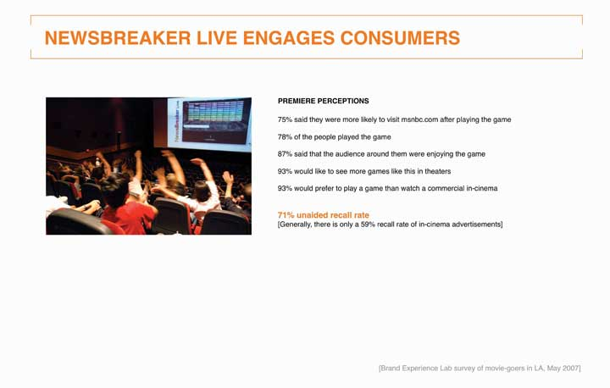
Audience members in Los Angeles play at the premiere of NewsBreaker Live, the first ever in-cinema game.
Figure 14.14
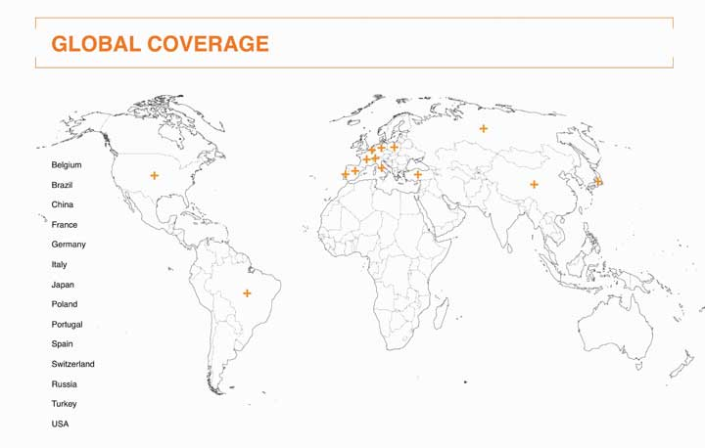
The game garnered significant press coverage worldwide. These are the countries where stories about NewsBreaker Live appeared in local media.
NewsBreaker Live yielded incredible results in terms of players’ recall of msnbc.com and enjoyment of the new innovative messaging. The team also aimed to measure impressions by counting tickets sold for the showtimes and films in which NewsBreaker Live played. The game ran in summer blockbusters such as Spider-Man 3, Shrek the Third, Ocean’s 13, and Ratatouille, so a large number of people were exposed to it.

Product Placement
In 2008 advertisers spent $3.6 billion to place their products in TV shows and movies. Until fairly recently, product placement was a casual operation where prop masters made informal arrangements to procure products they needed to dress a set. Today, it’s big business—but the effectiveness of these placements is anyone’s guess.
Nielsen, the company that compiles TV program viewership ratings, is working on a process with another company, IAG, to quantify when products appear in shows. IAG currently produces product placement ratings that are based on viewer recall; it asks 2.5 million people to respond to surveys online after they watch their favorite shows. These ask whether viewers remember the brand, think more positively about it, or want to purchase it, and whether the placement disrupted their viewing experience. Another firm called ITVX uses a system that measures up to sixty variables to determine a placement’s effectiveness, including whether a product appears in the foreground or background, whether a viewer is aware that a brand is on screen, and whether the show’s commercials are coordinated with the product placements. ^{[7]}

Video Advertising
Odds are you’ve watched a clip on YouTube recently. Advertisers want more access to viewers like you as online video advertising comes into its own. Some companies including CBS and Electronic Arts have reversed their positions about prosecuting users who post unauthorized clips of their content and have instead started to sell advertising on these spots. Interestingly, CBS is doing this even though its sister company Viacom is involved in a billion-dollar copyright lawsuit against Google, which owns YouTube. ^{[8]}
Reflecting the newness of this media platform, in 2006 the Interactive Advertising Bureau (IAB) developed a set of guidelines to help the industry determine at what point a piece even qualifies as a video commercial. It defines a video ad as a commercial that may appear before, during, and after a variety of content including streaming video, animation, gaming, and music video content in a player environment. For now, the industry still uses CPM as its primary metric. The majority of video ads are repurposed fifteen- and thirty-second television commercials, but as yet there is little data about how these translate to the online environment, which length is most effective, and so on.

Advergaming
Advergames, as you learned in , are custom-made videogames specifically designed around a product or service, such as Sneak King by Burger King. Many advertisers are intrigued by the possibilities they see here, especially since the elements within an online game can be changed over time. Videogames also can show digital video ads before play, during breaks in a game, or following completion of the game. A client can introduce its products directly into the game in the form of beverages, mobile phones, cars, and so on.
The Interactive Advertising Bureau (IAB) is at work to define standard metrics for this new medium. The videogame platform shares some characteristics of online ads because when people play online, clients can track which specific elements in a game yield a response (e.g., when a player clicks on a sponsored link). The IAB has identified basic metrics that include:
- Cost per thousand (CPM)—Advertising inventory is sold on the basis of “number of impressions delivered.” But just what constitutes an “impression” has yet to be agreed upon. For example, it may be defined as ten seconds of cumulative exposure to an ad format or element within a game session. In order for each one second to be counted, the scene the gamer sees must meet defined parameters for the angle of view to the ad in addition to the size of the ad unit on the screen. Other measurement methods count “interactive impressions” once there is an interaction between the gamer and the interactive ad unit.
- Cost per click (CPC)—A media company or search provider is paid only when the user or visitor clicks on an ad.
- Cost per action (CPA)—Performance ad networks often use this model where the revenue event is triggered only when the user or visitor takes the desired action with the advertiser (i.e., makes a purchase).
- Cost per view (CPV)—This relatively new model triggers the revenue event only when the user or visitor opts in to view the ad, often by clicking on a prompt or “bug.”
- Cost per session (CPS)—A session-based sponsorship where the user or visitor’s play experience is branded. ^{[9]}

SS+K Spotlight
SS+K created msnbc.com’s NewsBreaker game because the agency realized that its target segment of News Explorers also tend to be active in casual online games. The chart below illustrates two types of engagement with the NewsBreaker game: number of times played and how long the user plays.

Figure 14.15
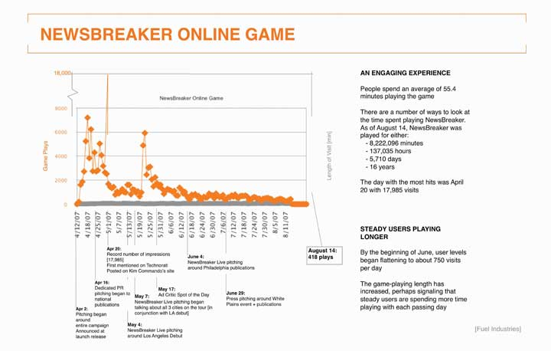
Chart tracking number of players and time spent playing NewsBreaker online.
As you can see, users spent an average of 55.4 minutes playing the game. Game enthusiasts have enjoyed playing the game well past the media buy, which ended in June 2007. The total time people spent playing the game from April 12 through the end of August is 8,714,295 minutes—around seventeen years!
The number of people playing peaked on April 20 at a whopping 17,985 people. That was at the beginning of the campaign; toward the end the numbers were closer to 750 per day, indicating that the media efforts attracted News Explorers to the game.

Direct and Online Advertising
In 2007, marketers—commercial and nonprofit—spent $173.2 billion on direct marketing in the United States. The Direct Marketing Association (DMA) claims that each dollar spent on direct marketing yields, on average, a return on investment of $11.69. ^{[10]} The strength of direct marketing is that it allows the advertiser to track the impact of a mailing or online ad directly. As direct marketers like to say, “What gets measured, gets managed.”
E-commerce marketers often use a metric they call the conversion rate—the percentage of visitors to an online store who purchase from it. Because each action online is trackable, it’s possible to go even further by breaking down the Web experience to understand which aspects of it are effective and which are not. For example, IBM computes microconversion rates to pinpoint more precisely how companies can improve their online shopping process. ^{[11]} This technique breaks down the shopping experience into the stages that occur from the time a customer visits a site to if or when she actually makes a transaction:
- Product impression: Viewing a hyperlink to a Web page that presents a product
- Click-through: Clicking on the hyperlink and viewing the product’s Web page
- Basket placement: Placing the item in the “shopping basket”
- Purchase: Actually buying the item
These researchers calculate microconversion rates for each adjacent pair of measures to come up with additional metrics that can pinpoint specific problems in the shopping process:
- Look-to-click rate: How many product impressions convert to click-throughs? This can help the e-tailer determine if the products it features on the Web site are the ones that customers want to see.
- Click-to-basket rate: How many click-throughs result in the shopper placing a product in the shopping basket? This metric helps to determine if the detailed information the site provides about the product is appropriate.
- Basket-to-buy rate: How many basket placements convert to purchases? This metric can tell the e-tailer which kinds of products shoppers are more likely to abandon in the shopping cart instead of buying them (believe it or not, this is a major problem for e-commerce businesses). It can also pinpoint possible problems with the checkout process, such as forcing the shopper to answer too many questions or making her wait too long for her credit card to be approved.
In some cases advertisers evaluate how much they spend on various ads compared to the visits or clicks they each create and then reallocate their ad spend to the ones with the highest ROI, as measured by cost per visit or cost per click. This method is easy to implement, but it can be misleading because it’s short-term oriented: one execution may result in a low cost per action, but customers may be “one-timers” who don’t return. Another execution might be more expensive, but customers may respond to it repeatedly over time, generating additional profits with no additional costs. ^{[12]}
Online advertising formats have historically faced problems with declining response rates over time. Banner ads debuted with click-through rates above 50 percent but faded to about 2 percent after their novelty wore off. Today, banners get fewer than five responses for every thousand advertisements shown, a response rate of about 0.5 percent. ^{[13]} That’s why advertisers now resort to other methods to capture surfers’ attention, such as pop-up ads that open on top of the Web site a person visits (also on their way out because they tend to be more annoying than entertaining) and, more lately, pop-under ads that open a new browser window under the active window so they allow the user to continue browsing at the intended site.
Numerous Web sites provide online calculators to determine ROI—of course these assume that you have accurate information to use (garbage in, garbage out). They typically consider these inputs:
- Site traffic: How many people visit your site in a typical month?
- Investment: How much do you spend on Web development, hosting, search engine marketing, or other advertising?
- Responses: What percentage of visitors do you expect to request more information, request a quote, or place an order?
- Conversions: What percentage of those who make one of the responses above do you realistically expect will buy?
- Average sale: How much do you expect each buyer to spend?
- Gross profit margin: What is the average percentage margin of your sales?
With this information in hand, you can calculate how much you spend to attract each visitor, how much you spend to attract each visitor who actually buys from you, and your net return on your investment. ^{[14]}

SS+K Spotlight
Since its core product is delivered online, it was a no-brainer that msnbc.com’s new branding campaign would include an online element.

Figure 14.16
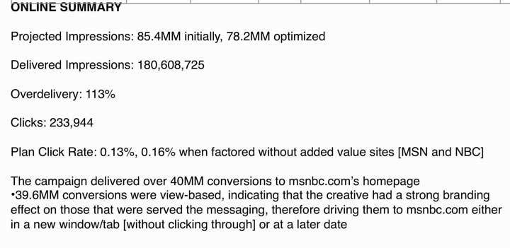
Summary of results from the msnbc.com online banner campaign including paid and in-kind media from NBC and MSN.
Figure 14.17
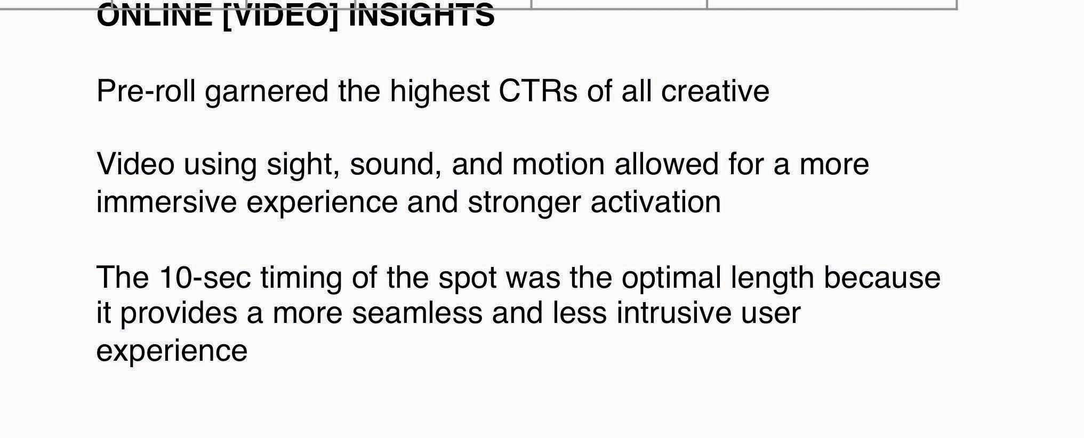
msnbc.com ran ten-second prerolls “Spectrum Rain” and “Spectrum Wall” and garnered the highest click-through rate of the campaign.

Figure 14.18
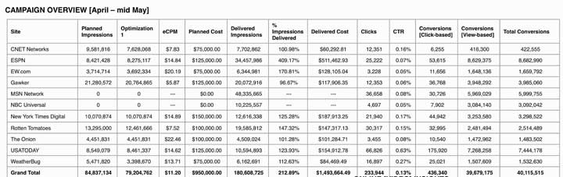
In order to optimize online dollars, it was important for msnbc.com, The Media Kitchen, and SS+K to pay attention to each site and each unit that was being utilized.

Buzz, PR, and WOM
Public relations campaigns traditionally measure impact in terms of the extent to which the client obtains media coverage. A basic metric is media impressions; as you learned in earlier chapters, this is an estimate of the number of people who see the plug in a magazine or newspaper or on a talk show or who hear about it in a radio interview. A PR firm typically delivers a comprehensive list of media citations to the client, and it may rank these in terms of the prestige or circulation of the outlet or how prominent the mention was in this outlet. Again, this metric doesn’t really speak to any impact the citations have on actual purchases or attitude change. ^{[15]}
As WOM (word-of-mouth) assumes a greater role in many advertisers’ strategies—especially online buzz—the pressure is on for agencies to demonstrate that this approach does more than just make people talk about a brand. In fact, one prominent WOM agency called BzzAgent recently took a bold step to back up its claims that its buzz campaigns yield attractive ROI. With its “WOM Impact Guarantee” program the agency invites any brand marketer and its agency partners to take part in a challenge in which BzzAgent and the agency partner will run competing campaigns. If BzzAgent does not top the competing agency by 20 percent across four metrics—brand awareness, consumer opinion, purchase intent, and actual sales—the agency will refund the marketer the cost of its word-of-mouth campaign and measurement costs. ^{[16]} That’s putting your money where your (word-of-) mouth is.
The explosion of blogs, chat rooms, and Web sites that let consumers spread the word about products they love and hate opens an entire new realm of possibilities to develop metrics for WOM. Contrary to the assumptions of many students who brazenly post embarrassing photos of themselves on Facebook, the Web is forever—most content that goes online can be traced and analyzed long after it’s been put there. That photo of you from last weekend’s wild party might come back to haunt you someday!
BuzzMetrics, a subsidiary of the Nielsen Company, offers marketers research services to help them understand how this consumer-generated content affects their brands. BuzzMetrics’ search engines identify online word-of-mouth commentary and conversations to closely examine phrases, opinions, keywords, sentences, and images people use when they talk about a client’s products. The company’s processing programs then analyze vocabulary, language patterns, and phrasing to determine whether the comments are positive or negative and whether the authors are men, women, young, or old to more accurately measure buzz. BuzzMetrics’ BrandPulse and BrandPulse Insight reports can tell advertisers how many people are talking about their products online, the issues they’re discussing, and how people react to specific ads or other promotional activities. ^{[17]}

SS+K Spotlight
Figure 14.19
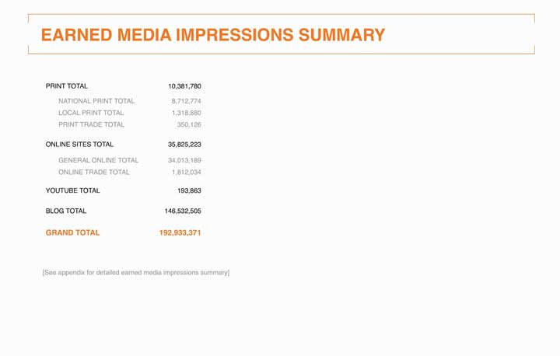
Total earned media impressions from the msnbc.com PR campaign.
In addition to measuring elements of the campaign, msnbc.com took some internal measurements. Taking these additional steps allowed them to see how the messaging impressions were affecting the site traffic. Using Omniture tracking, msnbc.com was able to analyze the action on their site while the campaign was in effect and to determine whether they met their goals.
Figure 14.20
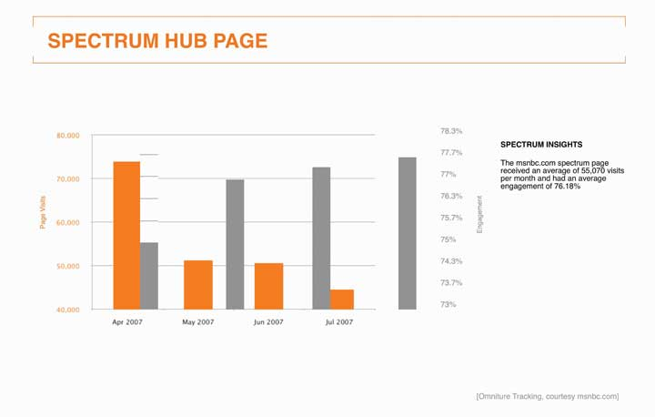
This chart follows the traffic numbers and time spent interacting withhttp://www.spectrum.msnbc.com, which was a landing destination for the campaign. Having a unique URL or phone number is a common way for direct marketers and online advertisers to measure success.
Figure 14.21
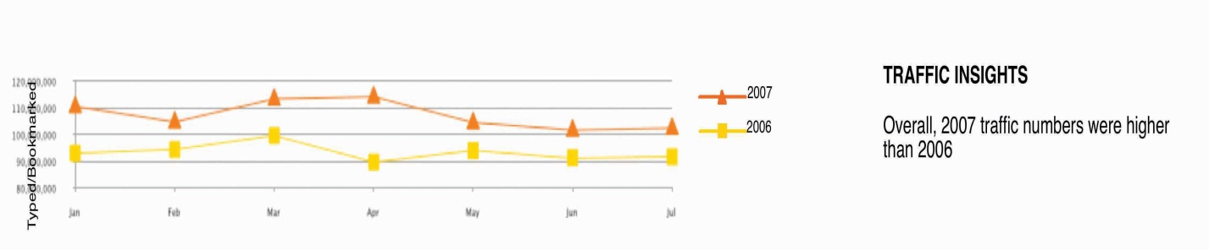
This chart tracks overall visits to msnbc.com from January to July in 2006 and 2007. Notice the big gap in April, the month the campaign launched. Analyzing this data helped msnbc.com to quantify the success of its goal of increasing overall traffic from the previous year.
Figure 14.22
One of the key measurements of success was to increase unique users, the number of different people who come to a site. If the same person visits a site five times a day, she still counts as one unique user.
Figure 14.23
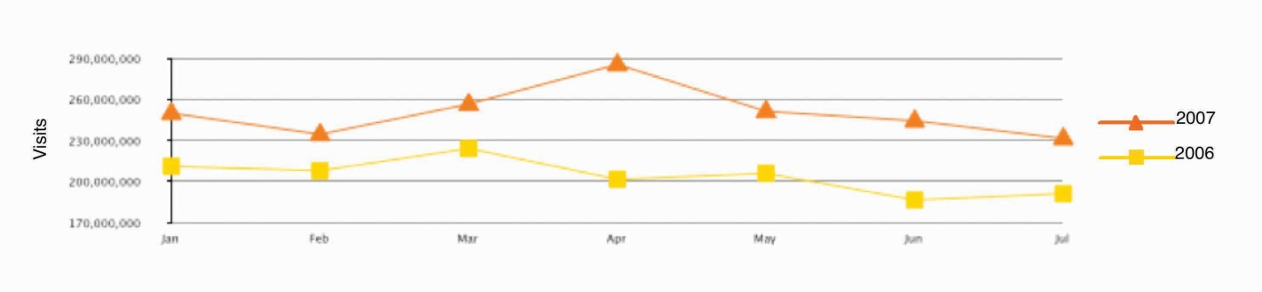
Another breakdown of the traffic shows the number of organic users. This is a user who types in a given URL, or who has that URL bookmarked as her form of entry into a given site, rather than clicking through a link (from a search page or ad).

Figure 14.24
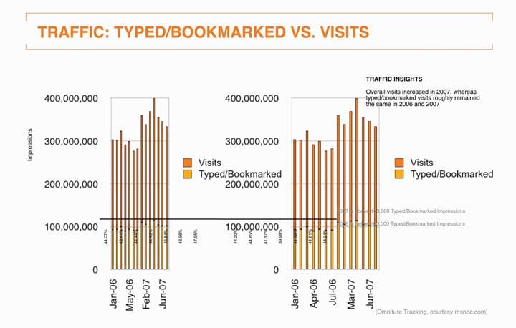
SS+K compared the rate of overall visits versus the rate of visits by organic users.
Figure 14.25
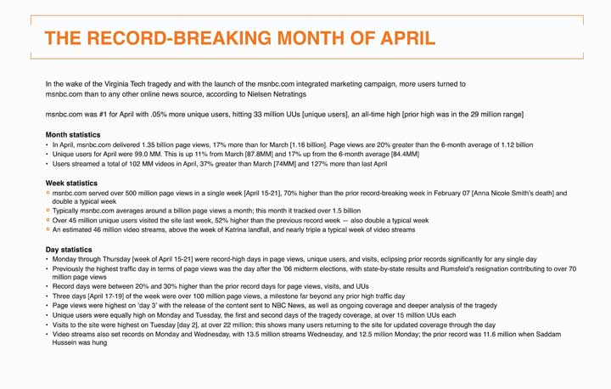
The bottom line: the first-ever branding campaign for msnbc.com was a huge success! The slide above captures the key statistics in the launch month of April 2007.
Figure 14.26
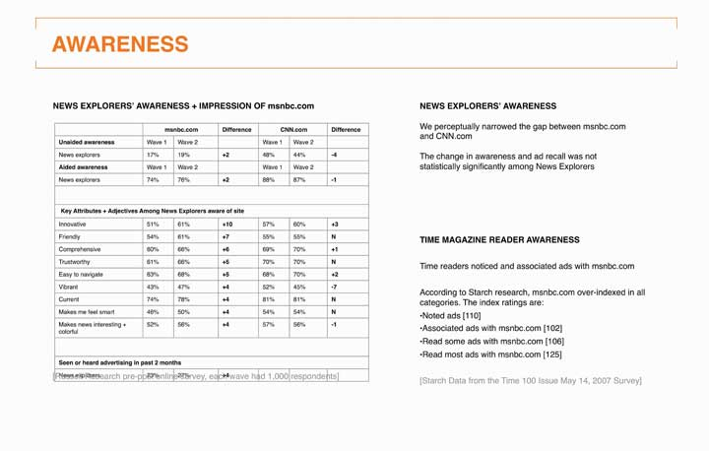
In addition to tracking traffic data, it was also important to consider awareness as a metric to determine the success of the campaign. Prepost survey results included both qualitative and quantitative data.
A few months after the campaign wrapped, SS+K conducted a set of interviews with the same internal stakeholders they’d interviewed when they won the account. One of the goals of the marketing campaign was to unite their multiple views of what the brand stood for. It turned out that even before it launched, stakeholders felt the campaign was successful in that it gave msnbc.com a clear story. It gave them a common lens they could use to evaluate new design concepts and editorial content, while it gave msnbc.com the cachet stakeholders felt was long overdue. It successfully overcame the past ambiguity about whether the site was primarily an offshoot of NBC versus Microsoft and promised stakeholders a clearer future. The head of msnbc.com ad sales noted: “Clients have called us asking, ‘How do we do something similar?’ It’s opened up doors.”

Table 14.1 Final Takeaway and Lessons from the msnbc.com Branding Campaign
A BRAND IS BORN
“This is a good thing, we now have an independent identity.”
—msnbc.com key stakeholder
INTERNAL RALLYING CRY
“It’s now visually clear that we are different and we’ve arrived somewhere special and unique, and it works because we brought it out ourselves, it’s who we are.”
—msnbc.com key stakeholder
STARTING TO GET THE WORD OUT
Paid media impressions: Over 730 million
Earned media impressions: Over 175 million
LOW CONSUMER AWARENESS
Statistically insignificant changes in awareness and ad recall among News Explorers
HIGH CONSUMER ENGAGEMENT
Large amount of time spent playing online game
High recall of game sponsor in-cinema
CLARIFIED IDENTITY HELPS DEVELOP AS NEWS SOURCE, NOT JUST A NEWS SITE
“The key is, we have to keep at it, this can’t be a one shot deal, we have to get it out there more.”
—msnbc.com key stakeholder
KEEP EVOLVING THE PRODUCT
“We know that CNN.com beat us to a redesign, and we know that we are behind them, we are working on getting our flexible design out there.”
—msnbc.com key stakeholder
Since the campaign, msnbc.com has been decorated with more than a dozen honors and accolades, including these awards. As you’ll note, these awards are in different categories from effectiveness to creativity. Visit each of their Web sites to learn more about the prestige of each of these awards.
- Winner of the prestigious international Webby Award for best Integrated Campaign, honoring excellence on the Internet
- Winner of a Gold EFFIE award (small budget campaign) for effective advertising, honoring the most significant achievement in the business of marketing communications: ideas that work
- Winner of the Gold One Show Interactive award for brand gaming
- Winner of the Gold One Show Interactive award for its integrated campaign (interactive and noninteractive)
- Winner of a Bronze ANDY award from the Ad Club of New York for creativity in advertising

KEY TAKEAWAY
Advertisers continue to search for new platforms as they compete for the attention of media-saturated consumers. Today virtually anything—from a cemetery to a rocket ship—can be used to get across a message. But these emerging venues don’t necessarily have a tradition (yet) of measuring direct impact. An exception is direct marketing; its lifeblood is about tying a message directly to a result. Whether via mail catalogs or online ads, direct marketers carefully track the effectiveness of each and every message they send. This sounds great, and it usually is—but remember, as we’ve already noted, short-term purchases may boost your bottom line this quarter but still come back to bite you in the long term if these messages don’t contribute to a more fundamental shaping of customers’ deep-seated feelings and beliefs about the product or service. And so, the search for the Holy Grail continues.

EXERCISES
- List and briefly characterize each of the alternative media forms listed.
- Identify and describe each of the Interactive Advertising Bureau’s (IAB) five basic metrics for advergaming.
- Describe how e-commerce marketers use the conversion rate metric to track customer activity.

[1] “In-Store Marketing Gives Highest Return,” November 2003,http://www.popai.com/AM/Template.cfm?Section=Search&section=June&template=/CM/ContentDisplay.cfm&ContentFileID=897(accessed August 16, 2008).
[2] “The Association of National Advertisers and POPAI Lead Global Marketing at-Retail Initiative (MARI),” http://www.popai.com, October 7, 2005 (accessed August 16, 2008).
[3] Ellen Byron and Suzanne Vranica, “Scanners Check Out Who’s Browsing Marketers, Retailers Test Sensors to Weigh Reach of In-Store Promotions,” Wall Street Journal, September 27, 2006, B2.
[4] Quoted in Sarah Mahoney, “TNS Unveils New In-Store Metrics For Grocers,” Marketing Daily, July 14, 2008, http://www.mediapost.com (accessed August 16, 2008).
[5] “Report: Digital Signage More Effective than Traditional Media,” October 24, 2007,http://www.digitalsignagetoday.com/article.php?id=18696&prc=407&page=190(accessed August 16, 2008).
[6] “Out-of-Home Video Advertising Bureau (OVAB) Expands Adding Screenvision and Target…,” Reuters, January 14, 2008,http://www.reuters.com/article/pressRelease/idUS108048+14-Jan-2008+PRN20080114(accessed August 16, 2008).
[7] Alana Semuels, “Research Firm Nielsen Tallying Product Placement Ads,” Los Angeles Times, July 21, 2008, http://www.latimes.com (accessed August 16, 2008).
[8] Brian Stelter, “Some Media Companies Choose to Profit from Pirated YouTube Clips,”New York Times Online, August 15, 2008 (accessed August 16, 2008).
[9] Game Advertising Platform Status Report: Let The Games Begin, Interactive Advertising Bureau, October 2007, http://www.iab.com (accessed August 14, 2008).
[10] The Power of Direct Marketing: ROI, Sales, Expenditures and Employment in the US, 2007-2008 Edition, Direct Marketing Association, http://www.the-dma.org/aboutdma/whatisthedma.shtml (accessed August 15, 2008)
[11] Joan Raymond, “No More Shoppus Interruptus,” American Demographics (May 2001): 39.
[12] “True Campaign ROI Links to LTV (Lifetime Value),”http://www.jimnovo.com/ROILTV.htm (accessed August 15, 2008).
[13] “IAB on Advertising ROI,” ZDNet Research, November 14th, 2003,http://blogs.zdnet.com/ITFacts/?p=4928 (accessed August 15, 2008).
[14] Blitz Media Design, http://www.webrefinements.com/seo/web-roi.html (accessed August 15, 2008).
[15] Deborah Holloway, “How to Select a Measurement System That’s Right for You,” Public Relations Quarterly (Fall 1992): 15–17.
[16] Michael Bush, “Better ROI or Your Money Back, Says Buzz Agency,” Advertising Age, July 14, 2008, http://adage.com/article?article_id=129593 (accessed July 16, 2008).
[17] Keith Schneider, “Brands for the Chattering Masses,” New York Times Online, December 17, 2006,http://www.nytimes.com/2006/12/17/business/yourmoney/17buzz.html?scp=4&sq=buzzmetrics&st=nyt (accessed April 14 2008); Nielsen Buzzmetrics,http://www.nielsenbuzzmetrics.com/products (accessed April 14, 2008).

14.4 Exercises

TIE IT ALL TOGETHER
Now that you have read this chapter, you should be able to determine how to choose the right media for client messages:
- You can identify and explain the term return on investment (ROI).
- You can describe and illustrate the value of using metrics to gauge the direct impact of a marketing communication.
- You can explain brand equity and why it is an important brand concept.
- You can demonstrate how msnbc.com measured the ROI of the campaign using five parameters.
- You can define and discuss the usefulness of the metric CPM (cost per thousand).
- You can characterize the usefulness of network TV metrics for providing evidence of message usefulness.
- You can recall the various radio day-parts.
- You can distinguish the three primary Starch scores.
- You can list and discuss the basic principles that increase a print ad’s likely impact on the reader.
- You can list and discuss ROI for alternative media.
- You can define and discuss media impressions.

USE WHAT YOU’VE LEARNED
- The famous ad line “What’s in your wallet?” might just become “Who’s in your car?” Progressive Corp. insurance now offers a device for its insured drivers that will assist in lowering the drivers’ insurance rates. The device is about the size of a box of Tic-Tacs and monitors one’s driving time, number of miles driven, and acceleration and braking patterns. The company then adjusts driver rates to reflect the presence or absence of risky driving habits. The hope is that insured drivers will adjust their risky driving habits or at least be more aware of what they are doing that is unsafe. The product and others like it are at least partially targeted toward teens and beginning drivers who are in the habit formation stage of driving. Obviously, there are those who see this form of monitoring as excessive, an invasion of privacy, and biased against those who don’t match Progressive’s “ideal driver” profile.
As an advertising director, what metrics would you suggest that your client Progressive use to determine the effectiveness of its future ads featuring the device? You will need to consider a target market for Progressive’s ads. Discuss your ideas in class. For more information on Progressive and its policies go to http://www.progressive.com.
- One of the central concepts associated with product placement in different media forms is the idea that the product appears in a natural setting and is perceived as being something other than an ad. This rationale would then assume that the viewer, reader, or Web surfer receives a different type of message than one received in a traditional advertisement. Additionally, since most product placements are not blocked by the consumer’s screening process, the advertiser has a higher chance of reaching the chosen market.
Do you use TiVo or some other product to block or zap ads in your favorite TV shows? Do you try to fast-forward past any ads that appear on your DVD disks? If so, you have just made the case for product placement within those shows or DVDs.
Your assignment is to watch several TV shows or DVDs over three to five days. Keep a diary of product placements in those shows or DVDs. Based on what you have recorded, comment on metrics that could be used to test the effectiveness of those placements. Explain your comments and choices.

DIGITAL NATIVES
The Point-of-Purchase Advertising Institute (POPAI) has a wealth of information about point-of-purchase (POP) advertising. One does not usually associate POP with the “wired world.” POPAI hopes that its Web viewers will learn more about POP and how it can be used in advertising. Who knows, in tomorrow’s world POP may appear in the e-commerce stores or in your personal Web spaces. Sound too strange? Data indicate that many alternative media forms are being adapted by industry and consumers to the “wired world.” Since POP is highly effective in the retail environment, you might be able to consider how useful it might be to capture the attention of the digital consumer.
Go to the POPAI Web site at http://www.POPAI.org and read the summary of one of the books available for viewing. You’ll find your book options at the bottom of the opening page of the organization’s Web site. Summarize what you have learned from the chosen e-book. Lastly, comment on what you perceive the future of POP to be.

AD-VICE
- Pick two magazine ads that demonstrate competitive products. Design a list of at least four metrics that could demonstrate which of the two ads is more effective in reaching the target market. Explain your reasons for your metric choices.
- According to material presented in the chapter, traditional (broadcast) media struggle to demonstrate a direct impact on the bottom line. Explain what is meant by this phrase. Explain the relationship between cost per thousand (CPM) and return on investment (ROI).
- Go to Google or another search engine and find information that lists the top five television ads from last year’s Super Bowl based on either viewers or critics’ choices. Next, find information on the advertising rates for that Super Bowl. Evaluate whether the exposure justifies the cost. Explain your evaluation procedure.
- Go to the Out-of-Home Video Advertising Bureau (OVAB) Web site athttp://www.ovab.org. Once there, explore the Web site to determine the function and services of the organization. Choose the Network Planning Guide option on the opening Web page and download the planning guide. Comment on what you find and how useful it appears to be for the advertising planner. What other information do you think the advertising planner might need to make a wise buy in this media category?

ETHICAL DILEMMA
Do you download software, movies, or songs without considering the legality of what you are doing? Even though this practice has consequences for some, many don’t see unauthorized downloading as necessarily bad or harmful to anyone. Using Google or another search engine, research copyright, file sharing, and music downloads to learn more about the current state of the downloading practice and any penalties associated with it. A good starting place would be the United States Copyright Office’s Web site at http://www.copyright.gov.
Visit RealNetworks at http://www.realnetworks.com. RealNetworks has developed a software product (see the RealPlayer product category) that allows computers to rip information from a disk in just a few moments. This information can later be transferred to other disks. At present this process is legal. Examine RealNetworks’ description of their products and services.
What future ethical dilemma do you think such products as RealPlayer might cause? As a consumer, do you think a positive or negative buzz should be started about such products? As an advertising executive, what would be your stance on accepting companies that made software of this nature as clients? Take a stance and discuss your position in class. Discuss your position with peers or have a minidebate about the issues and positions.

